**TimeTable**

**GitHub Repo:-** <https://github.com/Siddhant40/Worldline_tasks/tree/main/timetable>

**Live Demo :-** <https://siddhant40.github.io/Worldline_tasks/timetable/>

Screenshots:-

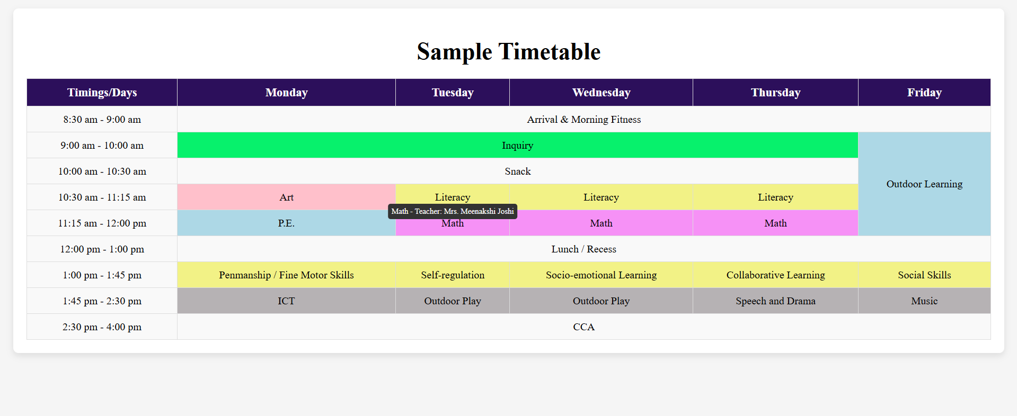

In this Timetable we can use mouse over to show the details of the class including time, subject name and teacher name.

**Signup/Login**

**GitHub:-** [**https://github.com/Siddhant40/Worldline_tasks/tree/main/Signup_page**](https://github.com/Siddhant40/Worldline_tasks/tree/main/Signup_page)

**LiveDemo:-** [**https://siddhant40.github.io/Worldline_tasks/Signup_page/**](https://siddhant40.github.io/Worldline_tasks/Signup_page/)

**Screenshots:-**

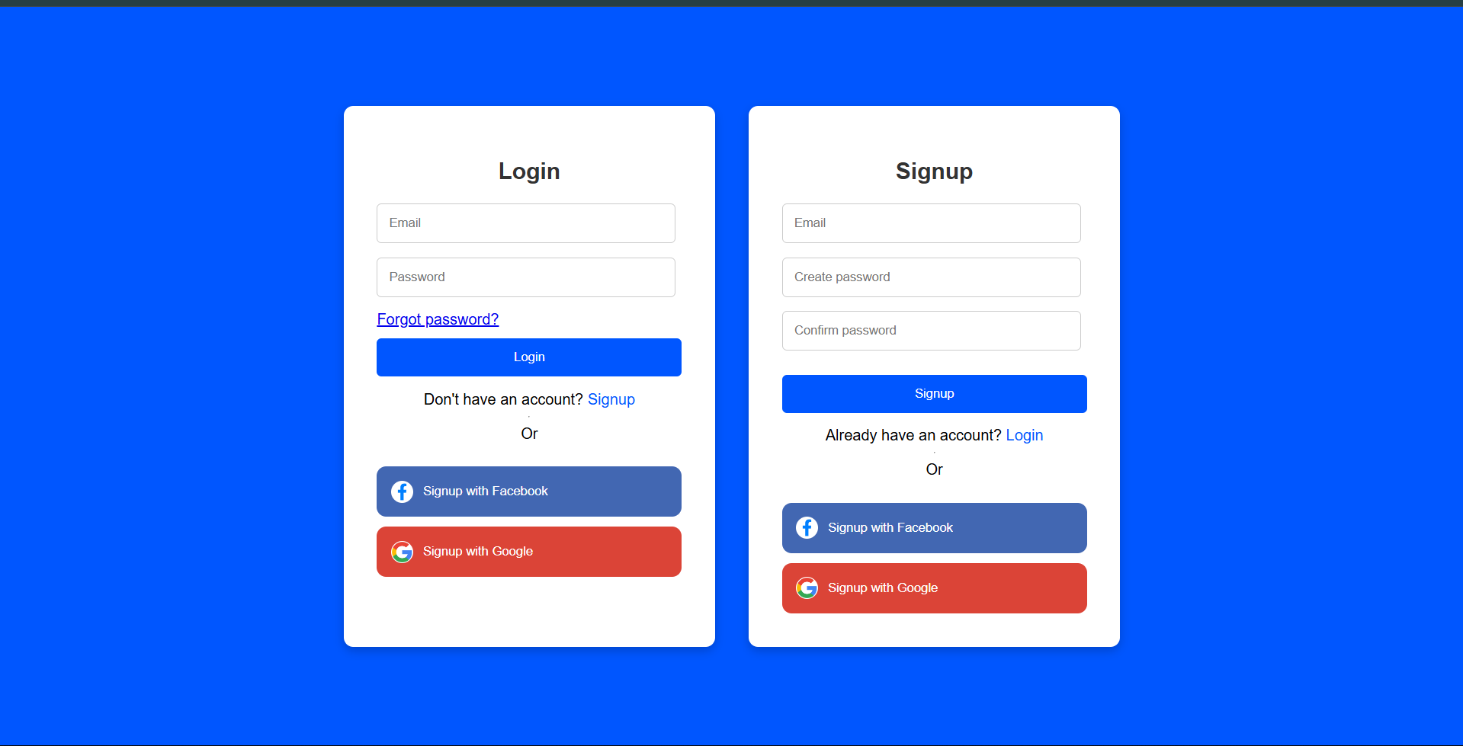

**The above registration form and use responsive design to display signup and login page and validate using HTML5 .**