**Task 2**

**1. Design a responsive webpage using HTML5 and CSS3 with the**

**following requirements:**

**GitHub Repo:-** [https://github.com/Siddhant40/Worldline_tasks/tree/main/na](https://github.com/Siddhant40/Worldline_tasks/tree/main/navbar)

**Live Demo :-** <https://siddhant40.github.io/Worldline_tasks/navbar/>

**Screenshots:-**

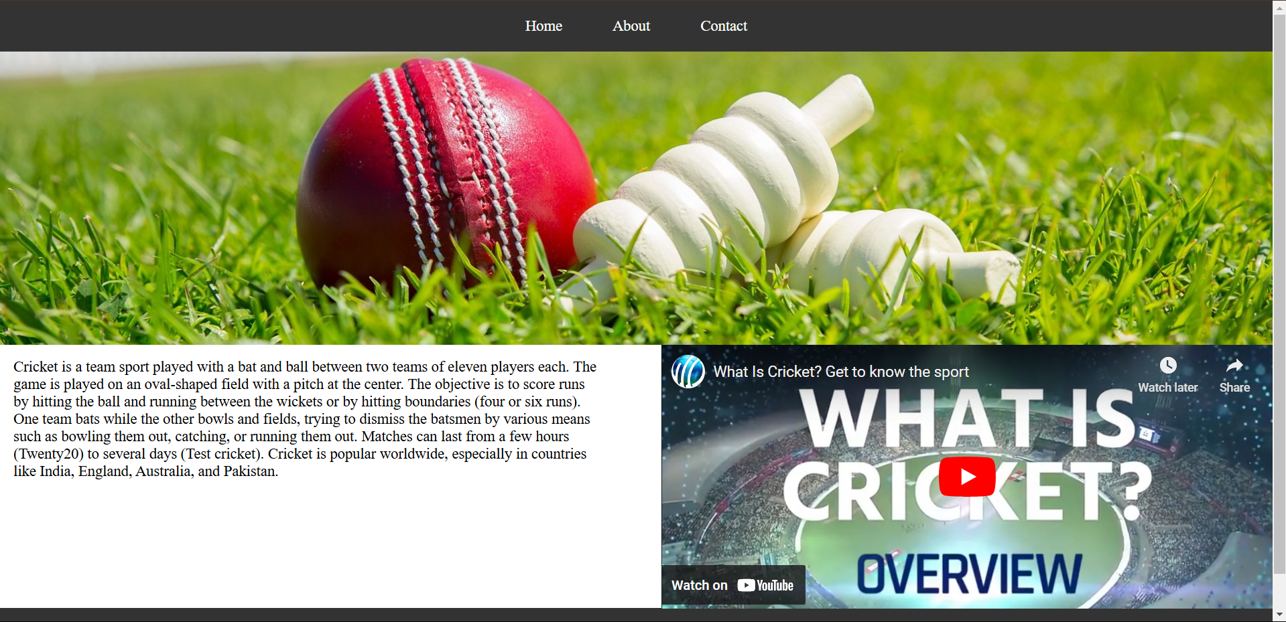

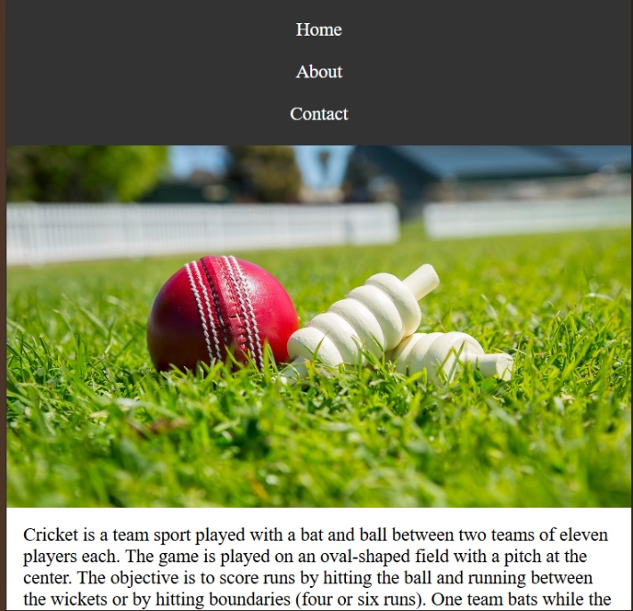Responsive Design:-



**2. Create a webpage that demonstrates CSS3 animations with the following requirements:**

**GitHub Repo:-** <https://github.com/Siddhant40/Worldline_tasks/tree/main/css_animation>

**Live Demo :-** <https://siddhant40.github.io/Worldline_tasks/css_animation/>

**Screenshots:-**

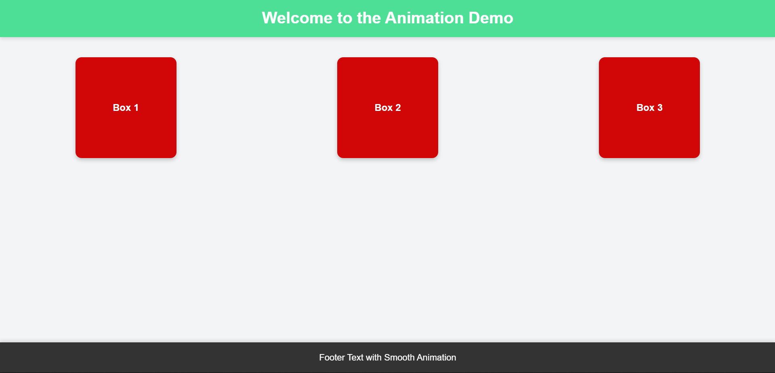

**Result:**

1. When you load the page, the header will fade in and slide down.
2. Hovering over any of the three boxes in the main section will cause them to rotate 360 degrees.
3. Footer has a "fade-in from the bottom" effect. This makes the footer smoothly slide into view as the page loads, creating a cleaner and more modern feel.