**Task 4**

**1. Design a responsive webpage using HTML5 and CSS3 with the**

**following requirements:**

**GitHub Repo:-** <https://github.com/Siddhant40/Worldline_tasks/tree/main/>form

**Live Demo :-** <https://siddhant40.github.io/Worldline_tasks/form/>

**Screenshots:-**

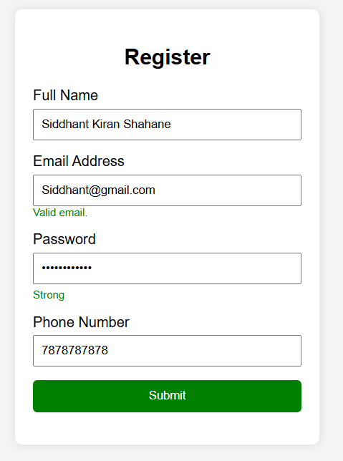

In the above image we can see following things: -

1. Name is in proper format
2. Email address is a vaild mail
3. Password is strong and has satisfised all the necessary conditions
4. Phone number is of 10 digits.
5. As all the conditions are Satisfied so the submit button has turn into green colour.

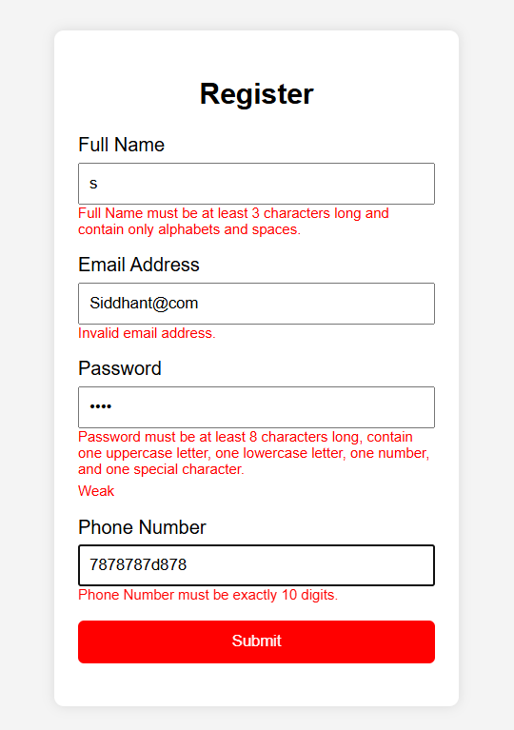

In above image we can see following things:-

1. Name is not entered correctly so it is showing error.
2. Email address is also in wrong format.
3. Password does not satisfy all the condition so necessary conditions are shown in red color below it.
4. Phone number is incomplete so we are getting warning for it in red font.
5. As all the conditions are not satisfied so the submit button is turn to red color.

* **Arithmetic Operations performed in JavaScript**

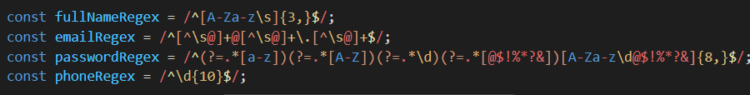

**Conclusion:** -

Hence our Form can validate the users input and then gives warnings to user so that user can enter the data properly.