**Task 5**

* **Design a webpage with a user registration form and interactive features using**

**GitHub Repo:-** <https://github.com/Siddhant40/Worldline_tasks/tree/main/>password

**Live Demo :-** [https://siddhant40.github.io/Worldline_tasks/password/](https://siddhant40.github.io/Worldline_tasks/passward/)

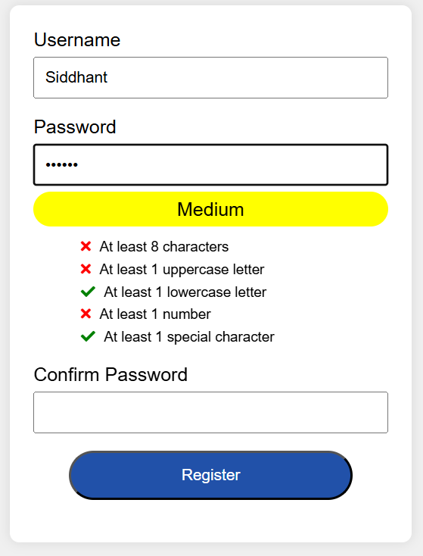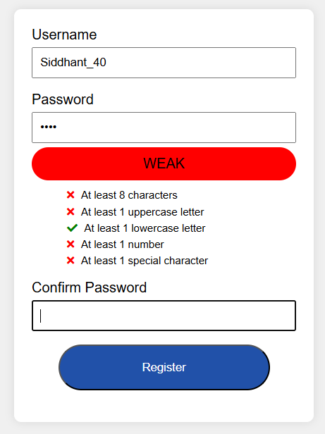**Screenshots:-**

* In the above images we can see following things: -
  1. Img-1
     1. User has entered small password.
     2. Small password is indicated as **weak** in red color.
     3. Only one condition is satisfied.
  2. Img-2
     1. User has entered long password.
     2. Password has satisfied only two conditions.
     3. As a result the password is indicated as **Medium** in Yellow color.

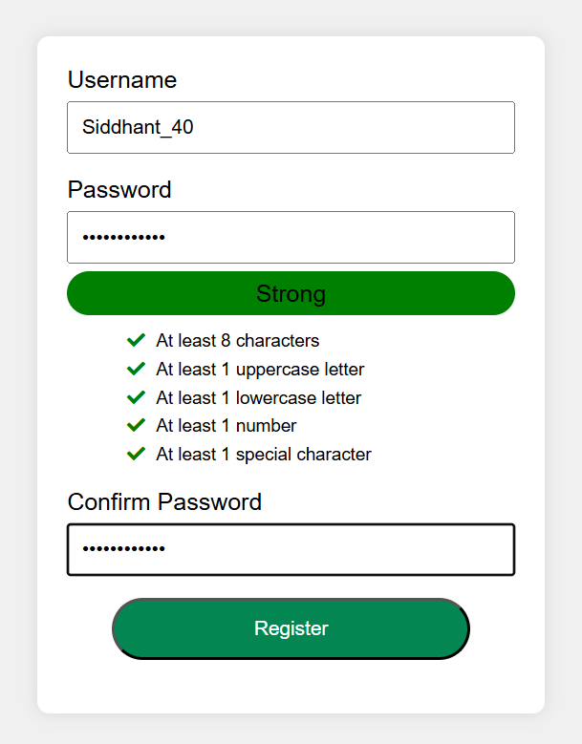

* In the above images we can see following things: -

1. User has entered 10 character password.
2. The password satisfies all the condition.
3. Hence the password is **strong** and indicated in **green** color.
4. Password and confirm password is mathched so no cautin is given.