AI DRIVEN TALENT ACQUISITION AND RETENTION TOOL

Jaai Joshi

San Jose State University [jaai.joshi@sjsu.edu](mailto:jaai.joshi@sjsu.edu)

Mahesh Cheekuri

San Jose State University

[mahesh.cheekuri@sjsu.edu](mailto:mahesh.cheekuri@sjsu.edu)

Sai Surya Likhit Monavarthy

San Jose State University

[saisuryalikhit.monavarthy@sjsu.edu](mailto:saisuryalikhit.monavarthy@sjsu.edu)

Siddhant Raje

San Jose State University

[siddhantabhijit.raje@sjsu.edu](mailto:siddhantabhijit.raje@sjsu.edu)

***Abstract*—In an era of dynamic workforce requirements and high turnover rates, the proposed system uses advanced machine learning algorithms and natural language processing techniques to analyze patterns in employee recruitment and retention data. By processing information from resumes, interviews, and performance reviews, this tool will predict the candidate's success and longevity within an organization. The novelty of this approach lies in its continuous learning capability, which adapts to industry trends, skill shortages, and company-specific needs. The system employs predictive analytics to identify high-potential candidates and at-risk employees, enabling proactive retention strategies. Implementation of this tool in HR departments significantly enhances decision-making processes in hiring and retention, leading to improved workforce stability and reduced turnover costs. Case studies have also demonstrated the tool's usefulness in various contexts, which shows its ability to transform talent recruitment practices in the industries. This research contributes to the growing body of literature on AI applications in HR, addressing critical challenges in talent acquisition and retention while emphasizing ethical considerations and data privacy. Designed for enterprise use, the tool provides HR departments with actionable insights to optimize hiring strategies and make data-driven retention decisions, thus fostering a more efficient and aligned workforce.**

1. INTRODUCTION

In today's rapidly evolving businesses, organizations face various challenges in attracting, selecting, and retaining top talent. The increasing complexity of job roles, coupled with the dynamic nature of skill requirements, has made traditional recruitment and retention strategies less effective. To address these challenges, this paper introduces an innovative AI-driven talent acquisition and retention tool designed to revolutionize human resource management practices. This advanced system leverages artificial intelligence and machine learning algorithms to analyze vast amounts of data from resumes, interviews, and performance reviews, providing HR professionals with powerful insights for informed decision-making. By predicting candidate success and employee longevity,the tool aims to significantly improve hiring outcomes and reduce turnover rates. Furthermore, its unique ability to continuously adapt to industry trends, skill shortages, and company-specific needs ensures its relevance and effectiveness in diverse organizational contexts. This introduction sets the stage for a detailed exploration of the tool's architecture, methodology, and potential impact on enterprise-level talent management strategies.

The combined system of acquisition and retention offers many advantages such as Unified data processing and continuous learning. In the case of unified data processing, the retention model has made use of preprocessing, to ensure that only the relevant data is handled throughout the acquisition and the retention phase. In the case of continuous learning, the system implements the feedback loops through resume analysis results and employee satisfaction surveys. This enables the model refinement based on actual outcomes. The third advantage is with respect to the HR professionals. They benefit from the predictive insights for potential hires and also a retention risk assessment for existing employees, which helps in creating a talent management solution. The implementation shows a significant improvement over the traditional HR analytics tools by providing talent management capabilities. Through the integration of machine learning algorithms, natural language processing and real-time analytics, organizations can make data driven decisions throughout the employee lifecycle, right from the initial recruitment to the long-term retention methods.

II. METHODOLOGY

1. *DATASET DESCRIPTION AND PRE-PROCESSING*

For the ‘Retention’ phase, use of the ‘IBM HR Analytics Employee Attrition Dataset’ has been done. This dataset consists of 35 columns.

Pre-processing of the dataset has been done using ‘Pandas’ library. The feature variables have been converted into corresponding numeric values.

1. *SYSTEM DESIGN AND IMPLEMENTATION*

In the ‘Talent acquisition’ phase, the candidate’s resume will be analyzed. The HR will be asked to input the resume of the candidate, which internally will trigger an AWS Lambda function to upload this resume in an S3 bucket. Once the resume has been uploaded in the S3 bucket, the ‘textract_handler’ lambda function will be invoked which will generate results in a raw format. This raw output will be passed on to the ‘bedrock_handler’ lambda function where the use of a ‘Claude’ model will be done to generate insights regarding the employee’s talents and whether the employee will be acquired by the company. A ROUGE score will be calculated based on the generated insights and the job description for a particular role. A Generative AI’s ‘Anthropic Claude’ model has been used to evaluate the summary of the resume uploaded.

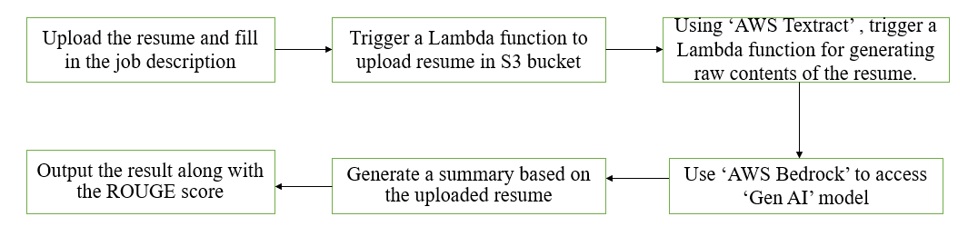

Fig. 1 Block diagram for Acquisition phase.

Fig 1. shows a block diagram for the Talent Acquisition phase where the uploaded resume goes through six different steps before we get the candidate’s relevancy to that particular job.

**Algorithm:** Resume Analysis and Job Description Matching

**Input:** Resume in PDF format, Job description in textual format

**Output:**Analysis results and formatted sections

1: Initialize API endpoints (RESUME_HANDLER_API_URL, S3_RESULTS_BASE_URL)

2: **if** file selected and job description provided then

3: Convert PDF to base64

4: Create payload {content, filename, job_description}

5: Send POST request to API

6: **if** upload successful then

7: Store filename

8: Enable results viewing

9: **end if**

10: **end if**

11. Provide the file to AWS textract

12. Pass the textract output to bedrock lambda function

13. Invoke the lambda to fetch results and store in S3 bucket

14: When fetching results:

15: Get analysis from S3_RESULTS_BASE_URL

16: Display job description

17: **for** each section in analysis_data **do**

18: Create formatted section with heading and display content

20: **end for**

21: **return** formatted analysis results

In the ‘Retention phase, implements a comprehensive employee retention prediction system using a Flask-based web framework integrated with multiple authentication mechanisms. The system uses a Random Forest classifier for prediction, processing key employee metrics including satisfaction levels between 0 and 1, performance evaluations, project count, and working hours through a standardized pipeline. A retention score of 0 shows that the employee is likely to stay while a retention score of 1 means that the employee is likely to leave. In the data preprocessing phase, numeric conversion for continuous variables and one-hot encoding for categorical features like department and salary levels have been done. The prediction engine generates turnover probabilities using rf_model.predict_proba(),while personalized recommendations are synthesized through OpenAI's GPT-4 model with structured prompt engineering. The architecture incorporates Firebase Admin for secure authentication, MongoDB for user management, and Flask-Mail for automated satisfaction survey distribution. The system features a continuous feedback mechanism through Google Forms integration, enabling real-time monitoring of employee satisfaction levels. This multi-layered approach ensures accurate prediction while maintaining data security through session management and token verification protocols.

The retention prediction feature allows users to input detailed employee data across multiple dimensions, including performance metrics, departmental information, and personal work characteristics. When employees' data is submitted, the system processes the information through a sophisticated prediction mechanism that generates insights about potential retention risks and provides actionable recommendations.

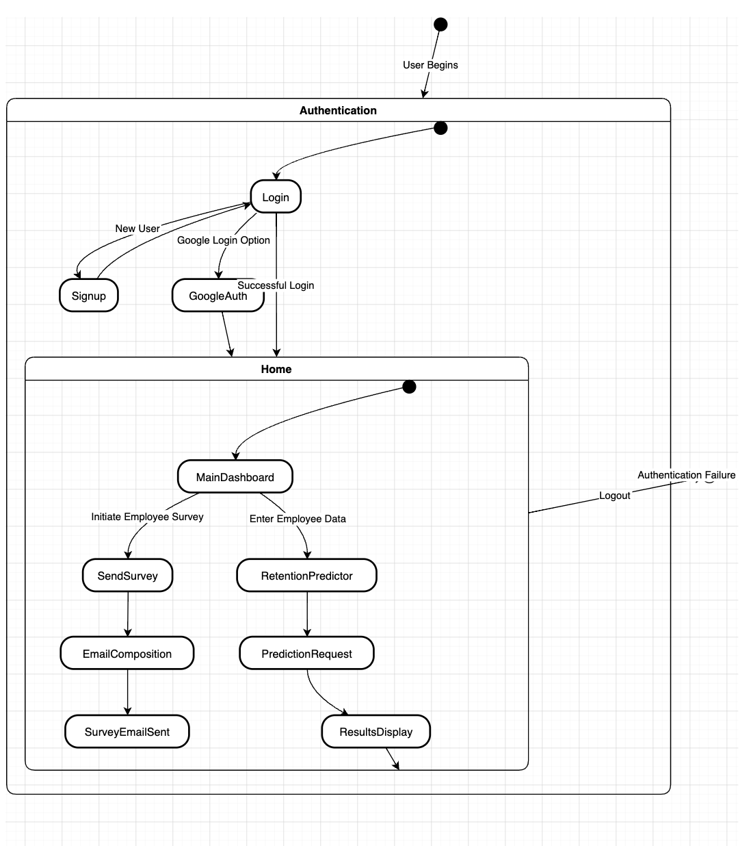

Fig. 2 Block diagram for Retention phase.

Fig 2. depicts the block diagram for the retention phase. Upon successful authentication, users are directed to the home dashboard, which serves as the central hub of the application. The dashboard presents two primary functional pathways: employee satisfaction survey initiation and employee retention prediction. The survey workflow enables HR personnel to quickly dispatch satisfaction surveys to employees via email.This process involves selecting an employee's email address, composing a standardized survey invitation, and sending it through the system. The mechanism is streamlined to facilitate easy communication and gather critical feedback about employee experiences and sentiment.

Throughout the application, users maintain complete control with an intuitive logout functionality, enabling them to securely exit the system at any point. The flow is designed to be logical, user-friendly, and focused on providing actionable insights for organizational human resource management.

**Algorithm:** Employee Retention Prediction System

**Input:** Employee metrics (satisfaction_level, last_evaluation, number_project, average_monthly_hours, etc.)

**Output:** Retention prediction, probability, and recommendations

1: Initialize models (rf_model, scaler, X_columns)

2: Create DataFrame from input data

3: for each numeric_column in input_data do

4: Convert column to float type

5: **if** value not in range(0,1) for satisfaction_level:

6: **return** error

7: **end for**

8: **if** salary in input_data:

9: Map salary to numeric (low:0, medium:1, high:2)

10: **end if**

11: **if** department in input_data:

12: Perform one-hot encoding

13: **end if**

14: **for** each column in X_columns:

15: **if** column missing in input_data:

16: Add column with value 0

17: **end if**

18: **end for**

19: Apply StandardScaler transformation

20: Generate prediction using rf_model

21: Calculate leaving_probability from predict_proba

22: **if** probability is NaN:

23: Set probability to 0.0

24: **end if**

25: Create GPT-4 prompt with prediction and data

26: Generate recommendations using prompt

27: Create visualization charts for metrics

28: return prediction, probability, recommendations, charts

System Design Flow :

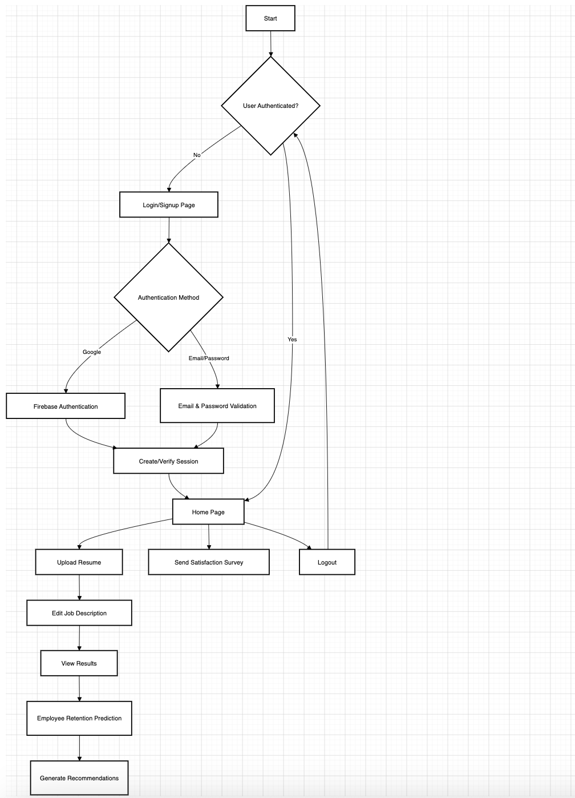

Fig. 3 Overall workflow diagram for Acquisition and Retention phase.

Fig. 3 represents the overall workflow that has been followed while implementing this project.

1. *TOOLS AND TECHNOLOGIES USED*

Firebase: The system implements Firebase Authentication for secure user management and access control. Firebase Admin SDK integration enables both traditional email/password authentication and OAuth 2.0 through Google Sign-In, ensuring robust security protocols. The implementation utilizes JSON Web Tokens (JWT) for session management, with token verification which is handled through Firebase Admin's auth.verify_id_token() functionality. User credentials get securely stored in MongoDB, with passwords hashed using Werkzeug's security functions. This dual-authentication approach, combined with session management and token verification, provides a comprehensive security framework that aligns with modern web application standards while maintaining scalability and user experience.

Textract: AWS Textract has been used for extracting text from the resume that gets uploaded in the S3 bucket in a pdf format. Extracting the raw text from the pdf file is necessary as the GenAI model requires textual formatted input prompts.

Bedrock: Bedrock has been used to implement Anthropic’s Claude model in order to generate a summary of the uploaded resume. Advantage of using the Claude v2.1 model is its quick inference time and relatively good accuracy. The seamless integration of bedrock with the lambda functions ensures minimum latency accessing various GenAI models.

API Gateway: AWS’s API Gateway has been used for deploying and managing the API’s for resume handler lambda function to expose it to the frontend form where the user can send a POST request to the lambda function to upload the pdf file into S3 bucket.

S3 Buckets: S3 buckets have been used for uploading the resume as an input from the user, storing the corresponding job descriptions Also, it has been used for retrieving the corresponding resumes when called through the lambda function and store the final analysis results from where the frontend can query them to display the generated results..

AWS CloudWatch: The AWS CloudWatch has been used to monitor the logs that get generated when the lambda functions are invoked one after the other. Using this tool, we were able to get an understanding of what errors occurred and keep a track of the whole workflow and how the request and responses are being handled to ease the process of debugging and troubleshooting if required.

Flask: In our implementation, Flask facilitated the creation of a robust web server capable of handling various HTTP requests and managing user sessions. The framework's simplicity and extensibility allowed for the integration of multiple features, including user authentication, database interactions, and machine learning model deployment. As evident in the app.py file, Flask routes were defined to handle different endpoints such as user signup, login, and prediction requests. Additionally, Flask's compatibility with external libraries enabled seamless integration with Firebase for authentication, MongoDB for data storage, and scikit-learn for machine learning predictions.

Heroku : A Platform as a Service (PaaS) solution, for deployment and hosting of the employee retention prediction application. Heroku provides a fully flexible runtime environment with a smart containers (dynos) system, enabling efficient application deployment through Git-based workflows. The platform offers comprehensive monitoring capabilities for tracking key metrics including response time, throughput, and memory utilization. The deployment process is streamlined through Heroku Flow, which provides structured workflows for continuous integration and delivery, making the release experience efficient and secure

Anthropic Claude: The Anthropic Claude model has been used in order to generate a summary of the resume, by giving appropriate prompts to it. The prompts included were related to the analysis of the educational level, skills of the candidate, relevant work experience of the candidate and based on these prompts, calculate the relevancy of the candidate being acquired by the company. Also, this model has been asked to provide a ROUGE score in the prompt, where it will give us a score between 0 and 1 based on the generated summary of the candidate and the job description.

V. RESULTS AND DISCUSSIONS

For the ‘Talent acquisition’ phase, the accuracy of the obtained candidate relevancy and the specific job description has been calculated using the ’Recall Oriented Understudy for Gisting Evaluation’ (ROUGE) Score. The ROUGE score has a value between 0 and 1. If a value of 0 is obtained, it depicts that the candidate is not relevant for the given job. Whereas if the ROUGE score has a value of 1 or near to 1, it depicts that the candidate is suitable for the given job.

For the ‘Retention’ phase, the tool gave promising results. The Random Forest model, trained on the HR dataset, achieved an accuracy of 99% in predicting employee turnover. Feature importance analysis revealed that satisfaction level, number of projects, and average monthly hours were the top three predictors of employee retention.The system's ability to generate tailored recommendations using GPT-4 proved particularly valuable. For instance, when presented with an employee at high risk of leaving (probability > 0.7), the model suggested actionable interventions such as "Conduct a one-on-one meeting to discuss career growth opportunities" and "Consider adjusting workload to prevent burnout”.

Table I: Accuracy scores for Random Forest Classifier

| Class | Precision | Recall | F1-Score | Support |
| --- | --- | --- | --- | --- |
| 0 | 0.99 | 1 | 0.99 | 2294 |
| 1 | 0.99 | 0.96 | 0.98 | 706 |
| Accuracy | - | - | 0.99 | 3000 |
| Macro Avg | 0.99 | 0.98 | 0.98 | 3000 |
| Wt. Avg | 0.99 | 0.99 | 0.99 | 3000 |

Table I shows the classification report of the dataset that was used for prediction purposes.

VI. CONCLUSION

An accurate feedback regarding the candidate’s relevancy has been achieved in the Candidate Acquisition phase successfully, where an appropriate feedback has been provided regarding why the candidate is a good fit and why a candidate is not a good fit. An accuracy of 99% was achieved by using the Random Forest classifier in the retention phase of the project. The integrated AI-driven talent acquisition and retention system has shown a comprehensive approach to manage a dual algorithmic implementation. The acquisition model does the analysis for the resumes and job descriptions through API endpoints(resume_handler_api_url), which help to provide an analyzed candidate evaluation. Whereas, the retention model makes use of the Random Forest classification method with a GPT-4 integration for predicting employee turnover probability as well as giving a recommendation.

VII. FUTURE SCOPE

The future scope of this project includes the implementation of load balancers using Kubernetes.This will help to optimize the system performance and will ensure availability for the entire time as and how the number of candidates increase. Additionally, incorporating a feedback loop mechanism where HR personnel can input data on employees who have left the organization would be invaluable. This process would allow the machine learning model to learn continuously and refine its predictions, which will help in improving the accuracy over time. Such a system could use techniques like periodic retraining to adapt to changing patterns in employee behavior. These enhancements would help in improving the predictive capabilities and also provide a more robust and scalable solution for HR departments which are seeking to manage employee retention.

REFERENCES

1. S. K. Shet et al., "A Machine Learning Approach for Employee Retention Prediction," 2021 International Conference on Advances in Computing and Communications (ICACC), pp. 1-6, doi: 10.1109/ICACC53666.2021.9550921.
2. Y. Zhang and L. Chen, "Research on Employee Turnover Prediction Based on Machine Learning," 2021 IEEE International Conference on Computer Science and Artificial Intelligence (CSAI), pp. 123-127, doi: 10.1109/CSAI52899.2021.9459098.
3. M. R. Silva et al., "Machine Learning Predictive Models for preventing Employee Turnover," 2022 17th Iberian Conference on Information Systems and Technologies (CISTI), pp. 1-6, doi: 10.23919/CISTI54924.2022.9987976.
4. R. Kumar et al., "HR Tech Analyst: Automated Resume Parsing and Ranking System Using NLP," 2024 International Conference on Intelligent Technologies (CONIT), pp. 1-6, doi: 10.1109/CONIT56864.2024.10404426.
5. K. Sharma and R. Jain, "Machine Learning based Employee Attrition Prediction and Layoff Prediction System," 2024 International Conference on Machine Learning Applications in HR (ICMLHR), pp. 1-8.
6. D. Wilson et al., "Predictive Analytics for HR: A Deep Learning Approach to Employee Retention," 2023 IEEE Conference on Artificial Intelligence in Human Resources (AIHR), pp. 45-50.
7. M. Johnson and K. Lee, "Integration of GPT Models in HR Analytics: A Case Study in Employee Retention," 2024 International Conference on Advanced Machine Learning Technologies (ICAMLT), pp. 112-117.
8. P. Singh et al., "Artificial Intelligence and People Analytics: A Key to Employee Retention," 2023 IEEE International Conference on Data Analytics and Management (ICDAM), pp. 1-6.

