Task 1: Research & Summarize (Approx. 450 words)
What is SORA?
SORA is a state-of-the-art text-to-video generation model developed by OpenAI. It translates natural language descriptions into realistic, high-quality videos. Unlike simple animations, SORA understands motion dynamics, physics, and 3D camera movement, allowing it to generate scenes with depth, perspective, and continuity. It is particularly effective at capturing nuanced visual elements such as lighting, textures, and real-world behavior, making it a powerful tool for creative and educational applications.
Comparison with DALL·E, Pika Labs, and RunwayML:
While DALL·E is also developed by OpenAI, it is limited to generating static images from text prompts. DALL·E is excellent for visual ideation and single-scene storytelling but cannot handle motion or time-based transitions like SORA.
Pika Labs and RunwayML are both text-to-video platforms that offer real-time video generation, typically using frame interpolation, animation, or diffusion models. RunwayML supports a wider range of creative workflows, including video editing and style transfer, and is popular among artists and filmmakers. Pika Labs focuses more on social media content creation with fast rendering. However, both still lag behind SORA in terms of temporal coherence, scene realism, and physics understanding.
Ethical Considerations:
The growing capabilities of AI video generation raise significant ethical concerns. One major issue is deepfakes — realistic but fake videos that can spread misinformation or harm reputations. There's also the risk of bias being encoded into the content if training data is skewed. Additionally, SORA and similar tools can hallucinate or distort real-world logic, potentially misleading viewers.
Another major concern is intellectual property: generating content that mimics real actors, logos, or copyrighted material could violate legal boundaries. Lastly, accessibility and control over such powerful tools could determine whether they are used for good (education, accessibility, innovation) or harm (propaganda, fraud, disinformation).

Task 2: Prompt Engineering Practice
- Education:
"A 10-second animation of a seed sprouting underground and growing into a sunflower under changing sunlight."
- Entertainment:
"A magical dragon soaring through a glowing night sky over a medieval castle during a firework celebration."
- Environment:
"An underwater shot of coral reefs thriving as plastic waste gets cleared by robotic fish."
- Technology:
"A robotic arm assembling a futuristic car on an automated production line with sparks flying."
- Health:
"A visualization of white blood cells attacking viruses inside the bloodstream with glowing effects."

Task 3: AI + Creativity Simulation

Role Chosen: Educator

Topic: Climate Change

Format: Image-based Visual Story (instead of a 15-sec video)

Scene-by-Scene Breakdown

Scene 1: Earth from Space – The Beginning
Prompt: “A view of Earth from space, glowing blue and green, with the Sun shining. The atmosphere is shown as a clear protective layer. Text label: ‘Earth’s Atmosphere Protects Us.’”
Description:
This image introduces Earth as a beautiful, healthy planet with a protective atmosphere. It sets the stage for explaining how the climate is being affected.
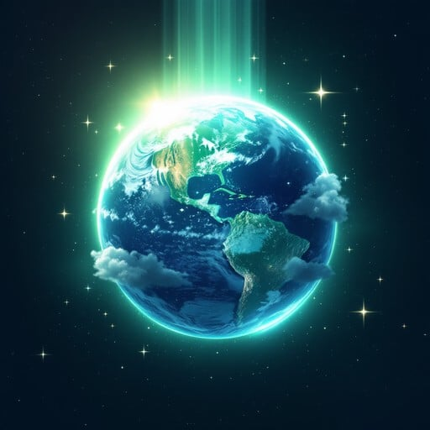

Scene 2: Pollution & Greenhouse Gases
Prompt: “Factories, cars, and airplanes emitting thick smoke. The atmosphere turning red and trapping heat rays inside. Text label: ‘Greenhouse Gases Trap Heat.’”
Description:
This image explains how human activities like burning fuels release greenhouse gases. The trapped heat is illustrated by arrows bouncing back toward Earth.
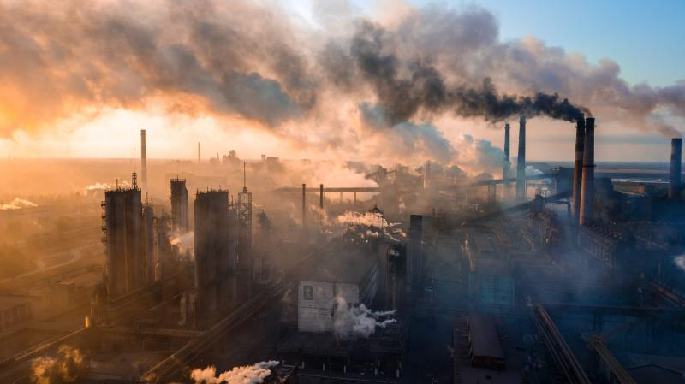

Scene 3: Effects of Climate Change
Prompt: “Melting polar ice caps, flooded coastal cities, and forests burning with wildfires, all in one split-scene illustration. Text label: ‘Climate Change Effects.’”
Description:
This image shows the negative impact of climate change: rising sea levels, ice melting, and natural disasters. It creates urgency and awareness.

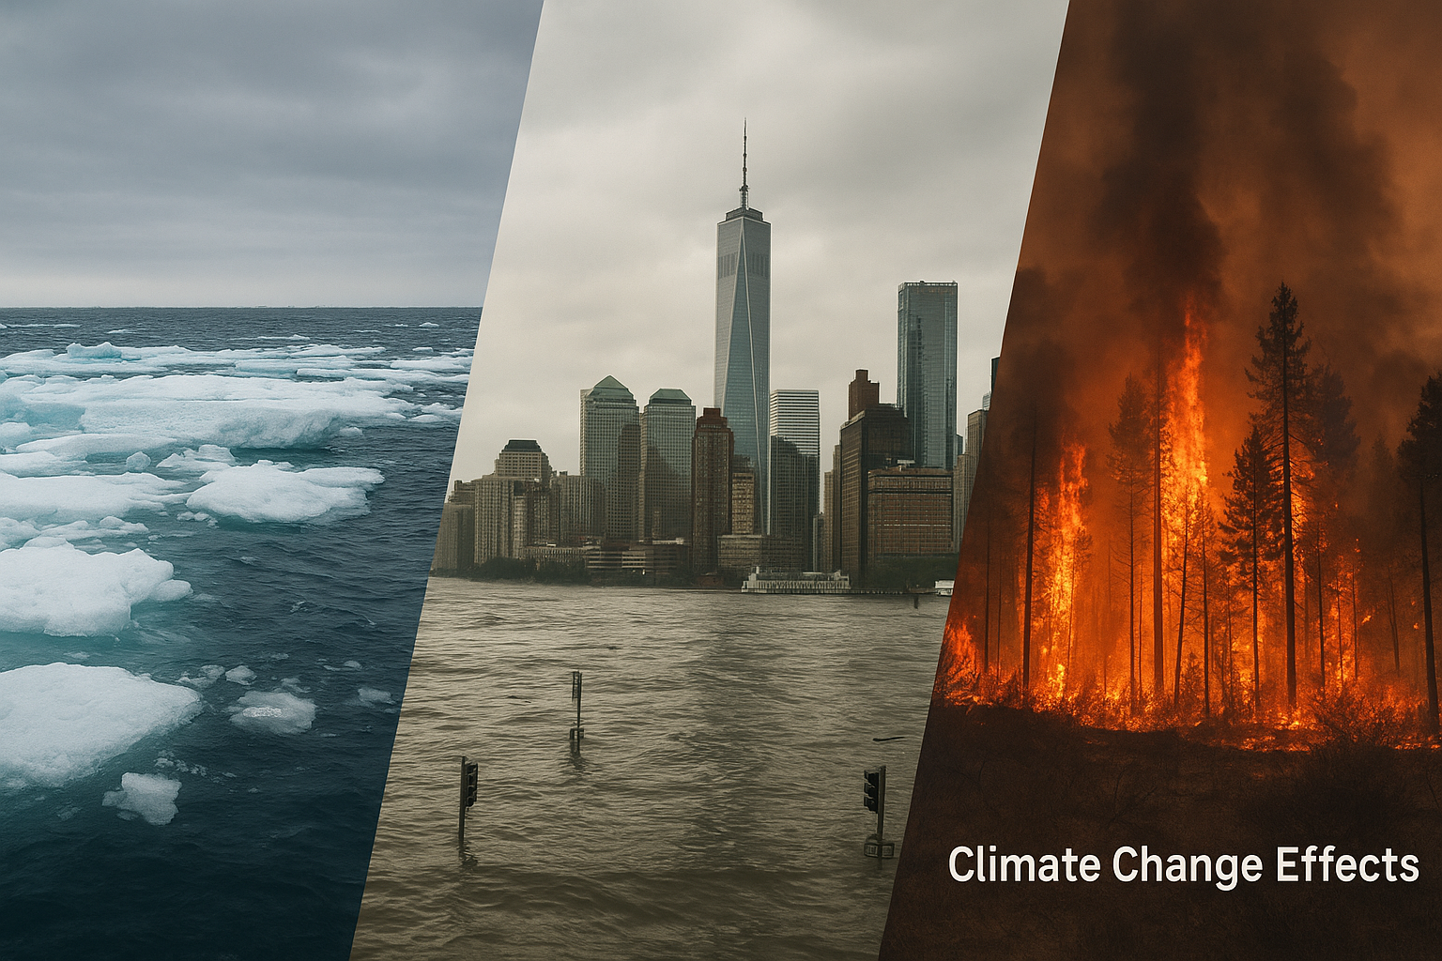

Scene 4: Hope & Solutions
Prompt: “Children planting trees, solar panels on rooftops, and wind turbines on green fields. The Earth is glowing green again. Text label: ‘Clean Energy = Bright Future.’”
Description:
This final image gives a positive message. It highlights renewable energy and collective action to fight climate change.

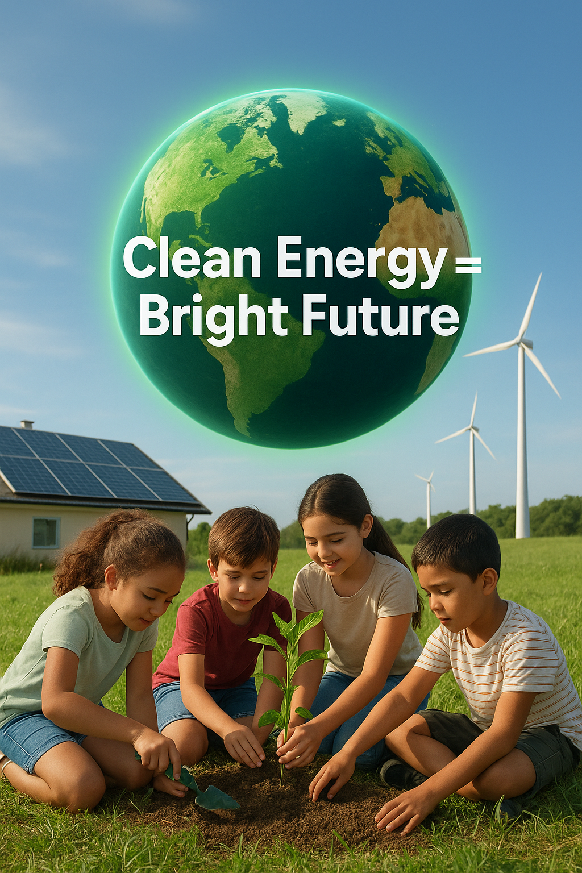

Conclusion
This 4-image storyboard explains Climate Change in a simple, engaging way. Each image represents a scene that would otherwise be shown in a 15-second SORA video. Using AI image generators, these prompts can be turned into visuals suitable for teaching, presentations, or awareness campaigns.

