Assignment 05: AI Image Generators

Task 1: Comparative Research

Comparison: DALL·E vs Midjourney
Criteria | DALL·E (by OpenAI) | Midjourney
Image Quality | Produces clear, photorealistic and stylized outputs. Strong at blending realism with creativity. | Very high artistic quality, with detailed and imaginative results, often resembling digital paintings.
Prompt Accuracy | Accurately follows prompts, especially structured or descriptive ones. Handles objects, environments, and text reasonably well. | Very creative but sometimes deviates from literal instructions. Leans towards artistic interpretation rather than strict accuracy.
Style Flexibility | Supports multiple art styles (realism, cartoons, sketches, etc.), adaptable for diverse needs. | Best known for artistic, fantasy, surreal, and cinematic visuals. Less suited for purely realistic tasks.
Usability | Integrated in ChatGPT, simple to use via text prompts. Accessible to beginners. | Requires Discord for access, which can be less intuitive for new users. Advanced prompt crafting skills improve results.
Licensing & Terms | OpenAI provides clear usage terms; free tier is limited, with paid plans for higher resolution & more credits. Commercial use allowed under license. | Subscription-based model; commercial use allowed depending on plan. Terms require acknowledgment of community guidelines.

Task 2: Visual Design Project

Option Chosen: Design a visual story using 3 image prompts

Theme: “The Future of Education with AI”

Introduction
Artificial Intelligence (AI) is reshaping every aspect of human life, and education is one of the most significant areas of transformation. With advancements in AI, classrooms of the future will no longer be limited to traditional teaching methods. Instead, they will integrate holographic teachers, immersive learning tools, and intelligent collaboration between humans and machines.
The following visual story imagines a future where AI plays a central role in guiding students, enhancing collaboration, and even celebrating achievements.

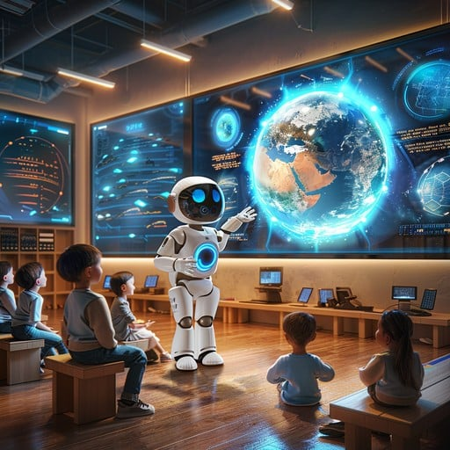

Scene 1: Futuristic Classroom
Prompt: “A futuristic classroom with AI-powered holographic teachers guiding students, interactive 3D displays showing planets, and children wearing AR glasses.”
Description:
In this scene, students are learning in a smart classroom where AI-powered holographic teachers provide real-time guidance. Instead of flat blackboards, interactive 3D displays project planets, galaxies, and complex diagrams. Children wear augmented reality (AR) glasses that allow them to experience lessons in an immersive way, making education highly engaging and effective.

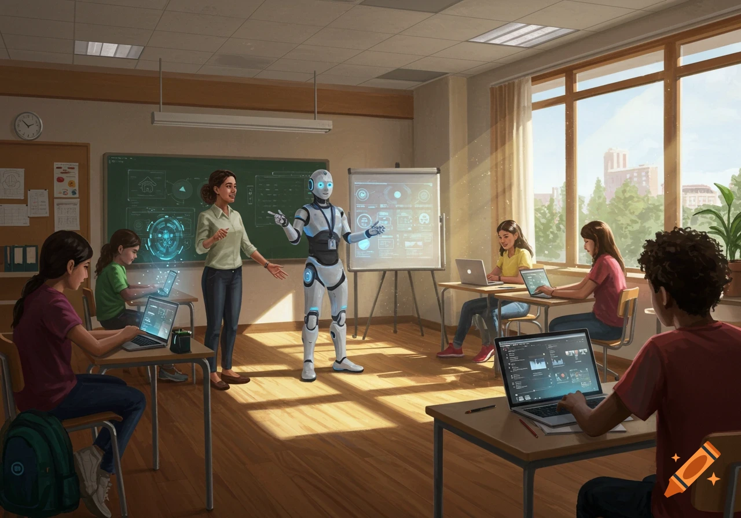

Scene 2: Collaboration with AI Robots
Prompt: “Students collaborating with AI robots, drawing on digital tablets, while the classroom windows show a green eco-city with flying cars.”
Description:
This scene highlights teamwork between humans and intelligent machines. Students work side by side with AI robots, exchanging creative ideas and drawing on digital tablets. The classroom windows reveal a futuristic eco-city with flying cars and sustainable green spaces, symbolizing how AI supports not just education but also environmental progress and smart living.

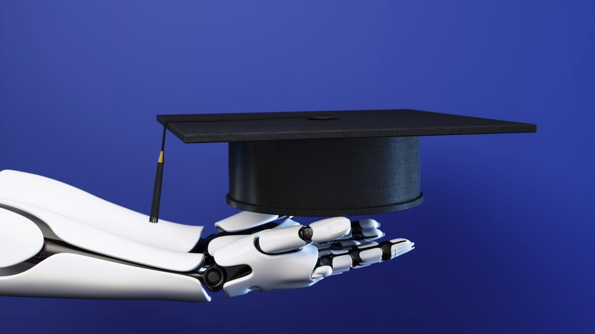

Scene 3: AI-Powered Graduation Ceremony
Prompt: “A graduation ceremony where students receive glowing digital diplomas from an AI assistant, with fireworks in the sky shaped like neural networks.”
Description:
The final scene presents a graduation ceremony where achievements are celebrated with the help of AI. Instead of traditional paper certificates, students receive glowing digital diplomas from an AI assistant. The sky lights up with fireworks shaped like neural networks, symbolizing the deep connection between technology, knowledge, and future success.

