**Experiment 7**

**Aim:** To Create Scrum Board for Scrum Master using JIRA Tool

**Implementation:**

Adding members to project:

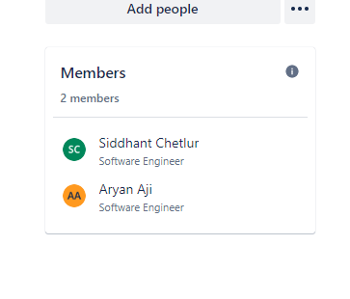

Creating a new epic called “Verify Gmail functionality”:

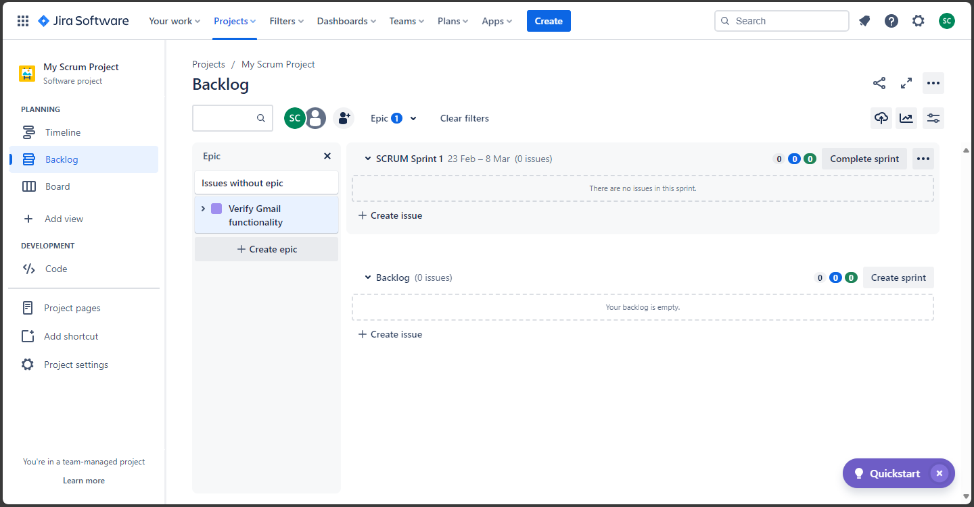

Creating 3 stories as follows:

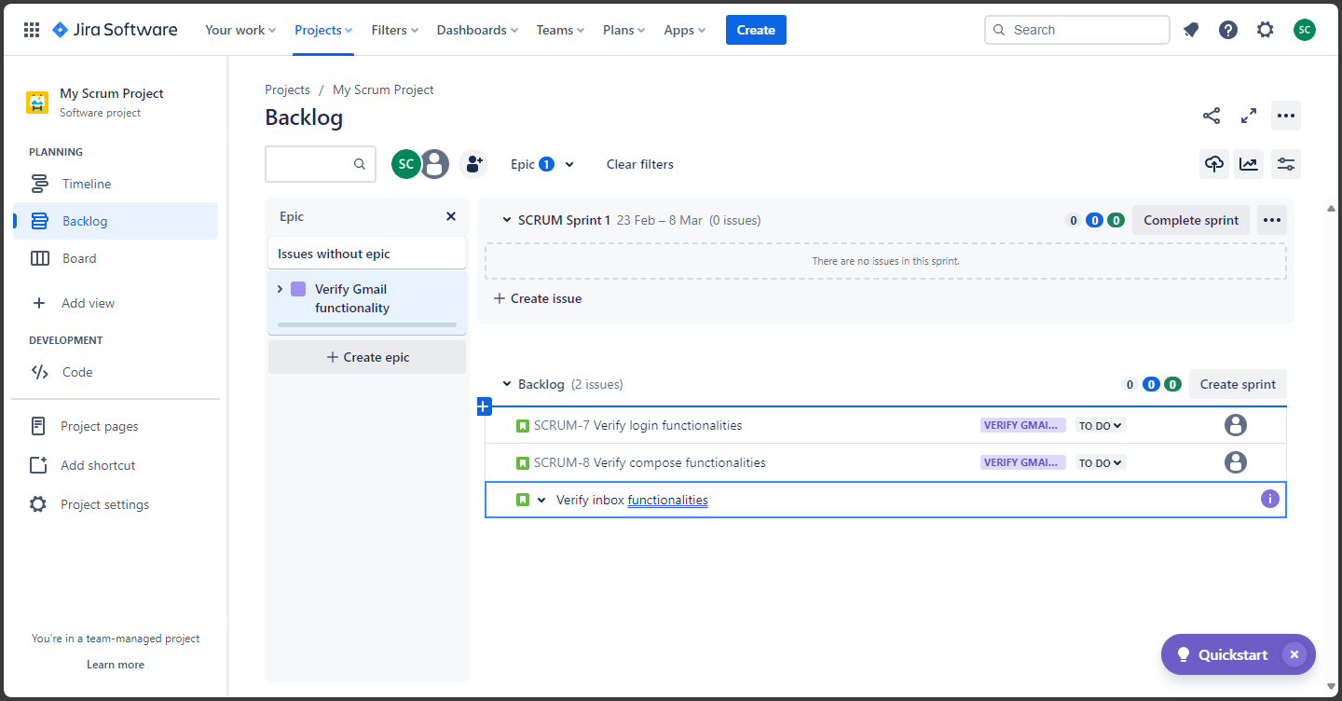

Creating sprint:

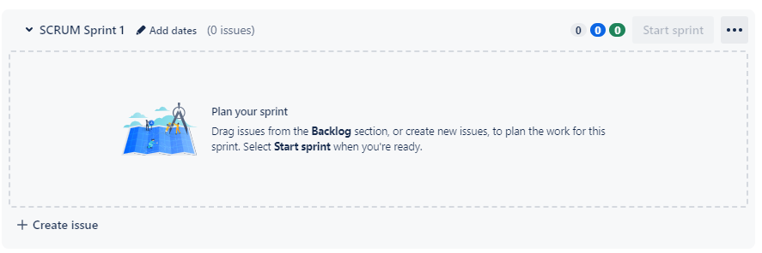

Adding stories to the sprint:

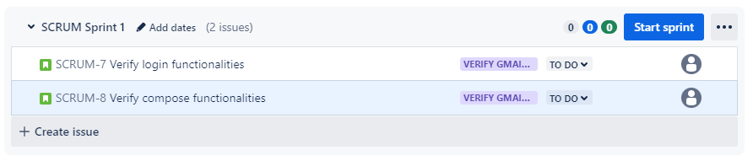

Starting the sprint:

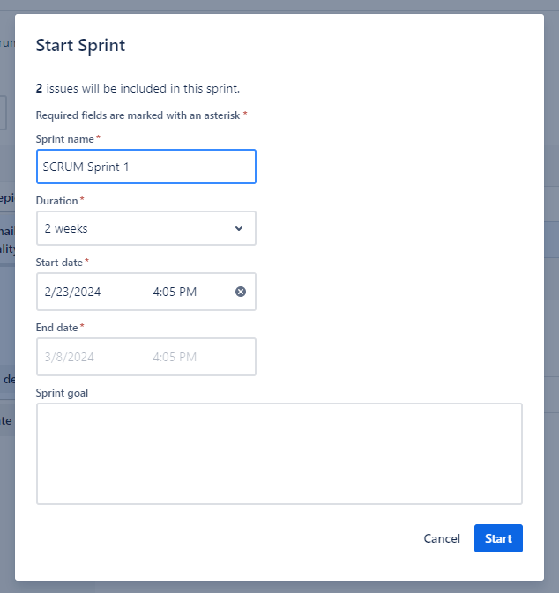

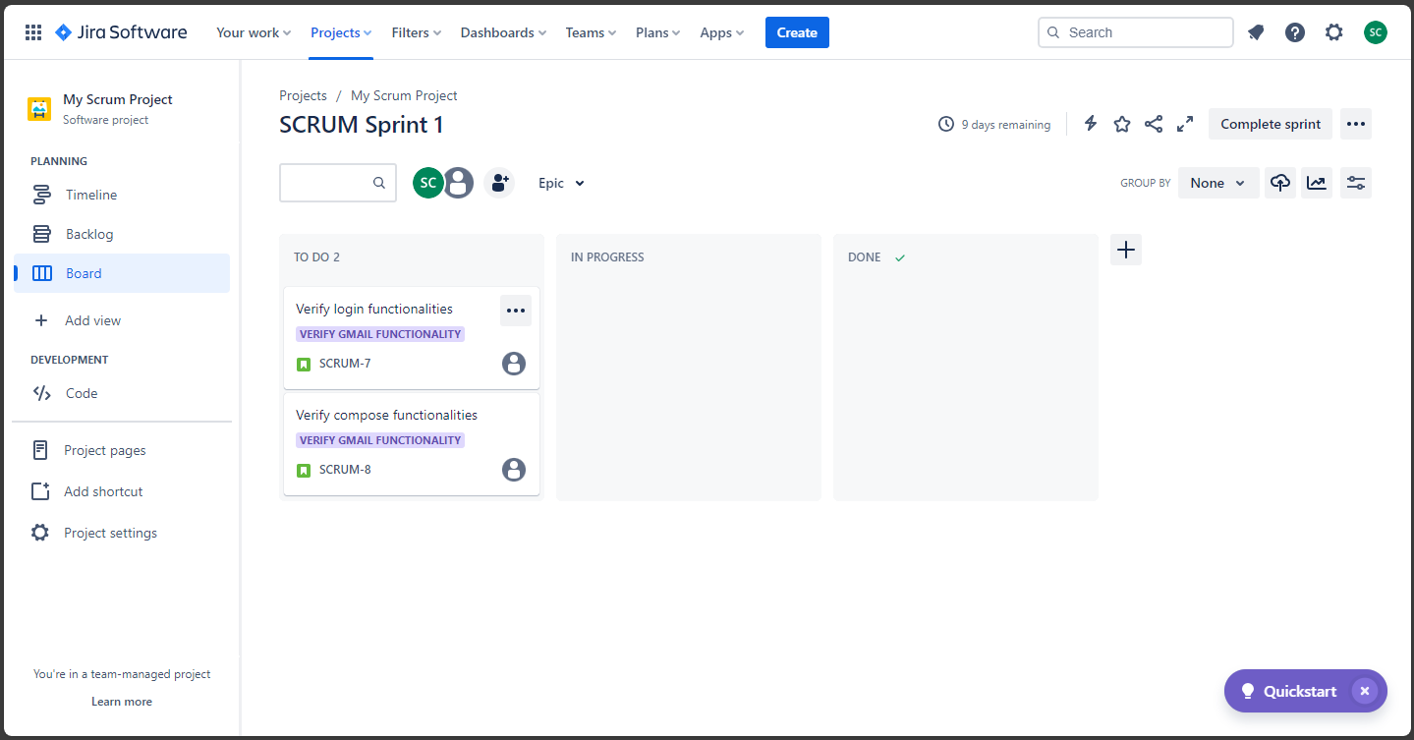

Updating story:

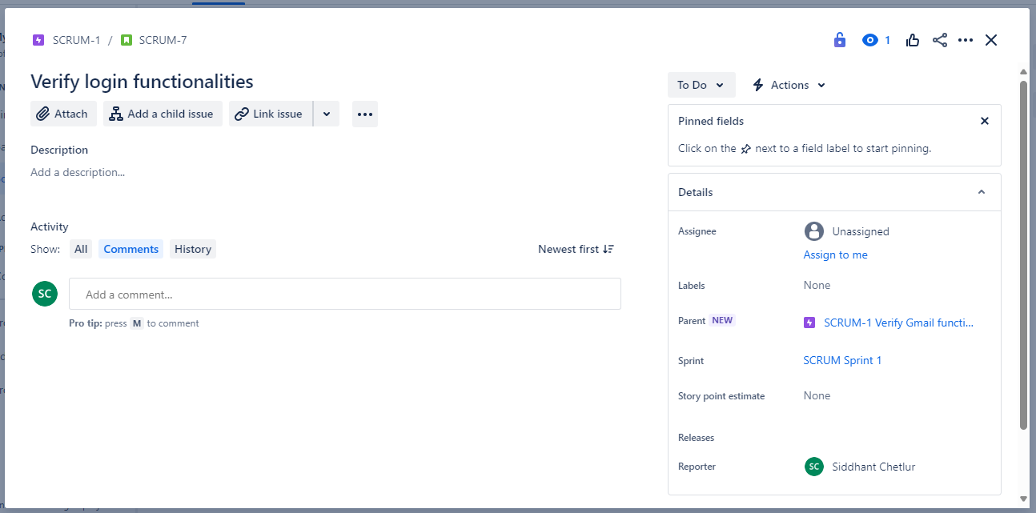

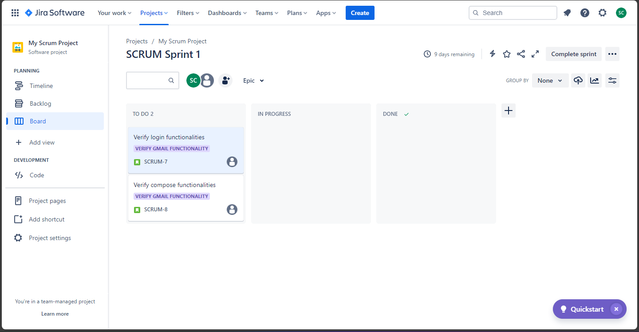

Creating subtasks / adding child issues:

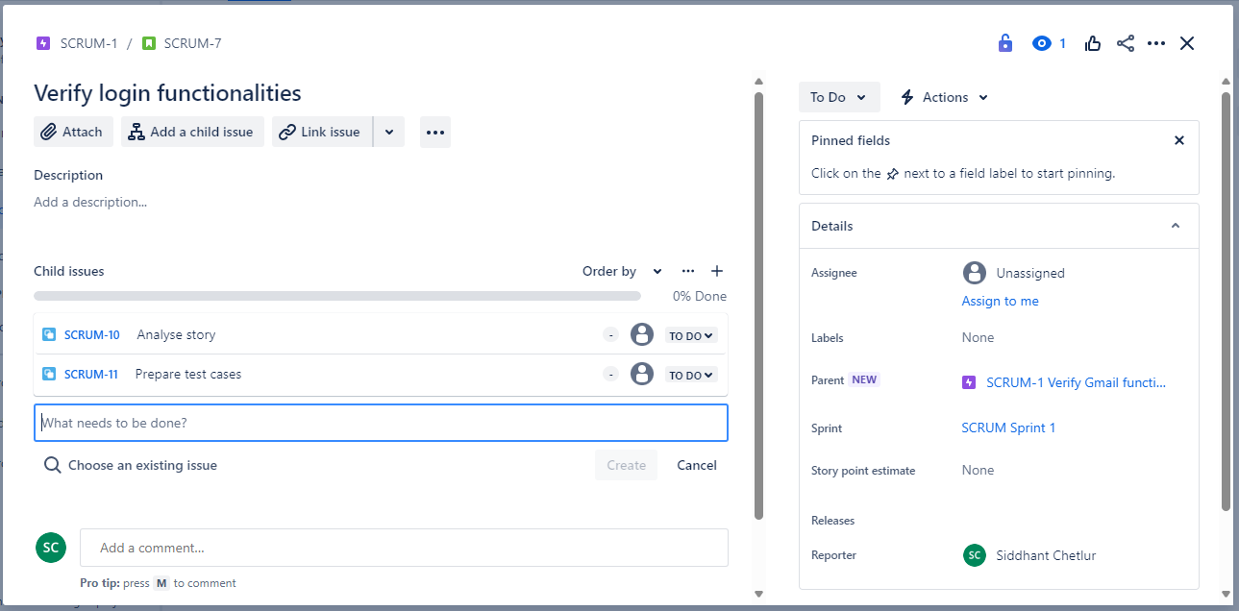

Mark a story as in progress:

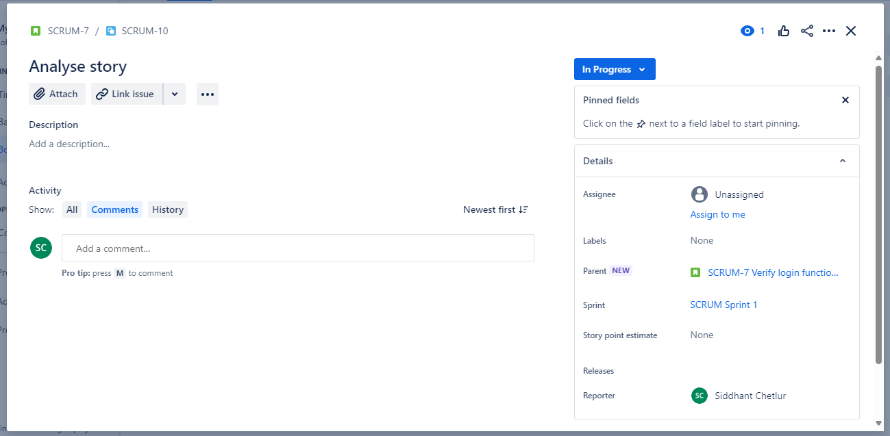

Mark the story as done once completed:

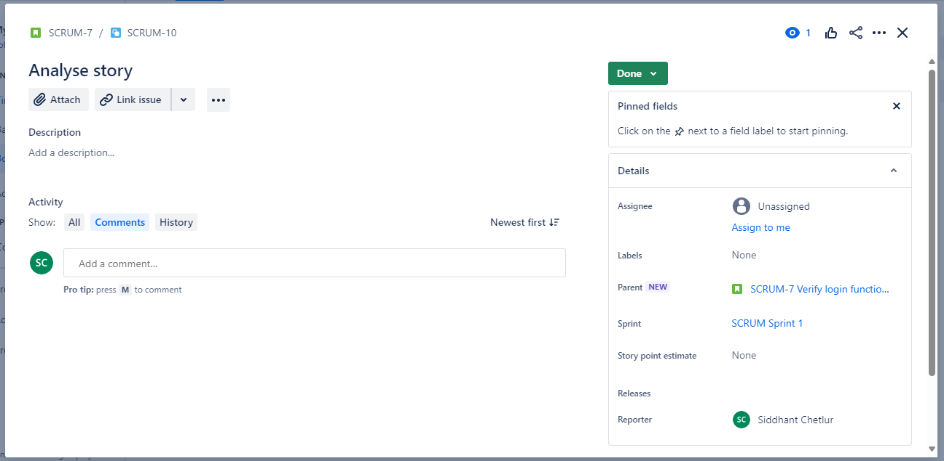

Creating an issue / raising a bug:

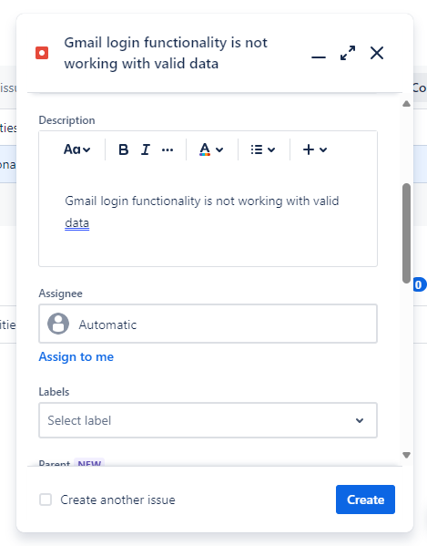

Viewing dashboard to check status:

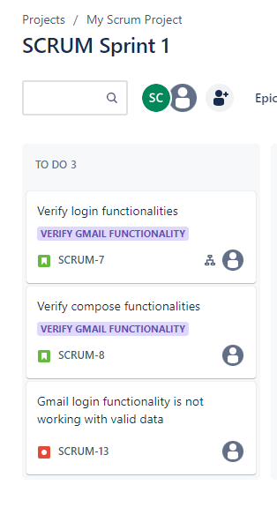

Finishing the sprint after work is done:

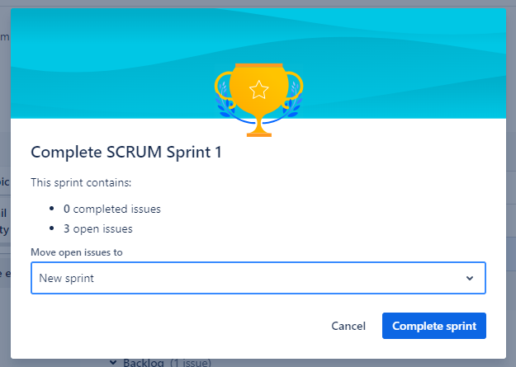

Adding Zephyr plugin:

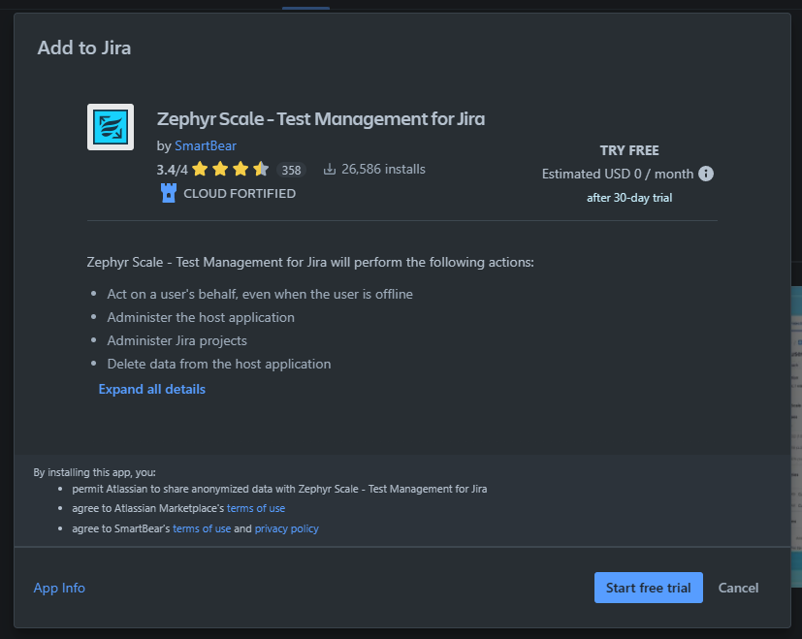

Creating a new test case:

Creating new test cycle:

Adding the test case to the cycle:

Run test cycle:

**Conclusion:** Thus, we have successfully created a SCRUM board using the JIRA tool and performed testing using Zephyr.