**TRF**

**CyberSecurity**

**Task-12**

**BY:Siddhant Pawar**

**Problem Statement  
Task_01:**

Racquel Murillo got an image from Professor.

The courier however says analyse the notes.

What does that mean?

**Solution:**

**TRF-CS{C0NGR4TU14TI0NS_0N_Y0UR_FIRST_F14G}**

**Task_02:**

1. The End is the Beginning and the Beginning is the End!

2. Analyze using Sonic Visualizer: https://www.sonicvisualiser.org/download.html

Challenge file: Hacks.mp4

**Solution:**

**TRF-CS{PR1V4CY_1S_PR1OR1TY}**

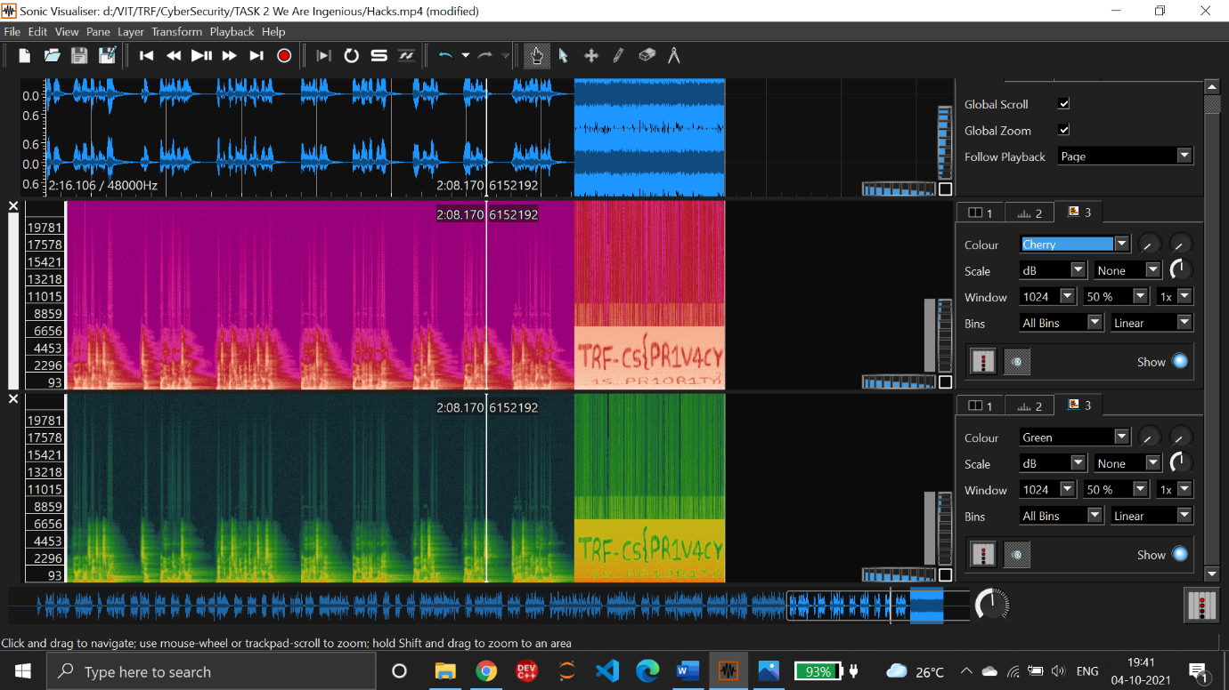

**Task_03:**

Joan Clarke is working at a Cryptography Challenge and loved history. She could not figure out how to crack

the python enigma emulator, even though it was broken before by her. However she gathered some digital evidences. Can you crack the machine?

EVIDENCE:

You have intercepted two messages.

1. The first is "FKYCEPWYRXTXDHYGUPNG". The second is "DPIWPOLLFEUPIKAKLQLC"

2. You have decrypted the first message and found that it is "THISISNOTGONNABEEASY"

3. Assume that "I II III" are rotors.

4. Plugboard is "AV BS CG DL FU HZ IN KM OW RX"

What is the flag? (Note that flag format for this challenge is a bit differrent. It will be a string in all capital alphabets.)

Hint: py-enigma.

**Solution:**

**SOYOUHAVEWHATITTAKES**

**Task_04:**

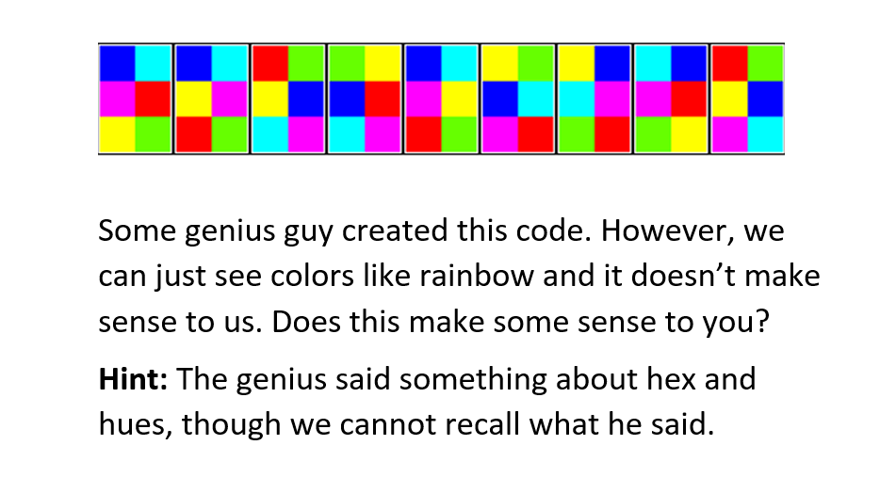

**Solution:**

**TRF IS LOVE**