Questions
1. Linux:
1. Provide steps to create a directory inside a directory where the parent directory does not exist.
2. How to install a package on a Linux server when there is no internet connection?
3. How to access specific folders of Server A from Server B and Server C?
4. How to check all the running processes from a server?
5. Provide the command to delete all the files older than X days inside a specific directory.
6. Create a shell script to identify the process ID
a. script should as a user input for process ID
b. If the process exists script should print the process ID and exit
c. If the process doesn’t exist script should print the process doesn’t exist and asks for another input
2. Docker:
1. What is docker and why do we need it?
2. Write a docker file for a sample Java/python application.
3. What is the docker lifecycle?
4. What is the difference between an image and a container?
5. How to check docker container logs? Provide the command for the same
3. Kubernetes:
1. What are different types of services?
2. What is a pod?
3. Create a pod with the above created custom image when a pod dies k8s should automatically restart
4. How to access the custom application with a specific port?
4. CI/CD:
1. Set up a pipeline (Github actions/Gitlab runner/ Jenkins or any open source tool) to build, test, create a docker image, publish and deploy to k8s. Use the application present in this public repo https://github.com/apiwizlabs/wizdesk.
2. Automate to spin up a network and virtual machines. Install the Nginx package and start the service(any cloud)

Answers
1. Linux:
1. Provide steps to create a directory inside a directory where the parent directory does not exist.
mkdir -p folder1/folder2
2. How to install a package on a Linux server when there is no internet connection?
General method is sudo apt install package
Without internet: sudo dpkg -i package-name.deb
3. How to access specific folders of Server A from Server B and Server C?
Install ssh: sudo apt-get install openssh-server
systemctl status ssh
on server A: sudo systemctl start ssh
on server B and C: ssh username@server_a_ip
4. How to check all the running processes from a server?
ps -e (power status - everything)
top (cpu usage)
5. Provide the command to delete all the files older than X days inside a specific directory.
find /mydata -type f -mtime +7 -exec rm {} \;
find (path)(type is f to specify it’s a file and not directory)(time specified in days)(remove command)
6. Create a shell script to identify the process ID
a. script should as a user input for process ID
b. If the process exists script should print the process ID and exit
c. If the process doesn’t exist script should print the process doesn’t exist and asks for another input
vi test.sh
#!/bin/bash
read -p "Enter a process ID: " process_id
if ps -p "$process_id" &>/dev/null; then
echo "Process $process_id exists."
else
echo "Process $process_id doesn't exist."
fi
chmod +x test.sh
./test.sh

2. Docker:

1. What is docker and why do we need it?
Docker is a very important devops tool which is mainly used to containerize projects. Docker architecture consists of docker container and docker image. Docker helps in testing process at production levels. When we dockerize a project it takes the package versions and other dependencies from the device on which it is successfully running. It can then be deployed on other devices which will have the same environment that the previous user had on which the project was running.
2. Write a docker file for a sample Java/python application.
Main.py:
import pandas as pd

data = {
'Name': ['John', 'Alice', 'Bob'],
'Age': [25, 30, 22],
'City': ['New York', 'San Francisco', 'Los Angeles']
}

df = pd.DataFrame(data)

print(df)

Dockerfile:
FROM python:3.11.6

ADD main.py .

RUN pip install pandas

CMD ["python", "./main.py"]

docker-v
docker build -t python-proj .
docker run python-proj
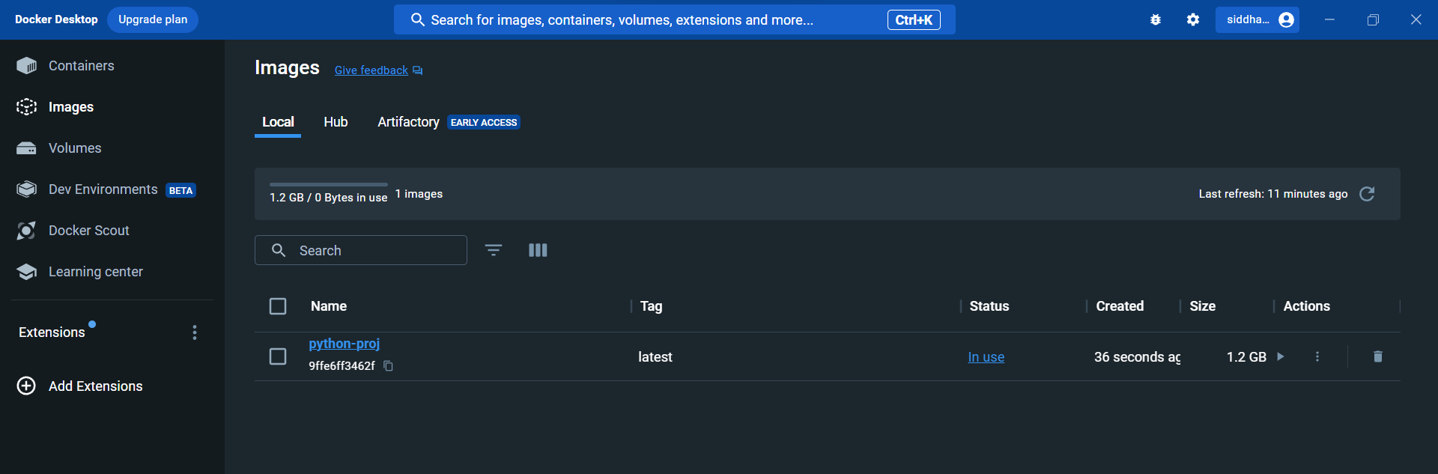
3. What is the docker lifecycle?
- Writing a Dockerfile: The Docker lifecycle begins with writing a Dockerfile, which is a script containing instructions for building a Docker image. The Dockerfile specifies the base image, sets up the environment, and defines how the application should run.
- Building an Image: The next step is to build a Docker image using the Dockerfile. The docker build command is used for this purpose. During the build process, Docker fetches the base image, executes the commands in the Dockerfile, and creates a new image with all the necessary dependencies and configurations. docker build -t my-image .
- Storing Images: Docker images are stored either locally or in a remote registry. You can push your image to a registry like Docker Hub using the docker push command if you want to share it with others. docker push my-image
- Running Containers: Once the image is built, you can run containers based on that image using the docker run command. Containers are instances of Docker images, and they run in isolated environments. You can specify various options during container creation, such as port mapping, environment variables, and volume mounts. docker run -p 4000:80 my-image
- Interacting with Containers: Docker provides commands like docker exec to interact with running containers. This allows you to execute commands inside a running container, inspect its logs, and perform other operations. docker exec -it container_id /bin/bash
- Stopping and Removing Containers: Containers can be stopped using the docker stop command and removed with the docker rm command. Stopping a container halts its execution, and removing it deletes the container instance. docker stop container_id docker rm container_id
- Cleaning Up Images: Unused images and containers can accumulate over time, consuming disk space. You can use the docker rmi command to remove images and docker system prune to clean up unused resources. docker rmi my-image docker system prune
4. What is the difference between an image and a container?
A Docker container is a self-contained, runnable software application or service. On the other hand, a Docker image is the template loaded onto the container to run it, like a set of instructions.
You store images for sharing and reuse, but you create and destroy containers over an application’s lifecycle. We give more differences next.
5. How to check docker container logs? Provide the command for the same.
To view logs: docker logs my_container
To view logs while using options: docker logs -f --since="2023-01-01T00:00:00" --tail=50 my_container
This command will follow the logs of "my_container" in real-time, starting from the specified timestamp and showing the last 50 lines.

3. Kubernetes:
1. What are different types of services?
ClusterIP (default): This is the default type of service. It exposes the service on a cluster-internal IP. The service is only accessible within the cluster.
NodePort: This type of service exposes the service on each Node's IP at a static port. This makes the service accessible externally from outside the cluster. It's useful when you need to access the service from outside the cluster, typically for development or testing purposes.
LoadBalancer: This type of service exposes the service externally using a cloud provider's load balancer. It automatically assigns an external IP to the service, making it accessible from the internet.
ExternalName: This type of service maps the service to the contents of the externalName field (e.g., example.com). It's useful for providing DNS names for services outside the cluster.
2. What is a pod?
In Kubernetes, a pod is the smallest and simplest unit in the Kubernetes object model. A pod represents a single instance of a running process in a cluster and encapsulates one or more containers. Containers within a pod share the same network namespace, allowing them to communicate with each other using localhost. Pods are the basic building blocks of Kubernetes applications.
apiVersion: v1
kind: Pod
metadata:
name: mypod
spec:
containers:
- name: mycontainer
image: nginx:latest
3. Create a pod with the above created custom image when a pod dies k8s should automatically restart.
4. How to access the custom application with a specific port?
Step1: Create a pod.
Step2: Create a service.
apiVersion: v1
kind: Service
metadata:
name: myapp-service
spec:
selector:
app: myapp
ports:
- protocol: TCP
port: 80
targetPort: 8080
Step3: Access the service.

4. CI/CD:
1. Set up a pipeline (Github actions/Gitlab runner/ Jenkins or any open source tool) to build, test, create a docker image, publish and deploy to k8s. Use the application present in this public repo https://github.com/apiwizlabs/wizdesk.
2. Automate to spin up a network and virtual machines. Install the Nginx package and start the service (any cloud)

