Short-Channel MOSFETs: Why Small Devices Behave Differently

Group Members
36 : Siddhant Malankar
37 : Harsh Maroo

Introduction
MOSFETs (Metal Oxide Semiconductor Field Effect Transistors) are among the most important components in modern electronics. They form the basic building blocks of processors, memory chips, smartphones, laptops, and many other digital systems.
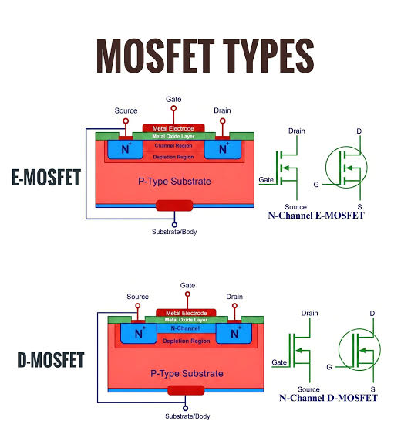 Over the years, the semiconductor industry has continuously reduced transistor dimensions in order to improve performance and fit more devices onto a single chip. This process, known as scaling, has enabled remarkable growth in computing power. However, as transistors become extremely small, their behavior begins to differ from that of traditional long-channel devices. These smaller devices are known as short-channel MOSFETs, and they exhibit several unique effects that must be carefully managed during design.

Why MOSFET Scaling is Important
The demand for faster and more powerful electronic systems has driven the continuous scaling of MOSFETs. By reducing transistor dimensions, engineers can place a much larger number of devices on a single integrated circuit. Smaller transistors generally switch faster, consume less power, and reduce the manufacturing cost per function. Technology has progressed from older nodes such as 180 nm and 90 nm to advanced technologies of 7 nm, 5 nm, and beyond. While this scaling has significantly improved computing performance, it has also introduced new physical challenges that were not significant in larger devices.
- Higher switching speed
- Increased transistor density
- Lower manufacturing cost per function
- Reduced power consumption
- Greater functionality in a smaller area

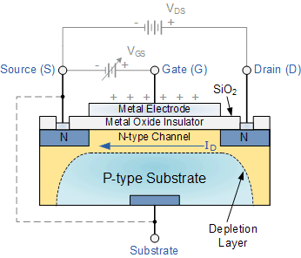

Short-Channel MOSFETs and Their Behavior
A MOSFET is considered a short-channel device when its channel length becomes comparable to the depletion regions surrounding the source and drain terminals. In conventional long-channel devices, the gate has strong control over the movement of charge carriers within the channel. In contrast, when the channel becomes very short, the electric fields associated with the source and drain begin to influence channel behavior. As a result, the transistor no longer follows the ideal assumptions used in long-channel device models. These deviations are collectively referred to as short-channel effects.
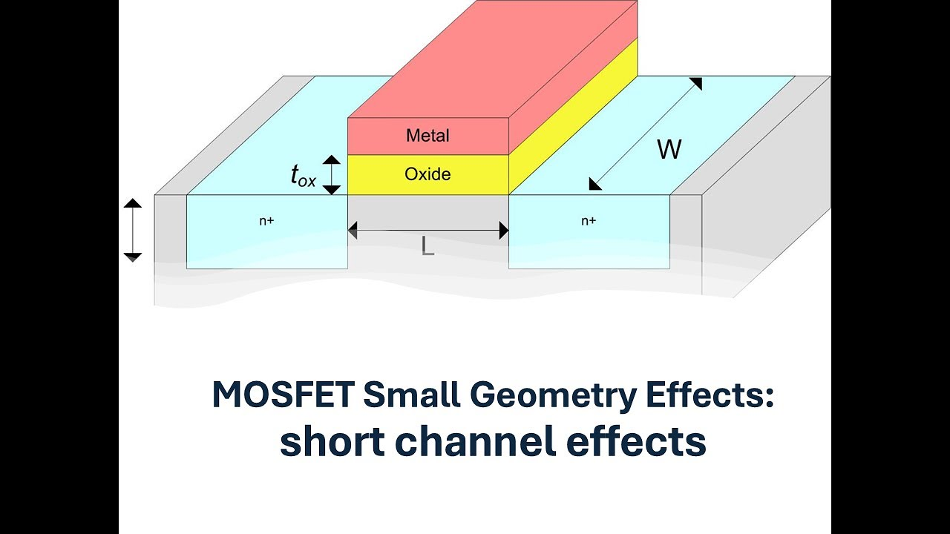
One of the most important short-channel effects is threshold voltage roll-off. The threshold voltage represents the minimum gate voltage required to switch the transistor ON. As the channel length decreases, the threshold voltage tends to decrease as well. This means that the transistor may begin conducting current more easily, increasing leakage and power consumption even when the device is supposed to be turned OFF.
Another significant effect is Drain Induced Barrier Lowering, commonly known as DIBL. In this phenomenon, a high drain voltage lowers the potential barrier near the source region, making it easier for charge carriers to enter the channel. This causes an increase in OFF-state current and reduces the effectiveness of gate control. DIBL has become one of the major concerns in nanoscale transistor design because it directly affects device reliability and energy efficiency.
Short-channel MOSFETs also experience channel length modulation. Ideally, the drain current should remain relatively constant once the transistor enters saturation. However, an increase in drain voltage can effectively shorten the channel length, causing the drain current to rise. This behavior affects the accuracy of analog circuits and reduces output resistance.

Velocity Saturation and Hot Carrier Effects
As device dimensions continue to shrink, electric fields within the transistor become extremely strong. Under these conditions, charge carriers eventually reach a maximum velocity and can no longer accelerate despite further increases in electric field strength. This phenomenon is known as velocity saturation. Because carrier velocity is limited, the expected improvement in current drive capability is reduced, placing practical limits on transistor performance.
Another issue associated with strong electric fields is the hot carrier effect. Charge carriers may gain sufficient energy to damage the gate oxide or create defects at the semiconductor interface. Over time, these defects degrade transistor performance and reduce device lifetime. Consequently, hot carrier degradation remains an important reliability concern in advanced semiconductor technologies.

Leakage Current Challenges
Leakage currents become increasingly important as MOSFET dimensions shrink. Even when a transistor is intended to be OFF, small amounts of current may continue to flow. Subthreshold leakage occurs below the threshold voltage, gate leakage results from tunneling through extremely thin oxide layers, and junction leakage arises across reverse-biased pn junctions. Although each leakage component may appear small individually, their combined effect becomes significant in chips containing billions of transistors. Excessive leakage increases standby power consumption, reduces battery life, and creates thermal management challenges

.

Modern Solutions

To address these challenges, semiconductor manufacturers have developed several advanced technologies. One important innovation is the use of high-k dielectric materials such as hafnium oxide. These materials provide better gate control while reducing gate leakage. Metal gate technology has also replaced traditional polysilicon gates in many modern devices, improving conductivity and threshold voltage control.
Perhaps the most significant advancement has been the introduction of FinFET technology. Unlike conventional planar transistors, FinFETs use a three-dimensional fin-shaped channel structure that allows the gate to exert stronger control over the channel. This reduces leakage current and improves scalability. More recently, Gate-All-Around FETs (GAAFETs) have emerged as the next step in transistor evolution. In these devices, the gate completely surrounds the channel, providing even better electrostatic control and further reducing short-channel effects.

Applications and Future Trends
Short-channel MOSFETs are used in:
- Smartphones
- Laptop and desktop processors
- AI accelerators
- Automotive electronics
- Data center hardware
- Memory devices
These devices rely on billions of nanoscale transistors to achieve high performance and energy efficiency.
Their ability to support extremely high transistor densities makes them essential for today's computing systems. Looking ahead, researchers are investigating technologies such as nanosheet transistors, Gate-All-Around FETs, carbon nanotube devices, and two-dimensional semiconductor materials to continue performance improvements beyond the limits of conventional scaling.

Conclusion
Short-channel MOSFETs have made it possible to integrate billions of transistors onto a single chip, enabling the extraordinary capabilities of modern electronic systems. At the same time, reducing channel length introduces important challenges such as threshold voltage roll-off, DIBL, velocity saturation, hot carrier effects, and leakage currents. Through innovations such as high-k dielectrics, metal gates, FinFETs, and Gate-All-Around FETs, the semiconductor industry has successfully addressed many of these issues. Understanding short-channel effects remains essential for engineers as transistor dimensions continue to shrink and new device technologies emerge.

