EE451 Programming HW #3



Siddhant S. Nadkarni

2596-6618-89

**System Information:**

OS: macOS Mojave (v10.14)

Processor: 1.6 GHz Intel Core i5

Memory: 8GB 1600 MHz DDR3

Graphics: Intel HD Graphics 6000 1536 MB

**Q1 Estimation PI**

Version a: Execution time – 0.193 seconds

Version b: Execution time – 0.190 seconds

**Q2 Sorting**

In both the cases, the pivot to partition array has been randomly picked using C++ rand() function.

Execution time for without OpenMP program quicksort – 5.50 seconds

Execution time for with OpenMP program quicksort – 4.20 seconds

**Q3 Parallel K-Means Clustering**

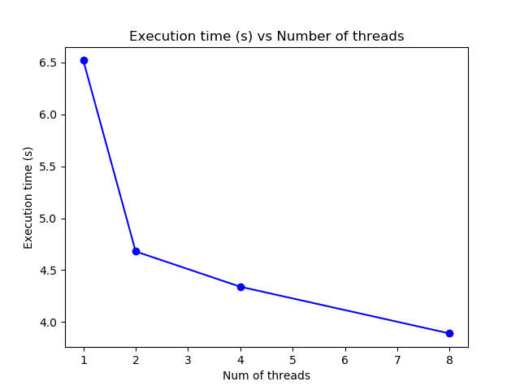

Execution time for thread (p)

For threads = 1:

Execution time (s) = 6.52

For threads = 2

Execution time (s) = 4.68

For threads = 4

Execution time (s) = 4.34

For threads = 8

Execution time (s) = 3.89

**Previous Execution time:**

For Threads = 8

Execution time (s) = 3.85

For Threads = 4

Execution time (s) = 4.16

Observation:

From the execution times of both methods, one with conditional variables + locks and previous one without any locks/conditional variables we can see that they take almost the same time to execute but the new program with conditional variables + locks is taking slightly more time, in the order of milli seconds. This could be probably because the threads have to be put to sleep while waiting on condition to be true and also each time a conditional variable has to be accessed, locks have to be created and released which might be creating slight overheads. But otherwise, both the programs on my system take almost the same time to execute.