EE451 Programming HW #4



Siddhant S. Nadkarni

2596-6618-89

**Q1 Pass Message in a Ring**

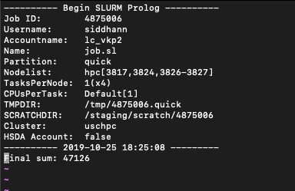

**Q2 Add Numbers using 4 Processors.**

**Q2 Part 1.**

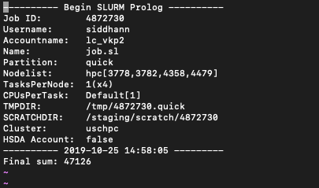

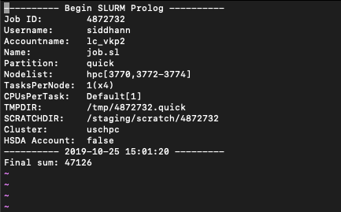**Q2 Part 2.**

**Q2 Part 3.**

