Gen Z vs. Millennials

Investment Risk & Portfolio Allocation — Multi-Source Analysis
Data sourced directly from: (1) FINRA Foundation & CFA Institute 2023, (2) Charles Schwab Modern Wealth Survey 2025, (3) Motley Fool Generational Investing Trends Survey July 2025. All figures are real — no estimates.

1. Data Sources
Source | Year | Sample | Key Contribution
FINRA Foundation & CFA Institute | 2023 | 2,872 (U.S., CA, UK, CN) | Asset ownership, risk appetite, FOMO, app usage
Charles Schwab Modern Wealth Survey | 2025 Wave 2 | 2,400 (U.S., 21–75) | Portfolio allocation %, crypto attitudes, trading behaviour
Motley Fool Generational Investing Survey | July 2025 | 2,000 (Pollfish) | Stock types, sectors, goals, trade frequency, info sources

2. Asset Ownership Rates
The FINRA/CFA 2023 survey measured what percentage of Gen Z and Millennial investors currently hold each asset class. Crypto ownership rates are nearly identical between the two generations — the more telling difference is that Gen Z is far more likely to have started their investing journey with crypto as their very first asset (44% vs. 35%).
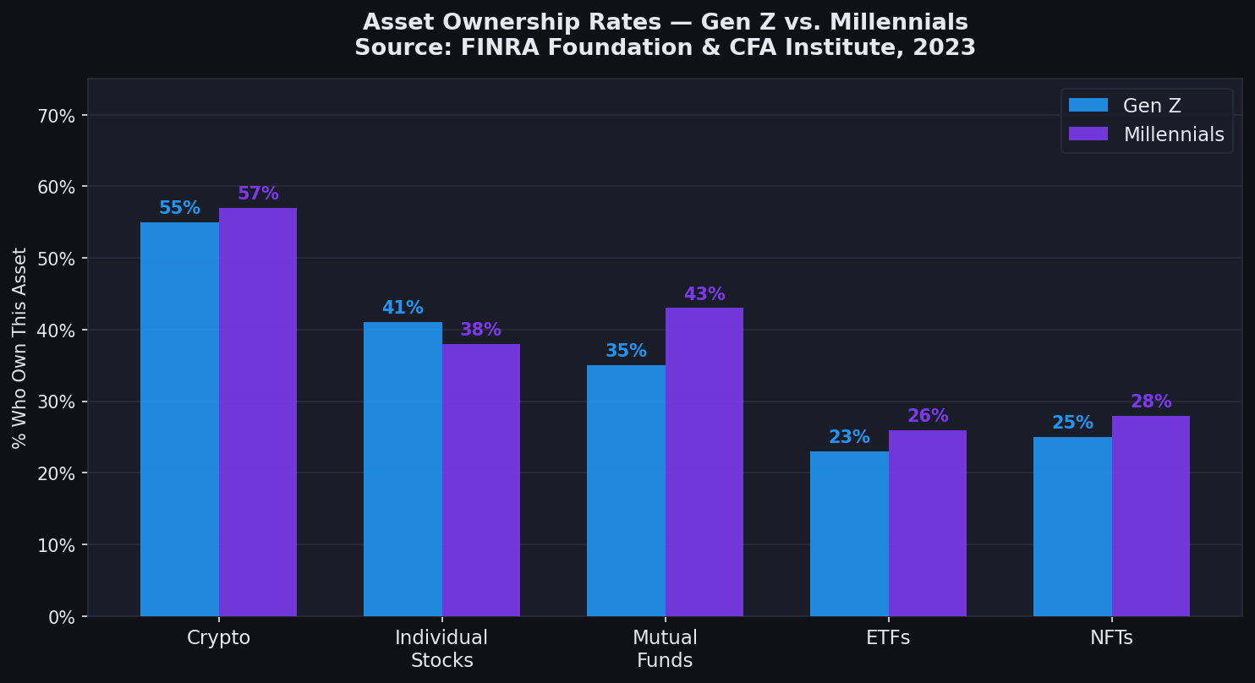
Figure 1: % of investors who own each asset class. Source: FINRA Foundation & CFA Institute, 2023
📌 Source: FINRA Foundation & CFA Institute. "Gen Z and Investing: Social Media, Crypto, FOMO, and Family." May 2023.
Asset | Gen Z | Millennials | Gen X
Cryptocurrency | 55% | 57% | 39%
Individual Stocks | 41% | 38% | 43%
Mutual Funds | 35% | 43% | 47%
NFTs | 25% | 28% | 15%
ETFs | 23% | 26% | 22%

Table 1: Asset ownership rates (% who hold the asset). Not portfolio allocation percentages.

3. Portfolio Allocation (Schwab 2025)
The Schwab 2025 Wave 2 survey (October 2025) is the only source that directly asked investors how their portfolio is allocated as percentages summing to 100%. This is across all U.S. investors — the public report does not break this out by generation, but it represents the most current real allocation data available.
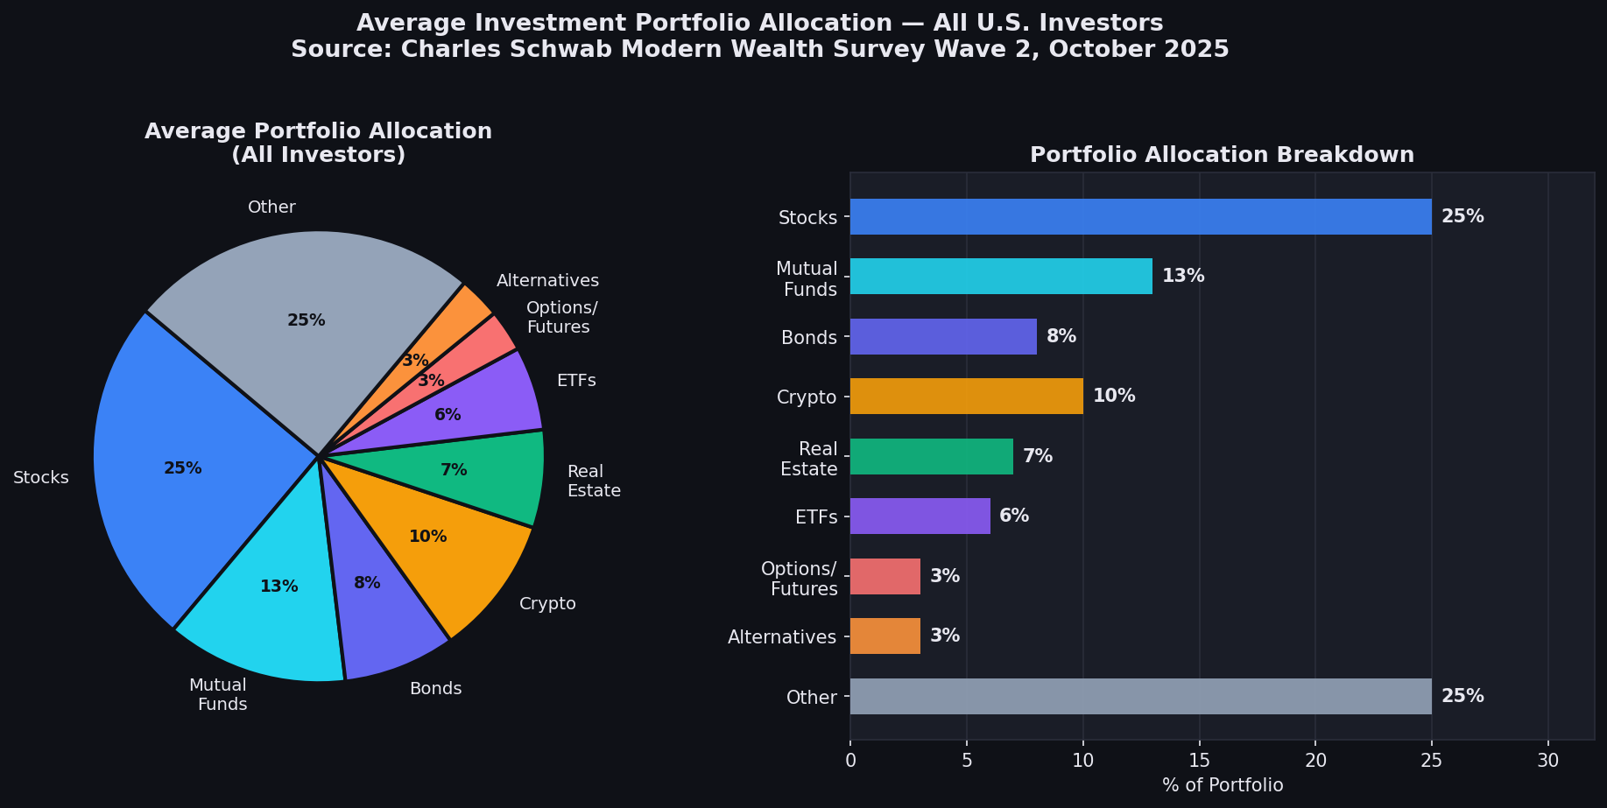
Figure 2: Average portfolio allocation across all U.S. investors. Source: Schwab Modern Wealth Survey Wave 2, October 2025
📌 Source: Charles Schwab Modern Wealth Survey 2025 Wave 2. content.schwab.com/web/retail/public/about-schwab/schwab-modern-wealth-survey-2025-wave2-findings.pdf
Asset Class | % of Avg Portfolio | Ownership Rate (% who own)
Stocks | 25% | 64%
Mutual Funds | 13% | 41%
Bonds | 8% | 37%
Cryptocurrency | 10% | 35%
Real Estate Investments | 7% | 25%
ETFs | 6% | 27%
Options / Futures | 3% | 15%
Alternatives | 3% | 12%
Other (incl. cash) | 25% | —

Table 2: Left column = actual portfolio weight. Right column = % of investors who hold the asset at all. Source: Schwab Wave 2 2025.

Key Crypto Findings (Schwab 2025)
- 29% of U.S. investors currently own crypto; 23% previously owned it.
- 41% of those aware of crypto consider it a good investment.
- 53% of crypto investors rate it HIGH risk — yet 65% plan to increase their crypto allocation over the next 20 years.
- Top reason to own crypto: strong long-term growth potential (53%).
- Top reason NOT to own: concern about scams or fraud (50%).

4. Stock Types Owned — Gen Z vs. Millennials (Motley Fool 2025)
The Motley Fool's July 2025 survey of 2,000 investors breaks down stock ownership by type across generations. Key finding: Gen Z leads on growth stocks, value stocks, REITs, ESG, and speculative stocks. Millennials lead on U.S. stocks broadly, dividend stocks, large-caps, and small/mid-caps.
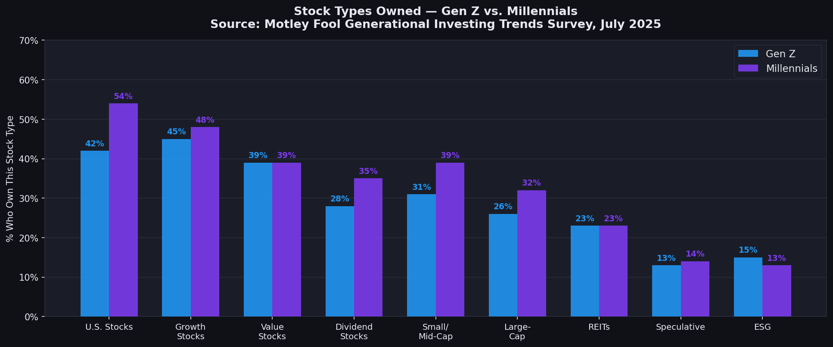
Figure 3: Stock types owned by generation. Source: Motley Fool, July 2025
📌 Source: Motley Fool Generational Investing Trends Survey, distributed via Pollfish, July 17, 2025. fool.com/research/what-are-gen-z-millennial-investors-buying/
Stock Type | Gen Z | Millennials | Gen X | Boomers
U.S. Stocks | 42% | 54% | 56% | 56%
Growth Stocks | 45% | 48% | 45% | 43%
Value Stocks | 39% | 39% | 29% | 16%
Dividend-Paying Stocks | 28% | 35% | 43% | 47%
Small- or Mid-Cap Stocks | 31% | 39% | 45% | 43%
Large-Cap Stocks | 26% | 32% | 38% | 38%
REITs | 23% | 23% | 15% | 9%
Speculative (Penny/Meme) | 13% | 14% | 9% | 4%
ESG / Socially Responsible | 15% | 13% | 6% | 4%

5. Investment Sectors — Gen Z vs. Millennials (Motley Fool 2025)
Gen Z under-indexes in Technology vs. Millennials (50% vs. 58%), and substantially trails in Healthcare & Biotech (29% vs. 36%) and Energy (30% vs. 34%). Gen Z leads in Real Estate (29% vs. 26%), AI stocks (22% vs. 21%), and Casino/Sports Betting (12% vs. 9%).
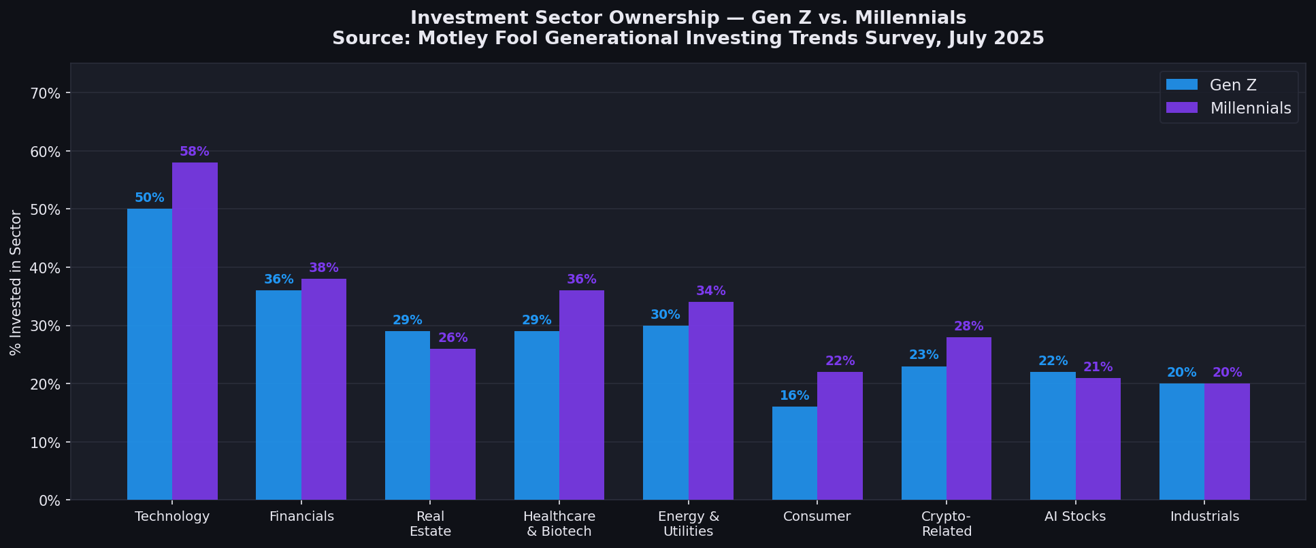
Figure 4: Sector ownership by generation. Source: Motley Fool, July 2025
📌 Source: Motley Fool Generational Investing Trends Survey, July 2025.
Sector | Gen Z | Millennials | Gen X | Boomers
Technology | 50% | 58% | 59% | 58%
Financials | 36% | 38% | 34% | 34%
Healthcare & Biotech | 29% | 36% | 40% | 42%
Energy & Utilities | 30% | 34% | 39% | 50%
Real Estate | 29% | 26% | 21% | 15%
Consumer (Disc. & Staples) | 16% | 22% | 26% | 23%
Crypto-Related Stocks | 23% | 28% | 16% | 8%
AI Stocks | 22% | 21% | 15% | 12%
Industrials & Materials | 20% | 20% | 23% | 24%
Casino & Sports Betting | 12% | 9% | 5% | 5%

6. Investment Goals — Gen Z vs. Millennials (Motley Fool 2025)
The most striking generational divergence in goals: 43% of Gen Z cite passive income as their primary investment goal, vs. only 20% who cite retirement planning. For Millennials, retirement planning (30%) and passive income (40%) are closer. Gen Z is also more likely to be investing to buy a home (16% vs. 9%) or start a business (9% vs. 4%).
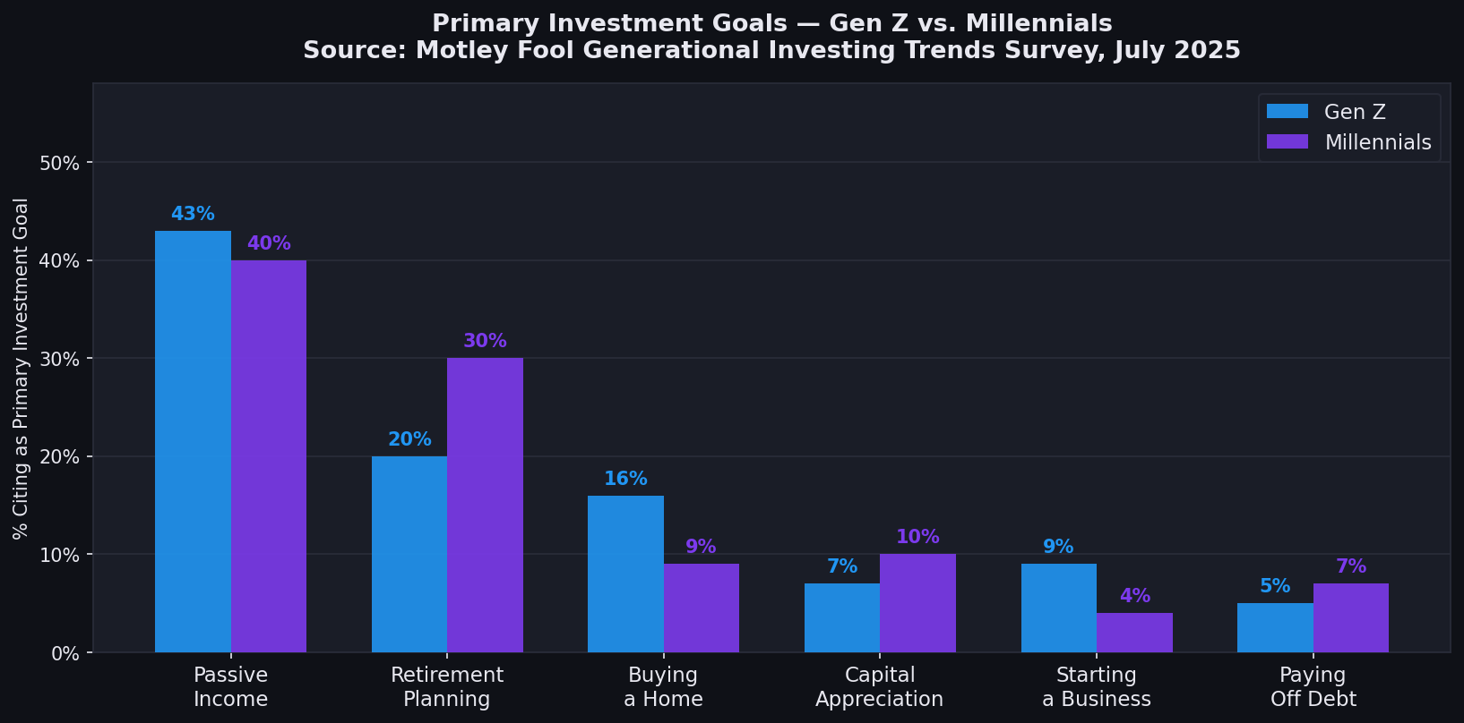
Figure 5: Primary investment goals by generation. Source: Motley Fool, July 2025
📌 Source: Motley Fool Generational Investing Trends Survey, July 2025.
Investment Goal | Gen Z | Millennials | Gen X | Boomers
Passive Income | 43% | 40% | 22% | 14%
Retirement Planning | 20% | 30% | 58% | 72%
Buying a Home | 16% | 9% | 2% | 2%
Capital Appreciation | 7% | 10% | 8% | 6%
Starting a Business | 9% | 4% | 3% | 0%
Paying Off Debt | 5% | 7% | 6% | 5%

7. Trading Frequency (Motley Fool 2025)
Gen Z trades significantly more frequently than any other generation. 50% of Gen Z trade daily or weekly (16% daily + 34% weekly), compared to 43% of Millennials. At the other end, 20% of Millennials trade less than once a month vs. 16% of Gen Z — consistent with Millennials' greater long-term investment focus.
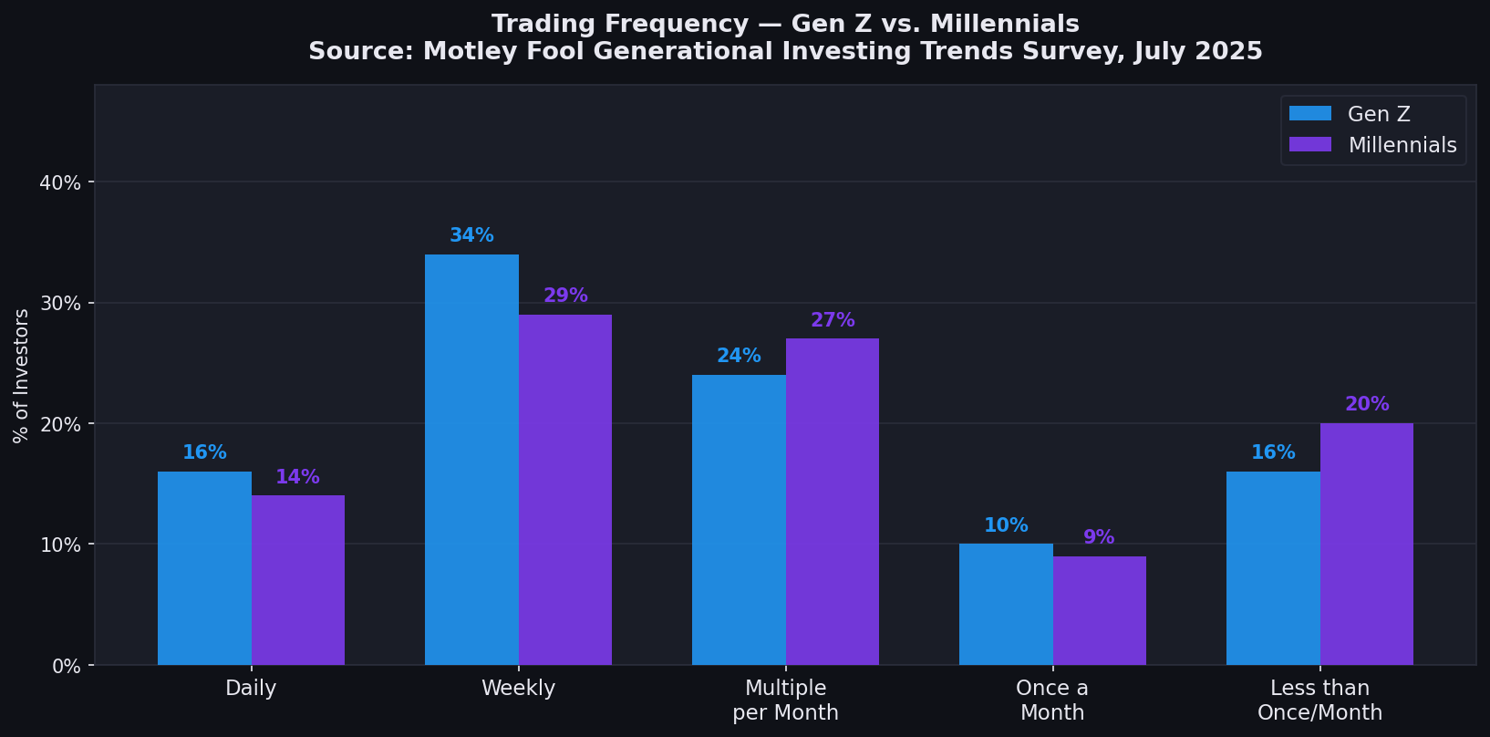
Figure 6: Trading frequency by generation. Source: Motley Fool, July 2025
📌 Source: Motley Fool Generational Investing Trends Survey, July 2025.

Schwab 2025 Corroborating Data
- 43% of all investors trade more frequently now than when they first started.
- 24% trade daily or weekly; 46% trade monthly or quarterly.
- Top reason for increased trading: better access to platforms and tools (51%).
- 54% of Gen Z agree investing today requires more short-term risk-taking (vs. 53% Millennials).
- Only 57% of Gen Z agree investing requires more long-term patience — the lowest of any generation (Millennials: 61%, Gen X: 65%, Boomers: 66%).

8. Risk Appetite & FOMO (FINRA 2023)
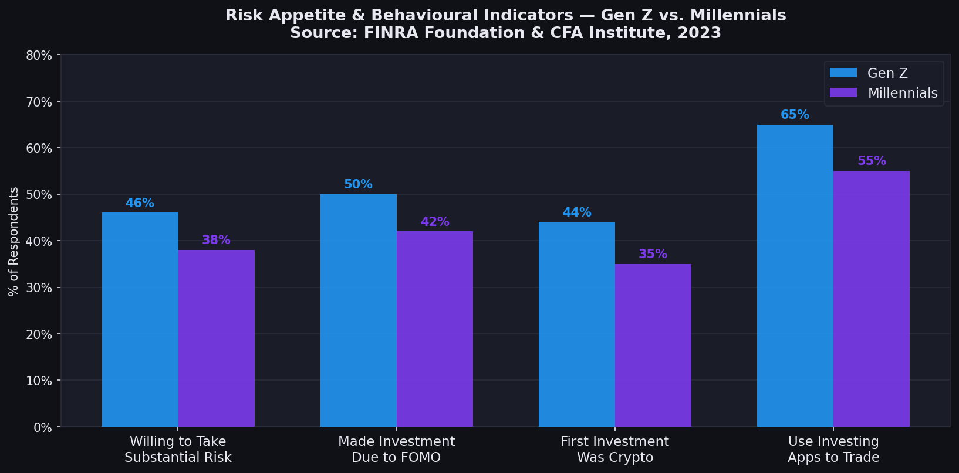
Figure 7: Risk & behavioural indicators. Source: FINRA Foundation & CFA Institute, 2023
📌 Source: FINRA Foundation & CFA Institute, 2023.
Behavioural Metric | Gen Z | Millennials
Willing to take substantial/above-avg risk | 46% | ~38%
Made an investment due to FOMO | 50% | 42%
First investment ever was crypto | 44% | 35%
Use investing apps to manage/trade | 65% | 55%
App suggestion influenced a trade | 67% | 79%
61% of Gen Z investors gamble online/in-person | 61% | —

9. Information Sources (Motley Fool 2025 + FINRA 2023)
Both surveys show a clear generational divide in where investing information comes from. Gen Z heavily relies on YouTube (67%) and TikTok (48%) — platforms that barely register for older generations. Millennials show more balanced use across platforms and are more likely to use free financial websites and financial advisors.
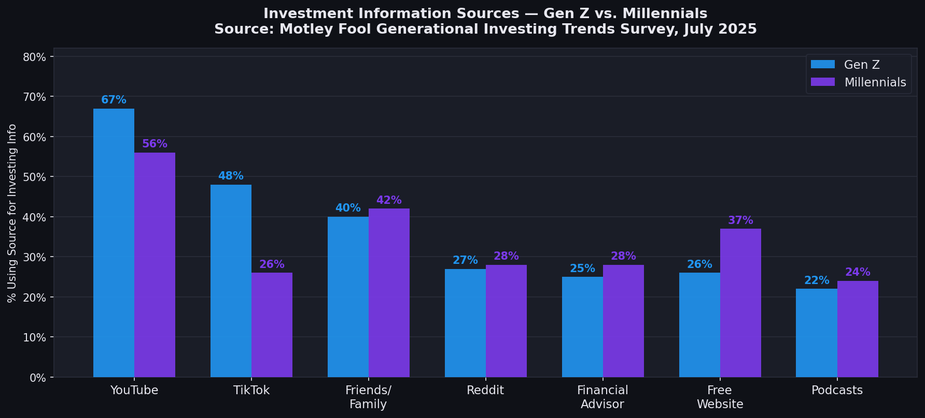
Figure 8: Investment information sources. Source: Motley Fool, July 2025
📌 Source: Motley Fool Generational Investing Trends Survey, July 2025.
Source | Gen Z (MF) | Millennials (MF) | Gen Z (FINRA) | Millennials (FINRA)
YouTube | 67% | 56% | 60% | —
TikTok | 48% | 26% | 37% | —
Friends / Family | 40% | 42% | 45% | 47%
Social Media (all) | — | — | 48% | —
Reddit | 27% | 28% | — | —
Financial Advisor | 25% | 28% | 30% | 39%
Free Website / Search | 26% | 37% | 47% | 53%

10. Dividends — Gen Z's "Side Hustle" Mentality (Motley Fool 2025)
A notable 2025 finding: 64% of Gen Z describe dividends as a "side hustle" — the highest of any generation. This framing reflects Gen Z's goal-oriented view of investing, where dividends are a near-term income stream rather than a compounding tool. By contrast, 70% of Boomers automatically reinvest dividends.
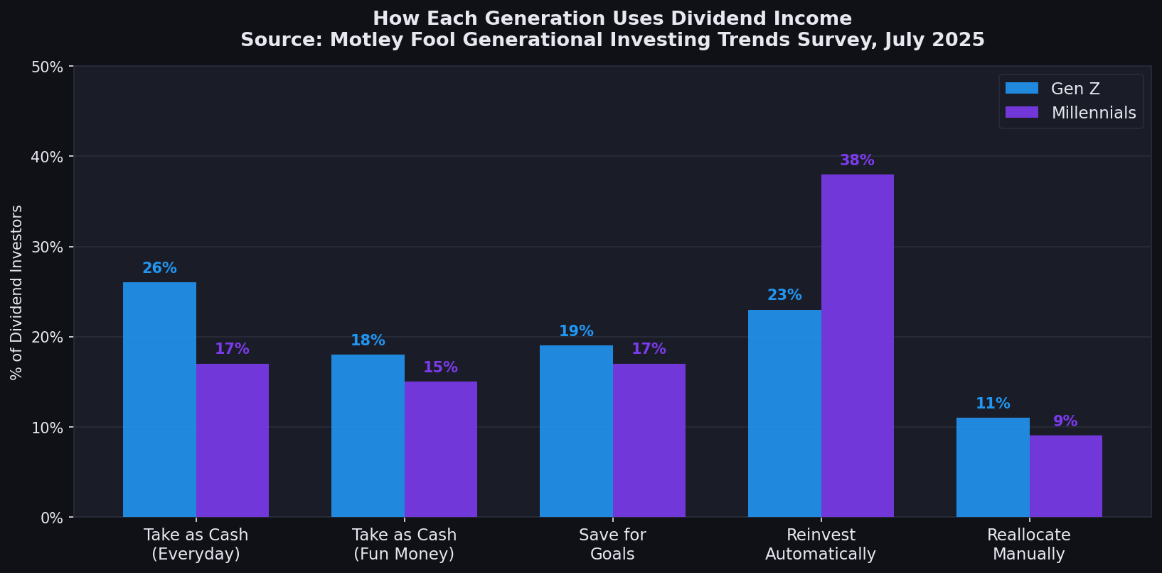
Figure 9: How each generation uses dividend income. Source: Motley Fool, July 2025
📌 Source: Motley Fool Generational Investing Trends Survey, July 2025.
Dividend Use | Gen Z | Millennials | Gen X | Boomers
Take as Cash — Everyday Expenses | 26% | 17% | 8% | 5%
Take as Cash — Fun Money | 18% | 15% | 9% | 4%
Save for Specific Financial Goals | 19% | 17% | 14% | 8%
Reinvest Automatically | 23% | 38% | 53% | 70%
Reallocate Manually | 11% | 9% | 10% | 10%

11. Master Comparison Table — All Sources
Metric | Gen Z | Millennials | Source
Crypto ownership rate | 55% | 57% | FINRA 2023
Individual stock ownership | 41% | 38% | FINRA 2023
ETF ownership | 23% | 26% | FINRA 2023
Mutual fund ownership | 35% | 43% | FINRA 2023
First investment was crypto | 44% | 35% | FINRA 2023
Made investment due to FOMO | 50% | 42% | FINRA 2023
Willing to take substantial risk | 46% | ~38% | FINRA 2023
Use investing apps to trade | 65% | 55% | FINRA 2023
Crypto % of avg portfolio | 10%* | 10%* | Schwab 2025 W2
Stocks % of avg portfolio | 25%* | 25%* | Schwab 2025 W2
Currently own crypto (investors) | 29%* | 29%* | Schwab 2025 W2
U.S. stocks ownership | 42% | 54% | Motley Fool 2025
Growth stocks ownership | 45% | 48% | Motley Fool 2025
Dividend stocks ownership | 28% | 35% | Motley Fool 2025
Value stocks ownership | 39% | 39% | Motley Fool 2025
Primary goal: passive income | 43% | 40% | Motley Fool 2025
Primary goal: retirement | 20% | 30% | Motley Fool 2025
Trade daily or weekly | 50% | 43% | Motley Fool 2025
Use YouTube for investing info | 67% | 56% | Motley Fool 2025
Use TikTok for investing info | 48% | 26% | Motley Fool 2025
View dividends as "side hustle" | 64% | 53% | Motley Fool 2025

* Schwab 2025 Wave 2 portfolio allocation data is not broken out by generation in the public report — figures represent all U.S. investors.

12. Full Citations
- FINRA Investor Education Foundation & CFA Institute (May 2023). "Gen Z and Investing: Social Media, Crypto, FOMO, and Family." finrafoundation.org/sites/finrafoundation/files/Gen-Z-and-Investing.pdf
- Charles Schwab & Co., Inc. (October 2025). "Modern Wealth Survey 2025, Wave 2." content.schwab.com/web/retail/public/about-schwab/schwab-modern-wealth-survey-2025-wave2-findings.pdf
- Motley Fool (August 2025). "Survey: What Are Gen Z and Millennial Investors Buying in 2025?" Distributed via Pollfish, July 17, 2025. fool.com/research/what-are-gen-z-millennial-investors-buying/

