

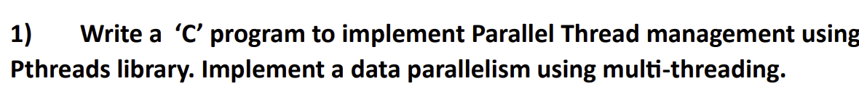

ANSWER->

//22BCE0682

CODE:

#include <stdio.h>

#include <stdlib.h>

#include <pthread.h>

#define T_COUNT 4

#define SIZE 1000000

typedef struct {

    int* a;

    int start_idx;

    int end_idx;

    long long total;

} *ThreadData*;

void* calc_partial_sum(void* *arg*) {

*ThreadData*\* td = (*ThreadData*\*)*arg*;

    long long s = 0;

    for (int i = td->start_idx; i < td->end_idx; i++) {

        s += td->a[i];

    }

    td->total = s;

    pthread_exit(NULL);

}

int main() {

    int* a = (int*)malloc(SIZE * sizeof(int));

*pthread_t* t[T_COUNT];

*ThreadData* td[T_COUNT];

    long long total_sum = 0;

    for (int i = 0; i < SIZE; i++) {

        a[i] = rand() % 100;

    }

    int chunk = SIZE / T_COUNT;

    for (int i = 0; i < T_COUNT; i++) {

        td[i].a = a;

        td[i].start_idx = i * chunk;

        td[i].end_idx = (i == T_COUNT - 1) ? SIZE : (i + 1) * chunk;

        td[i].total = 0;

        pthread_create(&t[i], NULL, calc_partial_sum, (void*)&td[i]);

    }

    for (int i = 0; i < T_COUNT; i++) {

        pthread_join(t[i], NULL);

        total_sum += td[i].total;

    }

    printf("Total sum: %lld\n", total_sum);

    free(a);

    return 0;

}

OUTPUT:

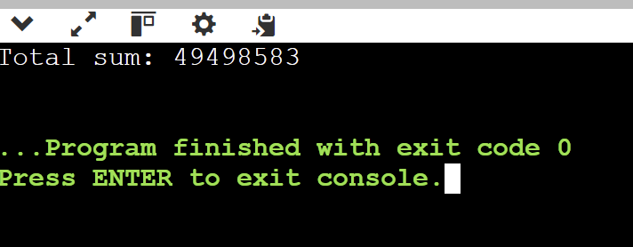

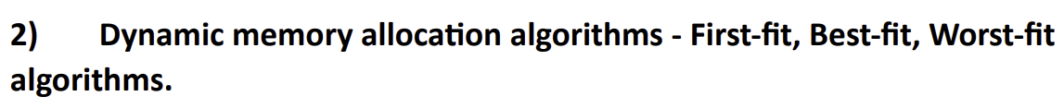

ANSWER->

//22BCE0682

CODE:

#include <stdio.h>

#include <stdlib.h>

#define MAX_MEMORY_BLOCKS 10

#define MAX_TASKS 10

struct *Block* {

    int bidx;

    int bcap;

    int isass;

    int tidx;

};

struct *Task* {

    int tidx;

    int tsize;

};

void initializeBlocks(struct *Block* *blocks*[], int *capacities*[], int *block_count*);

void firstFitAllocation(struct *Block* *blocks*[], int *block_count*, struct *Task* *tasks*[], int *task_count*);

void bestFitAllocation(struct *Block* *blocks*[], int *block_count*, struct *Task* *tasks*[], int *task_count*);

void worstFitAllocation(struct *Block* *blocks*[], int *block_count*, struct *Task* *tasks*[], int *task_count*);

void showMemoryStatus(struct *Block* *blocks*[], int *block_count*, const char* *algorithm_name*);

void copyMemoryState(struct *Block* *target*[], struct *Block* *source*[], int *block_count*);

int main() {

    struct *Block* memory[MAX_MEMORY_BLOCKS];

    struct *Block* temp_memory[MAX_MEMORY_BLOCKS];

    struct *Task* tasks[MAX_TASKS];

    int block_count, task_count, i;

    int block_capacities[MAX_MEMORY_BLOCKS];

    printf("Enter the number of memory blocks: ");

    scanf("%d", &block_count);

    printf("\nEnter the capacity of each memory block:\n");

    for(i = 0; i < block_count; i++) {

        printf("Block %d: ", i + 1);

        scanf("%d", &block_capacities[i]);

    }

    printf("\nEnter the number of tasks: ");

    scanf("%d", &task_count);

    printf("\nEnter the size of each task:\n");

    for(i = 0; i < task_count; i++) {

        printf("Task %d: ", i + 1);

        scanf("%d", &tasks[i].tsize);

        tasks[i].tidx = i + 1;

    }

    initializeBlocks(memory, block_capacities, block_count);

    printf("\n\n=== Memory Allocation Results ===\n");

    printf("\n1. First Fit Allocation\n");

    printf("----------------------------\n");

    copyMemoryState(temp_memory, memory, block_count);

    firstFitAllocation(temp_memory, block_count, tasks, task_count);

    showMemoryStatus(temp_memory, block_count, "First Fit");

    printf("\n2. Best Fit Allocation\n");

    printf("----------------------------\n");

    copyMemoryState(temp_memory, memory, block_count);

    bestFitAllocation(temp_memory, block_count, tasks, task_count);

    showMemoryStatus(temp_memory, block_count, "Best Fit");

    printf("\n3. Worst Fit Allocation\n");

    printf("----------------------------\n");

    copyMemoryState(temp_memory, memory, block_count);

    worstFitAllocation(temp_memory, block_count, tasks, task_count);

    showMemoryStatus(temp_memory, block_count, "Worst Fit");

    return 0;

}

void initializeBlocks(struct *Block* *blocks*[], int *capacities*[], int *block_count*) {

    for(int i = 0; i < *block_count*; i++) {

*blocks*[i].bidx = i + 1;

*blocks*[i].bcap = *capacities*[i];

*blocks*[i].isass = 0;

*blocks*[i].tidx = 0;

    }

}

void copyMemoryState(struct *Block* *target*[], struct *Block* *source*[], int *block_count*) {

    for(int i = 0; i < *block_count*; i++) {

*target*[i] = *source*[i];

    }

}

void firstFitAllocation(struct *Block* *blocks*[], int *block_count*, struct *Task* *tasks*[], int *task_count*) {

    for(int i = 0; i < *task_count*; i++) {

        int allocated = 0;

        for(int j = 0; j < *block_count*; j++) {

            if(!*blocks*[j].isass && *blocks*[j].bcap >= *tasks*[i].tsize) {

*blocks*[j].isass = 1;

*blocks*[j].tidx = *tasks*[i].tidx;

                printf("Task %d (%d KB) -> Allocated to Block %d (%d KB)\n",

*tasks*[i].tidx, *tasks*[i].tsize, *blocks*[j].bidx, *blocks*[j].bcap);

                allocated = 1;

                break;

            }

        }

        if(!allocated) {

            printf("Task %d (%d KB) -> Cannot be allocated\n",

*tasks*[i].tidx, *tasks*[i].tsize);

        }

    }

}

void bestFitAllocation(struct *Block* *blocks*[], int *block_count*, struct *Task* *tasks*[], int *task_count*) {

    for(int i = 0; i < *task_count*; i++) {

        int best_block_idx = -1;

        int smallest_diff = 999999; // Use a large initial value to find the minimum difference

        for(int j = 0; j < *block_count*; j++) {

            if(!*blocks*[j].isass && *blocks*[j].bcap >= *tasks*[i].tsize) {

                int diff = *blocks*[j].bcap - *tasks*[i].tsize;

                if(diff < smallest_diff) {

                    smallest_diff = diff;

                    best_block_idx = j;

                }

            }

        }

        if(best_block_idx != -1) {

*blocks*[best_block_idx].isass = 1;

*blocks*[best_block_idx].tidx = *tasks*[i].tidx;

            printf("Task %d (%d KB) -> Allocated to Block %d (%d KB)\n",

*tasks*[i].tidx, *tasks*[i].tsize, *blocks*[best_block_idx].bidx, *blocks*[best_block_idx].bcap);

        } else {

            printf("Task %d (%d KB) -> Cannot be allocated\n",

*tasks*[i].tidx, *tasks*[i].tsize);

        }

    }

}

void worstFitAllocation(struct *Block* *blocks*[], int *block_count*, struct *Task* *tasks*[], int *task_count*) {

    for(int i = 0; i < *task_count*; i++) {

        int worst_block_idx = -1;

        int largest_diff = -1; // Start with a negative value to find the largest available difference

        for(int j = 0; j < *block_count*; j++) {

            if(!*blocks*[j].isass && *blocks*[j].bcap >= *tasks*[i].tsize) {

                int diff = *blocks*[j].bcap - *tasks*[i].tsize;

                if(diff > largest_diff) {

                    largest_diff = diff;

                    worst_block_idx = j;

                }

            }

        }

        if(worst_block_idx != -1) {

*blocks*[worst_block_idx].isass = 1;

*blocks*[worst_block_idx].tidx = *tasks*[i].tidx;

            printf("Task %d (%d KB) -> Allocated to Block %d (%d KB)\n",

*tasks*[i].tidx, *tasks*[i].tsize, *blocks*[worst_block_idx].bidx, *blocks*[worst_block_idx].bcap);

        } else {

            printf("Task %d (%d KB) -> Cannot be allocated\n",

*tasks*[i].tidx, *tasks*[i].tsize);

        }

    }

}

void showMemoryStatus(struct *Block* *blocks*[], int *block_count*, const char* *algorithm_name*) {

    printf("\nFinal Memory State (%s):\n", *algorithm_name*);

    printf("Block\tCapacity\tStatus\t\tTask\n");

    printf("----------------------------------------\n");

    for(int i = 0; i < *block_count*; i++) {

        printf("%d\t%d\t\t%s\t\t",

*blocks*[i].bidx,

*blocks*[i].bcap,

*blocks*[i].isass ? "Assigned" : "Free");

        if(*blocks*[i].isass)

            printf("T%d\n", *blocks*[i].tidx);

        else

            printf("None\n");

    }

    printf("\n");

}

OUTPUT:

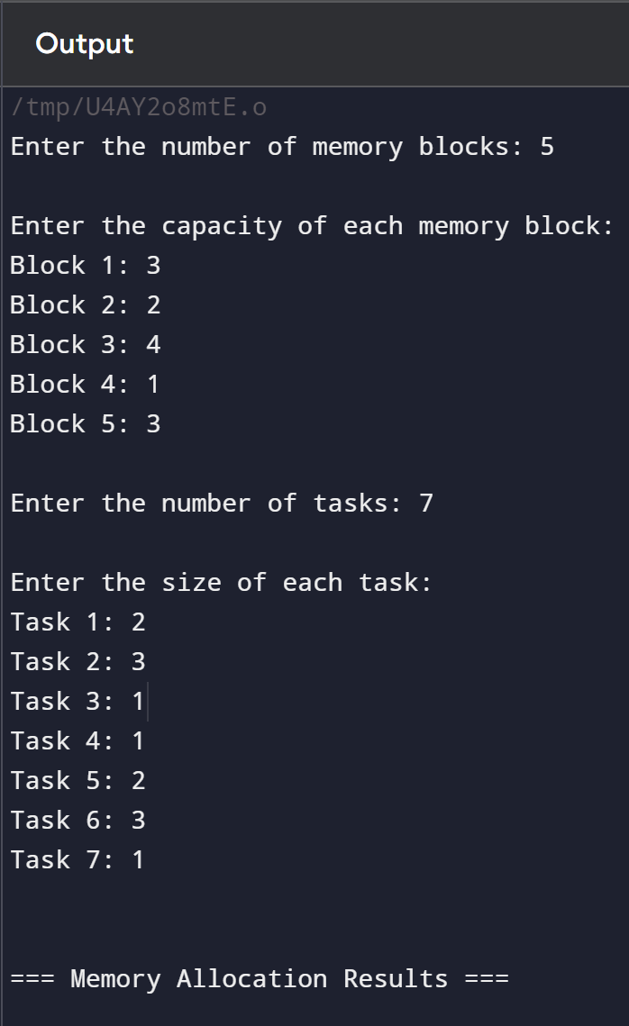

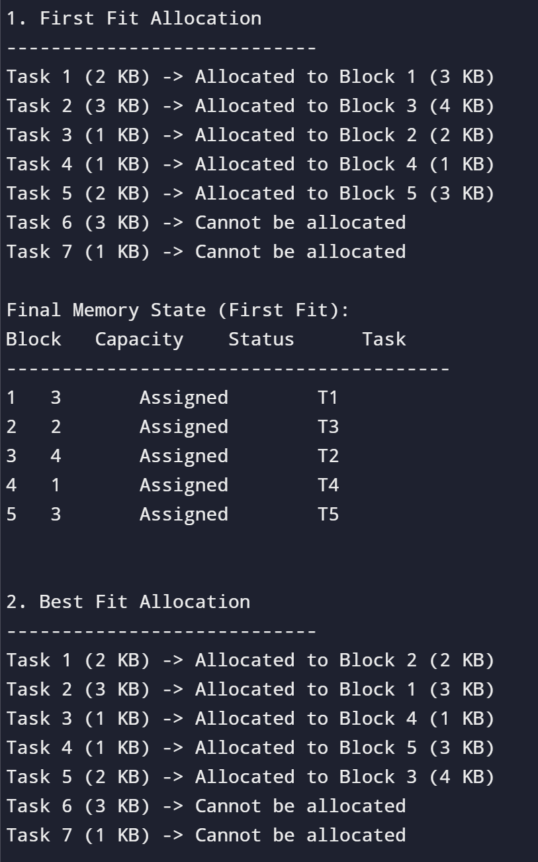

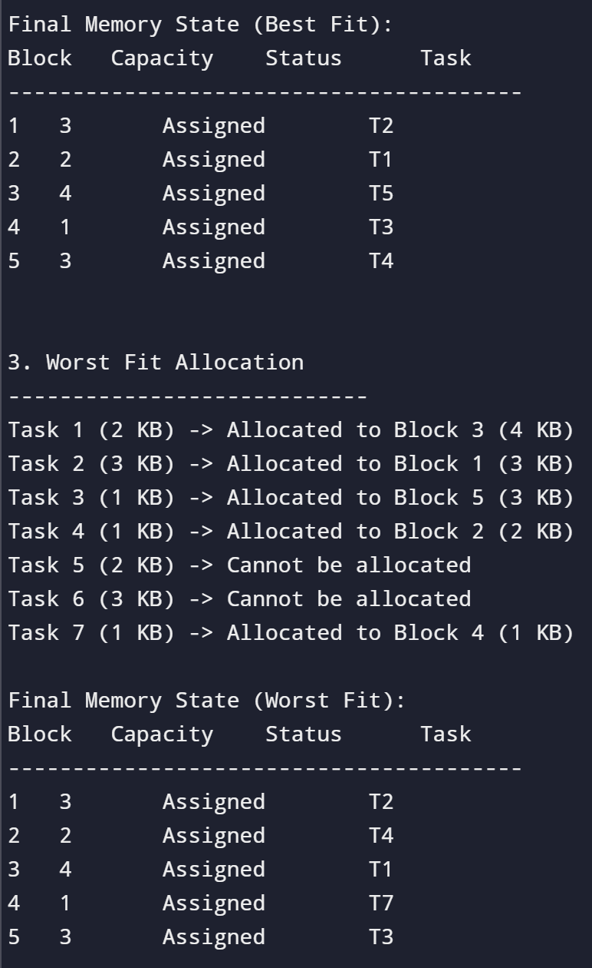



ANSWER->

//22BCE0682

CODE:

#include <stdio.h>

#include <stdlib.h>

#include <limits.h>

int srch(int *key*, int *fi*[], int *fo*) {

    for (int i = 0; i < fo; i++)

        if (fi[i] == key)

            return 1;

    return 0;

}

int Flru(int *time*[], int *n*) {

    int minimum = time[0], pos = 0;

    for (int i = 1; i < n; i++) {

        if (time[i] < minimum) {

            minimum = time[i];

            pos = i;

        }

    }

    return pos;

}

void FIFO(int *pages*[], int *n*, int *frames*) {

    int fi[frames];

    for (int i = 0; i < frames; i++) fi[i] = -1;

    int fo = 0;

    int pgfaults = 0;

    int current = 0;

    printf("\nFIFO Page Replacement Algorithm\n");

    for (int i = 0; i < n; i++) {

        printf("\nFor page %d: ", pages[i]);

        if (!srch(pages[i], fi, fo)) {

            if (fo < frames) {

                fi[fo] = pages[i];

                fo++;

            } else {

                fi[current] = pages[i];

                current = (current + 1) % frames;

            }

            pgfaults++;

        }

        for (int j = 0; j < fo; j++)

            printf("%d ", fi[j]);

    }

    printf("\nTotal Page Faults (FIFO): %d\n", pgfaults);

}

void LRU(int *pages*[], int *n*, int *frames*) {

    int fi[frames], time[frames];

    for (int i = 0; i < frames; i++) fi[i] = -1;

    int fo = 0;

    int pgfaults = 0;

    printf("\nLRU Page Replacement Algorithm\n");

    for (int i = 0; i < n; i++) {

        printf("\nFor page %d: ", pages[i]);

        if (!srch(pages[i], fi, fo)) {

            if (fo < frames) {

                fi[fo] = pages[i];

                time[fo] = i;

                fo++;

            } else {

                int pos = Flru(time, frames);

                fi[pos] = pages[i];

                time[pos] = i;

            }

            pgfaults++;

        } else {

            for (int j = 0; j < fo; j++) {

                if (fi[j] == pages[i]) {

                    time[j] = i;

                    break; // Fixed the typo here

                }

            }

        }

        for (int j = 0; j < fo; j++)

            printf("%d ", fi[j]);

    }

    printf("\nTotal Page Faults (LRU): %d\n", pgfaults);

}

// Updated OPTimal Algorithm

int fOPT(int *pages*[], int *fi*[], int *n*, int *index*) {

    int res = -1, far = index;

    for (int i = 0; i < n; i++) {

        int j;

        for (j = index; j < n; j++) {

            if (fi[i] == pages[j]) {

                if (j > far) {

                    far = j;

                    res = i;

                }

                break; // Fixed the typo here

            }

        }

        if (j == n)

            return i;

    }

    return res; // Simply return res

}

void OPT(int *pages*[], int *n*, int *frames*) {

    int fi[frames];

    for (int i = 0; i < frames; i++) fi[i] = -1;

    int fo = 0;

    int pgfaults = 0;

    printf("\nOPT Page Replacement Algorithm\n");

    for (int i = 0; i < n; i++) {

        printf("\nFor page %d: ", pages[i]);

        if (!srch(pages[i], fi, fo)) {

            if (fo < frames) {

                fi[fo] = pages[i];

                fo++;

            } else {

                int pos = fOPT(pages, fi, n, i + 1);

                fi[pos] = pages[i];

            }

            pgfaults++;

        }

        for (int j = 0; j < fo; j++)

            printf("%d ", fi[j]);

    }

    printf("\nTotal Page Faults (Optimal): %d\n", pgfaults);

}

int main() {

    int frames, n;

    printf("Enter the number of frames: ");

    scanf("%d", &frames);

    printf("Enter the number of pages: ");

    scanf("%d", &n);

    int pages[n];

    printf("Enter the page reference string: ");

    for (int i = 0; i < n; i++)

        scanf("%d", &pages[i]);

    FIFO(pages, n, frames);

    LRU(pages, n, frames);

    OPT(pages, n, frames);

    return 0;

}

OUTPUT:

