**CONTENT**

|  |  |
| --- | --- |
|  | INTRODUCTION TO THE TOPIC |
|  | WORKING PRINCIPLE |
|  | COMPONENTS USED |
|  | CIRCUIT DIAGRAM |
|  | SKETCH |
|  | ADVANTAGES |
|  | APPLICATIONS |
|  | CONCLUSION |
|  | BIBLIOGRAPHY |

**WHAT IS A TACHOMETER?**

A tachometer is a sensor device for measuring the rotation speed of an object such as the engine shaft in a car. This device indicates the revolutions per minute (RPM) performed by the object. The device comprises of a dial, a needle to indicate the current reading, and markings to indicate safe and dangerous levels.

**BRIEF HISTORY OF TACHOMETER**

Historically, the first mechanical tachometers were designed based on measuring the centrifugal force. In 1817, it was adapted to be used for measuring the speed of machines. But after 1840, it has been predominantly used to measure the speed of vehicles.

The first mechanical tachometers were based on measuring the [centrifugal force](https://en.wikipedia.org/wiki/Centrifugal_force), similar to the operation of a [centrifugal governor](https://en.wikipedia.org/wiki/Centrifugal_governor). The inventor is assumed to be the German engineer [Dietrich Uhlhorn](https://en.wikipedia.org/wiki/Diedrich_Uhlhorn); he used it for measuring the speed of machines in 1817.Since 1840, it has been used to measure the speed of [locomotives](https://en.wikipedia.org/wiki/Locomotive).

TYPES OF TACHOMETER

The types of tachometers commonly found are mentioned below:

* **Analog tachometers** - Comprise a needle and dial-type of interface. They do not have provision for storage of readings and cannot compute details such as average and deviation. Here, speed is converted to voltage via use of an external frequency to voltage converter. This voltage is then displayed by an analog voltmeter.
* **Digital tachometers** - Comprise LCD or LED readout and a memory for storage. These can perform statistical operations, and are very suitable for precision measurement and monitoring of any kind of time based quantities. Digital tachometers are more common these days and they provide numerical readings instead of using dials and needles.
* **Contact and non-contact tachometers** – The contact type is in contact with the rotating shaft. The non-contact type is ideal for applications that are mobile, and uses a laser or optical disk. In the contact type, an optical encoder or magnetic sensor is used. Both these types are data acquisition methods.
* **Time and frequency measuring tachometers** – Both these are based on measurement methods. The time measurement device calculates speed by measuring the time interval between the incoming pulses; whereas, the frequency measurement device calculates speed by measuring the frequency of the incoming pulses. Time measuring tachometers are ideal for low speed measurements and frequency measuring tachometers are ideal for high speed measurements.

**WORKING PRINCIPLE**

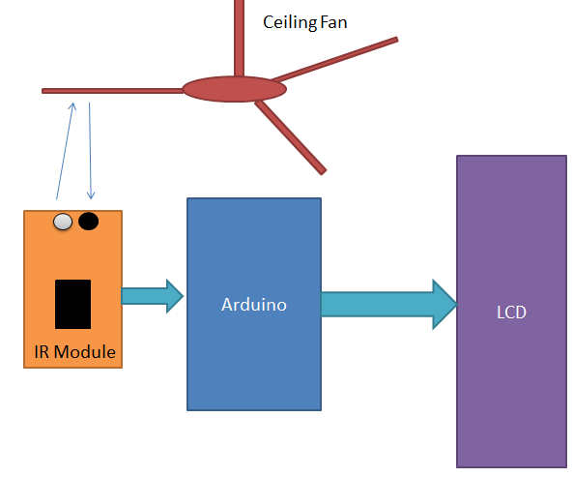

Fig 1

As shown in the above flow diagram , it contains Arduino, IR sensor module and LCD. Arduino controls the whole the process like reading pulse that IR sensor module generate according to object detection, calculating RPM and sending RPM value to LCD. IR sensor is used for sensing object. We can set sensitivity of this sensor module by inbuilt potentiometer situated on IR module. IR sensor module consist an IR transmitter and a photo diode which detects or receives infrared rays. IR transmitter transmits infrared rays, when these rays fall on any surface, they reflect back and sensed by photo diode . The output of photo diode is connected to a comparator, which compare photo diode output with reference voltage and result is given as output to arduino.

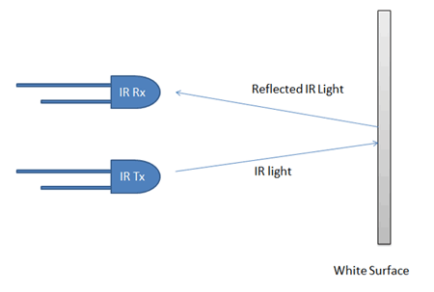

Fig 2

IR sensor module output pin is directly connected to pin 18 (A4). Vcc and GND are connected to Vcc and GND of arduino. A 16x2 LCD is connected with arduino in 4-bit mode. Control pin RS, RW and En are directly connected to arduino pin 2, GND and 3. And data pin D4-D7 is connected to pins 4, 5, 6 and 7 of arduino. A push button is also added in this project. When we need to count RPM we press this button to start this Arduino Tachometer to count RPM for five seconds. This push button is connected to pin 10 of arduino with respect to ground.

**COMPONENTS USED AND THEIR COST**

|  |  |  |  |  |
| --- | --- | --- | --- | --- |
| S NO. | COMPONENT | QUANTITY | SPECIFICATION | COST(INR) |
| 1. | MICROCONTROLLER DEVELOPMENT BOARD | 1 | ARDUINO UNO | 550 |
| 2. | IR SENSOR MODULE | 1 | HC-SR04(3-5V) | 150 |
| 3. | LCD/LAPTOP FOR DISPLAY | 1 |  | 200 |
| 4. | PUSH BUTTON | 1 |  | 6 |
| 5. | PCB | 1 |  | 30 |
| 6. | POWER SUPPLY CABLE | 1 | 12V | 50 |
| 7. | CONNECTING PROBES | 4 |  | 10 |

|  |  |
| --- | --- |
| TOTAL | 996 |

**CIRCUIT DIAGRAM**

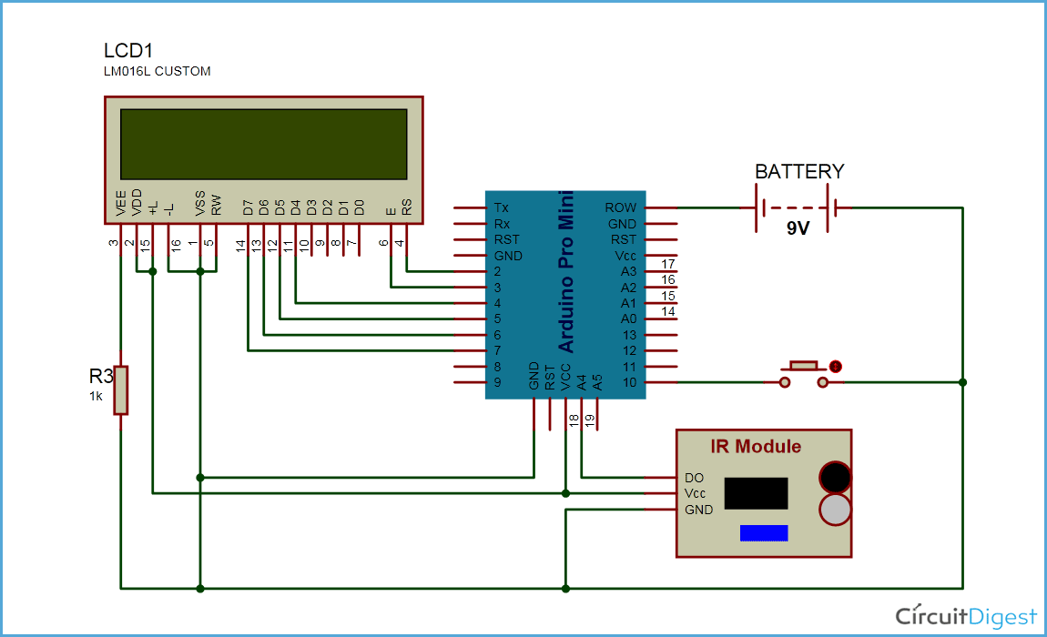

FIG 3

**SKETCH**

#define sensor 18

#define start 10

int delay1()

{

int i,j;

unsigned int count=0;

for(i=0;i<1000;i++)

{

for(j=0;j<1227;j++)

{

if(digitalRead(sensor))

{

count++;

while(digitalRead(sensor));

}

}

}

return count;

}

void setup()

{

pinMode(sensor, INPUT);

pinMode(start, INPUT);

pinMode(13, OUTPUT);

Serial.begin(9600);

Serial.println("TECHOMETER");

delay(2000);

digitalWrite(start, HIGH);

}

void loop()

{

unsigned int time=0,RPM=0;

Serial.println("Please press button to start");

while(digitalRead(start));

Serial.println("Reading RPM.....");

time=delay1();

Serial.println("Please Wait.....");

RPM=(time*12)/3;

delay(2000);

Serial.print("RPM = ");

Serial.println(RPM);

Serial.println("***************************************************************");

delay(5000);

}

**SKETCH (USING LCD)**

#include <LiquidCrystal.h>

LiquidCrystal lcd(3, 2, 4, 5, 6, 7);

#define sensor 18

#define start 10

int delay1()

{

int i,j;

unsigned int count=0;

for(i=0;i<1000;i++)

{

for(j=0;j<1227;j++)

{

if(digitalRead(sensor))

{

count++;

while(digitalRead(sensor));

}

}

}

return count;

}

void setup()

{

pinMode(sensor, INPUT);

pinMode(start, INPUT);

pinMode(13, OUTPUT);

lcd.begin(16, 2);

lcd.print("Techometer");

lcd.setCursor(0,1);

delay(2000);

digitalWrite(start, HIGH);

}

void loop()

{

unsigned int time=0,RPM=0;

lcd.clear();

lcd.print(" Please Press ");

lcd.setCursor(0,1);

lcd.print("Button to Start ");

while(digitalRead(start));

lcd.clear();

lcd.print("Reading RPM.....");

time=delay1();

lcd.clear();

lcd.print("Please Wait.....");

RPM=(time*12)/3;

delay(2000);

lcd.clear();

lcd.print("RPM=");

lcd.print(RPM);

delay(5000);

}

**ADVANTAGES OF USING DIGITAL TACHOMETER**

* Imposes no load on the shaft hence no power loss.
* No contact hence no attachment needed
* Highly accurate
* Simple to operate
* Its output is in digital form, so it is directly fed into the memory devices like the tape recorder, printers, floppy discs, and digital computer etc.

**APPLICATIONS OF DIGITAL TACHOMETER**

The following are the key application areas of tachometers:

* Automobiles, airplanes, trucks, tractors, trains and light rail vehicles
* Laser instruments
* Medical applications: Advanced tachometers are being applied in novel uses, for example, in the medical field, a **haematachometer** placed in an artery or vein can estimate the rate of blood flow from the speed at which the turbine spins. The readings can be used to diagnose circulatory problems like clogged arteries.
* Analogue audio recording, a tachometer is a device that measures the speed of audiotape as it passes across the head
* Numerous types of machinery and prime movers
* To estimate traffic speed and volume.

**CONCLUSION**

The main aim of this project is to calculate the speed of the motor. In earlier days, speed of the motor was calculated by using contact tachometer, here only limited speed can be calculated, and the accurate reading cannot be obtained and display the calculated value in analog form, this analog form display is difficult to understand. So in this project we can overcome these above problems, as here we are using here contact less tachometer.

From this tachometer we can calculate the speed of the motor to a large extent. And accurate reading is obtained; calculated value will be in the form of digital, which is easy to understand.

**BIBLIOGRAPHY**

**Book References**

* [Tachometers –An Overview – Utah State University](http://www.google.co.in/url?sa=t&rct=j&q=tachometer%20ppt&source=web&cd=1&cad=rja&ved=0CCkQFjAA&url=http%3A%2F%2Fmechatronics.ece.usu.edu%2Fece5320%2FSchedule%2Fhw01-2004%2Fali_Tachometers%2520%2520An%2520Overview.ppt&ei=0f9DUrW4KYmCrAf704EQ&usg=AFQjCNEb1i)
* [ELECTRICAL TACHOMETERS (MMC SERIES)- Industrial Instruments](http://www.industrialinstruments.co.uk/html/electrical_tachometers.html)
* [Maas.S .Austin-Healey Sprite Electronic Tachometer Conversion.Nonlintec.2009](http://www.nonlintec.com/sprite/Sprite_Electronic_Tach.pdf)
* [How Do Tachometers Work? - eHow](http://www.ehow.com/how-does_5019069_tachometers-work.html)
* [Digital Tachometers -Esters Elektronik](http://www.esters.de/en/download/ds/e180.20020626.pdf)

**Online References**

* <http://www.esters.de>
* https://www.azosensors.com