**Software Requirements Specification**

For

**Career Guidance App**

27 October, 2021

Prepared by

|  |  |  |
| --- | --- | --- |
| **Specialization** | **SAP ID** | **Name** |
| CSE CCVT | 500068490 | Vedika Jaint |
| CSE CCVT | 500068423 | Nishtha Khunteta |
| CSE CCVT | 500068534 | Siddhanth Andani |



Department of Informatics

School Of Computer Science

UNIVERSITY OF PETROLEUM & ENERGY STUDIES,

DEHRADUN- 248007. Uttarakhand

|  |  |  |
| --- | --- | --- |
| **Topic** | | **Page No** |
| Table of Content | | 2 |
| 1 | Introduction | 3 |
|  | 1.1 Purpose of the Project | 3 |
|  | 1.2 Target Beneficiary | 3 |
|  | 1.3 Project Scope | 3 |
|  | 1.4 References | 3 |
| 2 | Project Description | 4 |
|  | 2.1 Reference Algorithm | 4 |
|  | 2.2 Data/ Data structure | 4 |
|  | 2.3 SWOT Analysis | 4 |
|  | 2.4 Project Features | 4 |
|  | 2.5 User Classes and Characteristics | 5 |
|  | 2.6 Design and Implementation Constraints | 5 |
|  | 2.7 Design diagrams | 6 |
|  | 2.8 Assumption and Dependencies | 6 |
| 3 | System Requirements | 7 |
|  | 3.1 User Interface | 7 |
|  | 3.2 Software Interface | 7 |
|  | 3.3 Protocols | 8 |
| 4 | Non-functional Requirements | 8 |
|  | 4.1 Performance requirements | 8 |
|  | 4.2 Software Quality Attributes | 8 |
| Appendix A: Glossary | | 8 |
| Appendix B: Analysis Model | | 8 |

**1. Introduction**

**1.1 Purpose of the Project –**

With the rise in research and exploration in various domains, there are many new career opportunities in every field. This creates confusion in a student's mind to opt only one career. Because of these confusions, the student may select a wrong career option and therefore this wrong decision may lead to work dissatisfaction, poor performance, anxiety, stress, social disregard etc.

So we've created a career guidance app which will be able to help the student to pick the career path which might be suitable for his future.

**1.2 Target Beneficiary**

This project focuses on the group of college students. As we know college students are usually unclear about their career path as there are many fields of profession coming up every day. A career guidance app is intended to help the students understand the domain they are interested in, what they are good at, what the future career options might be.

**1.3 Project Scope**

To implement the suitable algorithms to give appropriate results according to the choices and other interests of the student. Apply the algorithms on the training dataset and train a model. To create a recommendation system that provides accurate suggestions.

**1.4 References**

1. https://www.analyticsvidhya.com/blog/2017/09/understaing-support-vector-machine-example-code/
2. https://www.irjet.net/archives/V7/i9/IRJET-V7I9195.pdf
3. https://towardsdatascience.com/https-medium-com-vishalmorde-xgboost-algorithm-long-she-may-rein-edd9f99be63d
4. https://www.javatpoint.com/machine-learning-decision-tree-classification-algorithm

**2. Project Description:**

**2.1 Reference Algorithm**

ML algorithms used are:

a. Decision Tree

b. Support Vector Machine

c. XGBoost

**2.2 Data/ Data Structure**

Trees, Lists

**2.3 SWOT Analysis**

**Strengths:**

1. Model performs better with already pre-processed and clean dataset.
2. Gradient boosting techniques enhances the performance of supervised machine learning approach.
3. XGBoost takes the output of weak learners (Decision trees) into consideration.

**Weakness:**

1. Poor performance with irrelevant, NULL and missing information in the dataset
2. Restricted to a particular domain.
3. False positives and negatives might hamper user’s experience.

**Opportunities:**

1. Learn new techniques and algorithms.
2. Project can be deployed for social cause.
3. Using AI powered solutions to solve real world scenarios.

**Threats:**

1. Information misconduct
2. Poor feature engineering can lead to wrong classifications

**2.4 Project Features**

1. Analysis
2. Classification
3. Recommendation
4. Model Boosting

**2.5 User Classes and Characteristics**

1. People who want guidance for their future career options
2. People who want to get better career predictions

**2.6 Design and Implementation Constraints**

**Minimum Recommended**

**OS**

Windows 7 Windows 8 or higher

**Processor**

Dual core 2.4GHz Quad Core 2.5GHz

**Memory**

2048 MB 4096 MB

**Storage**

2 GB 4 GB

**Graphics**

Video card with 512MB of VRAM Video card with 1024MB of VRAM

**2.7 Design Diagrams**

**Flowchart:**

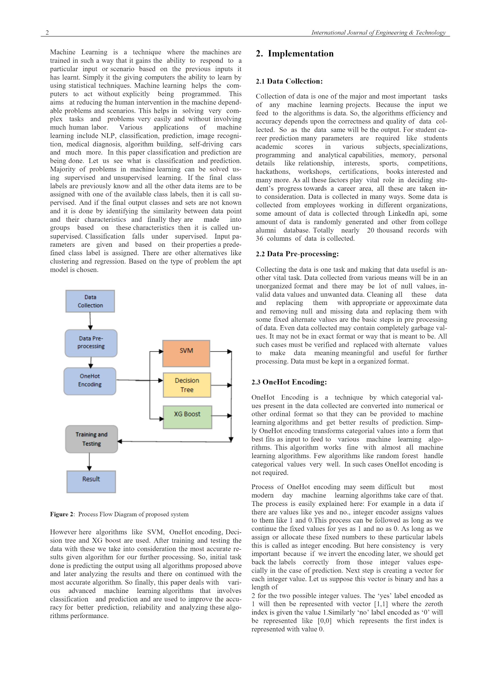

**Data Flow Diagram:**

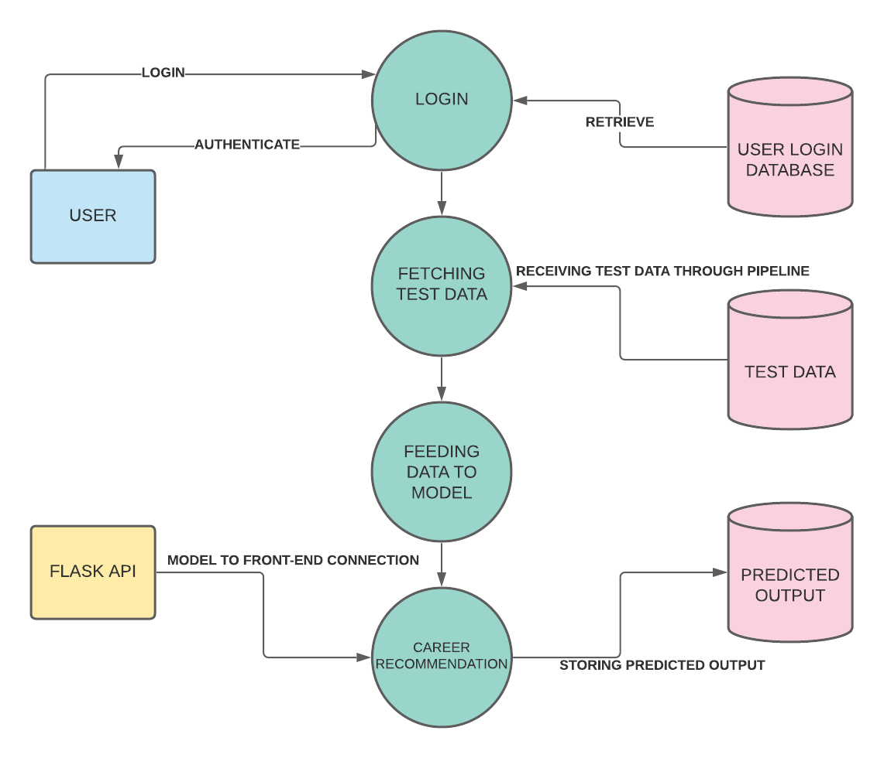

**2.8 Assumption and Dependencies**

1. Fully functional on a python confgured environment.

2. Students giving appropriate answers for the given questions asked.

**3. SYSTEM REQUIREMENTS**

**3.1 User Interface:**

HTML, CSS

**3.2 Software Interface:**

Processor : Intel Core™ i5-9750H CPU@2.5GHz

Disk Drive : Hard Disk Drive

RAM : 8 GB or higher

Operating System : Windows 10 OS

Programming Language : Python

Compiler : Jupyter Notebook,Google Colab

**3.3 Protocols:** HTTP

**4 NON-FUNCTIONAL REQUIREMENTS**

**4.1 Performance requirements:**

Pre-installed dependencies and fully configured python environment.

**4.2 Software Quality Attributes:**

It gives output very fast and very accurately.

**Appendix A: Glossary**

CPU: Central processing unit

XGBoost: Extreme Gradient Boosting

SVM: Support Vector Machine

**Appendix B: Analysis Model**

Chi Square Test