JAVA
java is a class-based, object-oriented programming language.
write once run anywhere that is compiled Java code can run on all platforms that support Java.
Java applications are compiled to byte code that can run on any Java Virtual Machine.

Java Virtual Machine(JVM): There are three execution phases of a program. They are written, compile and run the program.

-> Written done by us
->compile is done by the JAVAC compiler which is a primary Java compiler included in the Java development kit (JDK).
It takes the Java program as input and generates bytecode as output.
->In the Running phase of a program, JVM executes the bytecode generated by the compiler.

JVM excute karta h bytecode ko jo complier se produce hota hai
every OS has different JVM par jo output hota h vo same rahta h Bytecode vala toh isko Platform independent language bolte h

Bytecode in the Development process:
JDK compiles the java source code into bytecode so that it can be executed by JVM. It is saved as .class file by the compiler. To view the bytecode, a disassembler like javap can be used.

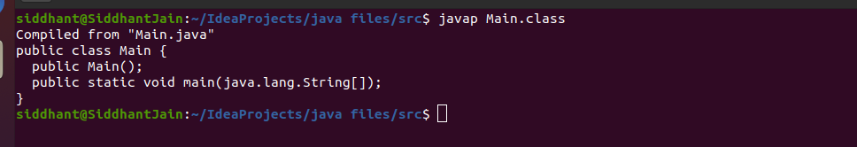
Java Development Kit(JDK):
Java development kit that includes everything including compiler, Java Runtime Environment (JRE), java debuggers, java docs, etc. For the program to execute in java, we need to install JDK on our computer in order to create, compile and run the java program.

Java Runtime Environment (JRE):

JRE installation on our computers allows the java program to run

Garbage Collector:
To delete or recollect that memory JVM has a program called Garbage Collector. Garbage Collectors can recollect the objects that are not referenced.

ClassPath:
The classpath is the file path where the java runtime and Java compiler look for .class files to load. By default, JDK provides many libraries. If you want to include external libraries they should be added to the classpath.

Just In Time Compiler :- a compiler that compiles code during program execution, rather than ahead of time. Many traditional compilers compiled code, transitioning between code input and machine language, well before runtime. A JIT compiler is a way to compile in real time or on the fly as the program executes.

Class Loader :
it is a part of JRE and used to load classes into jvm dynamically also adds security by seperating the package for the classes of local file system from those are imported from network resources

Bytecode Verifier:
it checks the code fragments for illegal code that can violate access right to object

OOPS :

Classes and Object :

An entity that has state(data) and behavior(functionality) is known as an object.

A class is a group of objects which have common properties. It is a template or blueprint from which objects are created.
logical entity.
Not present in physical.

It contain
Fields-field is a variable inside a class
Methods -a method is an action which an object is able to perform.
Constructors - a special method that is used to initialize objects
Blocks
Classes and interfaces

object gets the memory in heap memory area

User-defined Methods: We can create our own method based on our requirements.
Standard Library Methods: These are built-in methods in Java that are available to use

Instance Method :
An instance method is a method that belongs to instances of a class, not to the class itself. To define an instance method, just omit static from the method heading.

Getter Method : The method(s) that reads the instance variable(s) is known as the accessor method. We can easily identify it because the method is prefixed with the word get. It is also known as getters.
Setter Method : The method(s) read the instance variable(s) and also modify the values. We can easily identify it because the method is prefixed with the word set. It is also known as setters

Constructors :
A constructor in Java is a special method that is used to initialize objects. The constructor is called when an object of a class is created
same name as class

A Java constructor cannot be abstract, static, final, and synchronized
No return type, but the constructor returns the current class instance. We can write ‘return’ inside a constructor.
Each time an object is created using a new() keyword, at least one constructor (it could be the default constructor) is invoked to assign initial values to the data members of the same class.
No agruments Constructors
Parameterized Constructors

THIS :
keyword in Java
this is a reference variable that refers to the current object.

this can be used to refer current class instance variable.
this can be used to invoke current class method (implicitly)
this() can be used to invoke current class constructor.
passed as an argument in the method call
this can be passed as argument in the constructor call.
this can be used to return the current class instance from the method.

FINAL:
Java final variable : If you make any variable as final, you cannot change the value of final variable(It will be constant).
Java final method : If you make any method as final, you cannot override it.
Java final class: If you make any class as final, you cannot extend it.

STATIC :
it is a keyword which is used for memory management mainly.
The static can be:
- Variable (also known as a class variable) :
The static variable can be used to refer to the common property of all objects (which is not unique for each object), for example, the company name of employees, college name of students, etc.
The static variable gets memory only once in the class area at the time of class loading.
- Method (also known as a class method) :
A static method belongs to the class rather than the object of a class.
A static method can be invoked without the need for creating an instance of a class.
A static method can access static data member and can change the value of it.
There are two main restrictions for the static method. They are:
The static method can not use non static data member or call non-static method directly.
this and super cannot be used in static context.
If it were a non-static method, JVM creates an object first then call main() method that will lead the problem of extra memory allocation thats why main is static
- Block
Is used to initialize the static data member.
it is executed before the main method at the time of classloading.

class Main{
static{System.out.println("static block is invoked");}
public static void main(String args[]){
System.out.println("Hello main");
}
}
output :
static block is invoked
Hello main
- Nested class

Difference between final and static :

Variables
While static variables can be initialized again, final variables cannot be initialized again. This is a major difference between static and final.
Methods
Static methods can be called by other static methods and only access the static members of the class. On the other hand, final methods cannot be overridden. This is another important difference between static and final.

Class
An object cannot be created from a static class; it only consists of static members. Similarly, final classes cannot be inherited by other classes.
Inheritance :
Single: BASE → derived
Multilevel : BASE → Intermediate → Derived
Hierarchical : Base →Derived1 , Derived2
not support Multiple , Hybrid : To reduce the complexity and simplify the language, multiple inheritance is not supported in java.
If a class have an entity reference, it is known as Aggregation. Aggregation represents HAS-A relationship.

Polymorphism :
polymorphism means having many forms. In simple words, we can define polymorphism as the ability of a message to be displayed in more than one form.
Compile-time Polymorphism :
It is also known as static polymorphism. This type of polymorphism is achieved by function overloading or operator overloading.
Method Overloading: When there are multiple functions with the same name but different parameters then these functions are said to be overloaded. Functions can be overloaded by change in the number of arguments or/and a change in the type of arguments.
There are two ways to overload the method in java
- By changing number of arguments
- By changing the data type
by method overloading. You can have any number of main methods in a class by method overloading. But JVM calls main() method which receives string array as arguments only.

Runtime Polymorphism:
It is also known as Dynamic Method Dispatch. It is a process in which a function call to the overridden method is resolved at Runtime. This type of polymorphism is achieved by Method Overriding.
Method Overriding occurs when a derived class has a definition for one of the member functions of the base class. That base function is said to beoverridden.
Rules :
The method must have the same name as in the parent class
The method must have the same parameter as in the parent class.
There must be an IS-A relationship (inheritance).

Why can we not override static method?
It is because the static method is bound with class whereas instance method is bound with an object. Static belongs to the class area, and an instance belongs to the heap area.
Main is Static method

Super Keyword
The super keyword in Java is a reference variable which is used to refer immediate parent class object.
Whenever we create the instance of subclass, an instance of parent class is created implicitly which is referred by super reference variable.

Usage of Java super Keyword
- super can be used to refer immediate parent class instance variable.
- super can be used to invoke immediate parent class method.
- super() can be used to invoke immediate parent class constructor.

There are two types of binding
- Static Binding (also known as Early Binding) :
When type of the object is determined at compiled time(by the compiler), it is known as static binding.
If there is any private, final or static method in a class, there is static binding.
- Dynamic Binding (also known as Late Binding) :
When type of the object is determined at run-time, it is known as dynamic binding.

Abstraction :
Abstraction is a process of hiding the implementation details and showing only functionality to the user.
There are two ways to achieve abstraction in java
- Abstract class (0 to 100%)
- Interface (100%)
A class which is declared as abstract is known as an abstract class. It can have abstract and non-abstract methods. It needs to be extended and its method implemented. It cannot be instantiated.

Points to Remember
An abstract class must be declared with an abstract keyword.
It can have abstract and non-abstract methods.
It cannot be instantiated.
It can have constructors and static methods also.
It can have final methods which will force the subclass not to change the body of the method.
A method which is declared as abstract and does not have implementation is known as an abstract method.

An abstract class can have a data member, abstract method, method body (non-abstract method), constructor, and even main() method.
interface in Java is a blueprint of a class. It has static constants and abstract methods.
The interface in Java is a mechanism to achieve abstraction.
There can be only abstract methods in the Java interface, not method body.
It is used to achieve abstraction and multiple inheritance in Java.
It is used to achieve abstraction.
By interface, we can support the functionality of multiple inheritance.
It can be used to achieve loose coupling.
Interface fields are public, static and final by default, and the methods are public and abstract.

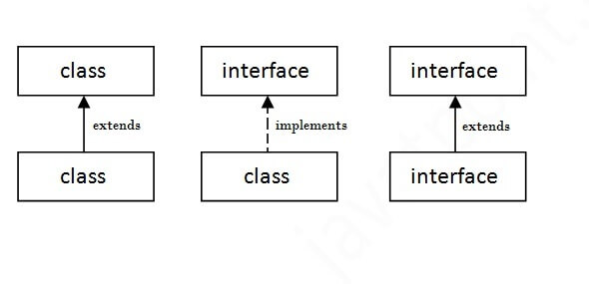
multiple inheritance is not supported in the case of class because of ambiguity. However, it is supported in case of an interface because there is no ambiguity. It is because its implementation is provided by the implementation class.
If a class implements multiple interfaces, or an interface extends multiple interfaces, it is known as multiple inheritance.
Package :
A java package is a group of similar types of classes, interfaces and sub-packages.
Package in java can be categorized in two form, built-in package and user-defined package.
Package inside the package is called the subpackage. It should be created to categorize the package further.

There are two types of modifiers in Java: access modifiers and non-access modifiers.
Access Modifiers :
private:
access level of a private modifier is only within the class. It cannot be accessed from outside the class.

Protected:
The access level of a protected modifier is within the package and outside the package through child class. If we do not make the child class, it cannot be accessed from outside the package.

Public:
The access level of a public modifier is everywhere. It can be accessed from within the class, outside the class, within the package and outside the package.

Default:
The access level of a default modifier is only within the package. It cannot be accessed from outside the package. If we do not specify any access level, it will be the default.

Access Modifier | within class | within package | outside package by subclass only | outside package
Private | Y | N | N | N
Default | Y | Y | N | N
Protected | Y | Y | Y | N
Public | Y | Y | Y | Y

Encapsulation in Java is a process of wrapping code and data together into a single unit

Advantage :
make the class read-only or write-only by providing getter and setter
control over the data
It is a way to achieve data hiding
easy to test. It is better for unit testing

Array :
array is an object which contains elements of a similar data type. Additionally, The elements of an array are stored in a contiguous memory location. It is a data structure where we store similar elements. We can store only a fixed set of elements in a Java array.

Advantages
Code Optimization: It makes the code optimized, we can retrieve or sort the data efficiently.
Random access: We can get any data located at an index position.

Disadvantages:
Size Limit:We can store only the fixed size of elements in the array. It doesn't grow its size at runtime. To solve this problem, collection framework is used in Java which grows automatically.

There are two types of array.
- Single Dimensional Array
- Multidimensional Array :data is stored in row and column based index (also known as matrix form).
Java supports the feature of an anonymous array, so you don't need to declare the array while passing an array to the method.
Common Exception in Array is ArrayIndexOutOfBoundsException
The Java Virtual Machine (JVM) throws an ArrayIndexOutOfBoundsException if length of the array in negative, equal to the array size or greater than the array size while traversing the array.

Jagged Array in Java
If we are creating odd number of columns in a 2D array, it is known as a jagged array. In other words, it is an array of arrays with different number of columns.
Int arr[][] = new int[3][];
arr[0] = new int[3];
arr[1] = new int[4];
arr[2] = new int[2];

Copying in a array :
public static void arraycopy(Object src, int srcPos,Object dest, int destPos,int length)

String:
string is basically an object that represents sequence of char values. An array of characters works same as Java string.

Java String class provides a lot of methods to perform operations on strings such as compare(), concat(), equals(), split(), length(), replace(), compareTo(), intern(), substring() etc.

java.lang.String class implements Serializable, Comparable and CharSequence interfaces.

CharSequence :
CharSequence interface is used to represent the sequence of characters. String, StringBuffer and StringBuilder classes implement it. It means, we can create strings in Java by using these three classes.

Java String is immutable which means it cannot be changed. Whenever we change any string, a new instance is created. For mutable strings, you can use StringBuffer and StringBuilder classes.

There are two ways to create String object:
- By string literal :
created by using double quotes
String s = “Siddhant”;
To make Java more memory efficient (because no new objects are created if it exists already in the string constant pool).
- By new keyword
String s = new String(“Siddhant”);
The String is immutable in Java because of the security, synchronization and concurrency, caching, and class loading. The reason of making string final is to destroy the immutability and to not allow others to extend it.
The String objects are cached in the String pool, and it makes the String immutable.
String constant pool is a special memory area. When we declare a String literal, the JVM creates the object in the pool and stores its reference on the stack. Before creating each String object in memory, the JVM performs some steps to decrease the memory overhead.

No. | Method | Description
1 | char charAt(int index) | It returns char value for the particular index
2 | int length() | It returns string length
3 | static String format(String format, Object... args) | It returns a formatted string.
4 | static String format(Locale l, String format, Object... args) | It returns formatted string with given locale.
5 | String substring(int beginIndex) | It returns substring for given begin index.
6 | String substring(int beginIndex, int endIndex) | It returns substring for given begin index and end index.
7 | boolean contains(CharSequence s) | It returns true or false after matching the sequence of char value.
8 | static String join(CharSequence delimiter, CharSequence... elements) | It returns a joined string.
9 | static String join(CharSequence delimiter, Iterable<? extends CharSequence> elements) | It returns a joined string.
10 | boolean equals(Object another) | It checks the equality of string with the given object.
11 | boolean isEmpty() | It checks if string is empty.
12 | String concat(String str) | It concatenates the specified string.
13 | String replace(char old, char new) | It replaces all occurrences of the specified char value.
14 | String replace(CharSequence old, CharSequence new) | It replaces all occurrences of the specified CharSequence.
15 | static String equalsIgnoreCase(String another) | It compares another string. It doesn't check case.
16 | String[] split(String regex) | It returns a split string matching regex.
17 | String[] split(String regex, int limit) | It returns a split string matching regex and limit.
18 | String intern() | It returns an interned string.
19 | int indexOf(int ch) | It returns the specified char value index.
20 | int indexOf(int ch, int fromIndex) | It returns the specified char value index starting with given index.
21 | int indexOf(String substring) | It returns the specified substring index.
22 | int indexOf(String substring, int fromIndex) | It returns the specified substring index starting with given index.
23 | String toLowerCase() | It returns a string in lowercase.
24 | String toLowerCase(Locale l) | It returns a string in lowercase using specified locale.
25 | String toUpperCase() | It returns a string in uppercase.
26 | String toUpperCase(Locale l) | It returns a string in uppercase using specified locale.
27 | String trim() | It removes beginning and ending spaces of this string.
28 | static String valueOf(int value) | It converts given type into string. It is an overloaded method.

String Builder :
Java StringBuilder class is used to create mutable (modifiable) String.
StringBuffer :
StringBuffer class is used to create mutable (modifiable) String objects.
String that can be modified or changed is known as mutable String. StringBuffer and StringBuilder classes are used for creating mutable strings

Difference :

No. | StringBuffer | StringBuilder
1) | StringBuffer is synchronized i.e. thread safe. It means two threads can't call the methods of StringBuffer simultaneously. | StringBuilder is non-synchronized i.e. not thread safe. It means two threads can call the methods of StringBuilder simultaneously.
2) | StringBuffer is less efficient than StringBuilder. | StringBuilder is more efficient than StringBuffer.
3) | StringBuffer was introduced in Java 1.0 | StringBuilder was introduced in Java 1.5

StringBuilder is faster and preferred over StringBuffer for the single-threaded program

Collections:
The Collection in Java is a framework that provides an architecture to store and manipulate the group of objects.
Java Collection means a single unit of objects. Java Collection framework provides many interfaces (Set, List, Queue, Deque) and classes (ArrayList, Vector, LinkedList, PriorityQueue, HashSet, LinkedHashSet, TreeSet).

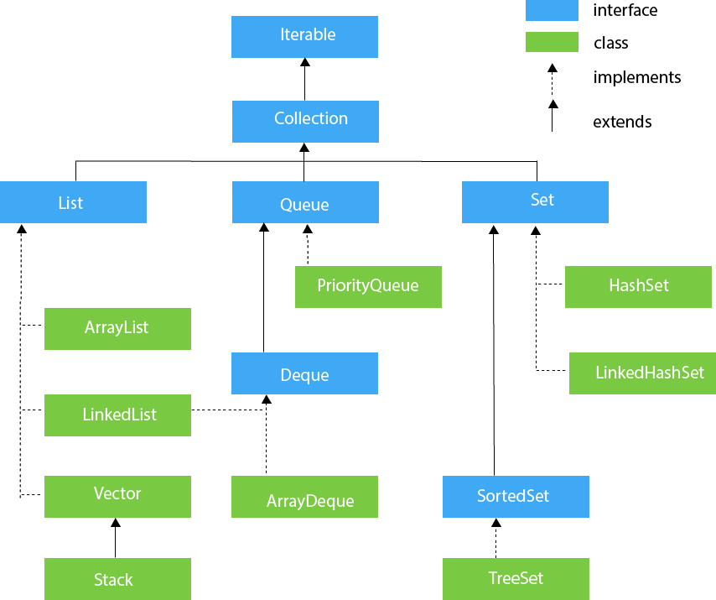

List interface is the child interface of Collection interface. It inhibits a list type data structure in which we can store the ordered collection of objects. It can have duplicate values.
List interface is implemented by the classes ArrayList, LinkedList, Vector, and Stack.
ArrayList :
uses a dynamic array to store the duplicate element of different data types. The ArrayList class maintains the insertion order and is non-synchronized.
LinkedList:
LinkedList implements the Collection interface. It uses a doubly linked list internally to store the elements. It can store the duplicate elements. It maintains the insertion order and is not synchronized.
Vector:
Vector uses a dynamic array to store the data elements. It is similar to ArrayList.
Stack :
The stack is the subclass of Vector. It implements the last-in-first-out data structure, i.e., Stack. The stack contains all of the methods of Vector class and also provides its methods like boolean push(), boolean peek(), boolean push(object o), which defines its properties.

ArrayList | LinkedList
1) ArrayList internally uses a dynamic array to store the elements. | LinkedList internally uses a doubly linked list to store the elements.
2) Manipulation with ArrayList is slow because it internally uses an array. If any element is removed from the array, all the bits are shifted in memory. | Manipulation with LinkedList is faster than ArrayList because it uses a doubly linked list, so no bit shifting is required in memory.
3) An ArrayList class can act as a list only because it implements List only. | LinkedList class can act as a list and queue both because it implements List and Deque interfaces.
4) ArrayList is better for storing and accessing data. | LinkedList is better for manipulating data.

Java HashSet
Java HashSet class is used to create a collection that uses a hash table for storage. It inherits the AbstractSet class and implements Set interface.
The important points about Java HashSet class are:
HashSet stores the elements by using a mechanism called hashing.
HashSet contains unique elements only.
HashSet allows null value.
HashSet class is non synchronized.
HashSet doesn't maintain the insertion order. Here, elements are inserted on the basis of their hashcode.
HashSet is the best approach for search operations.
The initial default capacity of HashSet is 16, and the load factor is 0.75.

Difference between List and Set
A list can contain duplicate elements whereas Set contains unique elements only.

Hierarchy of HashSet class
The HashSet class extends AbstractSet class which implements Set interface. The Set interface inherits Collection and Iterable interfaces in hierarchical order.
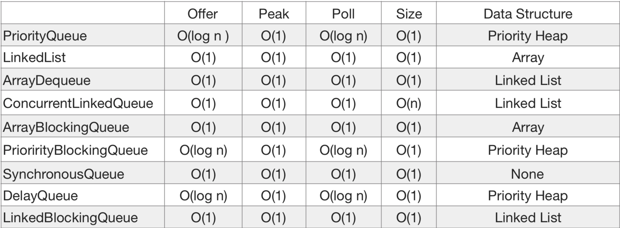

Exception Handling:
The Exception Handling in Java is one of the powerful mechanism to handle the runtime errors so that the normal flow of the application can be maintained.
In Java, an exception is an event that disrupts the normal flow of the program. It is an object which is thrown at runtime.
Exception Handling is a mechanism to handle runtime errors such as ClassNotFoundException, IOException, SQLException, RemoteException, etc.
The core advantage of exception handling is to maintain the normal flow of the application. An exception normally disrupts the normal flow of the application; that is why we need to handle exceptions.
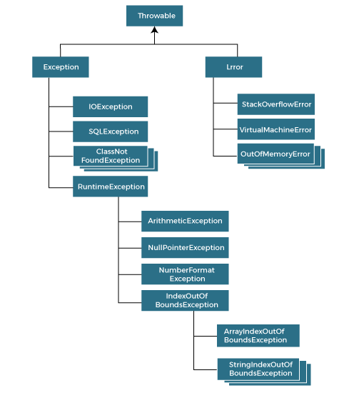

Types of Java Exceptions
There are mainly two types of exceptions: checked and unchecked. An error is considered as the unchecked exception.
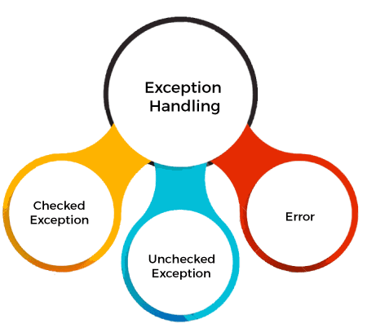

1) Checked Exception
The classes that directly inherit the Throwable class except RuntimeException and Error are known as checked exceptions. For example, IOException, SQLException, etc. Checked exceptions are checked at compile-time.

2) Unchecked Exception
The classes that inherit the RuntimeException are known as unchecked exceptions. For example, ArithmeticException, NullPointerException, ArrayIndexOutOfBoundsException, etc. Unchecked exceptions are not checked at compile-time, but they are checked at runtime.

3) Error
Error is irrecoverable. Some example of errors are OutOfMemoryError, VirtualMachineError, AssertionError etc.

Keyword | Description
try | The "try" keyword is used to specify a block where we should place an exception code. It means we can't use try block alone. The try block must be followed by either catch or finally.
catch | The "catch" block is used to handle the exception. It must be preceded by try block which means we can't use catch block alone. It can be followed by finally block later.
finally | The "finally" block is used to execute the necessary code of the program. It is executed whether an exception is handled or not.
throw | The "throw" keyword is used to throw an exception.
throws | The "throws" keyword is used to declare exceptions. It specifies that there may occur an exception in the method. It doesn't throw an exception. It is always used with method signature.

Internal Working of Try Catch block:
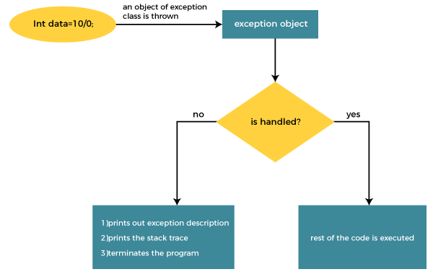
Sometimes a situation may arise where a part of a block may cause one error and the entire block itself may cause another error. In such cases, exception handlers have to be nested.
Java finally block is a block used to execute important code such as closing the connection, etc.
Java finally block is always executed whether an exception is handled or not. Therefore, it contains all the necessary statements that need to be printed regardless of the exception occurs or not.
The finally block follows the try-catch block.

Why use Java finally block?

finally block in Java can be used to put "cleanup" code such as closing a file, closing connection, etc.The important statements to be printed can be placed in the finally block.
Used Finally:
c1 : When an exception does not occur
c2 : When an exception occurr but not handled by the catch block
c3 : When an exception occurs and is handled by the catch block
For each try block there can be zero or more catch blocks, but only one finally block.
The finally block will not be executed if the program exits (either by calling System.exit() or by causing a fatal error that causes the process to abort).
The throw and throws is the concept of exception handling where the throw keyword throw the exception explicitly from a method or a block of code whereas the throws keyword is used in signature of the method.

S. No. | Key Difference | throw | throws
1. | Point of Usage | The throw keyword is used inside a function. It is used when it is required to throw an Exception logically. | The throws keyword is used in the function signature. It is used when the function has some statements that can lead to exceptions.
2. | Exceptions Thrown | The throw keyword is used to throw an exception explicitly. It can throw only one exception at a time. | The throws keyword can be used to declare multiple exceptions, separated by a comma. Whichever exception occurs, if matched with the declared ones, is thrown automatically then.
3. | Syntax | Syntax of throw keyword includes the instance of the Exception to be thrown. Syntax wise throw keyword is followed by the instance variable. | Syntax of throws keyword includes the class names of the Exceptions to be thrown. Syntax wise throws keyword is followed by exception class names.
4. | Propagation of Exceptions | throw keyword cannot propagate checked exceptions. It is only used to propagate the unchecked Exceptions that are not checked using the throws keyword. | throws keyword is used to propagate the checked Exceptions only.

Final
- It is a keyword.
- It is used to apply restrictions on classes, methods and variables.
- It can’t be inherited.
- It can’t be overridden.
- Final methods can’t be inherited by any class.
- It is needed to initialize the final variable when it is being declared.
- Its value, once declared, can’t be changed or re-initialized.

Finally
- It is a block.
- It is used to place important code in this block.
- It gets executed irrespective of whether the exception is handled or not.

Finalize
- It is a method.
- It is used to perform clean up processing right before the object is collected by garbage collector.

Garbage Collection :
In Java destruction of object from memory is automatically by the JVM
No Delete Keyword in Java
When there no reference to an object then that object is assumed to be no longer needed and the memory occupied by the object is released
This technique is called Garbage Collection accomplished by the JVM.
JVM Threads:
whenever we run a java program JVM creates three threads
main Thread : main task is to execute main() method
Thread Scheduler : is to schedule the threads(like OS)
Garbage Collector Thread : it is to sweep out abandoned objects from the heap memory
in this three threads main thread is a user thread and remaining two are daemon threads which run in background
Abandoned Object or dead object are those objects which does not have live reference.

Finalize method() :
Garbage Collector Thread before sweeping out an abandoned object , it calls finalize method of that object.
After finalize() method is executed , object is destroyed from the memory
use if object work is pending

gc()
We can call garbage collector explicitly using System.gc() or RunTime.getRunTime().gc().
But it is just a request to gc not a command
it is up to gc to honor this request

Regex :
it is regular expression java
A Regular Expression is a sequence of characters that constructs a search pattern. When we search for data in a text. We can use this search pattern to describe what we looking for.
Ex. :
^[a-z0-0_-]{3,15}$
^ : start of line
a-z0-9_- : letters numbers underscores hyphens
3,15 : 3 to 15 characters long
$ : end of line
JAVA Regex is an API which is used to define a pattern for searching or manipulating Strings. It is widely used to define the constraint on Strings such as password and email validation.
Matcher Class: used to performs the match operations on character sequence
boolean matches() : test whether the given regular expression matches or not
boolean find() : used to find the next expression that matches the pattern
boolean find(int start) : searches the next expression from the given start number
String group() : used to return the matched sequence
int start() : returns the starting index
int end() : returns the ending index
int groupCount() : returns the total number of the matched sequence

Pattern Class : compiled version of RE which is used to define pattern regex
Static Pattern compile(String regex) : it complies the given regex and returns the instance of a pattern
Matcher matcher(charSequence input) : used to create a matcher that matches the given input with the pattern
Static boolean matches(String regex) : it works as a combination of compile and matcher methods
String split[] : used to split the given string around matches of a given pattern
String pattern() : helps to return the regex pattern
int end() : returns the ending index
if we looking for .xx. In string AxxB it returns true but if we searche in Axbx it return false

Regex Character class :
[abc] : a,b or c (A simple class)
[^abc] : any class except a,b or c(negation)
[a-zA-Z] : A through Z or a through z inclusive(Range)
[a-d[m-p]] : a through d or m through p (union)
[a-z && [def]] : d,e, or f (intersection)
[a-z &&[^bc]] : A through z except b or c (Substraction)
[a-z && [^m-p]] : A through z and not m through p (Subtraction)

Regex Quantifiers:
x? : x occurs once or not at all
x+ : x occurs more than one time
x* : x occurs zero or more times
x{n} : x occurs n times only
x{n, } : x occurs n or more times only
x{y,z} : x occurs at least y times but less than z times

Regex Meta Characters :
. : it can be any character
d : represents any digits
D : Represents any non digit
s : Represents any white space
S: non white space character
w : word character
W: non word character
b : represents word boundary
B: represents non word boundary

JUNIT:
Testing is a process of checking functionality of an application to ensure code runs according to our requirements or not.

Functional Testing, Non-Functional Testing, Regression, Unit, Black Box,White Box etc
Junit is main method of unit testing
unit testing
we need to write test case as a developer to ensure that code works as it is expected
for each to check one condition at a time
Helps Software developer to write proper code without any errors to avoid surprises
Junit test type : Manual and Automate
Manual is all test case without any tool , Time Consuming , Huge labour, Error rate is high, depends on developer
Automate : very fast, not time consuming, no huge labour, not dependent on SD, Error Free, Easy to programmer
Unit test must have
one positive case
one negative case
Junit is a testing framework which helps automate all test case
Plays a important role in test driven development
(Test it write it)
Regression testing is a type of black box testing and black box testing means we are only concerned with input the output and not the functionality. It helps to verify of the new or altered code

Junit offers
Annotations
Assert
Test Suite
Exception test
Annotations:
Special form of syntactic metadata that can be added to the java source code for better code readability

@Test – tells the Junit that the public void method which it is attached to can be run as a test case.
@BeforeEach – the method to be run before each test method
@AfterEash – run after each test method
@BeforeAll – it is to be run once before any the test method in the class
@AfterAll – it is to be run after all tests are executed in test class used to perform clean-up activities
@Ignore – it will ignore the test and will not execute specific test tagged

