Stock Price Prediction Minor Project Report
Chronological Evaluation with Ridge Regression

Prepared by Siddhant
Minor Project
Dataset AAPL daily closing prices
Verified period 2020-01-02 to 2024-12-31
Repository https://github.com/Siddhantkr07/ML-Minor

Abstract
This project evaluates whether a regression model can forecast the next trading day's closing price from recent price history. Daily AAPL closing-price data from 2020-01-02 to 2024-12-31 was retrieved through Yahoo Finance using yfinance. The experiment builds lag, return, and rolling-window features, then reserves the newest 20 percent of eligible observations as a chronological holdout set. Ridge Regression achieved a mean absolute error of 2.3132, root mean squared error of 3.0384, and R-squared of 0.9858. The naive persistence baseline achieved a lower mean absolute error of 2.1306, showing that a simple next-close assumption remained the stronger benchmark for this run. The result is reported as an educational forecasting experiment and not as investment advice.

Problem Statement
The objective is to predict the closing price one trading day ahead using information available at the end of the current trading day. The project treats this as a time-series regression task and evaluates the model only on data that occurs after the training period.

Project Objectives
- Retrieve and validate historical daily closing-price data.
- Create time-aware features without using future prices as inputs.
- Train a reproducible Ridge Regression pipeline.
- Evaluate the model against a chronological holdout set and a naive benchmark.
- Produce a chart, metrics, saved model, and reusable project documentation.

Dataset
The verified run uses Apple Inc. daily historical price data with ticker AAPL. The data loader accepts either Yahoo Finance downloads or a local CSV with Date and Close columns. For the verified experiment, the close series was sorted chronologically, duplicate dates were removed while retaining the final occurrence, non-numeric values were discarded, and positive close values were required.
Attribute | Verified value
Data source | Yahoo Finance through yfinance
Ticker | AAPL
Observed date range | 2020-01-02 to 2024-12-31
Trading-day observations | 1258
Close price range | 56.09 to 259.02
Mean close price | 154.11

Feature Engineering
Each model row uses values available at the end of that row's date. The target is shifted one trading day forward, so the model learns to estimate the following close. Rows without enough history for every required feature are excluded from model fitting.
Feature group | Variables used
Current price | Current closing price
Lagged price | 1, 2, 3, 5, 10, and 20 trading-day lags
Momentum | Daily percentage return
Rolling statistics | 5, 10, and 20-day mean and standard deviation
Relative price | Distance from each rolling mean

Model and Evaluation Design
The fitted pipeline performs median imputation, standard scaling, and Ridge Regression with alpha equal to 1.0. The newest 20 percent of complete rows is held out as the test set. A chronological split is essential for time series because training on later observations would make the forecast evaluation unrealistically optimistic. The baseline predicts that the next closing price will equal the current closing price.
Experiment setting | Verified value
Forecast horizon | 1 trading day
Training rows | 989
Test rows | 248
Primary model | Median imputation + StandardScaler + Ridge Regression
Comparison model | Naive persistence baseline

Results
The table below reports out-of-sample performance on the final chronological holdout period. Lower MAE and RMSE are better; higher R-squared is better.
Model | MAE | RMSE | R-squared
Ridge Regression | 2.3132 | 3.0384 | 0.9858
Naive persistence | 2.1306 | 2.8970 | 0.9871

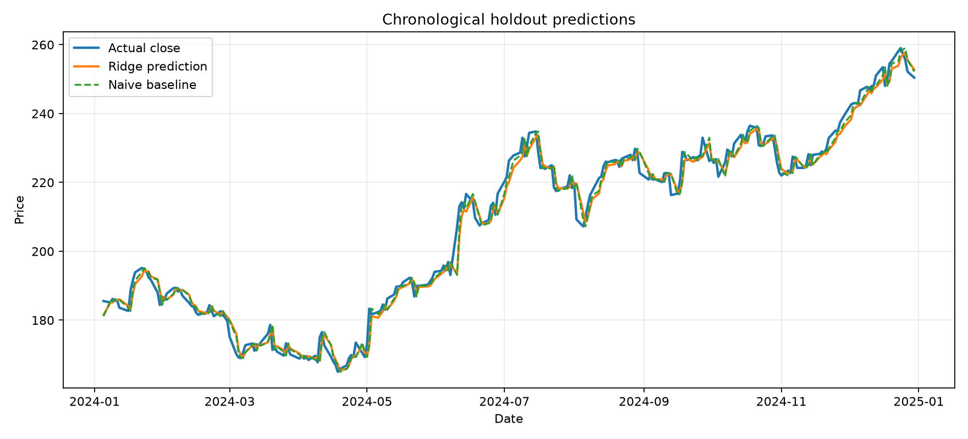
Figure 1. Chronological holdout predictions for AAPL.

Discussion
The Ridge model follows the broad movement of the actual closing-price series and achieves a high R-squared on this holdout period. However, the naive persistence baseline has lower MAE and RMSE and a slightly higher R-squared. This means the more complex model did not improve on simply using the current close as the next-close prediction for this particular experiment. Reporting this comparison is important because it prevents an overstatement of forecasting capability.

Limitations
- Only historical closing prices are used; the model has no news, earnings, fundamentals, macroeconomic, or intraday inputs.
- The result is based on one asset and one holdout period, so it may not generalize to other stocks or market conditions.
- The evaluation does not include trading costs, risk management, or portfolio performance.
- Forecasts are uncertain and must not be used as investment advice or an automated trading signal.

Reproducibility
The source code, tests, data documentation, model card, and report are available in the project repository. The following command reproduces the verified experiment from the project root after dependencies are installed:
$env:PYTHONPATH = "src"
.\.venv\Scripts\python.exe -m stock_predictor.cli train --ticker AAPL --start 2020-01-01 --end 2025-01-01
Each run writes the cleaned price history, data summary, holdout predictions, chart, metrics, and trained model to the local artifacts directory.

Conclusion
This project delivers a reproducible next-day stock-price forecasting workflow with data validation, leakage-aware feature construction, chronological evaluation, automated tests, and documented results. The verified AAPL run shows that Ridge Regression can closely track price movement, while the naive baseline remains stronger on the selected holdout metrics. Future work should use walk-forward validation, multiple assets, and carefully validated additional predictors.

References
- Yahoo Finance data accessed through yfinance. https://github.com/ranaroussi/yfinance
- scikit-learn Ridge Regression documentation. https://scikit-learn.org/stable/modules/generated/sklearn.linear_model.Ridge.html
- Hyndman, R. J., and Athanasopoulos, G. Forecasting Principles and Practice. https://otexts.com/fpp3/tscv.html
- Project repository. https://github.com/Siddhantkr07/ML-Minor

