BCA VI Semester – Project Synopsis
TaskFlow
Web Based Task, Notes & Event Management System
with Peer-to-Peer Task Assignment & Delegation

Frontend: React + Vite | Backend: Node.js + Express | Database: MySQL | Mobile: React Native
Project Title | TaskFlow – Web Based Task, Notes & Event Management System
Degree / Course | Bachelor of Computer Applications (BCA) – VI Semester
Submitted by | Siddhant Pal | Shubham Mendhe
Guided by | Dr. Sunita Dwivedi | Dr. Arvind Singh Rajput
Academic Year | 2024–25
Technology Stack | React + Vite, Node.js, Express, MySQL, React Native

Table of Contents
1. Introduction
2. Problem Statement
3. Proposed Solution
4. Objectives of the Project
5. Scope of the Project
6. Methodology
7. Target System & Market
8. ER Model
9. Use Case Diagram
10. Data Flow Diagram (DFD)
11. Features of the System
12. Impact of the Project
13. Limitations
14. Future Scope

1. Introduction
TaskFlow is a web-based task, notes, and event management system that enables any user to assign tasks to others, accept tasks from peers, and delegate sub-tasks further down the chain — creating a flexible, hierarchy-free collaboration model.
Unlike traditional role-locked systems (where only an 'Admin' can assign tasks), TaskFlow gives every user the power to be an Assigner, a Recipient, or both — depending on the context. A single user can receive a task from their manager, break it down, and delegate sub-tasks to teammates. The full delegation chain is stored and visible to all involved parties.
The system also includes personal productivity tools — personal to-do lists, notes management, and event scheduling — making it a complete one-stop workspace for individuals and teams alike.

Key Highlights
- Peer-to-Peer Assignment: Any registered user can assign a task to any other user — no fixed role required.
- Delegation Chains: A recipient can sub-assign tasks further, forming a traceable delegation tree.
- Full Task Lifecycle: Tasks move through: Assigned → Accepted → In Progress → Completed, with notifications at each step.
- Personal Workspace: Every user has personal Todos, Notes, and Events integrated into the same platform.
- Smart Notifications: Email (NodeMailer) and mobile push (Firebase FCM) notifications for all task events.

2. Problem Statement
Students and small organizations commonly rely on WhatsApp, notebooks, or disconnected apps to manage and share work. This informal approach creates several real and measurable problems:
- No Unified Assignment System: There is no easy way for one person to formally assign a task to another and track its completion. Assignments made over chat are easily lost or forgotten.
- No Delegation Support: When a person wants to pass on a task they received, there is no structured way to do so. It gets lost in message threads with no record of who is responsible.
- Zero Accountability: Without a system, no one can verify who is responsible for a task, whether it was accepted, or if it was completed. There is no audit trail.
- Disconnected Tools: Tasks, notes, events, and reminders are spread across different apps (WhatsApp, Google Keep, Calendar, etc.) with no integration or central view.
- No Automated Notifications: There is no automated way to notify someone that a task was assigned, updated, accepted, or completed. All follow-ups are manual.
- No Work History: Past tasks, completed work, and delegation chains are invisible — no report or audit trail exists for past activity.

3. Proposed Solution
We propose TaskFlow — a peer-to-peer task management platform where any user can assign, accept, complete, or delegate tasks. The solution removes fixed role restrictions and makes task flow natural, structured, and fully trackable.
- Peer Task Assignment: Any registered user can create a task and assign it to any other user in the system with title, description, priority (High/Medium/Low), and due date.
- Task Delegation Chain: A recipient can further delegate the task (or create a sub-task from it) to another user. That user can delegate again. The full delegation path is recorded as a tree structure using a parent_task_id foreign key in the Task table.
- Accept / Complete Workflow: Recipients can explicitly accept a task (acknowledging responsibility), mark it in-progress, and mark it complete. The original assigner is notified at each stage.
- Personal Productivity Tools: Every user also has a private workspace — personal to-do list, notes editor, and event scheduler with reminder dates — all within the same platform.
- Notifications – Email & Mobile Push: NodeMailer sends automated emails for all task events (assignment, delegation, acceptance, completion). Firebase Cloud Messaging (FCM) delivers push notifications to the React Native mobile app in real time.
- Dark / Light Mode & Calendar View: The interface supports dark/light theme switching and a visual calendar view showing tasks, deadlines, and events in a monthly/weekly layout.

4. Objectives of the Project
The objective of TaskFlow is to build a flexible, peer-driven task management system where any user can assign, accept, and delegate tasks without the constraints of a fixed role hierarchy. The primary goals are:
- Peer-to-Peer Task Assignment: To allow any user to assign a task to any other user in the system without needing a predefined role or administrative permission.
- Multi-Level Delegation: To support task delegation chains where a recipient can further delegate the task to another user, with full tracking of the delegation path using a parent_task_id reference in the database.
- Accept & Complete Workflow: To implement a clear task lifecycle — Assigned → Accepted → In Progress → Completed — so both the assigner and recipient can monitor the status at every stage.
- Personal Productivity: To provide every user with personal task management (Todos), Notes, and Event scheduling in a single unified platform, eliminating the need for separate apps.
- Smart Notifications: To send real-time notifications via email (NodeMailer) and mobile push (Firebase FCM) whenever a task is assigned, delegated, accepted, or completed.
- Transparency & Accountability: To maintain a full audit trail of every task — who created it, who it was delegated to, what the current status is, and when each status change occurred.
- User-Friendly Interface: To deliver a responsive, accessible web and mobile interface with dark/light mode toggle and a visual calendar view for managing tasks and events.

5. Scope of the Project

5.1 Functional Scope
- User Authentication: Secure registration and login for all users. Each user has a profile with name, email, and hashed password.
- Task Assignment: Any user can create a task and assign it to any other registered user with title, description, priority, and due date.
- Delegation Support: A task recipient can delegate the task (or create a sub-task) to another user. The full delegation chain is recorded.
- Task Lifecycle Management: Tasks move through statuses — Pending → Accepted → In Progress → Completed. Assigners can monitor status in real time.
- Personal Todos: Users can manage their own private to-do list independent of assigned tasks.
- Notes Management: Create, edit, and delete personal notes for quick reference or documentation.
- Event Scheduling: Add personal events with date, time, and optional reminder alerts.
- Notification System: In-app, email (NodeMailer), and mobile push (FCM) notifications for all task events.
- Dark / Light Mode: UI theme switching for user comfort, stored in user preferences.
- Visual Calendar View: A calendar showing all tasks, deadlines, and events in monthly/weekly views.

5.2 Non-Functional Scope
- Security: JWT-based authentication with bcrypt password hashing. Each user can only access their own tasks and data.
- Usability: Clean, intuitive web interface with a dark/light mode toggle and responsive layout for both desktop and mobile.
- Reliability: Consistent CRUD operations with database-level integrity constraints to prevent data loss or corruption.
- Notification Delivery: Email via SMTP (NodeMailer) and mobile push via Firebase Cloud Messaging (FCM).
- Scalability: Modular REST API design allows easy addition of new features like reporting, file attachments, or collaboration tools.
- Performance: Optimized database queries and efficient API responses for a smooth user experience.
- Auditability: Full delegation chain stored in the database — every assignment and delegation is logged with timestamps.

6. Methodology
The project is developed iteratively — starting with a working core and adding features one at a time. Each module is built, tested, and verified before the next one begins. This approach keeps the scope manageable and ensures each component is stable before integration.

Development Steps
- Step 1 – Plan & Design: Define what the system should do. Draw ER diagram, flow diagrams, and sketch the UI screens. Finalize the database schema and API endpoints before writing any code.
- Step 2 – Build the Database: Create MySQL tables for Users, Tasks (with parent_task_id for delegation), Notes, Events, and Notifications based on the finalized ER model.
- Step 3 – Build the Backend: Create REST APIs using Node.js + Express for all features — authentication, task assignment, delegation, notes, events, and notification dispatch (email + push).
- Step 4 – Build the Frontend: Build the web interface using React + Vite and connect it to the backend APIs. Implement dark/light mode toggle and visual calendar view. Develop the React Native mobile app with push notification support.
- Step 5 – Test & Fix: Test each feature individually (unit testing), then test the system as a whole (integration testing). Verify the full delegation chain, notification delivery, and all user flows work correctly.

7. Target System & Market
TaskFlow is designed for real-world environments where people need to assign, delegate, and track tasks without the overhead of complex enterprise software. The system fills the gap between simple to-do apps and heavyweight project management tools like Jira or Asana.

Primary Target Users
- Students & Project Groups: College students working on group projects who need to assign modules, track who is doing what, and follow up on completion — without needing a formal org structure.
- Small Teams & Startups: Teams of 5–50 people where a manager needs to assign tasks, a team member can delegate to a junior, and everyone can track progress in one place.
- Freelancers & Solopreneurs: Individuals who manage their own work and occasionally assign tasks to collaborators or contractors with clear deadlines and status tracking.

Market & Relevance
- The global task management software market is valued at over $4 billion and growing rapidly, showing high demand for such tools.
- TaskFlow fills the gap between overly simple to-do apps (Todoist) and overly complex project management tools (Jira, Asana).
- The peer-to-peer delegation model is unique — no fixed hierarchy means the system adapts to any team structure.
- With notifications on both web and mobile, TaskFlow ensures users stay informed without needing to constantly check the app.

8. ER Model – Entity Relationship Diagram
The Entity-Relationship (ER) Diagram models all data entities in the TaskFlow system and defines their attributes and relationships. It forms the blueprint for the MySQL database schema.

Entities & Attributes
Entity | Primary Key | Other Attributes
USER | user_id | name, email, password_hash, created_at
TASK | task_id | title, description, status, priority, due_date, parent_task_id (FK→Task), assigned_by (FK→User), assigned_to (FK→User), created_at
NOTE | note_id | title, content, created_by (FK→User), created_at
EVENT | event_id | title, description, event_date, reminder_date, created_by (FK→User), created_at
NOTIFICATION | notif_id | user_id (FK→User), task_id (FK→Task), type [email/push], sent_at

Relationships
- USER assigns TASK (1:N): One user can assign many tasks to other users.
- USER delegates TASK (1:N): One user can delegate many tasks, forming a delegation chain.
- TASK self-references for delegation: The parent_task_id field in TASK points to the parent task, creating a delegation tree.
- USER creates NOTE (1:N): One user can create many personal notes.
- USER creates EVENT (1:N): One user can create many calendar events.
- TASK triggers NOTIFICATION (1:N): Each task action (assign/delegate/accept/complete) triggers one or more notifications.

ER Diagram
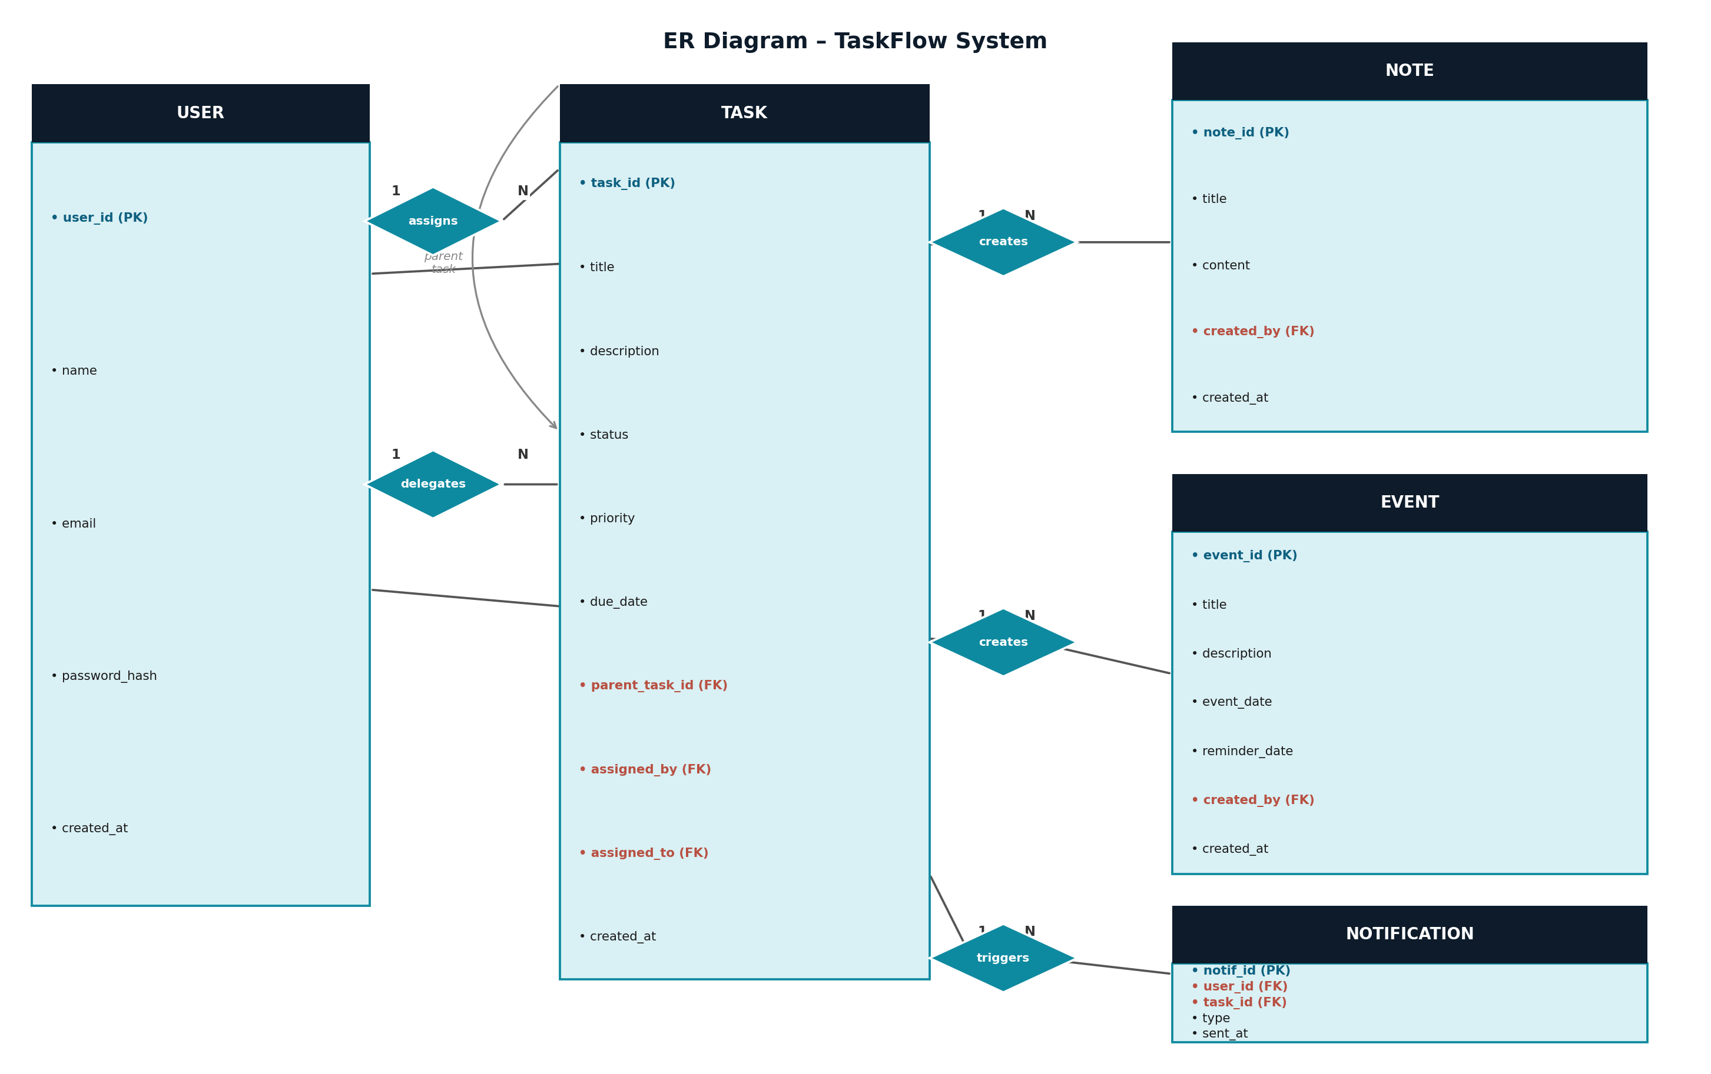

9. Use Case Diagram
In TaskFlow, every user can play multiple roles depending on context. The same person can be an Assigner for one task and a Recipient for another. There are no fixed roles assigned at registration — the role emerges from the action.

Actors & Use Cases
ASSIGNER | RECIPIENT | DELEGATE
- Register / Login  - Create & assign task  - Set priority & due date  - Track task status  - View delegation chain  - Receive completion alert | - Register / Login  - View assigned tasks  - Accept or decline task  - Mark task in-progress  - Mark task complete  - Get email/push notification | - All Recipient actions  - Create sub-task from task  - Assign sub-task to others  - Monitor sub-task progress  - Chain tracked to original  - Notify original assigner

All users also share common personal use cases: Manage Personal Todos · Create Notes · Add Events · Toggle Dark/Light Theme · View Calendar.

10. Data Flow Diagram (DFD)
The Data Flow Diagram shows how data flows between external actors (Assigner, Recipient, Delegate) and the internal processes of the TaskFlow system, and where that data is stored.

DFD Components
- External Entities: Assigner – creates and sends tasks to others. Recipient – receives, accepts, and completes tasks. Delegate – sub-assigns received tasks to another user.
- Processes: P1: User Authentication · P2: Task Assignment · P3: Delegation Management · P4: Notes Management · P5: Event Management · P6: Notification Dispatch (Email + Push)
- Data Stores: D1: User DB · D2: Task DB (with parent_task_id for delegation chain) · D3: Notes DB · D4: Event DB · D5: Notification DB
- Key Data Flows: Login credentials → P1 Auth → D1 User DB · Task data → P2 Task Assign → D2 Task DB · Delegation request → P3 → D2 Task DB · P6 Notifications → Email SMTP + FCM → Recipient's device

DFD – Visual Diagram
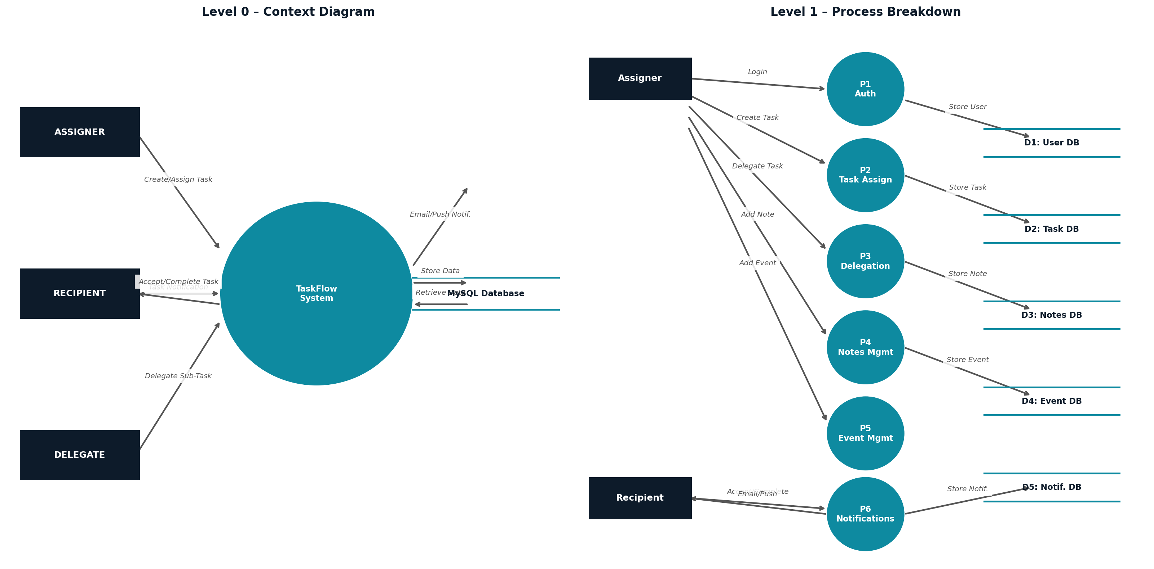

11. Features of the System

11.1 Task Management Features
- Assign Task: Any user can create a task with title, description, priority (High/Medium/Low), and due date, and assign it to any other registered user.
- Delegate Task: A recipient can forward the task or create a sub-task from it and assign it to another user. The delegation chain is stored using parent_task_id and is visible to all stakeholders.
- Accept / Decline Task: Recipients can explicitly accept a task (acknowledging responsibility) or decline with a reason. Assigners are notified of the recipient's response immediately.
- Mark In-Progress & Complete: Recipients can update task status to In-Progress when they start work, and Complete when done. The assigner receives a notification at each status change.
- Delegation Chain View: All users involved in a delegation chain can view the full tree — from original assigner to current holder — giving everyone full transparency.

11.2 Personal Productivity Features
- Personal Todos: Users can manage their own private to-do list — create, edit, delete, and mark tasks complete — independent of assigned tasks.
- Notes Manager: Create, edit, and delete personal notes with titles and rich content for quick reference and documentation.
- Event Scheduler: Schedule events with date, time, description, and optional reminder date. Events appear in the visual calendar view.
- Visual Calendar View: A monthly/weekly calendar view showing all tasks (by due date) and events, built using the FullCalendar library.
- Dark / Light Mode: UI theme switching using React context and CSS variables. User preference is saved and persists across sessions.

11.3 Notification Features
- Email Notifications (NodeMailer): Automated emails are sent when a task is assigned, delegated, accepted, or completed. Emails include task details and a link to view the task in the app.
- Mobile Push Notifications (Firebase FCM): Real-time push alerts are delivered to the React Native mobile app via Firebase Cloud Messaging whenever a task action occurs — even when the app is in the background.

12. Impact of the Project
TaskFlow addresses real inefficiencies in how students and small teams coordinate work, replacing informal, unreliable methods with a structured, accountable system.
- Eliminates Informal Task Sharing: Replaces WhatsApp/chat-based task sharing with a structured system where nothing falls through the cracks.
- Full Accountability: Every task has a clear owner, a status, and a full history. No more ambiguity about who is responsible for what.
- Flexible Delegation: A manager can assign a large task, a team member can split and sub-assign it — exactly mirroring real-world delegation without requiring a rigid org chart.
- One Platform for Everything: Todos, notes, events, and task assignments are all in one place. No more switching between five different apps.
- Instant Awareness: Email and push notifications ensure users are immediately informed of task changes without manually checking the app.
- Transparent Chain of Work: The delegation tree is visible to all stakeholders, making it easy to spot bottlenecks and understand task flow.

13. Limitations of the Project
The current version of TaskFlow has the following known limitations:
- No Real-Time Collaboration: Users cannot simultaneously edit the same task or note. There is no live co-editing feature in this version.
- No In-App Chat: There is no built-in comment thread or messaging on tasks. Users must communicate outside the platform.
- Basic Reporting: Task completion can be viewed per user but there are no downloadable PDF/Excel reports in the current version.
- No File Attachments: Users cannot attach files, images, or documents directly to tasks or notes.
- Internet Required: The system requires an active internet connection. There is no offline mode or data sync.
- Delegation Depth: While delegation chains are supported architecturally, very deep chains (5+ levels) may be complex to visualize clearly in the current UI.

14. Future Scope of the Project
The following features and enhancements are planned for upcoming versions of TaskFlow. Several of these are technically straightforward and can be added within a semester.
- Real-Time Collaboration & Live Co-Editing: Using Socket.io (standard Node.js library), users will see live status updates, comment on tasks in real time, and collaborate on shared notes without page refreshes. Estimated effort: 1–2 weeks.
- In-App Chat on Tasks: A comment/chat thread attached to each task so assigners, recipients, and delegates can communicate without leaving the platform. Built on the same Socket.io infrastructure.
- PDF & Excel Reporting: Generate downloadable task completion reports per user or team. pdfkit (PDF) and exceljs (Excel) are easy-to-integrate Node.js libraries. Estimated effort: 2–3 days.
- Dark / Light Mode Toggle: UI theme switching using React context and CSS variables is already planned in the current design and will be one of the first features implemented.
- Visual Calendar View: A monthly/weekly calendar interface showing all tasks (by due date) and events, built using the FullCalendar library for React.
- File Attachments in Tasks: Allow users to upload documents or images as attachments to tasks and notes, stored via cloud storage (AWS S3 or Cloudinary).
- AI Task Suggestions & Delegation Hints: Use task history and workload data to suggest the best person to delegate to and recommend realistic due dates based on past completion patterns.
- Multi-Organization Support: Allow multiple separate organizations to use TaskFlow with isolated data environments, enabling the system to serve as a SaaS product.

Conclusion
TaskFlow is a simple, complete, and academically sound project that addresses a real problem faced by students and small teams every day. By removing fixed role constraints and implementing a peer-to-peer task assignment model with full delegation support, TaskFlow mirrors how work actually flows in the real world.
The system is built on modern, industry-standard technologies (React, Node.js, MySQL, React Native) and covers all key phases of software development — from ER design and DFD to implementation and testing. It is fully implementable within a single semester with a clear path for future enhancements.

"Perfect Execution > Big Dreams"

Submitted by: Siddhant Pal | Shubham Mendhe
Under the Guidance of: Dr. Sunita Dwivedi | Dr. Arvind Singh Rajput
Course: Bachelor of Computer Applications (BCA) – VI Semester, 2024–25

