PROJECT REPORT

ON

MentDeck

##### SUBMITTED BY:

(Abhinav Bajpai 201500011)

(Siddhant Pathak 201500688)

(Abhi Maheshwari 201500010)



DEPARTMENT OF COMPUTER SCIENCE AND ENGINEERING

##### INSITUTE OF ENGINNERING & TECHNOLOGY

**GLA UNIVERSITY, MATHURA**





#### **DECLARATION**

I would like to express my special thanks of gratitude to my project guide **Mr. Bhanu Kapoor** sir who gave me the golden opportunity to do this wonderful project called, **MentDeck** , which also helped us in doing a lot of research and we came to know about so many new things. We are really thankful to them.

Secondly, we would also like to thank my parents and friends who helped me a lot in finalizing this project within the limited time frame.

Candidate’s Names:

**Abhinav Bajpai 201500011**

**Siddhant Pathak 201500688**

**Abhi Maheshwari 201500010**

#### **CERTIFICATE**

This is to certify that the above statements made by the candidates are correct to the best of my/our knowledge and belief.

**Project Supervisor**

Mr. Bhanu Kapoor

Assistant Professor

Date: 25-Nov-2022

**Table of Content**

**1. Introduction**

1.1 Overview …………………………….

1.2 Objective.…………………..…………

**2. Technology Used**

2.1 JAVA ……………………….………….

2.2 CSS………………………………………

2.3 BOOTSTRAP……………………………

2.4 PHP………………………………………

**3. System Requirements**

3.1 Software Required………………….………

3.2 Hardware Required……….……………………...

**4. Implementation**

4.1 Explanation of Source Code……………………......

4.2 Final Code …………………….................................

4.3 Output……………………………………………....

**5. Conclusion**

**INTRODUCTION**

Mental health is a level of psychological well-being or an absence of mental illness. It's the psychological state of someone who is functioning at a satisfactory level of emotional and behavioral adjustment.

It includes subjective well-being, perceived self-efficacy, autonomy, competence, intergenerational dependence, and self-actualization of one's intellectual and emotional potential, among others.

This list compiles several self-help resources we've personally found useful for a range of mental health problems, but in no way are they a replacement for professional help, psychotherapy or pharmacotherapy. We're not experts, and even if we were, most of these tools are meant as an aid to therapy, not as a substitute.

The idea is to create a platform for the people dealing with such issues to come forward and discuss openly about their issues and will be provided with every possible help. This platform will help people discuss and get help from the comfort of their home without any need to go out in public and discuss it.

#### **WEB DEVELOPEMENT:**

Web development refers to the process of creating websites on the Internet.

The term “Web Development” is relatively broad in its application. You could create a single website page from a wix template, or you could painstakingly develop a massive website with thousands of original pages — and technically, both of those would count as web development.

Nowadays web development is the thing which is in boost.

**TECHNOLOGY USED**

**HTML:**

HTML is an acronym which stands for **Hyper Text Markup Language** which is used for creating web pages and web applications. Let's see what is meant by Hypertext Markup Language, and Web page.

**HyperText:** HyperText simply means "Text within Text." A text has a link within it, is a hypertext. Whenever you click on a link which brings you to a new webpage, you have clicked on a hypertext. HyperText is a way to link two or more web pages (HTML documents) with each other.

**Markup language:** A markup language is a computer language that is used to apply layout and formatting conventions to a text document. Markup language makes text more interactive and dynamic. It can turn text into images, tables, links, etc.

**Web Page:** A web page is a document which is commonly written in HTML and translated by a web browser. A web page can be identified by entering an URL. A Web page can be of the static or dynamic type. **With the help of HTML only, we can create static web pages**.

**CSS:**

CSS stands for Cascading Style Sheets. It is a style sheet language which is used to describe the look and formatting of a document written in markup language. It provides an additional feature to HTML. It is generally used with HTML to change the style of web pages and user interfaces. It can also be used with any kind of XML documents including plain XML, SVG and XUL.

CSS is used along with HTML and JavaScript in most websites to create user interfaces for web applications and user interfaces for many mobile applications.

**BOOTSTRAP:**

* Bootstrap is the most popular HTML, CSS and JavaScript framework for developing a responsive and mobile friendly website.
* It is absolutely free to download and use.
* It is a front-end framework used for easier and faster web development.
* It includes HTML and CSS based design templates for typography, forms, buttons, tables, navigation, modals, image carousels and many others.
* It can also use JavaScript plug-ins.
* It facilitates you to create responsive designs

**PHP: (HYPERTEXT PREPROCESSOR)**

PHP is an open-source, interpreted, and object-oriented scripting language that can be executed at the server-side. PHP is well suited for web development. Therefore, it is used to develop web applications (an application that executes on the server and generates the dynamic page.).

PHP was created by **Rasmus Lerdorf in 1994** but appeared in the market in 1995. **PHP 7.4.0** is the latest version of PHP, which was released on **28 November**. Some important points need to be noticed about PHP are as followed:

* PHP stands for Hypertext Pre-processor.
* PHP is an interpreted language, i.e., there is no need for compilation.
* PHP is faster than other scripting languages, for example, ASP and JSP.
* PHP is a server-side scripting language, which is used to manage the dynamic content of the website.
* PHP can be embedded into HTML.
* PHP is an object-oriented language.
* PHP is an open-source scripting language.
* PHP is simple and easy to learn.

**SYSTEM REQUIREMENTS**

**Software Requirement-**

**To build application –**

* 64-bit Windows 8/10/11
* Libraries
* Visual Studio code (latest version).

**To Run Website –**

* Web Browsers (chrome, Mozilla,Brave)

**Hardware Requirement –**

* x86_64 CPU architecture;
* 2nd generation Intel Core or newer
* 4 GB RAM or more
* 8 GB of available disk space minimum

**IMPLEMENTATION**

**Final Code:**

* **page 1:**

<!DOCTYPE html>

<html>

<head>

<meta name="viewport" content="width=device-width, initial-scale=1.0">

<link rel="stylesheet" href="./Ist.css">

<script src="https://kit.fontawesome.com/550ae75c31.js" crossorigin="anonymous"></script>

</head>

<body>

<div class="header">

<a href="" class="logo">MentDeck</a>

<div class="header-right">

<a class="active" href="./IInd.html">Sign Up</a>

<a href="./IIIrd.html">Sign In</a>

</div>

</div>

<div style="padding-left:20px">

<div class="text">

<h1 class="maintext">

<H4 style="font-size: 20px;">YOU SEEK, </H4>

<H1 style="font-size:70px">WE HELP</H1>

<hr style="height: 2px; width:100%; background-color:hsl(0, 11%, 2%) ">

<h5 style="color: rgb(15, 16, 17); ">Mental health…is not a destination, but a process. It’s about how you drive, not where you’re going.</h5>

<hr style="height: 2px; width:100%; background-color:hsl(0, 11%, 2%) ">

</h1>

<img src="./Mentdeck.jpg" alt="MentDeck">

</div>

<footer>

<p>Contact us at:<br>

<br>

<a href="https://www.instagram.com/b_abhinav024/"> <i class="fa-brands fa-instagram"> </i></a> &nbsp;&nbsp;&nbsp;

<a href="https://www.linkedin.com/in/abhinav-bajpai-5b82811a6/"> <i class="fa-brands fa-linkedin"> </i></a>&nbsp;&nbsp;&nbsp;

<a href="https://www.facebook.com/profile.php?id=100088369232729"><i class="fa-brands fa-facebook"> </i></a>&nbsp;&nbsp;&nbsp;

<a href="#"> <i class="fa-brands fa-youtube"> </i></a>&nbsp;&nbsp;&nbsp;

<a href="https://github.com/abhinav-626"><i class="fa-brands fa-github"> </i></a>

</p>

</footer>

</body>

</html>

**Page 1 : CSS –**

* {margin: 0;

padding: 0;

}

body {

background-color: rgb(255, 255, 255);

}

.header {

overflow: hidden;

background-color: #110d0d;

padding: 20px 10px;

color: #fff;

}

.header a {

float: left;

color: rgb(255, 255, 255);

text-align: center;

padding: 12px;

text-decoration: none;

font-size: 18px;

line-height: 25px;

border-radius: 4px;

}

h1{

color: rgb(96, 184, 243);

}

h5{

font-family: cursive;

}

.header a.logo {

font-size: 50px;

font-weight: bold;

}

.header a:hover {

background-color: #ddd;

color: #000;

}

.header a.active {

background-color: dodgerblue;

color: white;

}

.header-right {

float: right;

}

img {

width: 100%;

height: 100vh;

}

footer {

text-align: center;

width: 100%;

text-decoration: none;

padding: 3px;

background-color: #000;

color: rgb(255, 255, 255);

}

footer a{

color: #ddd;

}

**Sign up page:**

<!DOCTYPE html>

<html lang="en">

<head>

<meta charset="UTF-8">

<meta http-equiv="X-UA-Compatible" content="IE=edge">

<meta name="viewport" content="width=device-width, initial-scale=1.0">

<title>Document</title>

<script>

function welcome() {

window.open("http://127.0.0.1:5500/index.html");

}

</script>

<link rel="stylesheet" href="./IInd.css">

</head>

<body>

<div class="signup-box">

<form action="page.php" method="post" >

<h1>SignUp</h1>

<label for="First Name">First Name</label> <br><input type="text" placeholder="First Name" id="First Name" name="FirstName"> <br>

<label for="Last Name">Last Name </label><br><input type="text" placeholder="Last Name"id="Last Name" name="LastName"><br>

<label for="Email">Email</label><br><input type="email" placeholder="Email" id="Email" name="Email"> <br>

<label for="Password">Password</label><br><input type="password" placeholder="password" id="Password" name="Password"><br>

<button onclick="welcome()"><input type="submit" name="save" value="submit"></button>

</form>

<p class="para">Already have an account? <a href="./IIIrd.html">Login here</a></p>

</div>

</body>

</html>

**SIGN UP PAGE: CSS-**

body{

background-color: #344a72 ;

font-family :'Roboto' , sans-serif;

}

.signup-box{

width:360px ;

height:550px;

margin:auto;

background-color: white;

border-radius: 10px;;

}

h1{

text-align: center;

padding-top:15px;

}

form{

width:300px;

margin-left:20px;

}

form label{

display:flex;

margin-top:20px ;

font-size :18px;

}

form input{

width:100% ;

padding:7px;

border:1px solid gray;

border-radius: 6px;

}

input[type=button]{

width:320px;

height :35px;

margin-top : 20px;

background-color: #49c1a2;

color:white;

font-size:18px ;

}

.para{

padding-inline : 1em;

padding-top :1em;

}

.login-box{

width:360px;

height:400px;

margin:auto;

border-radius: 3px;

background-color: white;

}

input type[submit]{

margin: 5% 40%;

top:50%;

background-color:#0a0a23;

color: #fff;

border:none;

border-radius:10px;

box-shadow: 0px 0px 2px 2px rgb(0,0,0);

}

.button:hover {

background-color:#4ecb9f;

transition: 0.7s;

}

**SIGN IN PAGE:-**

<!DOCTYPE html>

<html lang="en">

<head>

<meta charset="UTF-8">

<meta http-equiv="X-UA-Compatible" content="IE=edge">

<meta name="viewport" content="width=device-width, initial-scale=1.0">

<title>Document</title>

<script>

function welcome() {

window.open("http://127.0.0.1:5500/index.html");

}

</script>

<link rel="stylesheet" href="./IInd.css">

</head>

<body>

<div class="login-box">

<form>

<h1>Login</h1>

<label for="Email">Email</label><br><input type="email" placeholder="Email" id="Email"> <br>

<label for="Password">Password</label><br><input type="password" placeholder="password" id="Password"><br>

<button id="button1" onclick="welcome()" target="_blank">Submit</button>

</form>

<p class="para">Not have an account?<a href="./IInd.html">Sign UP here</a></p>

</div>

</body>

</html>

**SIGN IN PAGE: CSS-**

<!DOCTYPE html>

<html lang="en">

<head>

<meta charset="UTF-8">

<meta http-equiv="X-UA-Compatible" content="IE=edge">

<meta name="viewport" content="width=device-width, initial-scale=1.0">

<title>Document</title>

<script>

function welcome() {

window.open("http://127.0.0.1:5500/index.html");

}

</script> body{

background-color: #344a72 ;

font-family :'Roboto' , sans-serif;

}

.signup-box{

width:360px ;

height:550px;

margin:auto;

background-color: white;

border-radius: 10px;;

}

h1{

text-align: center;

padding-top:15px;

}

form{

width:300px;

margin-left:20px;

}

form label{

display:flex;

margin-top:20px ;

font-size :18px;

}

form input{

width:100% ;

padding:7px;

border:1px solid gray;

border-radius: 6px;

}

input[type=button]{

width:320px;

height :35px;

margin-top : 20px;

background-color: #49c1a2;

color:white;

font-size:18px ;

}

.para{

padding-inline : 1em;

padding-top :1em;

}

.login-box{

width:360px;

height:400px;

margin:auto;

border-radius: 3px;

background-color: white;

}

input type[submit]{

margin: 5% 40%;

top:50%;

background-color:#0a0a23;

color: #fff;

border:none;

border-radius:10px;

box-shadow: 0px 0px 2px 2px rgb(0,0,0);

}

.button:hover {

background-color:#4ecb9f;

transition: 0.7s;

}

<link rel="stylesheet" href="./IInd.css">

</head>

<body>

<div class="login-box">

<form>

<h1>Login</h1>

<label for="Email">Email</label><br><input type="email" placeholder="Email" id="Email"> <br>

<label for="Password">Password</label><br><input type="password" placeholder="password" id="Password"><br>

<button id="button1" onclick="welcome()" target="_blank">Submit</button>

</form>

<p class="para">Not have an account?<a href="./IInd.html">Sign UP here</a></p>

</div>

</body>

</html>

* **Index page:**

<html lang="en">

<head>

<meta charset="UTF-8">

<meta http-equiv="X-UA-Compatible" content="IE=edge">

<meta name="viewport" content="width=device-width, initial-scale=1.0">

<script src="https://kit.fontawesome.com/550ae75c31.js" crossorigin="anonymous"></script>

<title>MentDeck</title>

<link rel="stylesheet" href="index.css">

</head>

<body>

<div class="header">

<div class="container">

<div class="navbar">

<div class="logo">

<h1>MentDeck</h1>

</div>

<nav>

<ul>

<li><a href="">Home</a></li>

<li><a href="/ivth.html">Learn</a></li>

<li><a href="https://docs.google.com/forms/d/e/1FAIpQLSfsPNZBnDoqlwx_6JO7zLpE0_nuIukCMAP19yaROcjNi6jNYA/viewform">Survey</a></li>

<li><a href="#sec1">About</a></li>

<li><a href="#footer">Contact us</a></li>

</ul>

</nav>

</div>

</div>

<br><br>

<img src="/brain.jpg" alt="">

<div>

<h2>The Importance of Mental Health Awareness in Schools</h2>

<br>

<p>Mental health awareness is an important issue for all educators, who are often the first line of defense for their students. Education professionals have recognized the impact that a student's mental health has on learning and achievement, and they realize that there's a great deal that can be done to help students with mental health issues. As a high school teacher with more than 23 years of experience, I welcome the fact that mental health awareness is finally becoming an important part of a school's function and curriculum.</p>

</div>

<br><br><br>

<div>

<h2>Seeing the Signs in My Student</h2>

<br>

<p>A few years ago, a student in my senior class changed drastically in a short period of time. I noticed that Melina no longer did her homework, and she didn't even try on her essays. Previously meticulous in her appearance, Melina would come to school disheveled, wearing the same clothes. When I tried to speak to her, she was uncharacteristically distant and withdrawn. Because I had some training in mental health awareness, I knew Melina was in some sort of trouble.</p>

</div>

<br><br><br>

<div>

<h2>Spreading Awareness Across the Nation

</h2><br>

<p>Until mental health education is a mandatory aspect of all schools, teachers and administrators can work to promote awareness with their students. Key elements to shine a light on include the concept of self-care and responsibility for one's own mental health and wellness, with an emphasis on the fact that mental health is an integral part of health, and the concept of recovery from mental illness.

Teachers and students should be provided with ways to recognize signs of developing mental health problems, and there should be opportunities around the awareness and management of mental health crises, including the risk of suicide or self-harm. Further, instruction should address the relationship between mental health, substance abuse, and other negative coping behaviors, as well as the negative impact of stigma and cultural attitudes toward mental illness.</p>

</div>

</div>

<!--articles-->

<div class="img1">

<img src="img6.png">

<br>

<br>

<p clas="para">Mental health is more important now than ever before; it impacts every area of our lives. The importance of good mental health ripples into everything we do, think, or say.

Reasons to care for mental health

Maintaining a positive mental health and treating any mental health conditions is crucial to stabilizing constructive behaviors, emotions, and thoughts. Focusing on mental health care can increase productivity, enhance our self-image, and improve relationships. </p>

</div>

<div class="img2">

<img src="img3.jpg">

<br>

<br>

<p class="para">Other benefits of taking care of our mental health can include:

1.Improving our mood <br>

2.Reducing our anxiety <br>

3.Creating an enhanced sense of inner peace <br>

4.Thinking more clearly <br>

5.Improving our relationships <br>

6.Increasing our self-esteem</p>

</div>

<div class="img3">

<img src="img4.png">

<br>

<br>

<p class="para">Asking for help is a sign of strength. Working together allows us to begin building a foundation that respects and honors the importance of good mental health.

Another benefit to focusing on mental health awareness is that it can make signs and symptoms of certain conditions more well-known. Early intervention is predictive of how successful mental health treatment will be for many conditions. The earlier someone is diagnosed and begins treatment, the more likely it is that they’ll be able to manage their condition and improve their mental health.</p>

</div>

</div>

</div>

<br>

<br>

<hr>

<div class="about">

<section id="sec1">

<H2>About us:

</H2>

<p>

Mental health is a level of psychological well-being or an absence of mental illness. It's the psychological state of someone who is functioning at a satisfactory level of emotional and behavioral adjustment.

It includes subjective well-being, perceived self-efficacy, autonomy, competence, intergenerational dependence, and self-actualization of one's intellectual and emotional potential, among others.

This list compiles several self-help resources we've personally found useful for a range of mental health problems, but in no way are they a replacement for professional help, psychotherapy or pharmacotherapy. We're not experts, and even if we were, most of these tools are meant as an aid to therapy, not as a substitute.

The idea is to create a platform for the people dealing with such issues to come forward and discuss openly about their issues and will be provided with every possible help. This platform will help people discuss and get help from the comfort of their home without any need to go out in public and discuss it.

<br><br><br>

As per the attempt of the project is to help people with mental health issues come forward and seek for help. This issue that we are facing today is way bigger than we think. The number of patients are increasing day by day and the most of these numbers are coming from the working class and educational class of society. Kids from the age of 11 to adults of the age 55 are the most common patients of mental health.

The main focus of this project is to bridge a gap between the patients that shy out to ask for help and the people who can actually help them overcome this.

<br><br><br>

The scope of the project is to help more and more people and create a healthier and safer environment. This project will help the people get knowledge about how to deal with such problems. The idea is to research and make our services better so that more and more people can be helped.

</p>

</div>

</div></section>

<br>

<hr>

<div class="footer" id="footer">

<H3>Contact us at:</H3>

<br>

<br>

<a href="https://www.instagram.com/b_abhinav024/"><i class="fa-brands fa-instagram"> </i></a> &nbsp;&nbsp;&nbsp;

<a href="https://www.linkedin.com/in/abhinav-bajpai-5b82811a6/"><i class="fa-brands fa-linkedin"> </i></a>&nbsp;&nbsp;&nbsp;

<a href="https://www.facebook.com/profile.php?id=100088369232729"><i class="fa-brands fa-facebook"> </i></a>&nbsp;&nbsp;&nbsp;

<a href=""><i class="fa-brands fa-youtube"> </i></a>&nbsp;&nbsp;&nbsp;

<a href="https://github.com/abhinav-626"><i class="fa-brands fa-github"> </i></a>

</div>

</body>

</html>

**Index Pag: CSS-**

*{

margin: 0;

padding: 0;

box-sizing: border-box;

}

body{

margin: 10px 10px 10px 10px;

}

.navbar{

background-color: black;

display: flex;

align-items: center;

padding: 20px;

color: azure;

}

nav{

flex: 1;

text-align: right;

}

nav ul{

display: inline-block;

list-style-type: none;

}

nav ul li{

display: inline-block;

margin-right: 20px;

}

a{

color: azure;

text-decoration: none;

}

p{

color: #555;

}

footer {

text-align: center;

text-decoration: none;

padding: 3px;

background-color: hsl(15, 72%, 70%);

color: white;

}

.about{

background-color: rgb(220, 235, 238);

font-family: 'Gill Sans', 'Gill Sans MT', Calibri, 'Trebuchet MS', sans-serif;

}

.art{

margin: 70px 0;

}

.footer{

height: 10%;

text-align: center;

background-color: #000;

color: #fff;

}

.img1{

width:20%;

margin-top:10em;

display:inline-block;

float:left;

margin-bottom: 10px;;

}

.img2{

width:20%;

margin-top:10em;

display:inline-block;

margin-left: 17em;

}

.img3{

width:20%;

margin-top:10em;

display:inline-block;

float:right;

}

img{

width:100%;

}

.para{

margin-bottom:15em;

}

**Page 3:**

<html lang="en">

<head>

<meta charset="UTF-8">

<meta http-equiv="X-UA-Compatible" content="IE=edge">

<meta name="viewport" content="width=device-width, initial-scale=1.0">

<link rel="stylesheet" href="./ivth.css">

<title>Learn</title>

</head>

<body>

<h2>Frequently asked questions about Mental Health:

</h2>

<br>

<br>

<article class="article">

<h5 class="art">

Q. What is Mental Health?

</h5>

<p class="art">

<em> <b>Answer.</b></em> Mental health includes our emotional, psychological, and social well-being. It affects how we think, feel, and act. It also helps determine how we handle stress, relate to others, and make choices. Mental health is important at every stage of life, from childhood and adolescence through adulthood.

Over the course of your life, if you experience mental health problems, your thinking, mood, and behavior could be affected. Many factors contribute to mental health problems, including:

Biological factors, such as genes or brain chemistry

Life experiences, such as trauma or abuse

Family history of mental health problems

Mental health problems are common but help is av

</p>

<h5 class="art">

Q. What are the symptoms of Mental Illness?

</h5>

<p class="art">

<em><b>Answer.</b></em>

Signs and symptoms of mental illness can vary, depending on the disorder, circumstances and other factors. Mental illness symptoms can affect emotions, thoughts and behaviors.

<br>

Examples of signs and symptoms include:

<br>

1. Feeling sad or down

<br>

2. Confused thinking or reduced ability to concentrate

<br>

3. Excessive fears or worries, or extreme feelings of guilt

<br>

4. Extreme mood changes of highs and lows

<br>

5. Withdrawal from friends and activities

</p>

<h5 class="art">

Q. Are there cures for mental health problems?

</h5>

<p class="art">

<em> <b>Answer.</b></em> it is often more realistic and helpful to find out what helps with the issues you face. Talking, counselling, medication, friendships, exercise, good sleep and nutrition, and meaningful occupation can all help.

</p><h5 class="art">

Q. What do I do if I'm worried about my mental health?

</h5>

<p class="art">

<em> <b>Answer.</b></em> The most important thing is to talk to someone you trust. This might be a friend, colleague, family member, or GP. In addition to talking to someone, it may be useful to find out more information about what you are experiencing. These things may help to get some perspective on what you are experiencing, and be the start of getting help.

</p><h5 class="art">

Q. How do I know if I'm unwell?

</h5>

<p class="art">

<em> <b>Answer.</b></em> If your beliefs , thoughts , feelings or behaviours have a significant impact on your ability to function in what might be considered a normal or ordinary way, it would be important to seek help.

</p><h5 class="art">

Q. How do I deal with someone telling me what to do?

</h5>

<p class="art">

<em> <b>Answer.</b></em> Some people may advise you on good evidence of what works with the best of intentions, but it’s important to find out what works best for you.

</p><h5 class="art">

Q. What should I do if I’m worried about a friend or relative?

</h5>

<p class="art">

<em> <b>Answer.</b></em> This may depend on your relationship with them. Gently encouraging someone to seek appropriate support would be helpful to start with.

</p><h5 class="art">

Q. What do I do if the support doesn’t help?

</h5>

<p class="art">

<em> <b>Answer.</b></em> It can be difficult to find the things that will help you, as different things help different people. It’s important to be open to a range of approaches and to be committed to finding the right help and to continue to be hopeful, even when some things don’t work out.

</p><h5 class="art">

Q. Can you prevent mental health problems?

</h5>

<p class="art">

<em> <b>Answer.</b></em> We can all suffer from mental health challenges, but developing our wellbeing, resilience, and seeking help early can help prevent challenges becoming serious.

</p><h5 class="art">

Q. What causes mental health problems?

</h5>

<p class="art">

<em> <b>Answer.</b></em>Challenges or problems with your mental health can arise from psychological, biological, and social, issues, as well as life events.

</p><h5 class="art">

</article>

</body>

</html>

**Page 3 : CSS:**

*{

font-family:Arial, Helvetica, sans-serif ;

background: -webkit-linear-gradient(#fff,#e0effd)

}

**BACKEND CODE : (DATABASE , SIGNUP , LOGIN)-**

* **SIGN UP:**

<?php

$Fname = $_POST['FirstName'];

$Lname = $_POST['LastName'];

$email = $_POST['Email'];

$pass = $_POST['Password'];

$connection = mysqli_connect("localhost","root","","project");

if(!connection){

die("Unable to Connect");

}

if(isset($_POST['save'])){

$insert_query = "INSERT IN TO signup(FirstName,LastName,Email,Password) VALUES ('$Fname','$Lname','$email','$pass')" ;

}

if (mysqli_query($connection,$insert_query)){

header("refresh:5,url=signup.html");

}

else{

echo"unable to register";

}

?>

**WORKING**

1. User will open the site and will see the home page.
2. On the home page we have two options: signup and login.
3. Here a new user can sign up and can create an account,

Existing Users can login by entering the desired details.

1. After login, the customer will be directed to the main landing page of the website, where we have all our services.

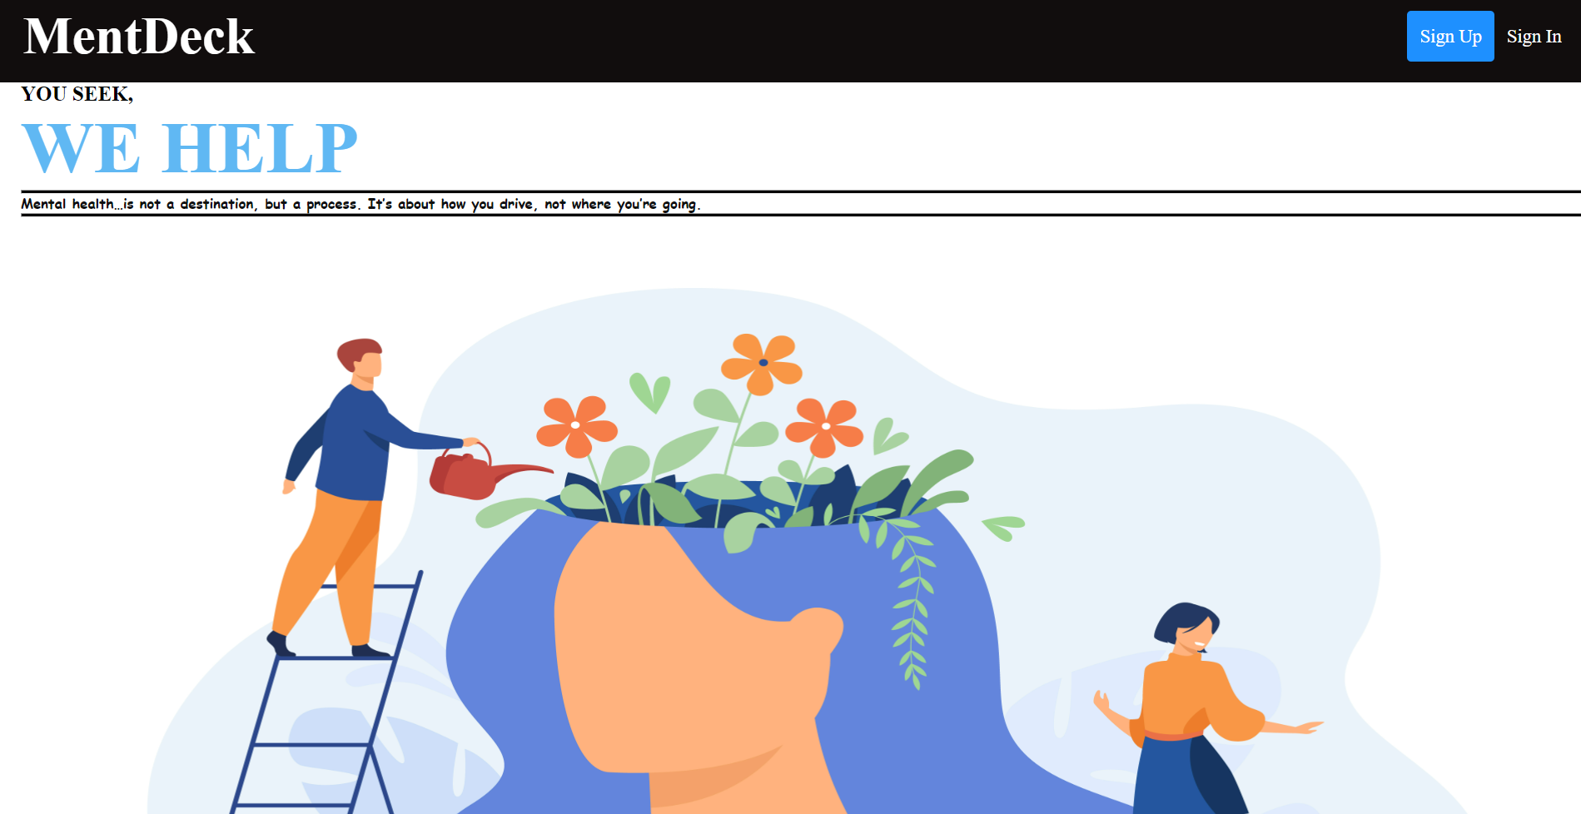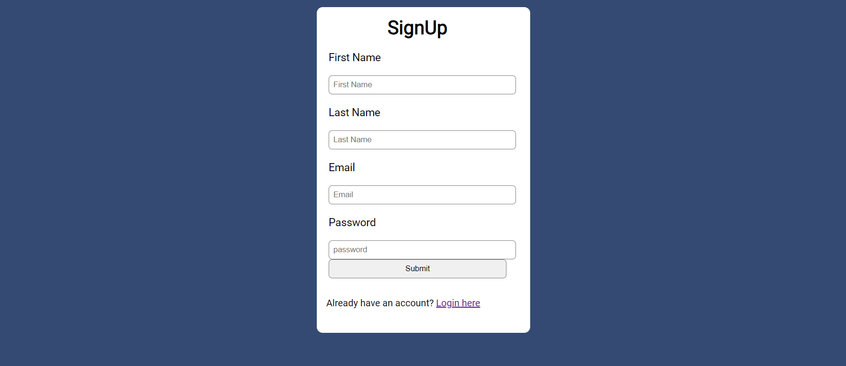

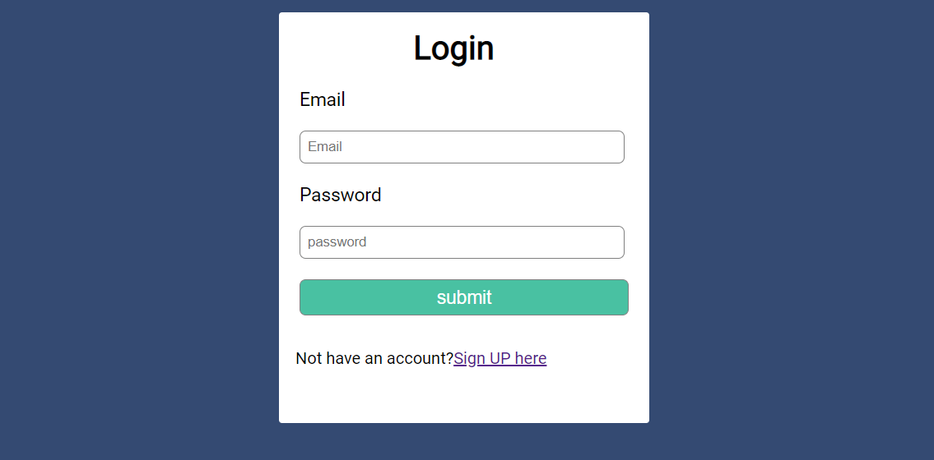

**OUR WEBSITE IS FULLY RESPONSIVE:-**

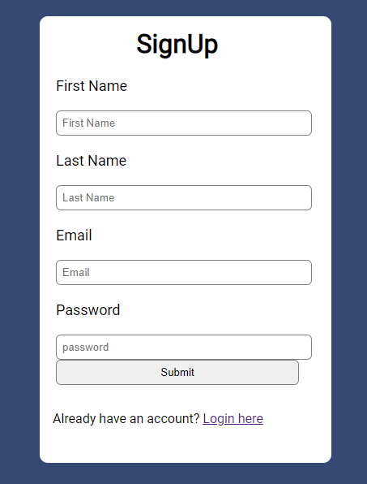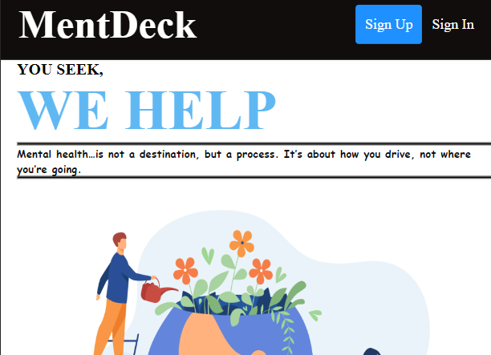

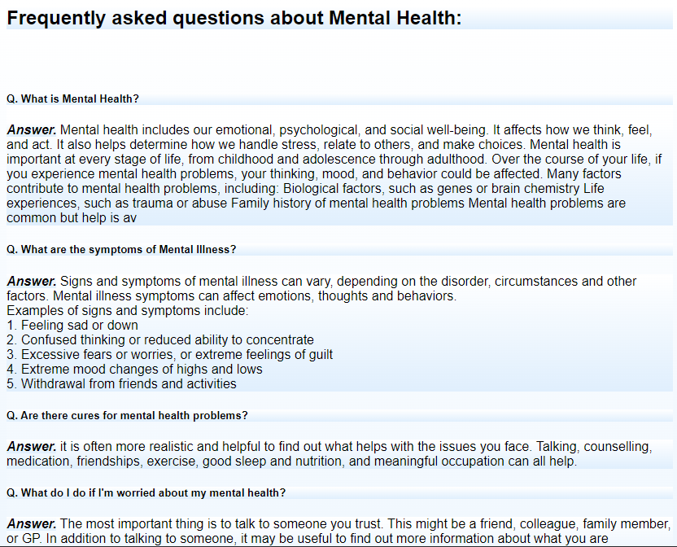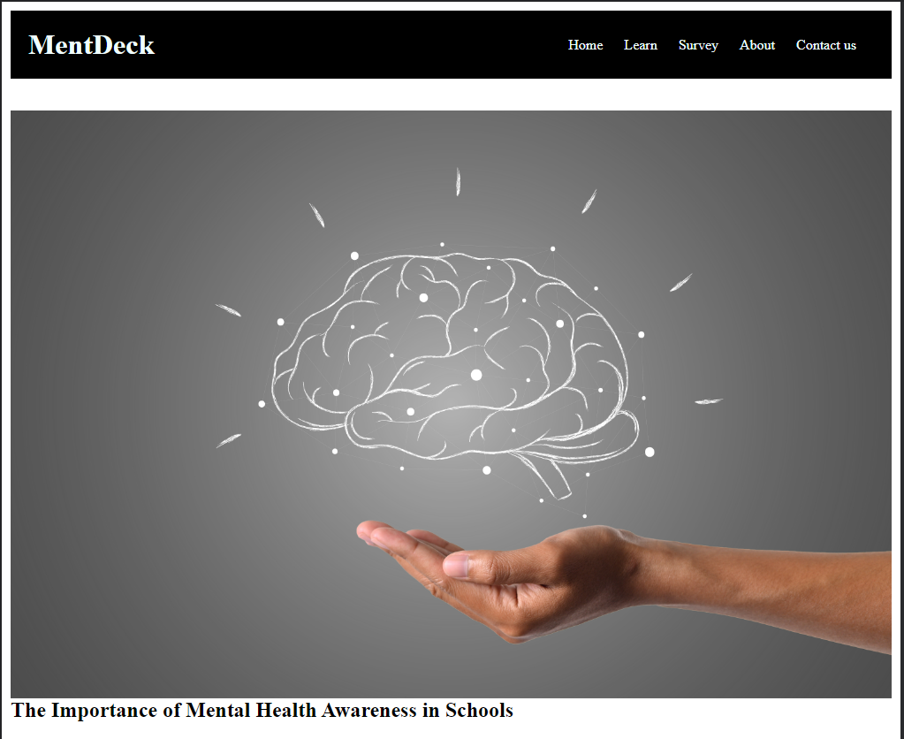

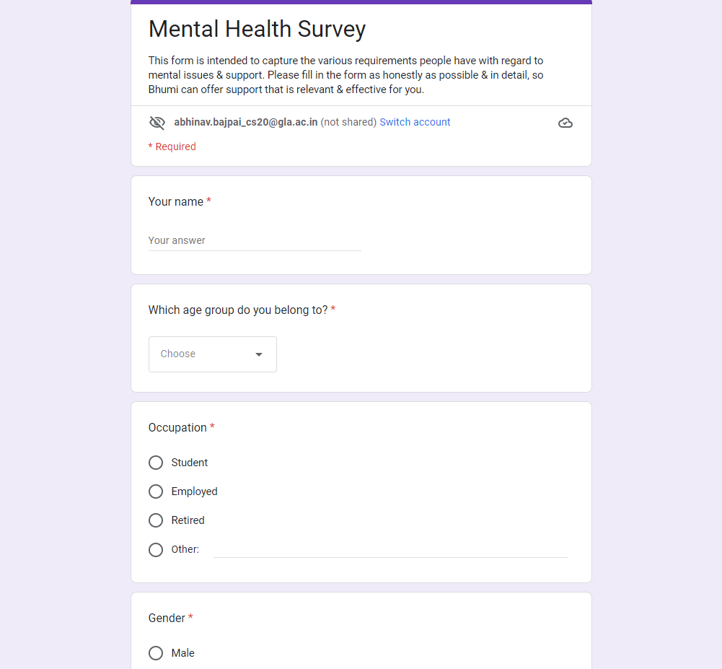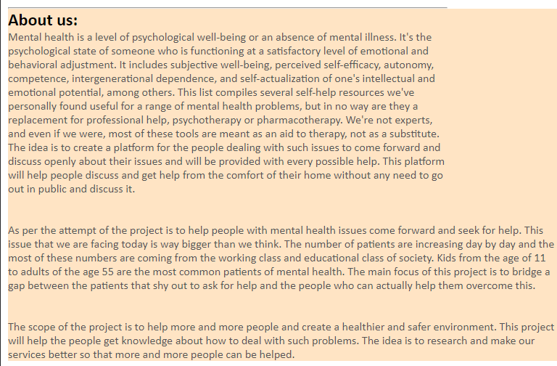

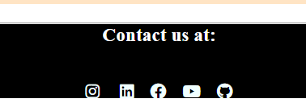

**CONCLUSION AND FUTURE WORK**

**Conclusion:**

As per the attempt of the project is to help people with mental health issues come forward and seek for help. This issue that we are facing today is way bigger than we think. The number of patients are increasing day by day and the most of these numbers are coming from the working class and educational class of society. Kids from the age of 11 to adults of the age 55 are the most common patients of mental health.

The main focus of this project is to bridge a gap between the patients that shy out to ask for help and the people who can actually help them overcome this.

**Future work: -**

The scope of the project is to help more and more people and create a healthier and safer environment. This project will help the people get knowledge about how to deal with such problems. The idea is to research and make our services better so that more and more people can be helped.

[Github Link](https://github.com/Sanjeev718191/GLA-Complex-):

https://github.com/abhinav-626/Mini-Project