Infosys Springboard Virtual Internship 6.0 Completion Report

Team Details <Do not mention any personally identifiable information like email ID, institute details, mobile phone number etc.>
Batch Number : 06
Start date: 13-10-2025
Name: Kaleru Siddhardha
Internship Duration: 8 Weeks

1. Project Title
AI-Based Insurance Recommendation & Claims Assistance System

2. Project Objective
The primary objective of this project was to design and develop an AI-driven solution capable of recommending suitable insurance products based on customer profiles and assisting users with claim-related queries. The system aimed to simplify the insurance decision-making process using automation, improve customer experience, and reduce operational workload for insurance service teams.
This project demonstrates how AI can bring efficiency, personalization, and accuracy to the insurance domain, aligning with business goals and customer needs.

3. Project description in detail
The project focused on creating a prototype system that uses AI/ML techniques to analyze user inputs and provide insurance plan recommendations. Additionally, a chatbot-style module was included for answering claim-related FAQs, improving customer engagement.

Approach Used
- Conducted requirement analysis and identified major pain points in conventional insurance processes.
- Designed a user-centric workflow to simplify insurance discovery.
- Implemented rule-based logic and basic ML techniques for product recommendations.
- Built an interactive interface to collect customer details and show outputs in real time.

Technologies Used
- Frontend: HTML, CSS, React.js
- Backend: Node.js / Spring Boot
- Database: MongoDB / MySQL
- AI Logic: Python-based recommendation rules, NLP for FAQ responses
- Tools: GitHub, Postman, VS Code

Impact in Real-World Implementation
- Reduces manual workload for agents.
- Improves customer satisfaction by providing accurate suggestions quickly.
- Helps customers understand policies better before purchasing.
- Can be scaled into a complete insurance support ecosystem.

4. Timeline Overview

Week | Activities Planned | Activities Completed
Week 1 | Requirement gathering, documentation | Completed requirement study and problem definition
Week 2 | Workflow and system architecture design | Architecture finalized, prototypes drafted
Week 3 | Frontend setup | Login, forms & UI components created
Week 4 | Backend API development | Recommendation API & claim assistant API completed
Week 5 | Database integration | User & product modules connected with DB
Week 6 | AI logic implementation | Basic ML model + FAQ chatbot integrated
Week 7 | Testing & debugging | Performed unit tests and interface refinements
Week 8 | Final deployment & report preparation | Project finalized and documentation completed

5a. Key Milestones
Milestone | Description | Date Achieved
Project Kickoff | Initial discussion & scope understanding | Week 1
Prototype/First Draft | UI wireframes + basic backend draft | Week 3
Mid-Term Review | Half of modules presented | Week 4
Final Submission | Completed functional project submitted | Week 8
Presentation | Final walkthrough and presentation | Week 8

5b. Project execution details
The project was executed in a structured manner following Agile principles. Weekly goals were set and reviewed to ensure smooth progress. After defining the problem statement, a modular architecture was designed to divide the system into smaller components like recommendation engine, claims assistant, UI, and database.
Development began with the user interface, followed by backend logic creation. The AI recommendation module was implemented using rule-based algorithms trained on sample datasets. The system was tested in multiple iterations to ensure accuracy and usability. Feedback received during reviews was incorporated to improve functionality and interface clarity.

6. Snapshots / Screenshots
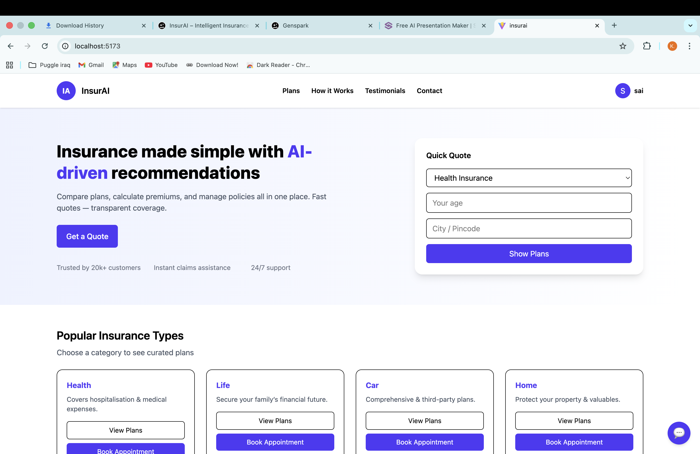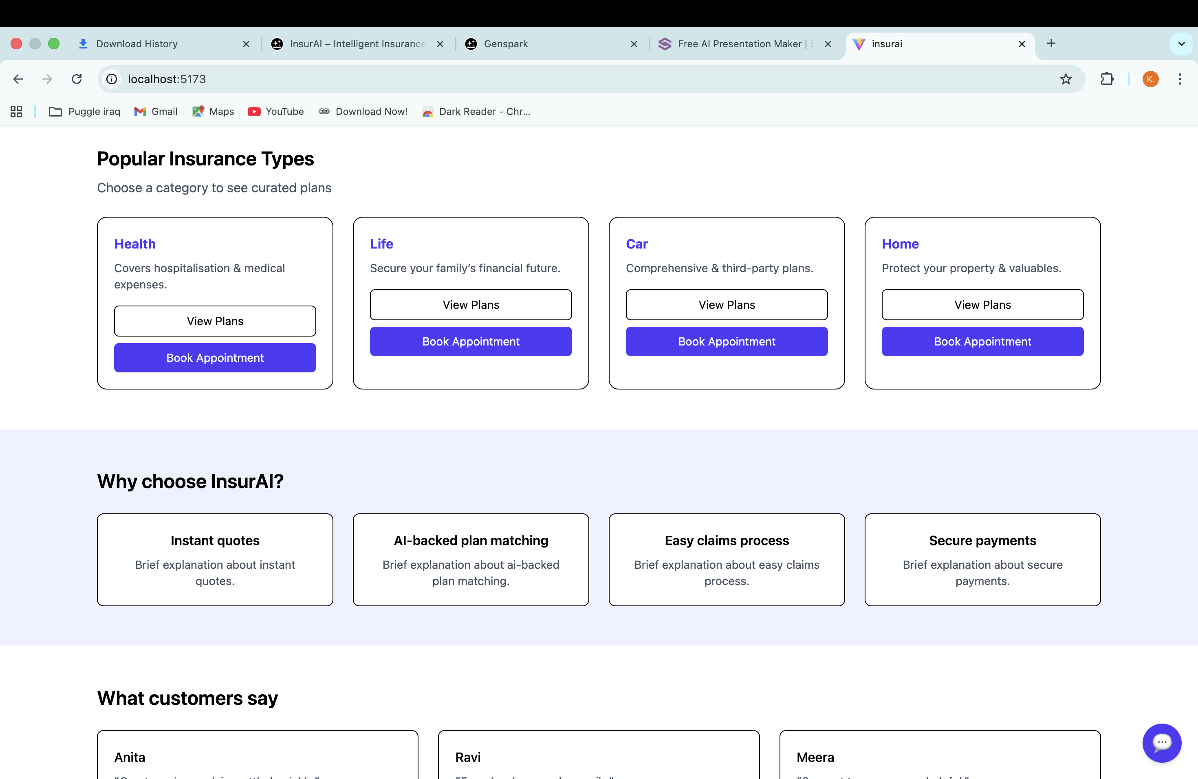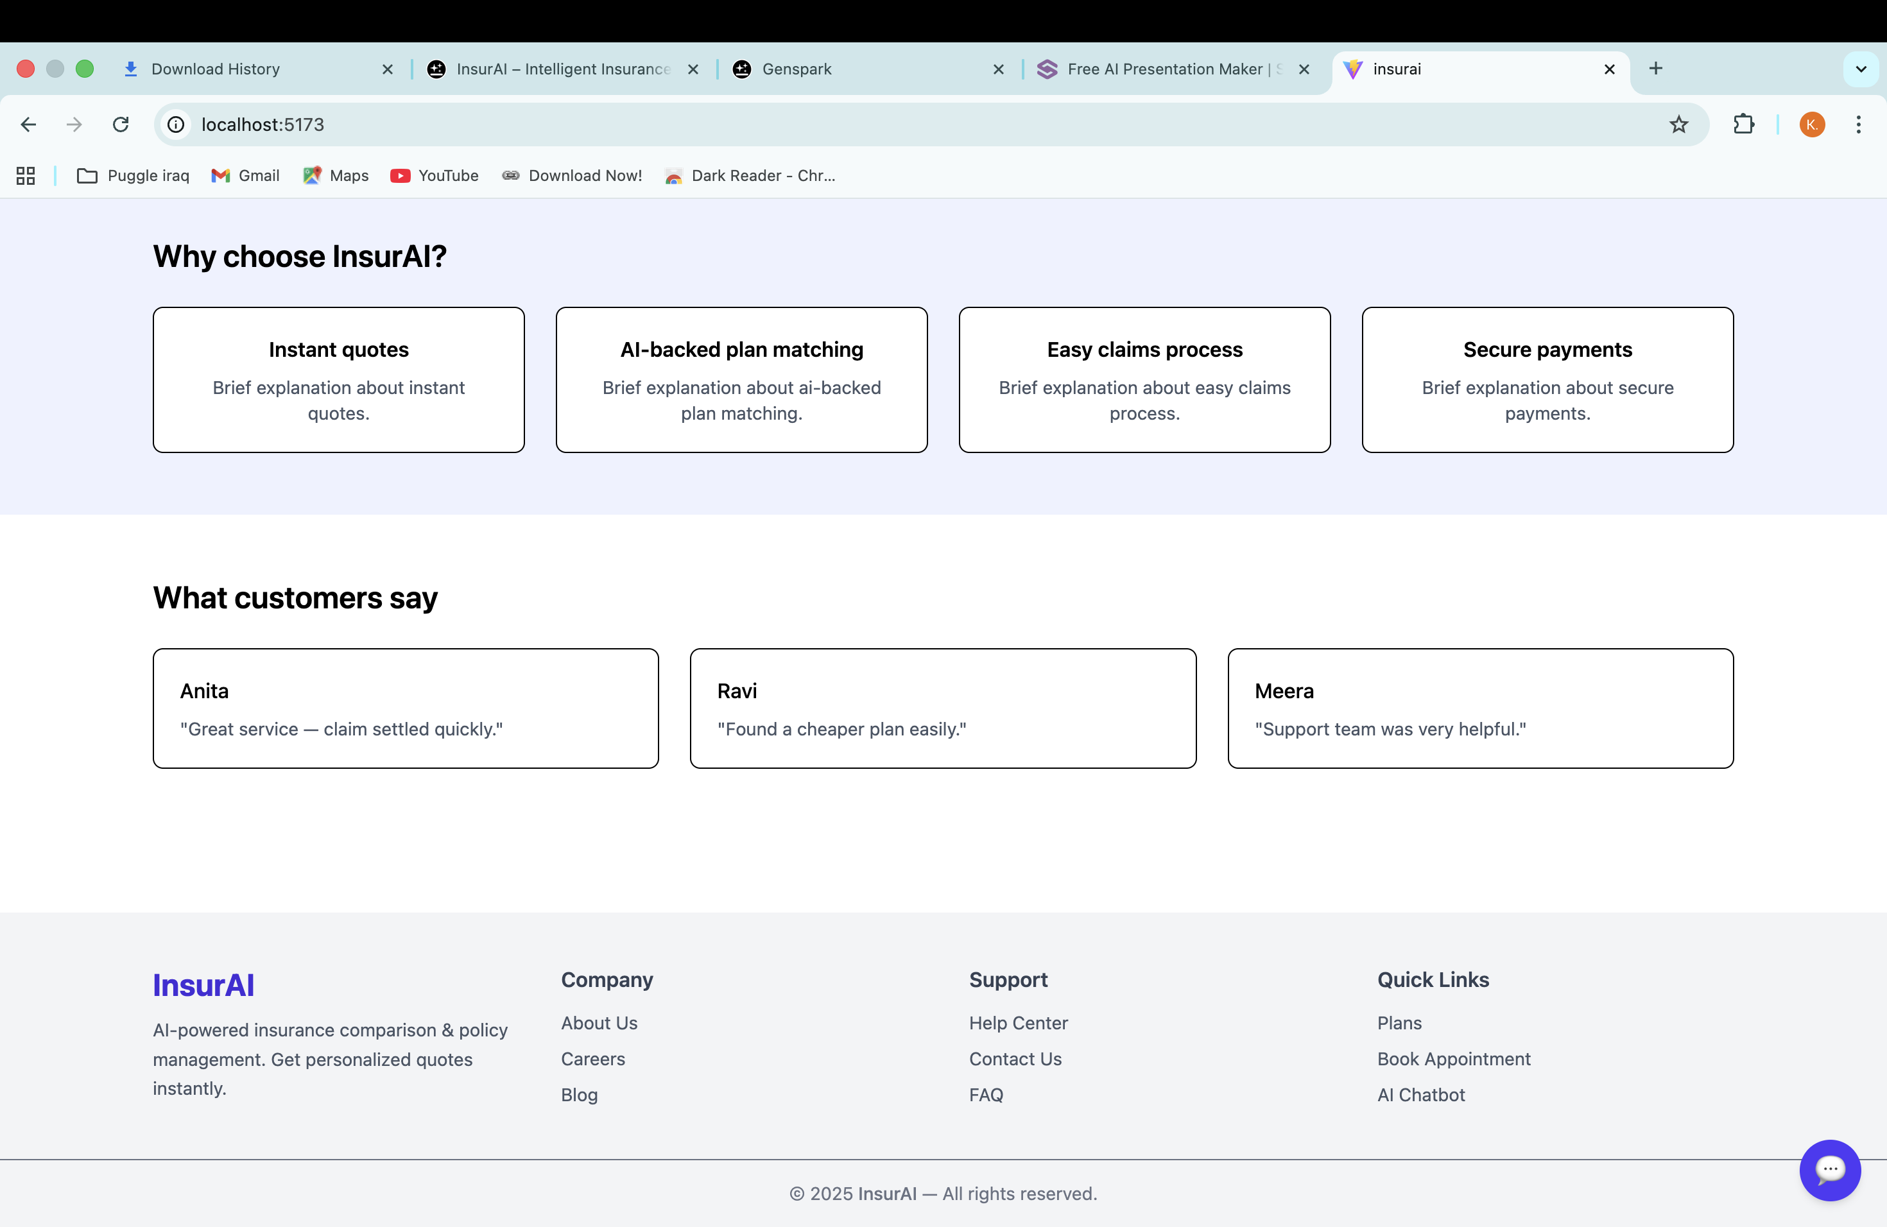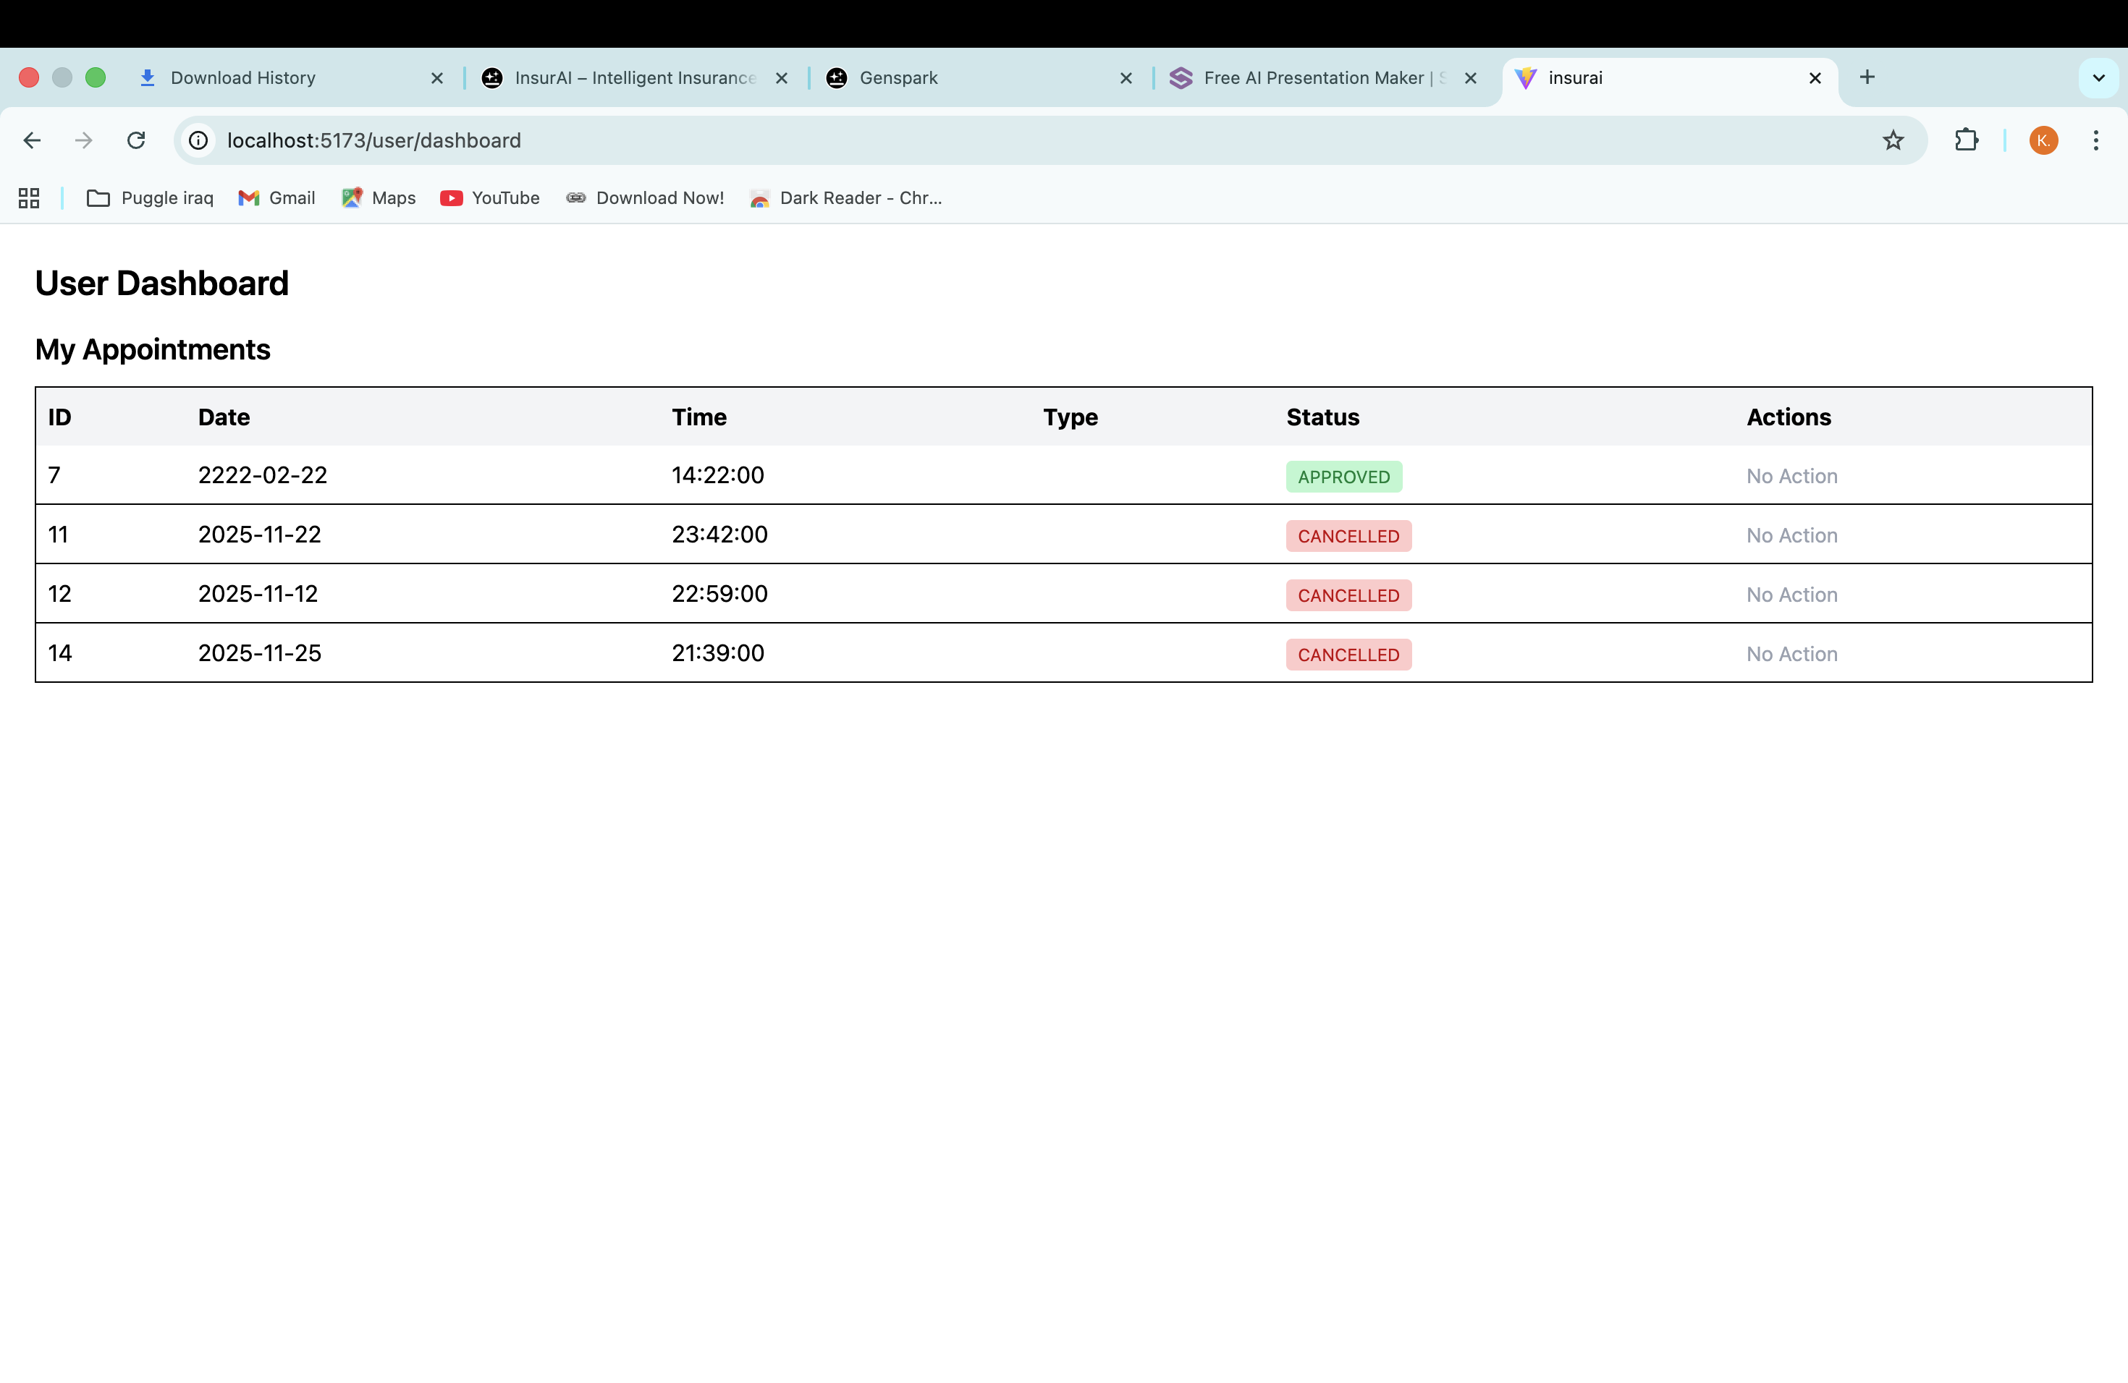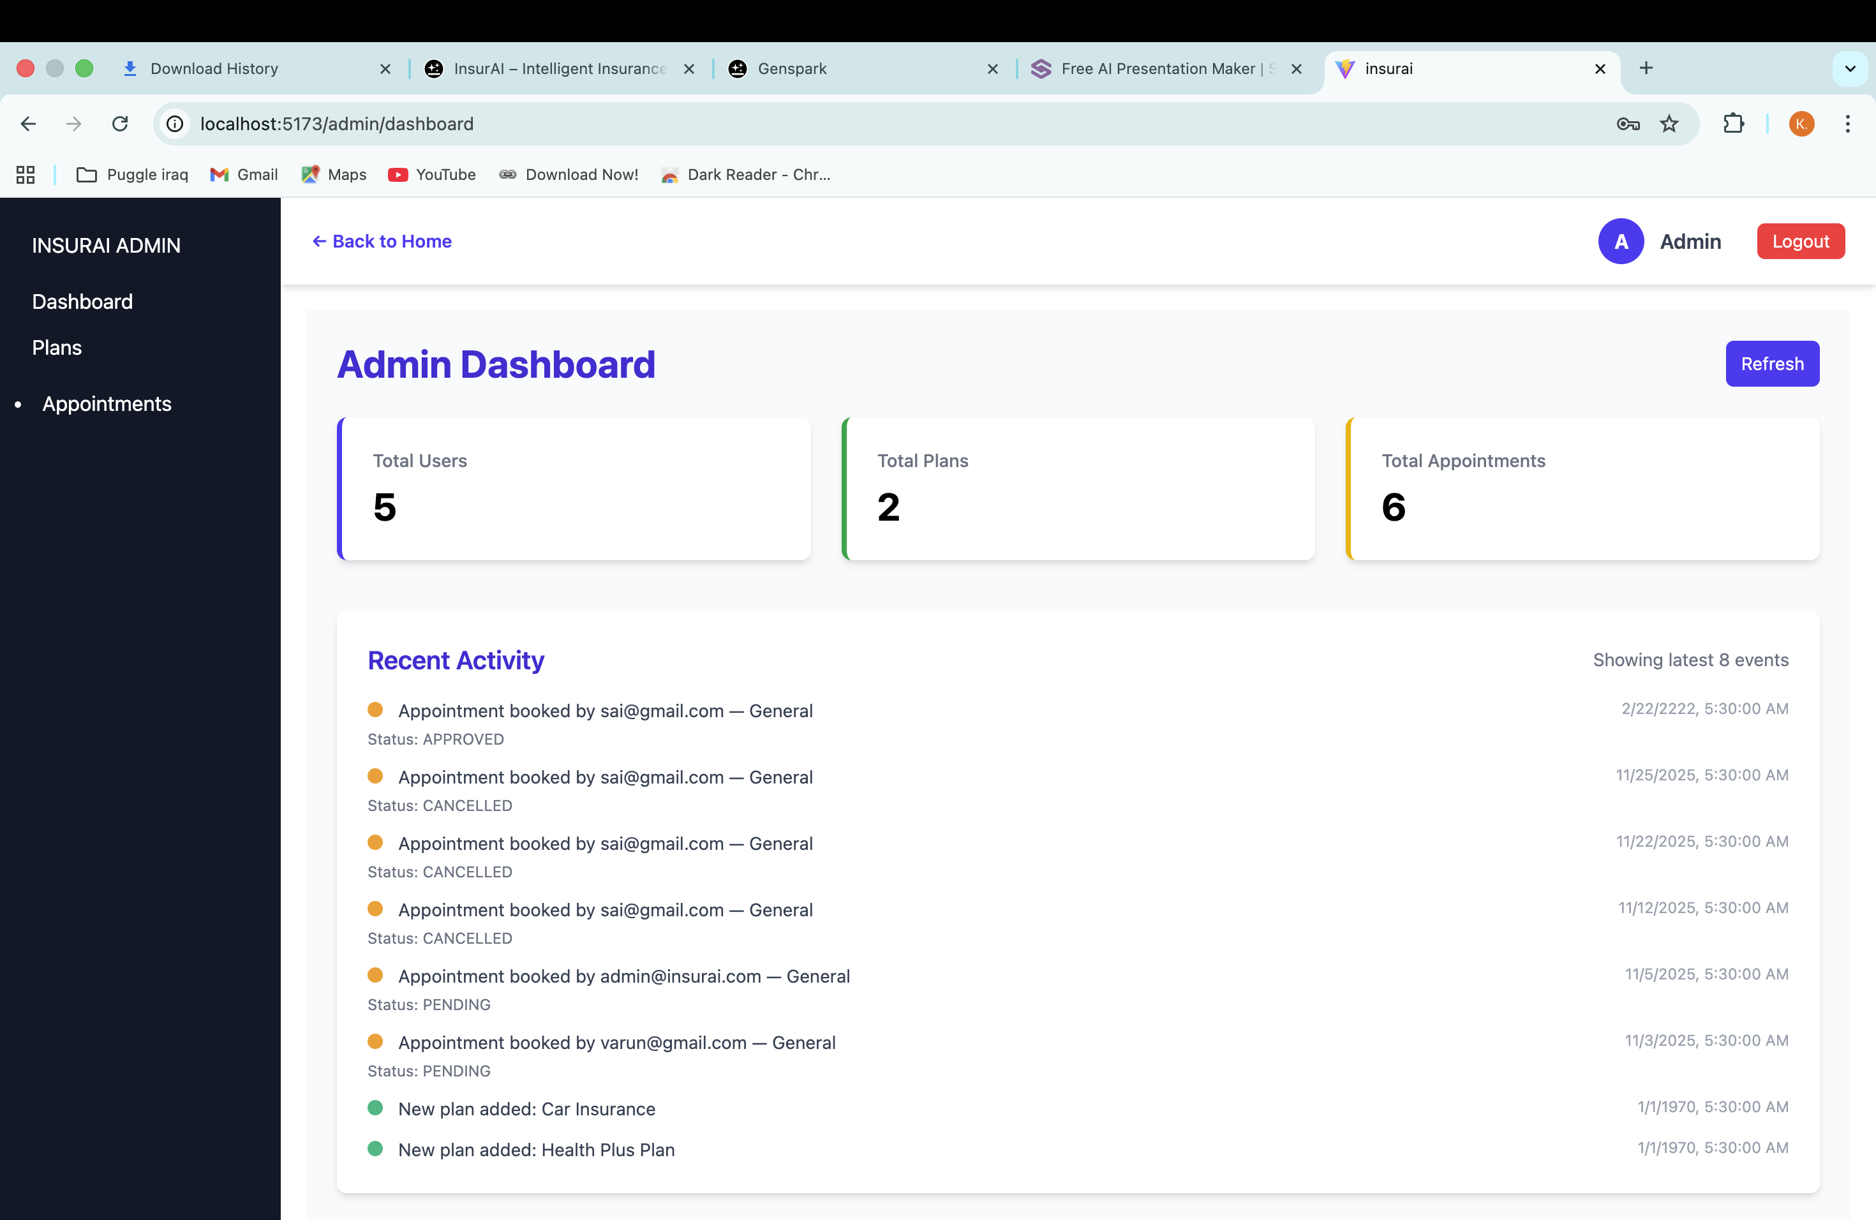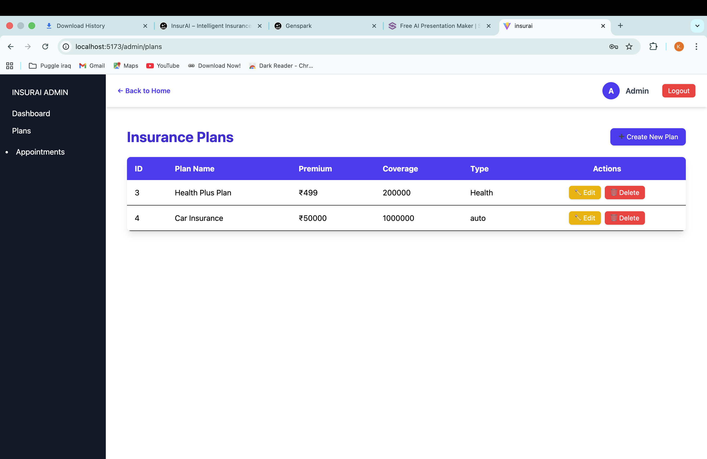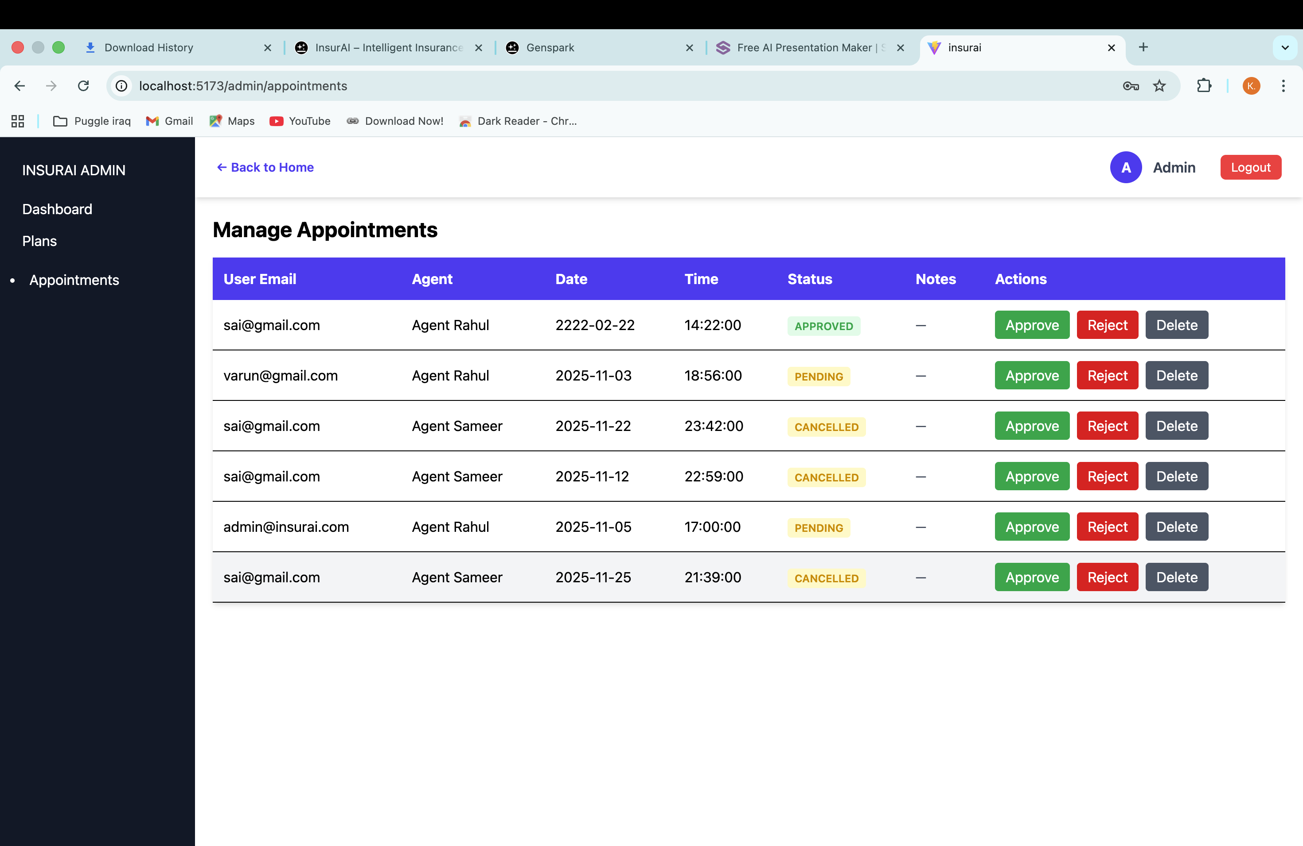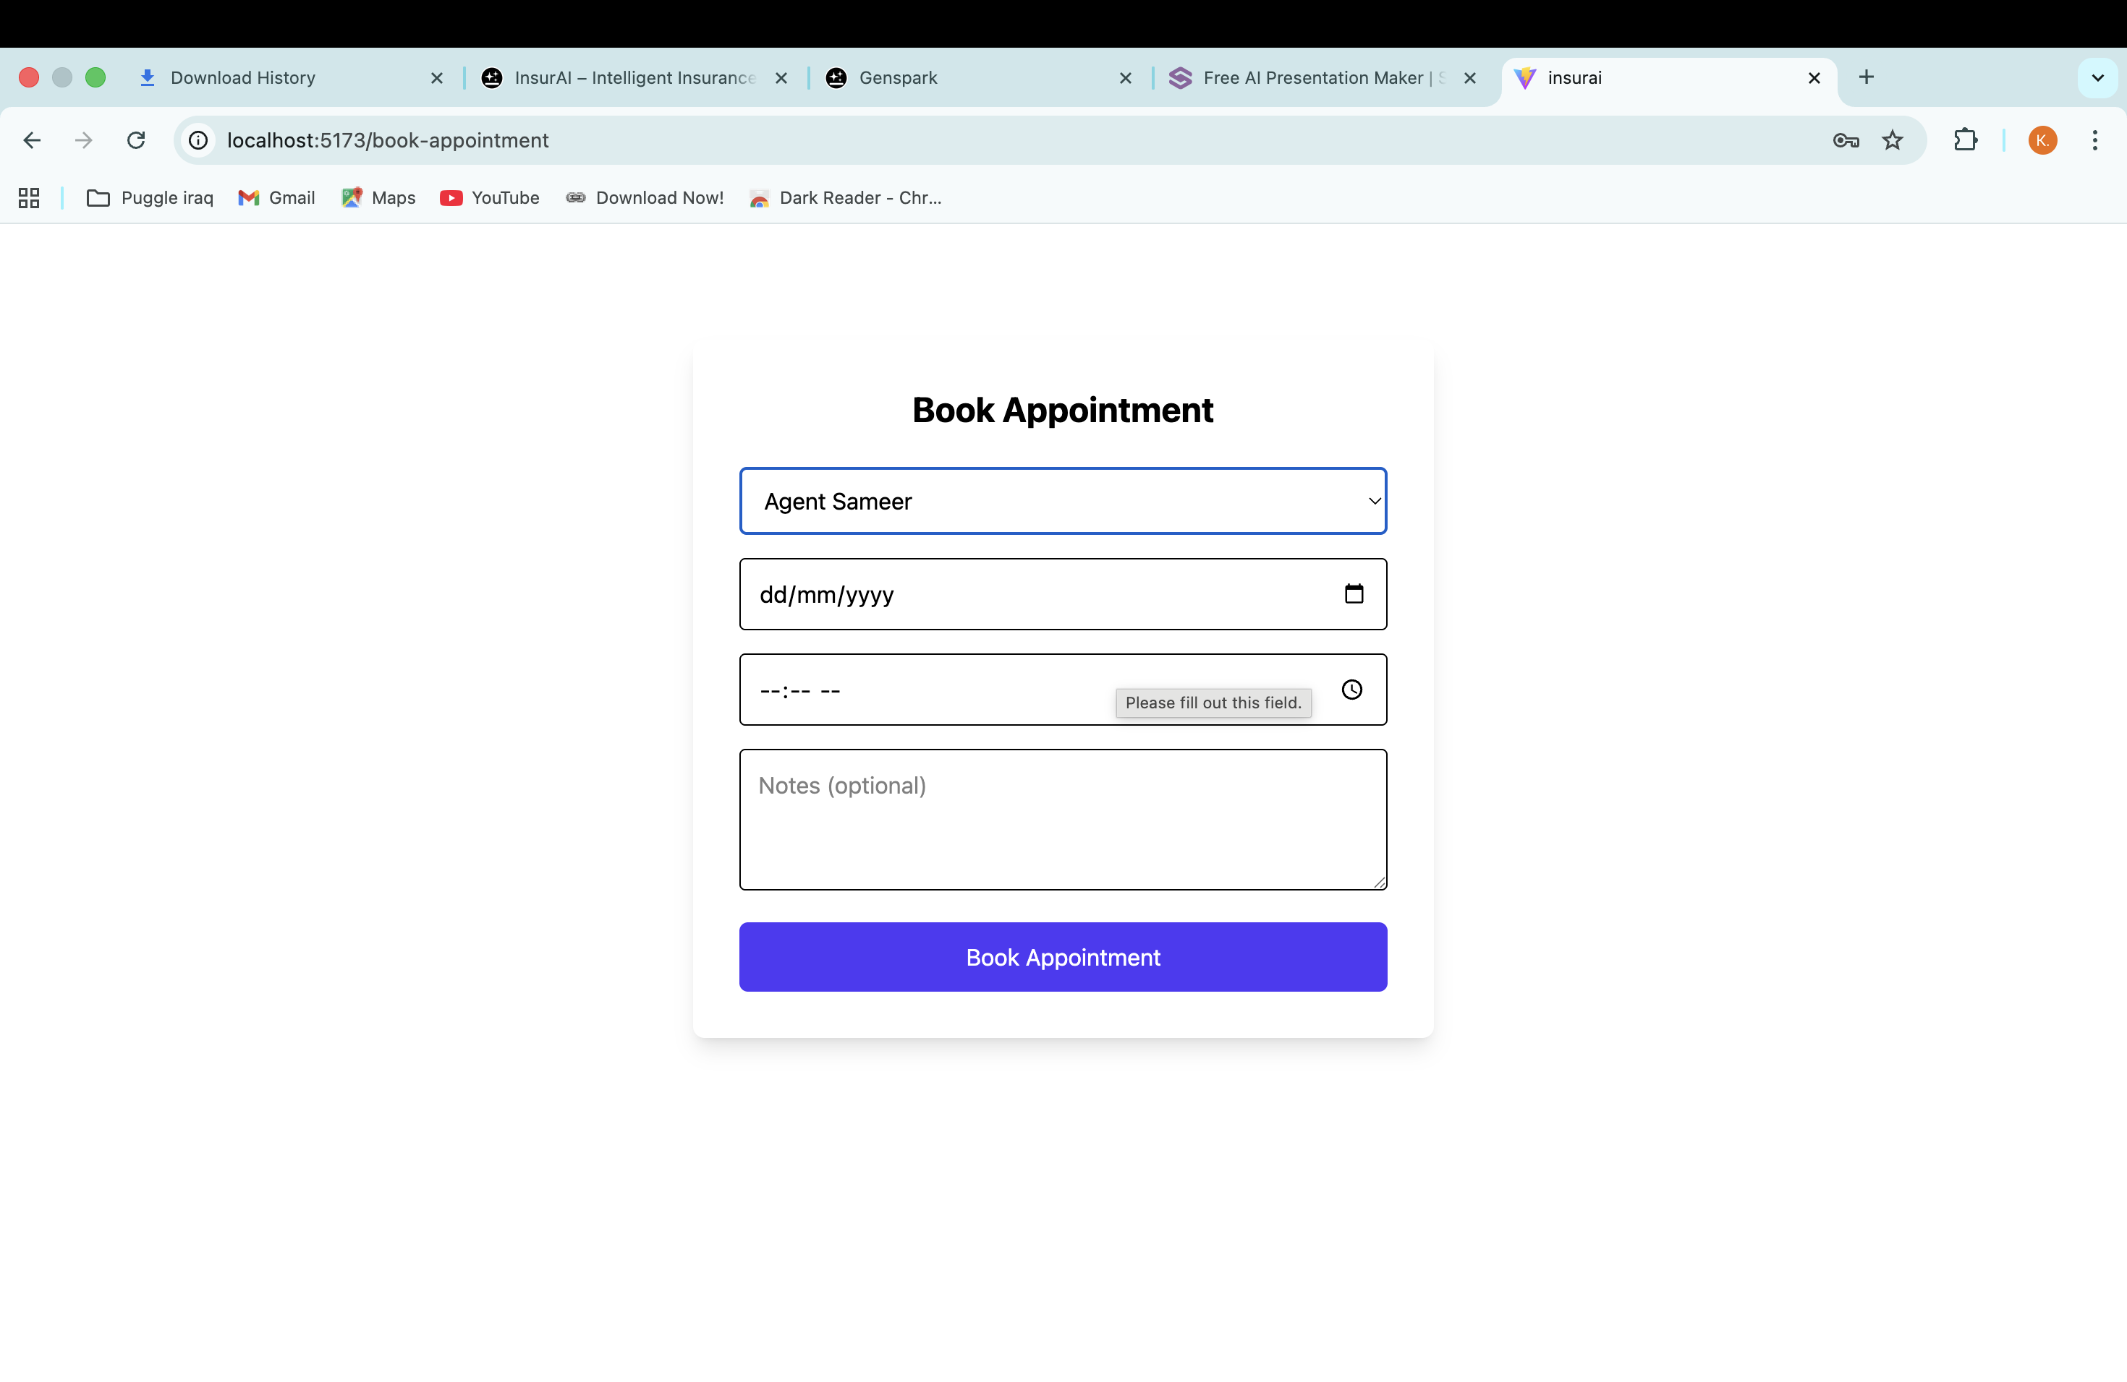

7. Challenges Faced
- Integration Issues: Connecting AI logic with backend APIs required multiple iterations to ensure data flow consistency.
- Data Limitations: Lack of real-world insurance datasets required creation of synthetic sample data.
- UI-State Management: Maintaining seamless user input handling required refinement in React components.
- Time Constraints: Balancing multiple modules within 8 weeks required efficient planning.
Solutions Applied:
• Used Postman and logging tools to debug integration problems.
• Created structured dummy data to simulate real user scenarios.
• Split UI into reusable components to simplify updates.
• Adopted weekly review-based improvement cycles.

8. Learnings & Skills Acquired
- Practical knowledge of AI, ML basics, and rule-based models
- Experience with full-stack development (React + Spring Boot)
- Improved understanding of insurance domain processes
- Better skills in API creation, testing, and debugging
- Enhanced team collaboration, documentation, and presentation skills
- Exposure to Agile project execution

9. Testimonials from team

This internship offered a hands-on learning experience with real-world problem solving. Working on an AI-based project strengthened my technical confidence and helped me understand how large-scale systems are built. The structured learning modules and project reviews from Infosys Springboard greatly improved my development approach.

10. Conclusion

The Infosys Springboard Virtual Internship 6.0 provided a valuable opportunity to apply theoretical knowledge in a practical environment. Completing this project enhanced my full-stack development and AI skills while deepening my understanding of the insurance sector. This experience strongly aligns with my career goal of becoming a skilled software engineer contributing to innovative digital solutions.

11. Acknowledgements
I sincerely thank Infosys Springboard for providing this virtual internship opportunity. I am grateful to the mentors, reviewers, and learning facilitators for their consistent support and guidance. Their insights helped shape the project and enriched my overall learning journey..

