SSH
SSL- Secure Shell protocol
Port no.: 22
Steps to follow:
Basic installation and configuration
Step-1: Install openssl package
# yum install openssl
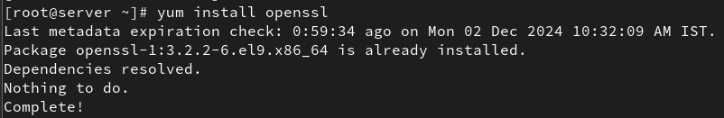
Step-2: Start and enable the SSH service:
# systemctl start sshd
# systemctl enable sshd
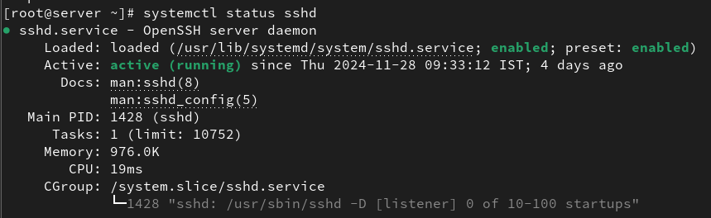
Step-3: From a client machine, connect using:
# ssh root@192.168.1.11
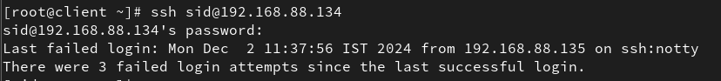

Changing the SSH Port
Step-1: Edit the SSH Configuration File:
# vi /etc/ssh/sshd_config

Step-2: Find the Port Setting:
# Port 2222
Step-3: Update Firewall
# sudo firewall-cmd --permanent --add-port=2222/tcp
# sudo firewall-cmd --reload
Restart the SSH Service:
# sudo systemctl restart sshd
Step-4: From the client, Connect Using the New Port:
# ssh user@remote_host_ip -p 2222

