**Industrial Internship Report on**

**”Core Java”**

**Prepared by**

**Nihal K Sayed**

|  |
| --- |
| *Executive Summary* |
| This report provides details of the Industrial Internship provided by upskill Campus and The IoT Academy in collaboration with Industrial Partner UniConverge Technologies Pvt Ltd (UCT).  This internship was focused on a project/problem statement provided by UCT. We had to finish the project including the report in 6 weeks’ time.  My project was (Tell about ur Project)  This internship gave me a very good opportunity to get exposure to Industrial problems and design/implement solution for that. It was an overall great experience to have this internship. |

**TABLE OF CONTENTS**

1 Preface 4

2 Introduction 5

2.1 About UniConverge Technologies Pvt Ltd 5

i. UCT IoT Platform 5

2.2 About upskill Campus (USC) 9

2.3 The IoT Academy 11

2.4 Objectives of this Internship program 11

2.5 Reference 11

3 Problem Statement 12

4 Existing and Proposed solution 13

4.1 Code submission (Github link) 13

4.2 Report submission (Github link) : 13

5 Proposed Design/ Model 14

5.1 Interfaces (if applicable) 14

6 Performance Test 15

6.1 Test Plan/ Test Cases 15

6.2 Test Procedure 15

6.3 Performance Outcome 15

7 My learnings 16

8 Future work scope 17

# Preface

The 6 week Internship Program was very well planned and organized by UCT and Uniconverge technologies . Five weekly projects were given which had weekly deliverables with code and report on the upskill portal

Internships prepare a student about how to face job work load , and also develop the skills professionally hence Internship is a vital resource

A Console based expense tracker application that allows users to manage their personal expenses. The application should provide functionalities to record and track expenses, view spending summaries, and manage categories for better organization , An Opportunity given by USC/UCT.

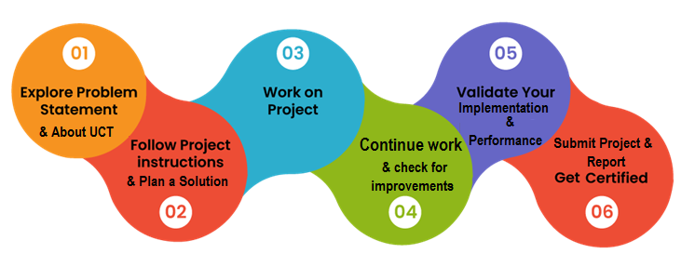

I have learned lots of things in this internship. Like how to prepare for an interview, what soft skills are required to crack the interview, salaries and work profiles of various posts in the data field. Learned about various topics in data science through the resources provided by USC, important interview questions in data science and more.

Thank to all who have helped you directly or indirectly.

My message to my juniors and peers is that this internship is great for you to get an industry level experience and hands on project

# Introduction

## About UniConverge Technologies Pvt Ltd

A company established in 2013 and working in Digital Transformation domain and providing Industrial solutions with prime focus on sustainability and RoI.

For developing its products and solutions it is leveraging various**Cutting Edge Technologies e.g. Internet of Things (IoT), Cyber Security, Cloud computing (AWS, Azure), Machine Learning, Communication Technologies (4G/5G/LoRaWAN), Java Full Stack, Python, Front end**etc.

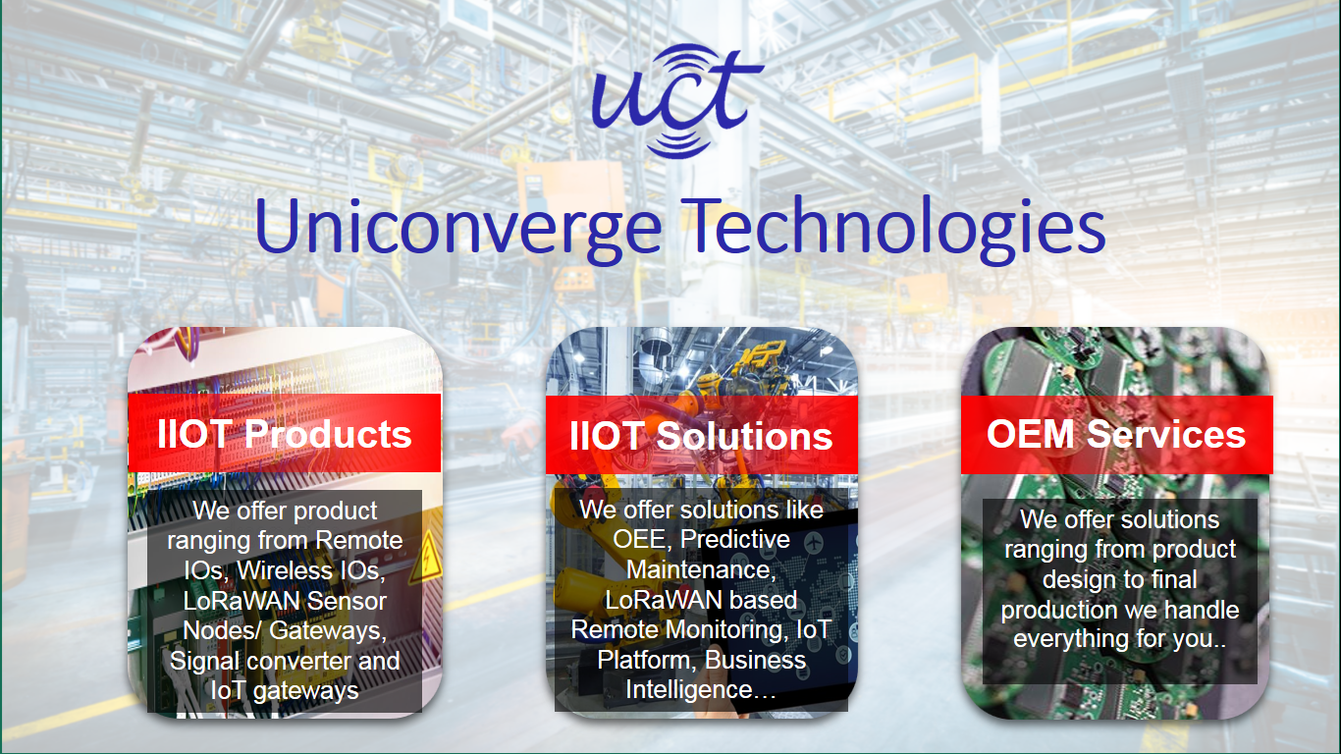

1. UCT IoT Platform **(****)**

**UCT Insight** is an IOT platform designed for quick deployment of IOT applications on the same time providing valuable “insight” for your process/business. It has been built in Java for backend and ReactJS for Front end. It has support for MySQL and various NoSql Databases.

* It enables device connectivity via industry standard IoT protocols - MQTT, CoAP, HTTP, Modbus TCP, OPC UA
* It supports both cloud and on-premises deployments.

It has features to  
• Build Your own dashboard  
• Analytics and Reporting  
• Alert and Notification  
• Integration with third party application(Power BI, SAP, ERP)  
• Rule Engine

 

1. **Smart Factory Platform (****)**

Factory watch is a platform for smart factory needs.

It provides Users/ Factory

* with a scalable solution for their Production and asset monitoring
* OEE and predictive maintenance solution scaling up to digital twin for your assets.
* to unleased the true potential of the data that their machines are generating and helps to identify the KPIs and also improve them.
* A modular architecture that allows users to choose the service that they what to start and then can scale to more complex solutions as per their demands.

Its unique SaaS model helps users to save time, cost and money.

 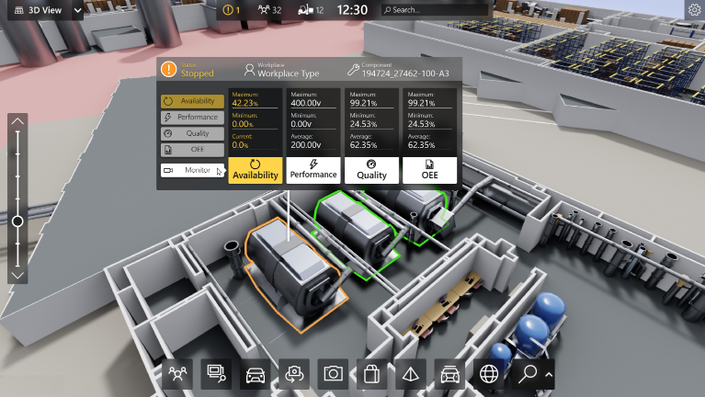

1. 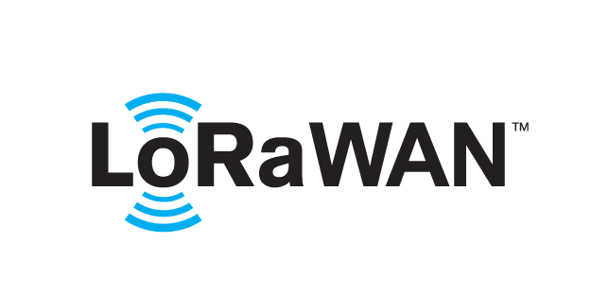 based Solution

UCT is one of the early adopters of LoRAWAN teschnology and providing solution in Agritech, Smart cities, Industrial Monitoring, Smart Street Light, Smart Water/ Gas/ Electricity metering solutions etc.

1. Predictive Maintenance

UCT is providing Industrial Machine health monitoring and Predictive maintenance solution leveraging Embedded system, Industrial IoT and Machine Learning Technologies by finding Remaining useful life time of various Machines used in production process.



## About upskill Campus (USC)

upskill Campus along with The IoT Academy and in association with Uniconverge technologies has facilitated the smooth execution of the complete internship process.

USC is a career development platform that delivers **personalized executive coaching** in a more affordable, scalable and measurable way.



Seeing need of upskilling in self paced manner along-with additional support services e.g. Internship, projects, interaction with Industry experts, Career growth Services

<https://www.upskillcampus.com/>

upSkill Campus aiming to upskill 1 million learners in next 5 year

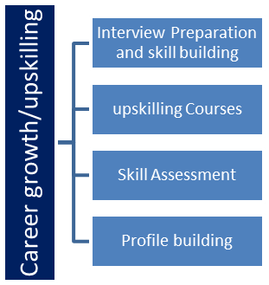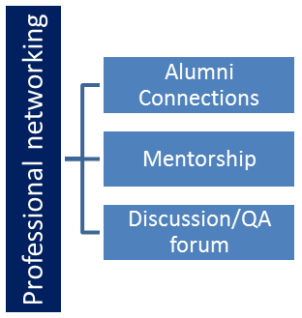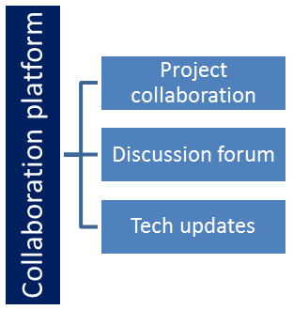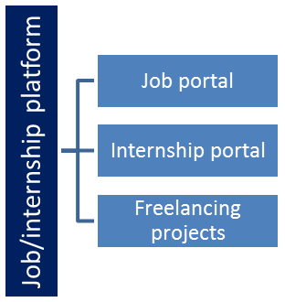

## The IoT Academy

The IoT academy is EdTech Division of UCT that is running long executive certification programs in collaboration with EICT Academy, IITK, IITR and IITG in multiple domains.

## Objectives of this Internship program

The objective for this internship program was to

 ☛ get practical experience of working in the industry.

 ☛ to solve real world problems.

 ☛ to have improved job prospects.

 ☛ to have Improved understanding of our field and its applications.

 ☛ to have Personal growth like better communication and problem solving.

## Reference

[1] http://www.geeksforgeeks.org/

[2] http://www.stackoverflow.com/

[3] http://www.Javatpoint.com/

# Problem Statement

Create a console based expense tracker application that allows users to manage their personal expenses. The application should provide functionalities to record and track expenses, view spending summaries, and manage categories for better organization.

# Existing and Proposed solution

Currently There are very few expense trackers in the Market , and the ones that are available are pretty complex to use hence I have come up with a simple console based expense tracker with following features

1. Expense Recording: Allow users to enter details of their expenses, including the date, amount, category, and description. The application should provide validation for inputs and store the recorded expenses.
2. Expense Categories: Enable users to create and manage expense categories. Users can assign expenses to specific categories to classify their spending
3. Expense Tracking: Implement features to track and display the total expenses for a specified time period or by category. Users should be able to view their spending summaries and get insights into their expenditure patterns.
4. Expense Filtering: Provide options for users to filter and view expenses based on specific criteria such as date range, category, or amount. This feature helps users analyze their spending in more detail.
5. Expense Modification and Deletion: Allow users to modify or delete recorded expenses if needed. Users should be able to edit expense details such as date, amount, category, or description
6. Data Persistence: Ensure that the recorded expenses and category information are stored persistently so that users can access and manage their expenses even after restarting the application.
7. Error Handling: Implement error handling mechanisms to handle invalid inputs, errors, and exceptions gracefully, providing informative error messages when necessary.

## Code submission (Github link)

https://github.com/Nihal-sayed/UpSkill-Uniconverge-Internship

## Report submission (Github link) :

https://github.com/Nihal-sayed/UpSkill-Uniconverge-Internship/blob/main/USC%20UCT%20Nihal%20Report.pdf

# Proposed Design/ Model

The application is implemented in Java programming language. The data structure used for expense management is a HashMap, with category names as keys and lists of expenses as values. User input and interaction are handled using the Scanner class in Java. The application follows an object-oriented design, with classes for Expense and ExpenseTracker functionality

# Performance Test

The main Objective of the project was to create a simple User friendly Console tracker application and that it should perform the way it is meant to , fast , simple and easy to use and no data redundancy.

## Test Plan/ Test Cases

The test cases decided were based on the stress testing approach in which the application was put under rigorous amount of inputs and output in loop.

## Test Procedure

Huge number of data inputs were provided and simultaneous requests to retrieve the data were also made . The inputs had lot of digits as data as well as the output .

## Performance Outcome

The application Performed well and was able to handle all the amount of requests given to it , the application consumed minimum amount of time and minimum memory to perform the requests

# My learnings

I have learned a lot of things in this internship. I learned about the company UCT (UniConverge Technologies Pvt Ltd), which domains it works in, what kind of project/solutions does it work on, which technologies it uses. I learned about the technologies like IoT, LoRAWAN. Also learned about UpSkill Campus and IoT Academy

In this internship I learned about various concepts in java and my confidence in the industry has increased to a great extent . I am now confident on my problem solving skills and programming skills and aware of the types of problems I might face in this industry as a full time employee

Also I am thankful to UCT and USC to give me an opportunity to work on an industry project. I have learned a lot of things in this project. It has given me a chance to work on a real world data science project.

I believe this internship will add a value to my profile and resume. It will open doors to lot of opportunities for me. I am really grateful to UCT, USC and IoT Academy for giving me this opportunity.

# Future work scope

The Console-based Expense Tracker Application can be further enhanced with the following features:

* Date Filtering: Allow users to filter expenses based on specific dates or date ranges.
* Expense Modification: Provide the ability to modify or delete individual expenses.
* Data Persistence: Implement a data persistence mechanism to store expenses across sessions.
* Reporting and Analysis: Generate reports and perform analysis on expenses for better financial insights.