Weekly Report

Work done in last week ( Attach supporting Documents):

- Created Landing Page
- Created Multi Step Form
3. Connected Backend to Database
4. Added one more section
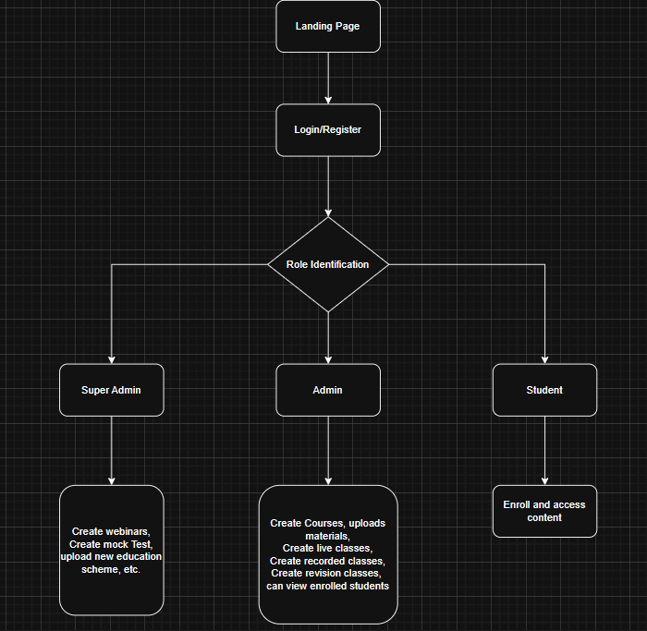

Figure 1 Flow of Project

Plans for next week:

1.
2.
3.

References:

Signature of External Guide Signature of Internal Guide

