**Siddharth Khachane**

**Mask Detection CNN**

**Simple Implementation (Raw Grayscale Images as the Input)**

**Problem**🡪

These were a lot of useless features which were taken into account like the exact pixels face.

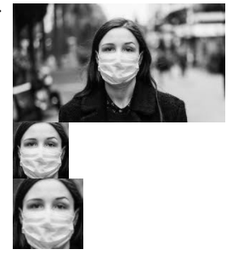

**Solution**🡪

We could use Edge Detection to have only the essential features in the image.

**Different Edge detections**

**Canny**🡪

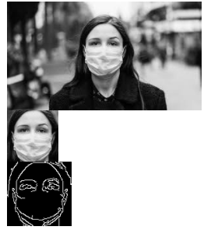

**Sobel**🡪

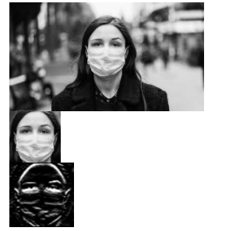

**Solution**🡪

I tried many edge detection techiniques and so far canny detected the edges properly

**Canny Threshold problem🡪**

**Low difference** between lower and upper bound🡪

Cv2.canny(img,100,150)

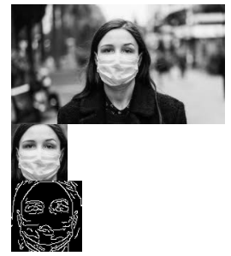

Masks have folds on them so if the difference between lower and upper bounds of the thresholds is low, then these folds might be detected as edges and thus result in the wrong prediction as the model might confuse these edges as facial features.

**High difference** between lower and upper bound🡪

Cv2.canny(img,100,600)

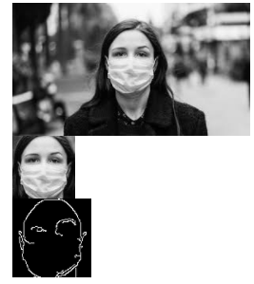

If the difference between the threshold bounds is very high then it might result in the loss of essential features.

**Problem**🡪

For Each Image, these threshold limits vary for getting the optimal edges. We cannot set a common Threshold limit for all images

**Solution**🡪

We should use some parameters which find the correct value for the threshold limits.

**Using median to compute the thresholds**

def auto_canny(image, sigma=0.33):

  # compute the median of the single channel pixel intensities

  v = np.median(image)

  # apply automatic Canny edge detection using the computed median

  lower = int(max(0, (1.0 - sigma) * v))

  upper = int(min(255, (1.0 + sigma) * v))

  edged = cv2.Canny(image, lower, upper)

  # return the edged image

  return edged

gray=cv2.cvtColor(img1,cv2.COLOR_BGR2GRAY)

resized=cv2.resize(img1,(100,100))

blurred = cv2.GaussianBlur(resized, (3, 3), 0)

wide = cv2.Canny(blurred, 10, 200)

tight = cv2.Canny(blurred, 225, 250)

auto = auto_canny(blurred)

reshaped=np.reshape(auto,(1,100,100,1))

result=model.predict(reshaped)

print(result)

cv2_imshow(auto)

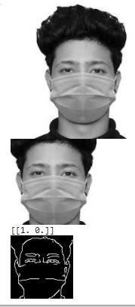

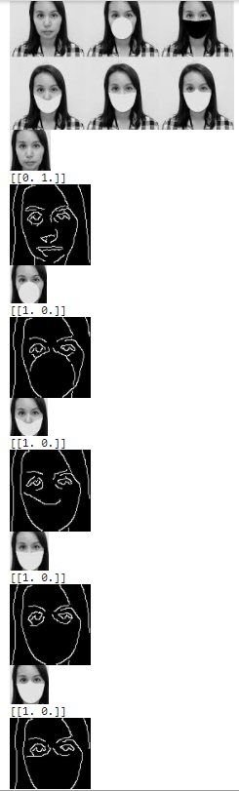

Problem🡪 This may still fail as we are computing the thresholds on the basis of median, adaptive thresholding is better