# ALUMNI MANAGEMENT SYSTEM

1 Siddharth Ramawat, B-Tech, Final Year, Dept. Of CSE, St. Martin’s Engineering College, Dhulapally , Hyderabad, Telangana,siddharth_ramawat@yahoo.com

2 Medam Sai Sirisha, B-Tech, Final Year, Dept. Of CSE, St. Martin’s Engineering College, Dhulapally , Hyderabad, Telangana, ssirisha639@gmail.com

3 Ashish Kamatala, B-Tech, Final Year, Dept. Of CSE, St. Martin’s Engineering College, Dhulapally , Hyderabad, Telangana,kamatalaashish@gmail.com

4 Dr. Govinda Rajulu G., Professor, Dept. Of CSE, St. Martin’s Engineering College, Dhulapally, Hyderabad, Telangana, rajulug7@gmail.com

***Abstract-* Alumni management is one of the thrust areas considered focal to institutional development mostly in developing countries. A strong alumni system plays an important role in reaping anonymous benefits for student-student networks as well as institution-student networks. A major problem with some of the existing systems is the details of any student is exposed to anyone on the web. There is no Alumni Management System for most of the colleges in “Telangana State” (Tier - 3).**

**Our system proposes an easy and interactive management portal for creating networks among students as well as institutes. The portal allows currently enrolled students as well to create networks with graduates of the organization. The system validates the students enrolled to the organization based on their Registration Number collected from the Institute/Organization.**

**Our system makes it easier for users to register into the system, connect with the alumni of organization, easy creation of events like postings on jobs, events happening around the city etc. The users will be notified about the new events and the users can register for a particular event from their feed.**

**Keywords:** Alumni management, University alumni, JSON, Android SDK, Android Virtual Device, Web View.

# INTRODUCTION

Web programming, also known as web development, is the creation of dynamic web applications. Web development is the work involved in developing a website for the Internet (World Wide Web) or an intranet (a private network).Web development can range from developing a simple single static page of plain text to complex web-based internet applications (web apps), electronic businesses, and social network services. It includes aspects such as web design, web publishing, web programming, and database management.

Examples of web applications are social networking sites like Facebook or e-commerce sites like Amazon.

People today are learning web development because they want to create a new startup or find a job in the industry. It’s super easy to get started hence the best choice to begin development with. No matter whether you’re looking for a career or just want to learn coding, learning how to develop for the web is for you. It’s one of the smartest decisions you will ever make.

The two broad categories into which web development is divided into is front-end development (sometimes called as client-side development) and back-end development (sometimes called as server-side development).

Android software development is the process by which new applications are created for devices running the Android operating system. Google states that "Android apps can be written using Kotlin, Java, and C++ languages" using the Android software development kit (SDK), while using other languages is also possible. All non-JVM languages, such as Go, JavaScript, C, C++ or assembly, need the help of JVM language code, that may be supplied by tools, likely with restricted API support.

Mobile app development is the creation of software intended to run on mobile devices and optimized to take advantage of those product's unique features and hardware. Mobile application development is the process of creating software applications that run on a mobile device, and a typical mobile application utilizes a network connection to work with remote computing resources. Hence, the mobile development process involves creating installable software bundles (code, binaries, assets, etc.), implementing backend services such as data access with an API, and testing the application on target devices.

There are two dominant platforms in the modern smartphone market. One is the iOS platform from Apple Inc. The iOS platform is the operating system that powers Apple's popular line of iPhone smartphones. The second is Android from Google. The Android operating system is used not only by Google devices but also by many other OEMs to build their own smartphones and other smart devices.

1. LITERATURE SURVEY

Alumni are the living examples and testimonials of any organization. It’s because of the strong alumni network that leads to the recognition and fame of the college.

A constant and active involvement of the alumni with the institute proves to be very useful for the college as well as students.

Alumni Management System is used to connect with the students who have passed out of the college(ex-students).

An Online Alumni Tracking System is an example of web application which is under the information systems. [2] It helps an academic institution in tracking its alumni. Also, it helps the alumni to communicate with the institution through the use of the internet. This application can be very useful especially to those alumni who are now living abroad because they can still get connected with their fellowmen and the institution. This application is also useful because it can make transactions and process paperless.

Some systems are designed to get the ranking of universities by analyzing the strength of alumni network. [1]

Nowadays, computers have infiltrated all the aspects of our society. The computer is most likely one of the great technological mechanism for future change. It can now simply make our works easier and lighter. With this great thing it won’t be more useful without the computer’s software. Software is a generic term for organized collections of computer data and instructions, often broken into two major categories: system software that provides the basic non-task-specific functions of the computer, and application software which is used by users to accomplish specific tasks.

1. PROPOSED SYSTEM

The goal of our application is to help university students to create networks and interact with alumnus of the university. The application lets the users to connect with alumnus by searching for them using name registration numbers.

The basic function of the application is to provide registered and authorized users an easy and interactive way to create events, post feedbacks about the curriculum/infrastructure etc., create and edit blogs, view feed and most importantly get referrals and create network with the alumnus. [3] The registered users can also participate in the events that are created by other users. The users get notified about the same.

**Components**

1. *Users component*

This component is used to login or sign up to the system. The new users are authorized by the admin, once they are authorized they can access the system by logging in. The user’s table is an extension to the default auth_user table provided by Django. The password is stored using SHA256 algorithm as a hash hence it is secure. After successful login the user is directed to dashboard where he can view all the recent blogs, posts, events posted by other users. The password is stored using different hashing algorithm by default to secure the user passwords.

1. *Events component*

The events can be created by any authorized user. Events such as technical events, recruitment events, fests, seminars, lectures etc. can be created. The users can view the percentage of available slots for a particular event. They can register for a particular event. Once they register for an event, they get notified about any updates from the event organizer about the event. Mailgun is being used to send mails to the registered users for a particular event. The users can contact the organizer for the event information on mail.

1. *Feedback component*

The registered users can post feedback about curriculum, infrastructure, or general feedback. [9] The feedback received by all users can only be viewed by the admin of the website, he can clear either entire feedback or can choose a particular date, the feedback posted till that date would be completely cleared. [3]

1. *Blog Component*

The registered users can create blogs or post where they share technical knowledge or their interview experiences with other registered users on the system. The post can be deleted or updated the author of the post.

**Other functionalities:**

1. *Search:* The users can search other users by typing their name or registration number or department or job or company or location. The search results can be further filtered again based on users’ requirement. The user can check the profile of other user that appeared in the search result.
2. *Profile:* Once the user has created the account, user can update their profile by visiting the profile section where they can update details like email id, image, job role, working location and company in which they are currently working.
3. *Blog:* Users can like or dislike posts on the feed.
4. *Poll Percentage:* Users can view the number of people registered for the event.
5. Authorized users can check the profile of the person giving feedback.
6. Users can check the profile of the organizer of the event.
7. The users can change their old passwords, there’s a default PasswordChangeForm provided by default in Django that is being used to update the user’s password. As soon as the password is updated the user will be logged out of current session.
8. Apart from these functionalities, there are various security filters and form validators available curbing the access to authorized pages and submission of forms respectively.

**Implementation Details**

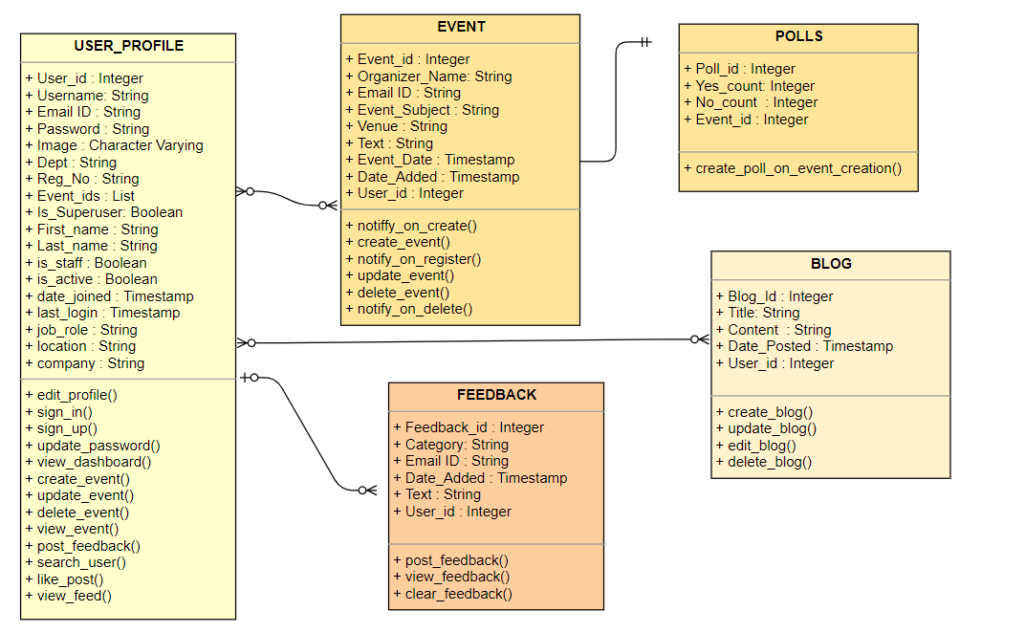

Fig. 1. Class Diagram

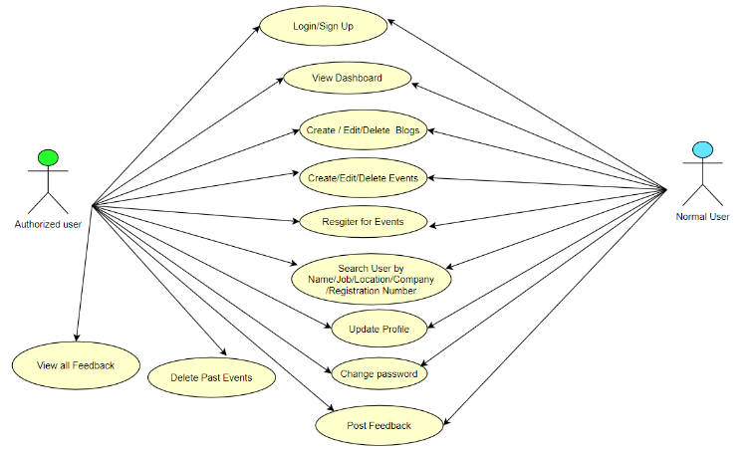

Fig. 2. Use Case Diagram

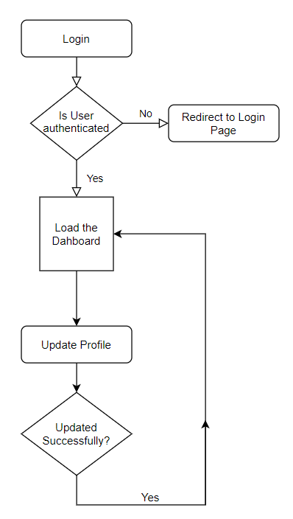

Fig . 3. Flowchart for Updating Profile

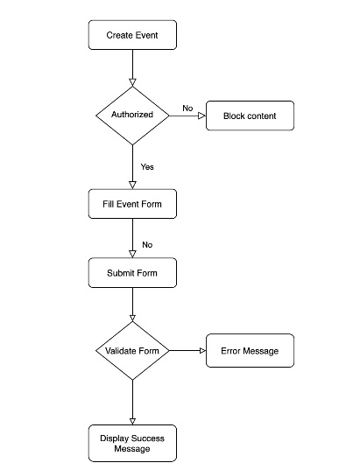

Fig. 4. Flow Diagram of Create Event

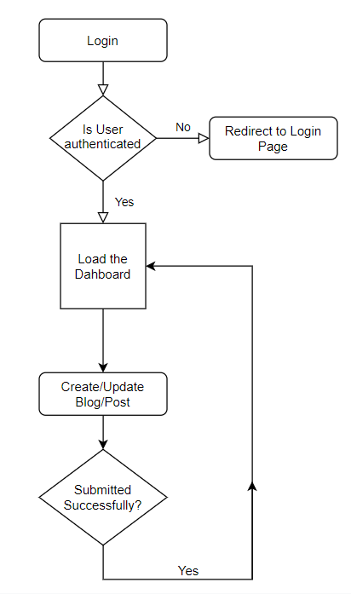

Fig. 5. Flow Diagram of Create/Update Blogs

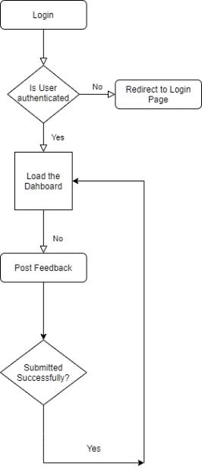

Fig. 6. Flow Diagram to Post Feedback

1. DISCUSSIONS AND RESULTS

On hitting the website, the login page is shown where the users can either login if they are already registered or create an account.

If registered users login into the system, they are initially redirected to the dashboard. The dashboard has options to choose to create blog, create event. Search other users, update their profile, insert feedback.

The blog posted by users is visible on the feed of every other registered user on the system. The users can either update or delete the blogs if they are the authors of the particular post or blog.

The events posted by users is also visible on the view events page of every registered user. The users can choose to attend the event by clicking on the poll, if he hasn’t already voted in the poll.

If the user who is logged in now is the organizer of the event he has the option of updating the event. The admin or authorized user has access to delete the past events which have event date less than the current date.

The Feedback option is visible only to the admin of the system. The admin can view all feedback given by various users. The data about the user posting feedback is not stored hence remains anonymous for the admin. The admin can further check feedback based on filters such as Infrastructure, Curriculum and General (which is by default taken for all feedbacks). [3]

If any user apart from admin tries to view the feedback the stalker alert page would be shown.

When a user searches for another user, he gets search results displayed. The searched user’s profile can be checked by others. In order have the details hidden, users can choose to keep their data private by setting their preferences. [3]

The user can change his password by clicking the settings button on the navigation bar, as soon as the password is successfully updated the user is logged out and has to login with new password.

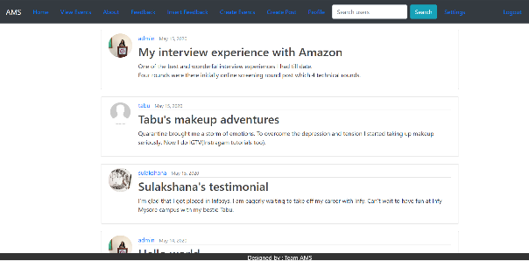

Fig.7 Dashboard

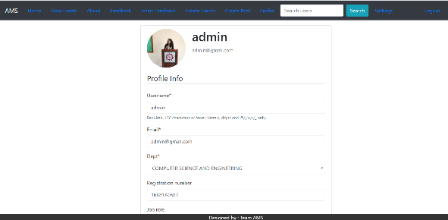

Fig.8 Profile Section

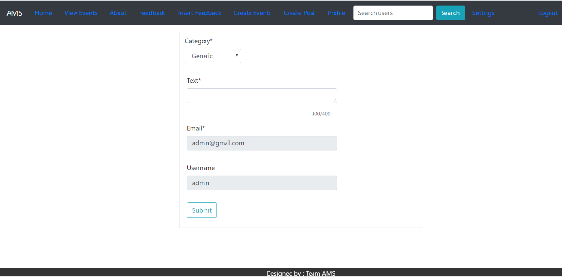

Fig. 9 Insert Feedback

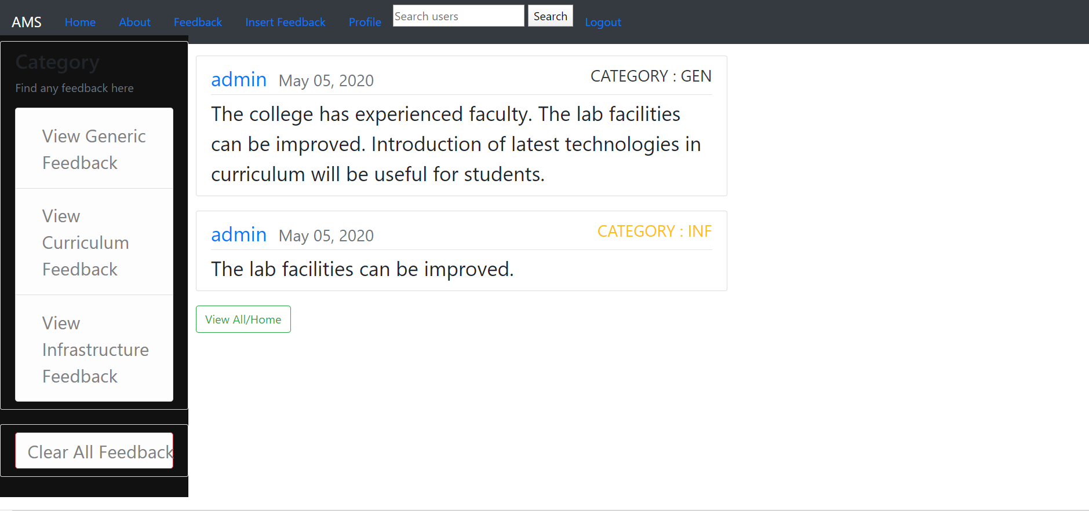

Fig. 10 View Feedback

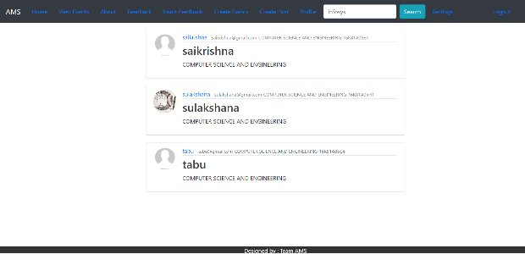

Fig. 11 Search results Page

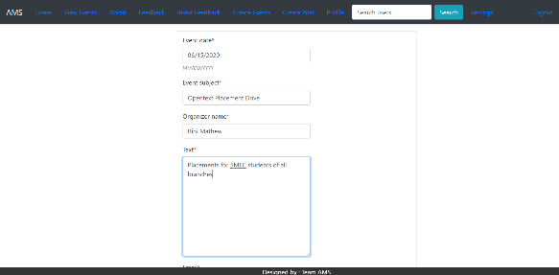

Fig. 12 Create Event

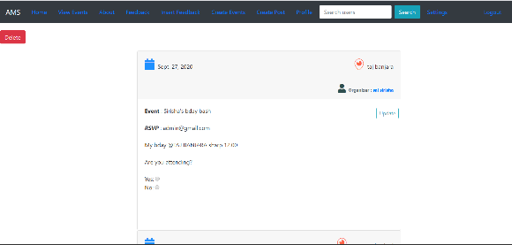

Fig. 13 View Events

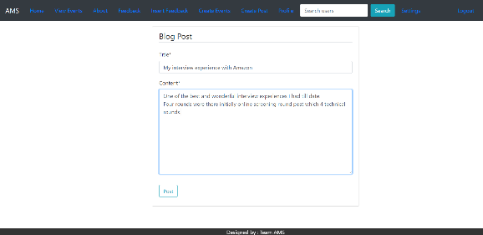

Fig.14 Create Post

The Android Application supports similar kind of functionalities. When the user opens the application the splash screen is displayed , he can login and signup to the application.

If the user tries to update his profile picture ,the file manager opens from where he can choose the picture. The screen automatically resizes based on the screen size.

The user can do all other operations similar to the what he can perform in website like search users, create/update events, view events, post feedback, create/update blog, delete blog etc.

1. CONCLUSIONS AND FUTURE WORK

The alumni management system that we propose is a centralized system for a university. Any alumnus of the university can register to the system. It removes the toil of hard work required in maintain records about the alumni. This system can be accessed from any website or mobile phone that is compatible. This system lets students currently enrolled in the university to connect with the alumni in an efficient manner. They can choose to connect to people based on their job profile, location, company working for etc.

Challenges in the system are:

* Updating and reminding users to update their profiles in timely manner
* Time commitment from leaders
* Informing new users about the events that are going to be held in future about which the notifications are already sent out.
* Real time chat and video conference among users and alumni.
* Providing a platform to ease the complete recruitment process online
* Resume filtering mechanism to process applications and find eligible candidates
* Getting users to attend the events
* Notifying attendee users on update or deletion of events

The future work that can be done in the system:

1. Addition of chatting feature that allows users to communicate with each other.
2. Users can choose to hide or block some user in chatting.
3. The users can get a detailed summary of the alumni placed in big tech giants or with highest packages.
4. The results of recruitment events can be posted on the system.
5. The system can be configured to generate a resume by asking the users to fill up some columns or forms or based upon the profile.
6. They can connect via Linkedin profiles also. There can be an option provided for the users to communicate with each other using Linkedin to get referrals.
7. We can give premium accounts for users so they can access advanced features like going live on system, webinars access etc.
8. The system can be used to take online interviews by creating a video calling feature, that might help people to give referrals to the eligible candidates after conducting screening rounds. [3] [7]

REFERENCES

[1] N Rubens et al., "Alumni network analysis," in IEEE Global Engineering Education Conference (EDUCON), 2011, pp. 606- 611.

[2] Centralized Alumni Management System (CAMS) - A Prototype Proposal

IEEE, Dept. of CSE, Techno International Batanagar, Kolkata, India

[3] K Sivaprasad, "Making best use of alumni associations for holistic development of engineering institutes," in IEEE International Conference on Engineering Education: Innovative Practices and Future Trends (AICERA), 2012, pp. 1-11.

[4] almabase. [Online]. HYPERLINK "https://www.almabase.com/" https://www.almabase.com/

[5] J E Sharp, "Work in progress: alumni mentoring of engineers in a technical communication course," in 34th Annual Frontiers in Education, 2004, pp. F2F-11.

[6] J L Huff, W C Qakes, and C B Zoltowski, "Work in progress: Understanding professional competency formation in a service learning context from an alumni perspective," in 2012 Frontiers in Education Conference Proceedings, 2012, pp. 1-3.

[7] J E Sharp, "Work in Progress: Using Mock Telephone Interviews with Alumni to Teach Job Search Communication," in Frontiers in Education. 36th Annual Conference, 2006, pp. 7- 8.