AWS Cloud Architecture
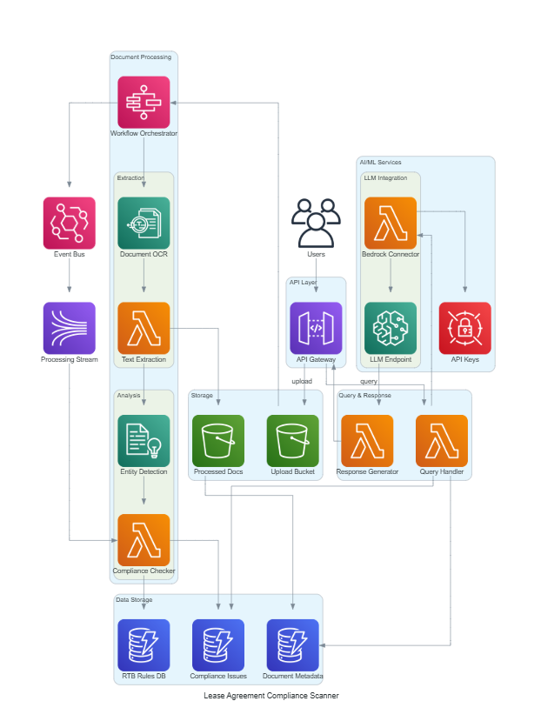

Estimated Monthly Total
$1,217 - $4,678
USD/month

Service Breakdown
S3
$50 - $200/mo
500GB storage, 10K PUT requests, 50K GET requests monthly

Lambda
$100 - $400/mo
5 functions, 100K invocations each, 512MB memory, 5s avg duration

Textract
$300 - $1200/mo
2000-8000 pages processed monthly using DetectDocumentText API

Comprehend
$150 - $600/mo
500K-2M units of text analyzed for entity recognition

Sagemaker
$400 - $1500/mo
ml.g4dn.xlarge instance running 12 hours/day or ml.m5.xlarge 24/7

Dynamodb
$80 - $300/mo
On-demand pricing, 10GB storage, 500K reads, 200K writes monthly across tables

Eventbridge
$5 - $20/mo
100K-400K custom events published monthly

StepFunctions
$50 - $150/mo
2000-5000 standard workflow executions, 10 state transitions each

APIGateway
$35 - $120/mo
100K-350K API requests monthly with data transfer

Kinesis
$45 - $180/mo
1-4 shards running continuously with moderate throughput

SecretsManager
$2 - $8/mo
3-5 secrets stored with 10K API calls monthly

