Project Title:
ClauseGuard: AI-Assisted Compliance Checking for Irish Residential Lease Agreements

Project Summary:

ClauseGuard is an AI-based system that analyses a tenant's residential lease before it is signed, with the aim of identifying potential issues and ensuring compliance with current tenancy legislation.

Each clause is identified by a Retrieval Augmented Generation model (RAG) and assessed using a rule engine against the Residential Tenancies Acts 2004-2026 and the guidance documents provided by the Residential Tenancies Board (RTB). A colour-coded result is provided for each clause, together with a clear explanation in plain English and a precise reference to the relevant legal provisions supporting each identified issue.
● What: A web application for tenant to upload lease and get a step-by-step compliance report with references and a "grounded" question and answer chat option for answering additional questions.
● Why: This system is especially applicable to the fact that in Ireland there are provisions in the leases that may not comply with the current tenancy legislation, for example with regards to the notice period, the excess of the deposit paid or waiver of the same that is illegal. There is currently no fast, cheap, and easy way for many tenants to examine their lease to see if there are any problems before they sign it.
● Who: Prospective and current tenants in the Irish private rental market, and as a secondary audience, advice services such as Threshold that currently review leases manually.
● How: a tenant uploads a PDF lease before signing, sees each clause highlighted green, amber or red within about a minute, and can ask a follow-up question such as “can my landlord end this to sell the property?” and get an answer grounded in the exact section of the Act, not a generic disclaimer.

Project Development:

The first MVP is a really simple vertical slice: upload a lease, extract clauses, return verdicts and citations based on rules (such as notice period, deposit cap, rent-review frequency etc.) that have clear numeric thresholds.

By deploying this early, we can determine if real leases examine well, if the rule engine is accurate enough to deal with quantifiable clauses, and we can tell where a language model really needs to be used. We measure clause-extraction accuracy, per-category precision and recall against a hand-labelled sample, and end-to-end latency per lease.

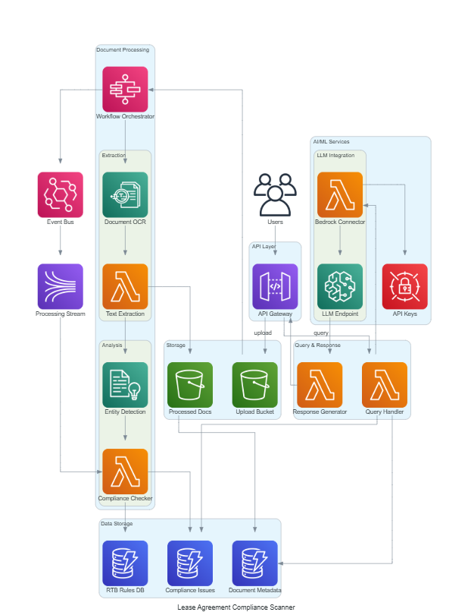

The above diagram is the closest architecture(data flow) the team has decided to work on, but as stated as we are yet to confirm our technology stack, the architecture will be finalized by the end of Sprint 1.

- How will you build your system?
o Front-end: a React app with drag-and-drop upload, a colour-coded clause report, a document-anchored PDF viewer that highlights the exact clause text, and a grounded Q&A chat panel.
o Back-end: a FastAPI service with async Celery workers, a deterministic rule engine for quantifiable clauses, a hybrid BM25-plus-dense retrieval and reranking layer for grounded classification, a citation verifier, and a conformal-prediction abstention layer so the system flags “needs review” rather than guessing.
o Data sources: the Residential Tenancies Acts 2004-2026, RTB plain-language guidance and determination orders, and the Housing (Standards for Rented Houses) Regulations 2019 - which were compiled into a version-dated knowledge base, and for which a labelled dataset of real and synthetic lease clauses was developed by the team during two rounds of annotation and checked by a second annotator.
o The technology stack put across in this documentation is yet to be finalized among the team members and will be finalized till Sprint 1.

Methodology: Scrum, daily two-commit cadence per person, a shared board, six two-week sprints, each person had one of the six rotating roles, Project Manager/Legal Research Lead, NLP/AI Engineer, Backend/Knowledge-Base Engineer, Frontend/UX Developer, QA/Data/Documentation Lead.
Evaluation:

Evaluation is quantitative, with a single held-out test set that is frozen partway through the project, meaning no result is tuned to the data that it is evaluated on.

● How: four systems — a keyword/rule baseline, a zero-shot LLM classifier, a fine-tuned classifier, and a hybrid retrieval-augmented system — are compared on the frozen test set using per-class precision, recall and F1 with bootstrapped confidence intervals, alongside cost and latency, conformal-abstention coverage, and a ten-participant usability study scored with the System Usability Scale.
● How it feeds development: a clause category with weak recall gets more labelled data or a rule-based fallback before the next sprint, and usability friction found in the study is triaged straight into the following sprint’s backlog rather than held for a final pass.

Project Management:

The project is run as a strict twelve-week Scrum schedule with GitHub as the single source of truth for code and progress.

- How: Scrum, six two-week sprints from 21 September to 13 December 2026, stand-up calls of 45min every alternate day, sprint planning, backlog refinement, review and retrospective each sprint, and a Definition of Done requiring a peer-reviewed pull request and a green CI build before any story is closed.
- Deadlines: proposal and repository sign-off by 4 Oct; architecture, schemas and CI gates by 18 Oct; first end-to-end slice by 1 Nov; test set frozen 15 Nov; full evaluation results by 29 Nov; feature freeze 30 Nov; final report, demo and submission on 13 Dec 2026.
- Success: a working system that answers all six research questions from one frozen test set, a usability score at or above the SUS benchmark of 68, and the report, code and demo submitted on time.

Tooling: GitHub is the system of record for issues, branches, pull requests and CI; Zenhub is used as the visual sprint board, populated directly from the GitHub issue set.

Team Name:
ClauseGuard — Group 3
Team Members:

Name | Student Number | Contact Number
Siddharth Varma Raja - Project Manager / Legal Research Lead | A00047237 | +353871194903  A00047237@myTUDublin.ie
Shubham Tatyasaheb Patil - NLP / AI Engineer | A00047193 | +353870675319  A00047193@myTUDublin.ie
Prasad Nitin Pansare - Backend & Knowledge-Base Engineer | A00047190 | +353894323354  A00047190@myTUDublin.ie
Kameshwara Karthik Ayyalasomayajula - Frontend / UX Developer | A00046404 | +353899882735 A00046404@myTUDublin.ie
Jude Fernandes - QA, Data & Documentation Lead | A00046791 | +353894819510  A00046791@myTUDublin.ie
Swapnil Lingaraj Prachande – Security engineer | A00049311 | +353872234057  A00049311@myTUDublin.ie

Team Meetings:

Meetings are kept short and mandatory only where the whole team needs to be aligned; everything else is optional pairing.

Our approach:
● Attendance: All 6 members, daily stand up, fortnightly sprint planning, review and retrospective, ad hoc pairing sessions are optional.
● Frequency: 45 minutes stand-up every 2 days and sprint planning, backlog refinement, review and retrospective every 2 weeks.
● Boundaries: personal conflict is not brought up in stand up – it is first discussed in private and then in the retrospective – if it is not resolved.
● Format: stand-ups and routine ceremonies are online; sprint planning and reviews are face-to-face where possible, especially the two supervisor-attended reviews.
Decisions: consensus-based (otherwise the role owner's call prevails within their own realm, legal wording, architecture, UI) and cross-cutting calls to a majority of the 6.
● Turn Taking – stand-up updates are not always the first or last, they are in the order of the story on the sprint board.

Team Conflict:

Conflict is handled early and against written references - the board, the Definition of Done, the RAID log - rather than left to escalate.

Our approach:
● Individual habits: the commit log and board make a missed commit or a silent day visible immediately, so it is raised as a fact at stand-up, not a character judgement, before it becomes a pattern.
● Unresolved issues: were not left open for an indeterminate period, but were transferred to the retrospective as an action item with an owner and a due date.
● Conflict: privately raised between person(s) involved, if not solved within a Sprint, then mediated by the Project Manager, then to the supervisor.
● Some of the ambiguity left by a conflict can be removed by avoiding it – having clear role ownership, a written Definition of Done and decisions recorded in the RAID register.
● Ultimate veto: the Project Manager on schedule and scope; on legal-content disputes, whoever completed the RTB cross-check for that item, since that decision is documented and checkable rather than a matter of opinion.

