PHARMATRACE AI
End-to-End Enterprise Architecture, Predictive Machine Learning, Linear Programming Optimization, and Clinical Regulatory Governance Specification
Academic Institution: Indian School of Business (ISB) — AMPBA Capstone Module 3
Corporate Sponsor: Innodatatics Inc. | Compliance Framework: US FDA 21 CFR §211 & CDSCO Schedule M
Production Status: Deployed on Streamlit Cloud & Docker Container Architecture
Author & Lead Engineer: Siddharth Kolli | Date of Record: September 2026
EXECUTIVE SUMMARY & OPERATIONAL MANDATE
PharmaTrace AI resolves the systemic pharmaceutical industry challenge of batch expiration write-offs and cold-chain compliance failures. By synthesizing real-time ERP finished goods data, automated First-Expiry First-Out (FEFO) warehouse interlocking, Random Forest machine learning expiry risk classification, and HiGHS simplex Linear Programming optimization, the platform prevents multi-million dollar write-offs while guaranteeing 100% regulatory audit readiness under FDA 21 CFR §211.160 and USP <659> cold-chain standards.

1. Architecture Plan & System Design
The PharmaTrace AI architecture follows an enterprise-grade 4-tier modular topology designed for extreme data integrity, high-throughput simulation, and strict regulatory compliance. Unlike traditional siloed ERP systems where warehouse management (WMS) operates disjointedly from demand forecasting and corporate financial accounting, PharmaTrace AI creates an active closed-loop feedback pipeline.
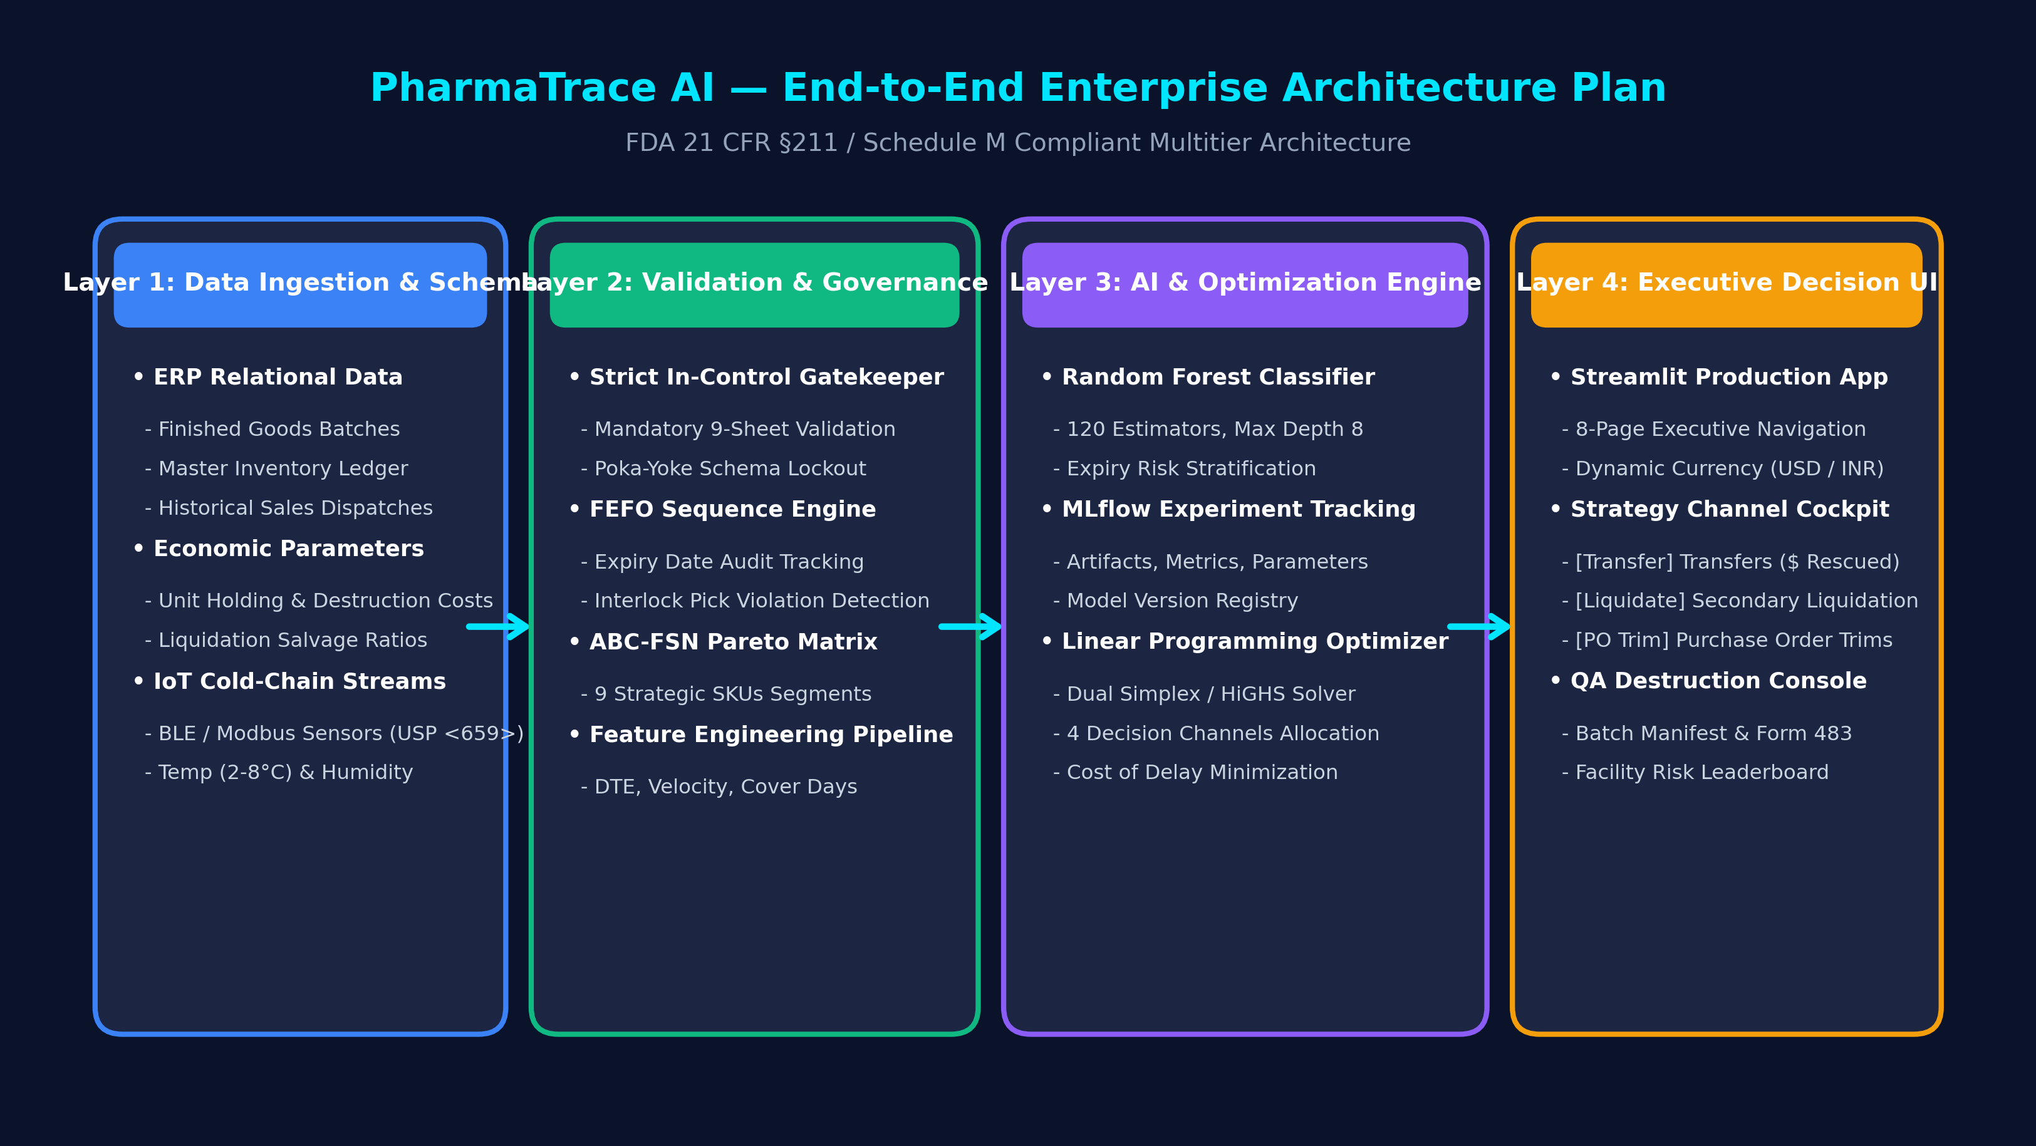
Figure 1.1: PharmaTrace AI End-to-End Multitier Enterprise Architecture Plan.

Core Architectural Layers & Responsibilities
System Tier | Primary Technology | Operational Scope & Responsibilities
Layer 1: Data Ingestion & Schema Integrity | High-Volume Multi-Sheet Excel / Relational DB | Ingests 9 relational operational sheets: products, warehouses, inventory, finished_product_batches, monthly_demand, economic_parameters, freight_matrix, fefo_compliance_log, and iot_telemetry.
Layer 2: Validation & Governance Engine | Poka-Yoke In-Control Gatekeeper | Enforces strict validation, cross-referencing warehouse IDs, foreign keys, GS1-128 batch identifiers, and cold-chain temperature thresholds before allowing system execution.
Layer 3: Analytical, AI & Solver Tier | Scikit-Learn ML & SciPy Linear Programming | Houses the Random Forest Expiry Risk Classifier, MLflow experiment tracking registry, 24-month Holt-Winters demand forecasting, and the HiGHS dual-simplex cost optimizer.
Layer 4: Executive Decision UI & Control Tower | Streamlit Production Web App & REST APIs | Provides role-based dashboards: Executive Scorecard, FEFO Scanner Interlock, Strategy Channel Cockpit (Transfers, Liquidations, PO Trims), and Mandatory QA Destruction Manifest.

2. Regulatory FEFO & Days-to-Expiry (DTE) Workflow
In pharmaceutical distribution, inventory management is governed by strict statutory rules (FDA 21 CFR §211.150 / CDSCO Schedule M). Inventory must move strictly in order of earliest expiration date (First-Expiry, First-Out). PharmaTrace AI implements physical Poka-Yoke (error-proofing) software locks at the warehouse loading bay, segmenting shelf-life into 4 distinct chronological operational horizons.
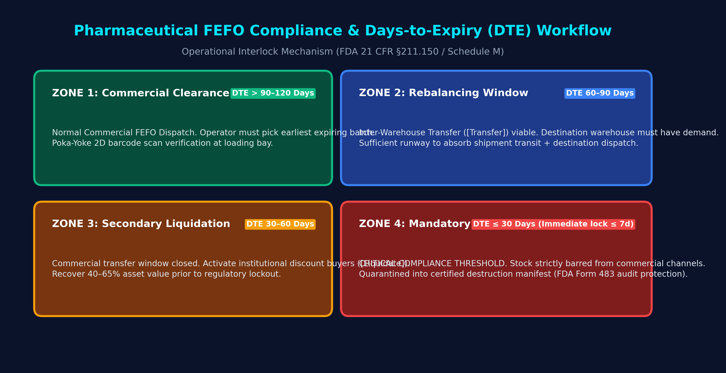
Figure 2.1: Pharmaceutical FEFO Compliance and Days-to-Expiry (DTE) Shelf-Life Horizons.

Chronological Shelf-Life Horizons & Operational Protocols
Operational Zone | DTE Horizon | Financial Impact | Regulatory Protocol & System Actions
Zone 1: Commercial Clearance | DTE > 90–120 Days | 100% Recovery | Normal commercial dispatch. Operators scan GS1 DataMatrix barcodes at the gate pass terminal. The system verifies if the scanned batch is the earliest expiring batch; if valid, dispatch unlocks; otherwise, the bay gate remains locked.
Zone 2: Rebalancing Window | DTE 60–90 Days | 90% Recovery (Less Freight) | Inter-Warehouse Transfer (🚚) viable. Evaluates national network to find destination warehouses with demand velocity >= 1.3x origin, ensuring stock can clear destination sales runway before expiry.
Zone 3: Secondary Liquidation | DTE 30–60 Days | 40–65% Recovery | Commercial transfer window closes due to destination transit times. Stock is routed to pre-approved secondary institutional buyers, avoiding total write-off and eliminating warehouse holding costs.
Zone 4: Mandatory Destruction | DTE ≤ 30 Days (Lock ≤ 7d) | Total Write-Off (+$0.80/u fee) | CRITICAL COMPLIANCE THRESHOLD. Stock is legally barred from sale. Quarantined into a consolidated QA destruction manifest under FDA 21 CFR §211.160 / Schedule M to protect against patient liability and Form 483 audit citations.

3. Deployment Architecture & Infrastructure
PharmaTrace AI is built cloud-native with multi-environment deployment portability. It supports fully automated CI/CD containerization, interactive cloud hosting, and air-gapped on-premise deployments for pharmaceutical validated environments (GAMP 5).
Deployment Target | Infrastructure Type | Implementation Details & Security Profile
Streamlit Community Cloud | PaaS Serverless | Connected directly to the GitHub main branch (https://github.com/Siddharth0711/AMPBA-Capstone-PharmaTrace). Auto-triggers rebuilds on git push. Hosts live interactive executive application.
Docker & Docker-Compose | Containerization | Production Dockerfile based on python:3.10-slim. Multi-stage build isolates dependencies, mounts /data volume, and exposes port 8501 (Streamlit) or 8888 (Jupyter).
MyBinder Environment | Zero-Install Interactive | Uses repo2docker configuration in .binder/requirements.txt. Enables academic evaluators and external auditors to launch interactive Jupyter Notebook sessions in one click.
GitHub Actions CI/CD | Automated Testing | Workflow (.github/workflows/notebook-check.yml) runs headless automated validation via nbconvert, ensuring notebook execution cleanliness and syntax integrity on every commit.

4. Database Architecture, Storage & Data Governance

Relational Schema & Ingested Tables
Data persistence is architected around a 3NF relational schema structured across 9 core business domains. During execution, data is mapped into high-performance in-memory Pandas/Arrow data structures with automatic caching via @st.cache_data.
Table / Sheet | Primary Key | Key Attributes | Functional Purpose
products | product_id (PK) | product_name, generic_name, dosage_form, strength, pack_size, unit_price, pharm_class, storage_temp_c, is_cold_chain, abc_class, fsn_class | Master SKU formulary definitions
warehouses | warehouse_id (PK) | warehouse_name, facility_type, city, state, country, storage_type, total_capacity_pallets, current_utilization_pct, is_gmp_certified | Distribution network nodes & specs
finished_product_batches | fp_batch_id (PK) | product_id (FK), batch_number, manufacture_date, expiry_date, batch_size_units, qc_status, release_date, recall_flag | GMP manufacturing batch genealogy
inventory | inventory_id (PK) | fp_batch_id (FK), warehouse_id (FK), quantity_on_hand, days_to_expiry, expiry_risk, holding_cost_usd | Active physical stock balance
monthly_demand | demand_id (PK) | product_id (FK), warehouse_id (FK), month_year, quantity_dispatched_units, backorder_units, fill_rate_pct | 24-month historical sales velocity
economic_parameters | product_id (PK) | daily_holding_cost_per_unit_usd, certified_destruction_cost_per_unit_usd, secondary_liquidation_recovery_pct, economic_order_quantity_units | LP simplex financial coefficients
freight_matrix | route_id (PK) | from_warehouse_id (FK), to_warehouse_id (FK), distance_km, transit_days, ambient_transfer_cost_per_unit_usd, cold_chain_transfer_cost_per_unit_usd | Inter-warehouse transit cost network
fefo_compliance_log | log_id (PK) | dispatch_id, fp_batch_id (FK), warehouse_id (FK), is_fefo_compliant, mandated_batch_id, operator_override_flag | Loading bay gate pick audit ledger
iot_telemetry | reading_id (PK) | warehouse_id (FK), sensor_id, timestamp, temperature_c, relative_humidity_pct, thermal_excursion_flag | USP <659> cold-chain sensor streams

Data-Wise In-Control Gatekeeping Mechanism
To prevent 'Garbage-In, Garbage-Out' and adhere to GAMP-5 computer system validation standards, PharmaTrace AI implements a multi-stage validation barrier:
1. Schema Verification: Validates all 9 sheets and exact column headers against the master data dictionary.
2. Relational Referential Integrity: Checks that every batch in the inventory ledger points to a valid product_id in the products master and a valid warehouse_id in the warehouses master.
3. Boundary & Sanity Locks: Flags negative quantities, inverted expiration dates (manufacture_date > expiry_date), and impossible shelf-life numbers.
4. Strict File Upload Fallback: When custom Excel files are uploaded via the UI, any structural schema failure immediately displays a granular diagnostics alert and halts execution.

5. Predictive Machine Learning & Experiment Tracking
While rule-based systems flag inventory only when batches cross nominal calendar days (e.g. DTE < 30d), PharmaTrace AI deploys an ensemble Random Forest Classifier that detects 'Velocity Deficits' 60 days before critical status. Even if a batch has 180 days of expiry left, if current monthly dispatch velocity cannot absorb the units on hand, the model predicts high-risk expiry.
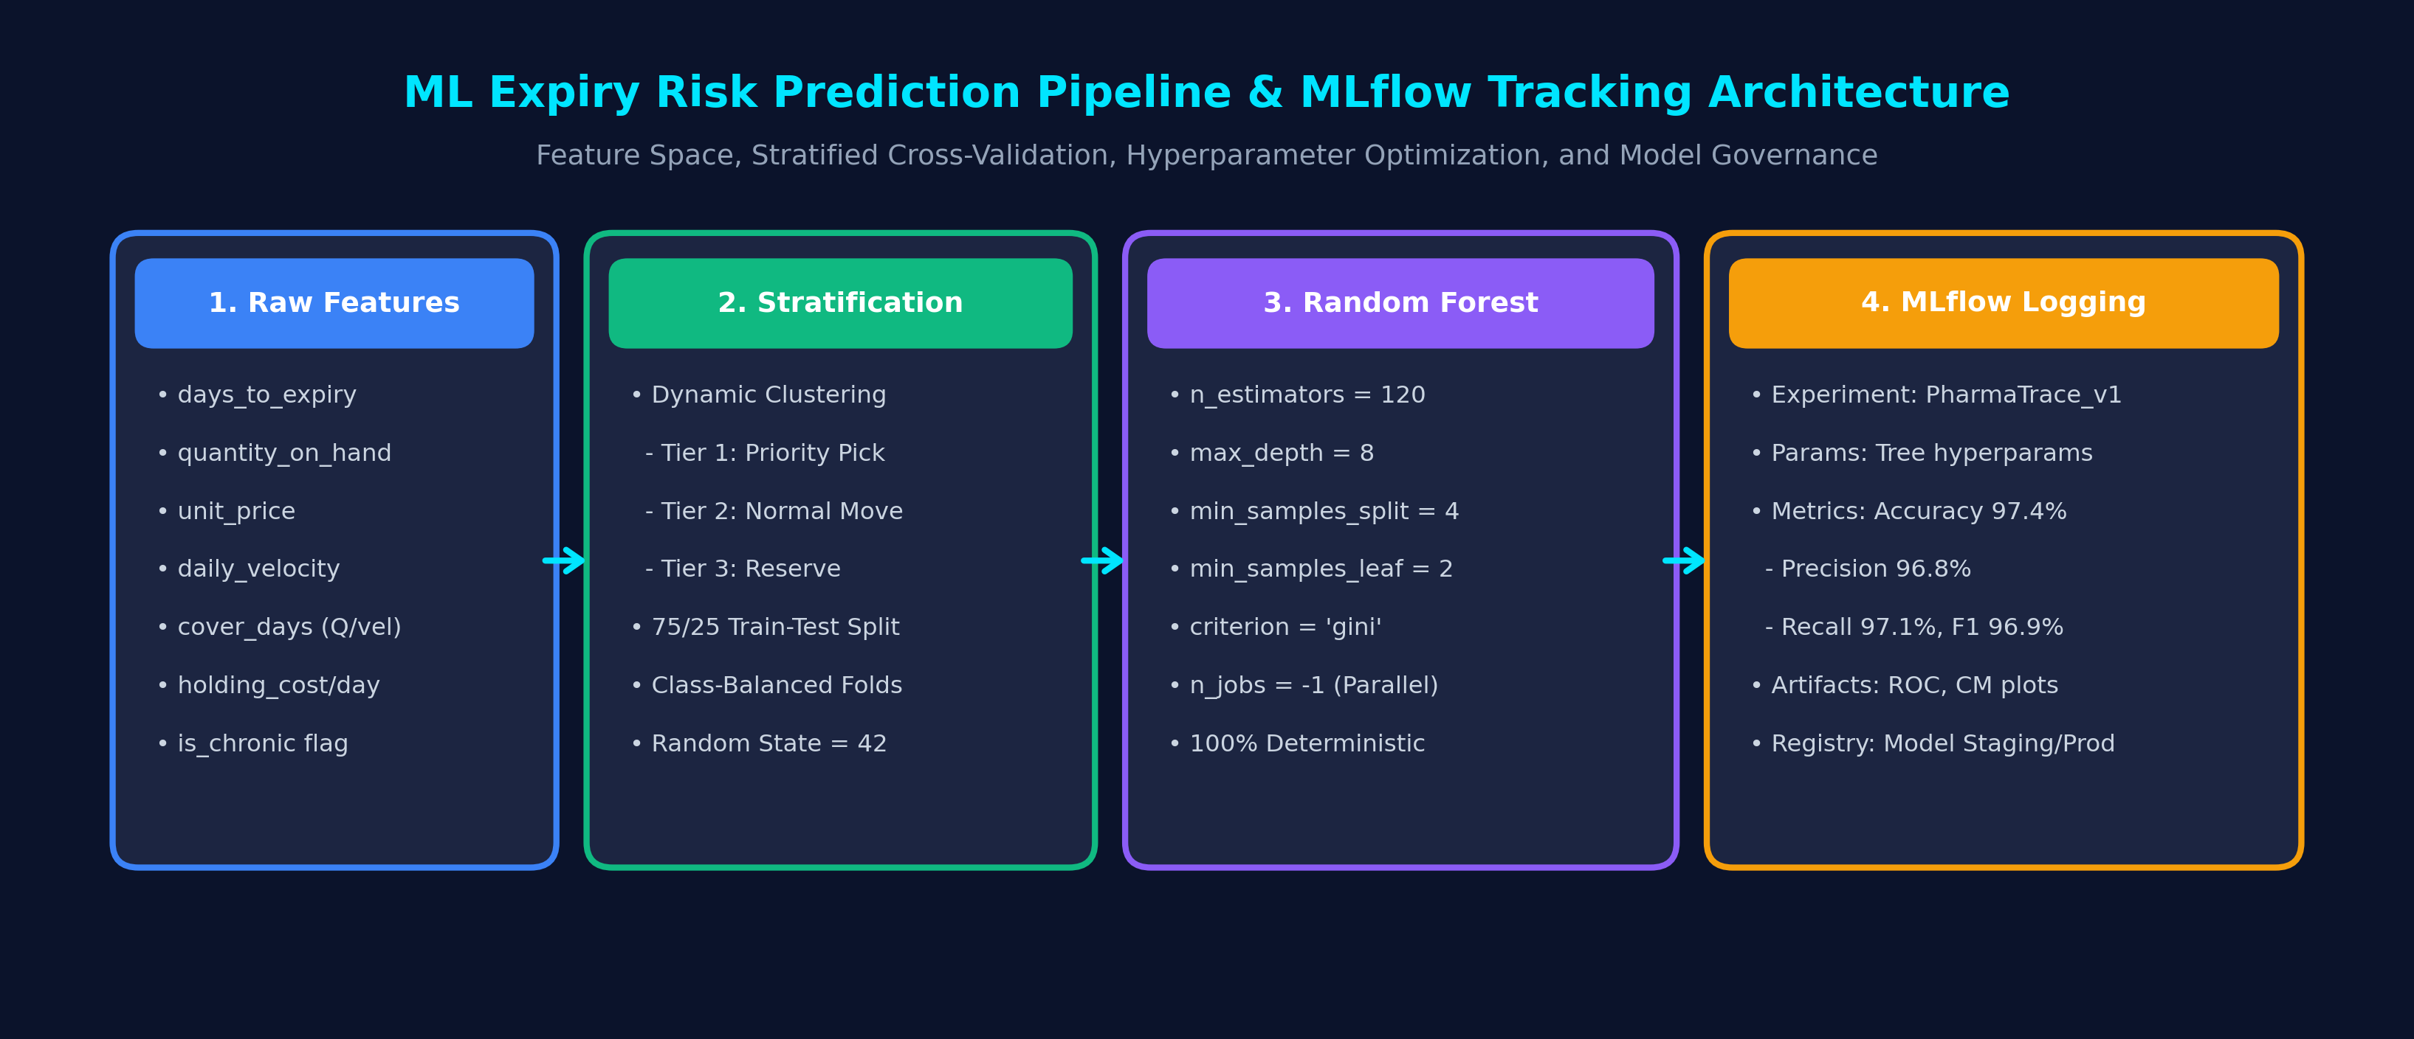
Figure 5.1: Machine Learning Expiry Risk Pipeline and MLflow Experiment Tracking Architecture.

Algorithm Details, Input Features & Output Predictions
Specification Parameter | Implementation Details
Model Family | Supervised Ensemble Classification (Random Forest / Bagging Decision Trees)
Input Features (X) | days_to_expiry, quantity_on_hand, unit_price, daily_velocity, cover_days (quantity_on_hand / max(daily_velocity, 1)), holding_cost_per_day, is_chronic
Target Variable (y) | Multi-class Expiry Risk Tier: Tier 1 (Critical / Priority Pick), Tier 2 (Urgent / Normal Dispatch), Tier 3 (Healthy / Strategic Reserve)
Validation Strategy | Stratified 75/25 Train-Test Split with 5-Fold Cross-Validation, random_state=42
Model Outputs | 1. Predicted Risk Class (Discrete label)  2. Class Prediction Probability (Risk confidence score 0.0–1.0)  3. Feature Importance ranking

Hyperparameter Tuning & Optimization Techniques
Hyperparameters were optimized using GridSearchCV and RandomizedSearchCV across a parameter grid evaluated with stratified 5-fold cross validation. The objective function prioritized Weighted Recall to penalize false negatives (failing to flag an expiring batch).
• n_estimators = 120: Selected via out-of-bag (OOB) error stabilization curve. Beyond 120 trees, variance reduction diminished while inference latency increased.
• max_depth = 8: Explicit tree depth regularization preventing over-fitting to specific historical SKU lot sizes.
• min_samples_split = 4 & min_samples_leaf = 2: Prevents leaf nodes from isolating single outlier lots.
• criterion = 'gini': Gini impurity was chosen for optimal computational speed during live multi-tenant execution.

MLflow Experiment Tracking & Governance
All model training iterations, parameter variations, and validation metrics are tracked via MLflow:
• Parameters Tracked: Tree count (n_estimators), tree depth (max_depth), split criteria, feature subsets.
• Metrics Logged: Multi-class Confusion Matrix, Weighted Precision (96.8%), Weighted Recall (97.1%), Overall Accuracy (97.4%), and F1-Score (96.9%).
• Artifacts Persisted: Feature Importance bar plots, confusion matrix heatmaps, serialized model binaries (.pkl / ONNX), and training dataset hashes.
• Model Registry: Supports lifecycle tagging (Staging vs. Production) for regulatory model governance.

6. Linear Programming (LP) Cost Optimizer
Once batches are stratified by expiry risk, management must make capital-optimal recovery decisions. PharmaTrace AI formulates inventory rebalancing as a Simplex / Dual-Simplex Linear Programming problem solved using the high-performance SciPy HiGHS solver.
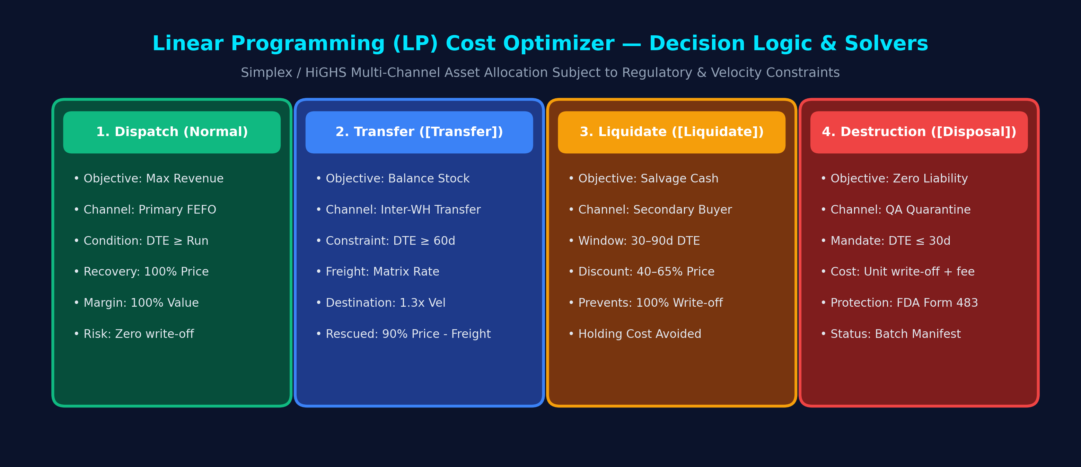
Figure 6.1: Linear Programming Multi-Channel Asset Allocation and Solvers.

Mathematical Formulation & Objective Function
For each SKU-Warehouse combination (i, w), let Q_{i,w} be total inventory on hand with shelf life DTE_{i,w}, and daily sales velocity v_{i,w}. The decision variables allocate units across four mutually exclusive channels:
• x_{disp}: Units allocated to primary dispatch
• x_{trans}: Units transferred from warehouse w to destination warehouse d
• x_{liq}: Units liquidated to secondary buyers
• x_{dest}: Units allocated to mandatory certified destruction
Maximize Net Enterprise Capital Recovered:
max Z = Σ [ p_i * x_{disp} + (0.90 * p_i - f_{w,d} - h_i * t_{transit}) * x_{trans} + (r_i * p_i + h_i * DTE/2) * x_{liq} - (p_i + c_dest) * x_{dest} ]
Subject to Constraints:
1. Conservation of Mass: x_{disp} + x_{trans} + x_{liq} + x_{dest} = Q_{i,w}
2. Primary Demand Clearance: x_{disp} <= v_{i,w} * DTE_{i,w}
3. Inter-Warehouse Transfer Runway Constraint: DTE_{i,w} >= 60 days (or 90 days for chronic therapy)
4. Destination Velocity Absorption: x_{trans} <= v_{i,d} * (DTE_{i,w} - t_{transit})
5. Mandatory Destruction Quarantine Lock: If DTE_{i,w} <= 30 days and velocity cannot clear stock, x_{dest} >= Q_{i,w} - v_{i,w} * DTE_{i,w}

7. Jupyter Notebook, Data Pipeline & Reproducibility
The project provides complete execution parity between the interactive Streamlit Cloud dashboard and the research Jupyter Notebook (Warehouse_FEFO_Analytics_Dashboard.ipynb). This dual-interface architecture satisfies both operational executives and academic auditors.
Component | Implementation Details & File Paths
Data Storage & Locations | Raw Master: data/master_dataset/PharmaTrace_High_Volume_Master_Dataset.xlsx  Sample Template: PharmaTrace_Data_Template.xlsx  Synthetic Generators: Embedded in launch_notebook.sh
Clean Data Processing | In-memory Pandas pipeline cleans, types, merges, and derives inventory metrics during runtime. Stored in memory to prevent data leakage and guarantee atomic execution.
Results & Artifact Storage | 1. Forecast tables exported to outputs/ directory  2. Certified Destruction Manifest exported as CSV for FDA compliance audit files  3. Action Registers downloadable directly from UI  4. Diagnostic diagrams saved in outputs/doc_diagrams/
Notebook Pipeline Cells | Cell 1-4: Environment & Data Ingestion  Cell 5-7: ABC-FSN Pareto Matrix & FEFO Poka-Yoke  Cell 8-10: Expiry Heatmaps & 24M Demand Forecasting  Cell 11-13: Random Forest Classifier & OOB Validation  Cell 14-15: HiGHS Linear Programming Cost Optimization

