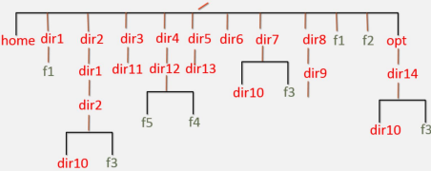

1 :- cd vboxuser
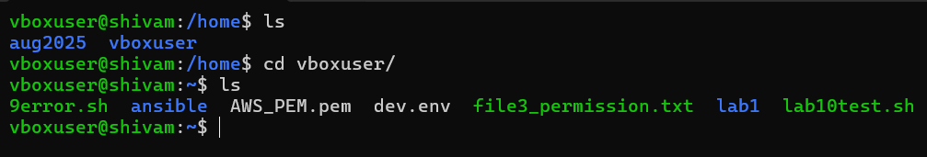

2:- mkdir dir{1..8} opt && touch file1.txt file2.txt
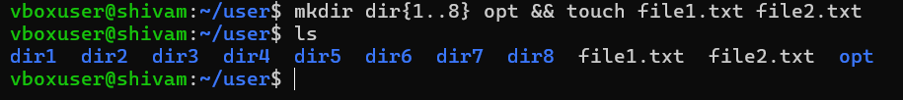

3:- touch dir1/file1
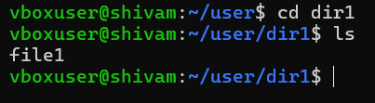

4:- mkdir -p dir2/dir1/dir2/dir10
touch dir2/dir1/dir2/f3

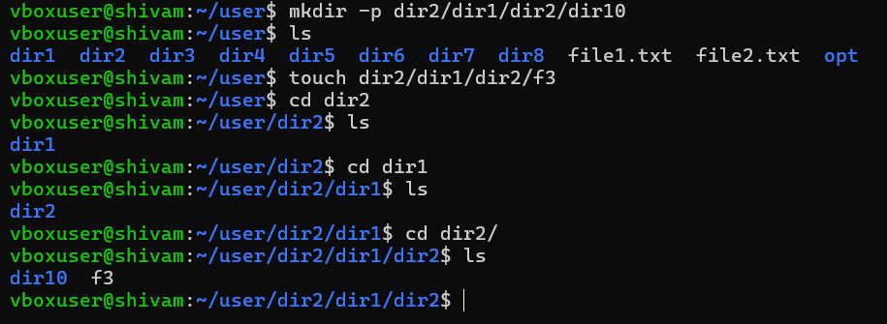

5:- mkdir dir3/dir11
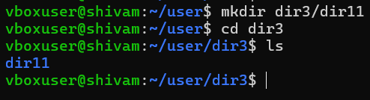

6:- mkdir -p dir4/dir12
touch dir4/dir12/f5 dir4/dir12/f4
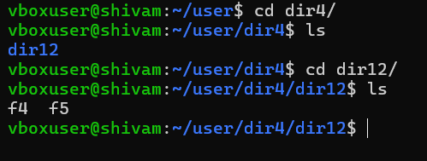

7:- mkdir dir5/dir13
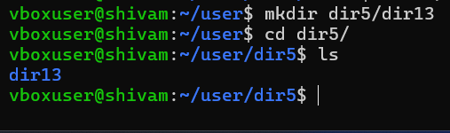

8:- mkdir dir10 && touch f3
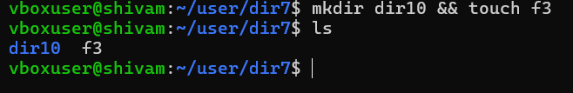

9:- mkdir -p dir8/dir9
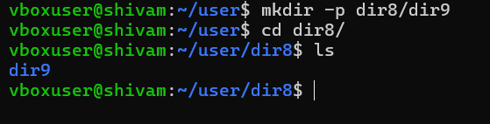

10:- mkdir -p opt/dir14/dir10
touch opt/dir14/f3
