- Search for a specific word “apple” in a file and count it.

grep -o "apple" friuts.txt | wc -l
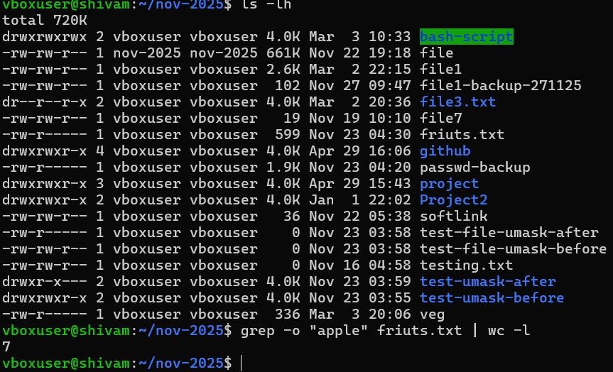

- Show current users logged in.

who
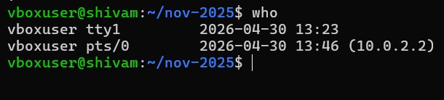

- Show total number of .txt files in current directory.

ls -1 | wc -l

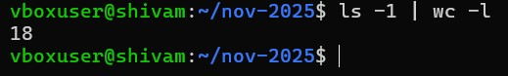

- Show list of all system users from /etc/passwd.

cat /etc/passwd
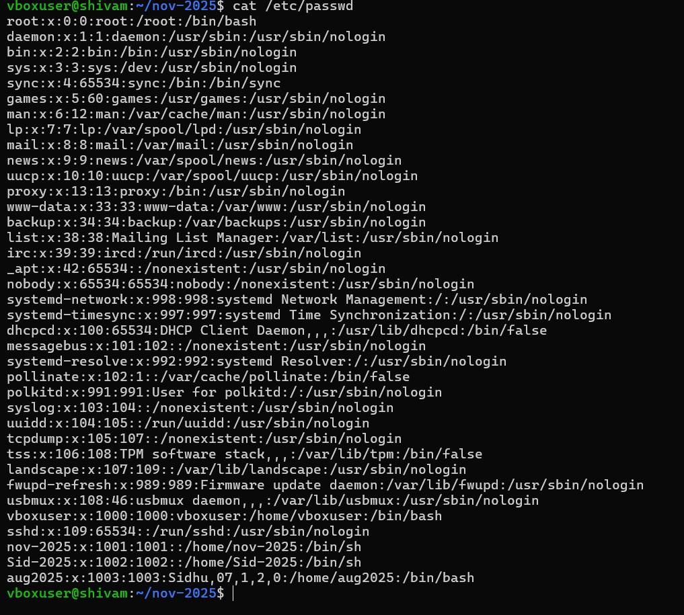

- Find how many times a word and each match should be on newline.

grep -o "word" filename.txt echo "Total count: $(grep -o "word" filename.txt | wc -l)"

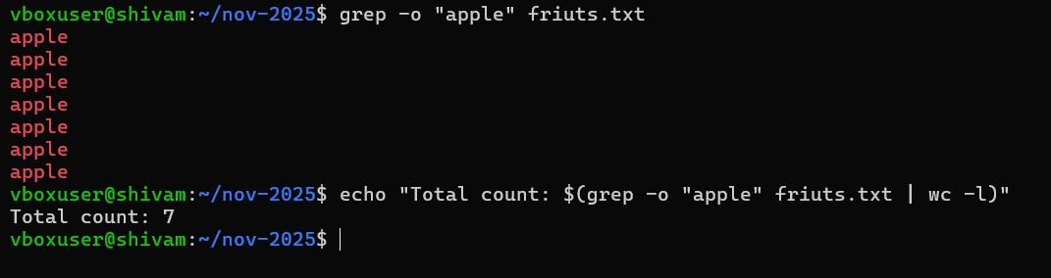
- Show running processes and search for "root".
ps aux | grep root
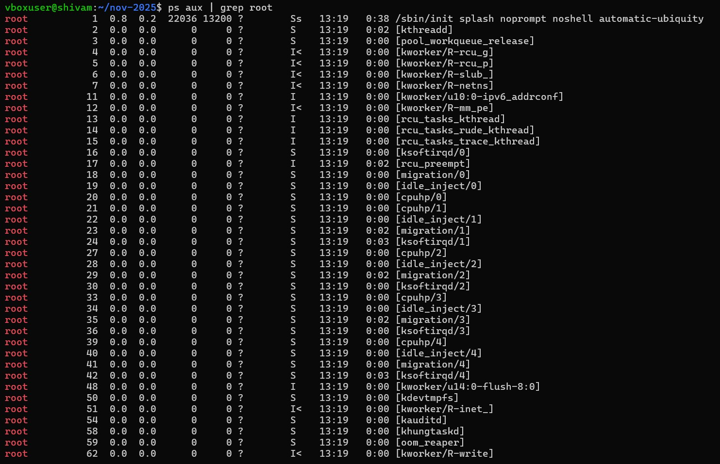
- Show only .log files and sort them alphabetically.
ls *.log | sort
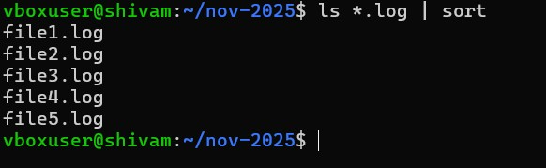
- See disk space and filter "drivers”.
df -h
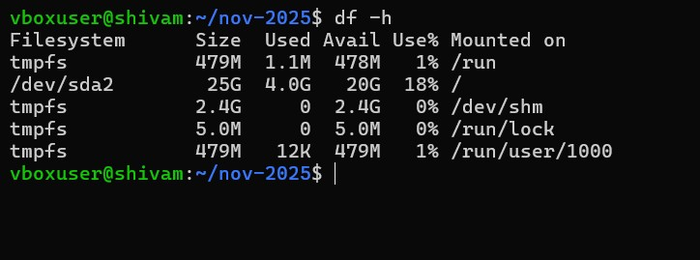
- Sort names alphabetically and remove duplicates.
sort -u friuts.txt
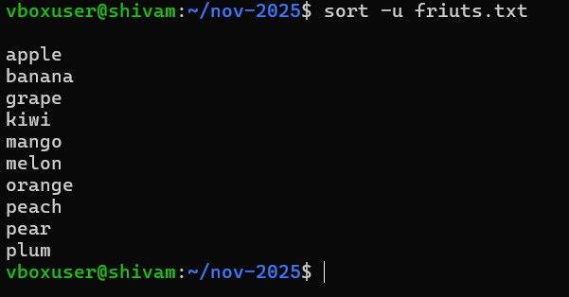
- Find all .log files modified in last 1 day.
find . -type f -name "*.log" -mtime -1
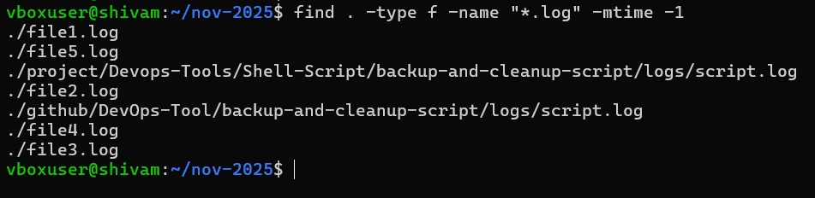
- Delete .tmp files older than 7 days.
find . -type f -name "*.tmp" -mtime +7 -delete
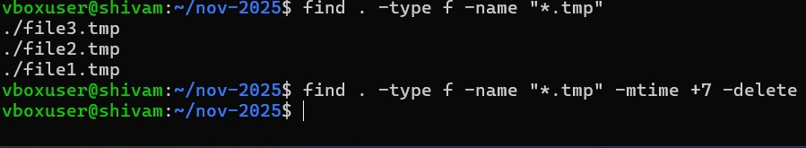
- Count how many .java files exist in a project.
find . -type f -name "*.java" | wc -l
