LCHS4003 Component 1 Portfolio
Task 1: Mini Report – Community Mental Health Services
Task 2: Essay – Ambulance Services

Student name: [Your Name]
Student number: [Your Student Number]
Module code and title: LCHS4003 – [Insert Module Title]
Lecturer: [Lecturer’s Name]
Assignment title: Component 1 Portfolio (Mini Report + Essay)
Submission date: [Submission Date]
Word count: Task 1 = 600 words; Task 2 = 600 words (excluding title page, report header, figures, captions and references)

Task 1: Mini Report
To: Councillor [Full Name], [Ward Name] Ward, [Local Authority Name], [Council Address]
Subject: Addressing the Shortage of Community Mental Health Services in [Local Area]
Prepared by: [Student Name]
Date: [Submission Date]

1. Introduction
Community mental health services (CMHS) support adults with mental illness close to their homes. They include community teams, crisis support, psychological therapies and social care assessments. NHS England (2019) describes a place-based model linking primary care, specialist teams, councils and voluntary groups. However, this report responds to a shortage of these services within the borough. It explains why the service is needed and how the shortage affects residents. It then recommends realistic and achievable actions for the local authority. The Care Act 2014 forms the legal basis for every recommendation. Its Part 1 duties make wellbeing and prevention central to council decisions (Department of Health and Social Care [DHSC], 2025).

2. Impact on the Community
National evidence shows a local shortage would cause serious harm. The Care Quality Commission (CQC, 2025) surveyed more than 14,000 people using community mental health services. Four in ten respondents felt they had waited too long for care. Furthermore, 42% said their mental health worsened while waiting, rising to 71% after six months. Long waits also push people towards emergency services instead of planned care. In one survey, 78% of people waiting contacted emergency or crisis services (Royal College of Psychiatrists [RCPsych], 2022). The report linked these hidden waits to national shortages of psychiatrists. Therefore, a local shortage moves pressure onto A&E departments, ambulance crews and police.
The Dahlgren and Whitehead (2021) model of health determinants explains the wider community effects. It shows that health depends on lifestyle, social networks, living conditions and wider policy. Without support, people may lose jobs, tenancies and social contacts. These losses then deepen poor mental health and isolation, while unpaid carers absorb extra strain. Marmot et al. (2020) found people in deprived areas live shorter lives with more ill health. A shortage is therefore likely to widen existing local inequalities. This conflicts with the wellbeing principle in section 1 of the Care Act 2014. That principle includes emotional wellbeing, relationships, suitable accommodation and participation in work.

3. Recommendations
First, the council should commission early support under its prevention duty. Section 2 of the Care Act 2014 requires councils to prevent, reduce or delay care needs. Funding should support community hubs, peer support and voluntary sector “waiting well” programmes.
Second, the council should expand joint working with local NHS partners. Section 3 requires councils to promote integration between health and social care. Social workers should join integrated primary and community mental health teams (NHS England, 2019).
Third, timely needs assessments should be protected through dedicated staffing capacity. Section 9 requires an assessment wherever an adult appears to need care and support. Faster assessments would identify eligible needs earlier and reduce avoidable deterioration (DHSC, 2025).
Fourth, the council should strengthen information and advice under section 4. A local directory should list crisis lines, support groups and housing advice. This would guide people on waiting lists towards suitable help.
Finally, investment should follow the principle of proportionate universalism (Marmot et al., 2020). Resources should be targeted towards wards with the highest deprivation and need. Progress should be monitored through waiting times, crisis contacts and service user feedback. Figure 1 links each recommendation to its supporting Care Act duty.
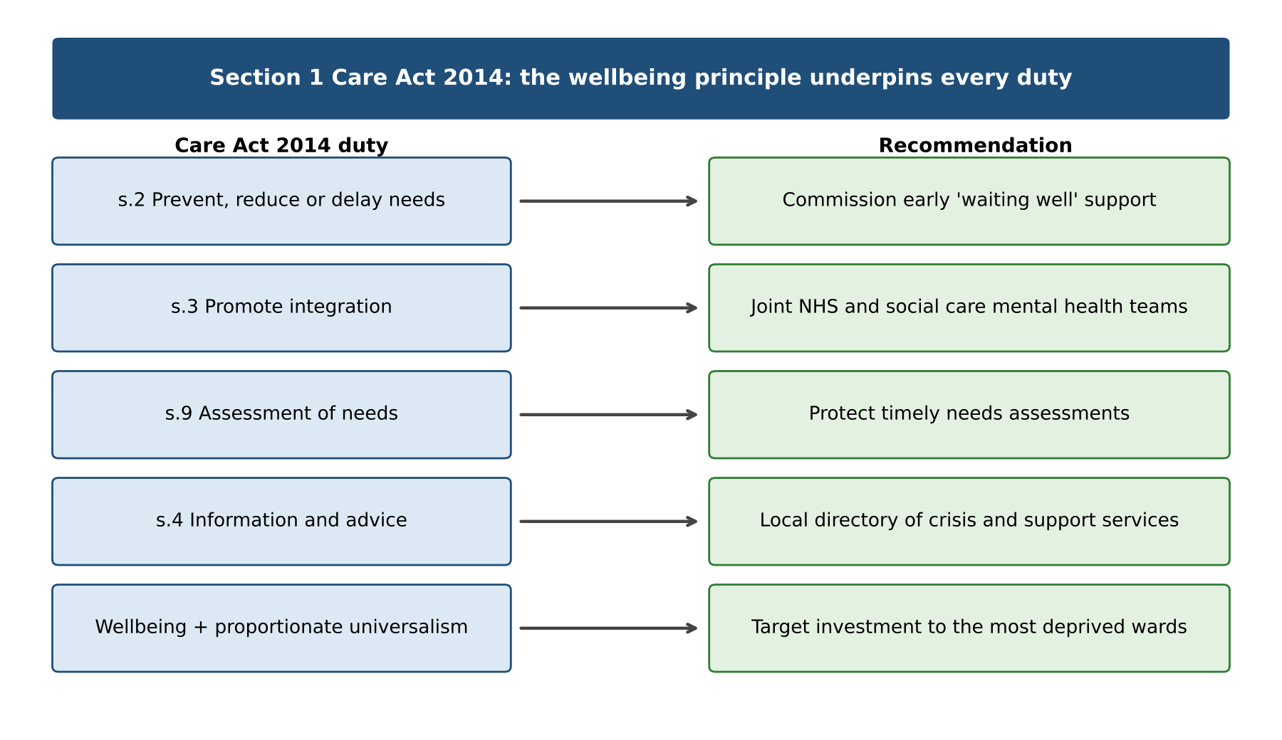
Figure 1: Care Act 2014 duties linked to the report’s recommendations (author’s own, based on Care Act 2014; DHSC, 2025; Marmot et al., 2020)

4. Conclusion
Community mental health services protect wellbeing, independence and social inclusion. A shortage causes longer waits, worsening symptoms and greater pressure on emergency services. It also widens health inequalities between affluent and deprived neighbourhoods. The Care Act 2014 gives the council clear duties to respond. The councillor is therefore advised to support prevention funding, integrated teams and targeted investment. These steps are realistic, lawful and likely to improve outcomes for residents.
Word count (Task 1): 600

Task 2: Essay
Ambulance Services in England: History, Function and Significance for Service Users

Introduction
Ambulance services provide urgent and emergency care to people outside hospital. In England, NHS ambulance trusts answer 999 calls and respond to patients across regions. Their workforce includes call handlers, emergency medical technicians and registered paramedics. Their role has changed since the creation of the NHS. Eaton (2023) describes modern ambulance services as mobile healthcare providers rather than transport services. This essay explains how the service originated, developed and operates today. It then critically evaluates its strengths and limitations for service users. The essay argues that ambulance services remain vital, but wider system pressures limit their effectiveness.

Historical Context and Current Function
Before the National Health Service, ambulance provision was patchy and often depended on voluntary bodies. After 1948, the NHS made ambulances available to everyone who needed them (London Ambulance Service, no date). However, early services focused mainly on transporting patients rather than treating them. From the early 1970s, trained paramedics began delivering emergency care in southern England (Eaton, 2023). This shift was significant because treatment could now begin at the scene. Since 2000, paramedics have required professional registration, and their title is protected by law. An honours degree is now required to join the paramedic register (Eaton, 2023). Independent prescribing followed in 2018, widening their clinical role further. These changes reflected shifting demand, as only around 8% of 999 calls are life-threatening (Eaton, 2023). Figure 2 summarises the key historical milestones of the service.
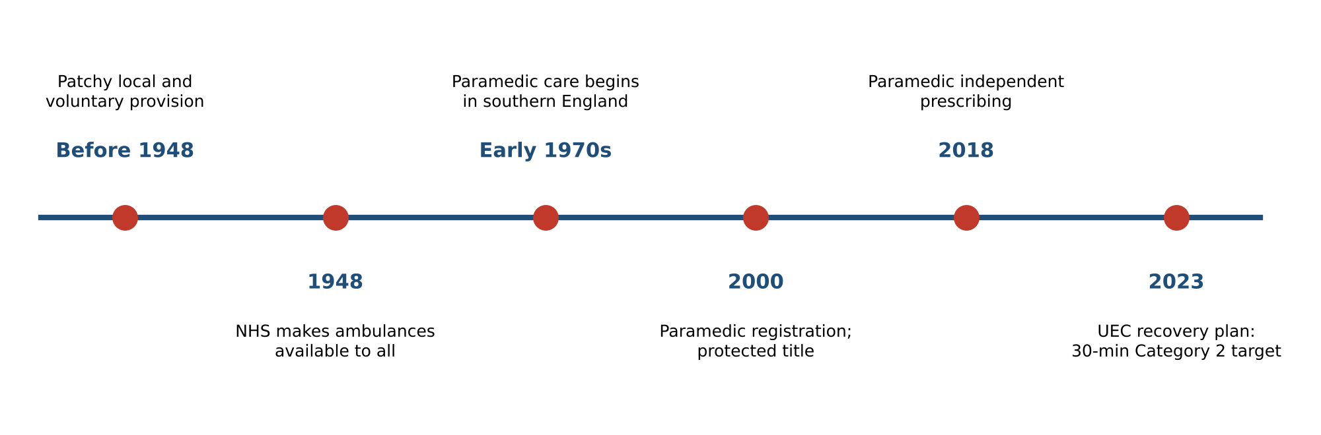
Figure 2: Key milestones in the development of ambulance services in England (author’s own, based on London Ambulance Service, no date; Eaton, 2023; NHS England and DHSC, 2023)
Today, emergency calls are triaged into response categories according to clinical urgency. The standard for life-threatening Category 1 calls is a mean response of seven minutes (NHS England, 2025). In September 2025, 18.1% of incidents were closed through “hear and treat” telephone advice (NHS England, 2025). A further 28.4% were treated at the scene without hospital transport. Only 48.9% of patients were conveyed to an emergency department (Figure 3).
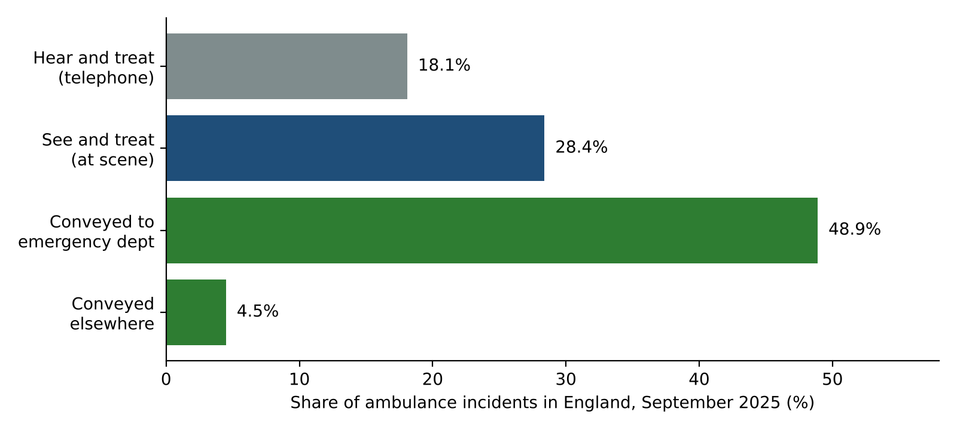
Figure 3: Outcomes of ambulance incidents in England, September 2025 (author’s own, data from NHS England, 2025)

Critical Evaluation and Significance for Service Users
Eaton (2023) contrasts the Anglo-American “scoop and run” model with the Franco-German “stay and stabilise” model. England now blends both approaches, which is a major strength for service users. Treating people at home avoids unnecessary admissions and supports independence and quality of life. The 999 service is free, available all day and accessible to everyone. Paramedics in general practice may also reduce pressure on general practitioners (Eaton et al., 2020). However, the same review found limited evidence about their clinical contribution.
Eaton (2023) also argues that ambulances act as a safety net for gaps elsewhere. Crews increasingly respond to mental health crises, chronic illness and unmet social care needs. Lord Carter’s review found unwarranted variation between ambulance trusts (NHS Improvement, 2018). Hospital handover delays create a further risk to patient safety. Over eight in ten patients delayed beyond one hour were potentially harmed (AACE, 2021). These delays keep crews at hospitals and slow responses to new emergencies. As a result, fewer crews are available for the wider community. In September 2025, Category 2 calls averaged 30 minutes and 46 seconds (NHS England, 2025). This missed the temporary 30-minute recovery target (NHS England and DHSC, 2023). Therefore, patient outcomes depend on the whole health and care system, not ambulances alone.

Conclusion
Ambulance services have evolved from transport into a clinical, mobile healthcare system. Registration, degree education and prescribing rights have strengthened the paramedic role. Hear and treat and see and treat now help many people avoid unnecessary hospital visits. However, handover delays and rising demand still limit timely emergency care. Improving quality of life therefore requires investment across hospitals, community services and social care. Ambulance services cannot solve these pressures alone, but they remain essential for public safety.
Word count (Task 2): 600

Reference List
Association of Ambulance Chief Executives (AACE) (2021) Delayed hospital handovers: impact assessment of patient harm. London: AACE. Available at: https://aace.org.uk/hospital-handovers/ (Accessed: 22 October 2026).
Care Act 2014, c. 23. Available at: https://www.legislation.gov.uk/ukpga/2014/23/contents (Accessed: 22 October 2026).
Care Quality Commission (CQC) (2025) High demand, long waits, and insufficient support mean people with mental health issues still not getting the support they need. Press release, 3 April. Available at: https://www.cqc.org.uk/press-release/high-demand-long-waits-and-insufficient-support-mean-people-mental-health-issues (Accessed: 22 October 2026).
Dahlgren, G. and Whitehead, M. (2021) ‘The Dahlgren-Whitehead model of health determinants: 30 years on and still chasing rainbows’, Public Health, 199, pp. 20–24. Available at: https://doi.org/10.1016/j.puhe.2021.08.009.
Department of Health and Social Care (DHSC) (2025) Care and support statutory guidance. Updated 22 July 2025. Available at: https://www.gov.uk/government/publications/care-act-statutory-guidance/care-and-support-statutory-guidance (Accessed: 22 October 2026).
Eaton, G. (2023) ‘Addressing the challenges facing the paramedic profession in the United Kingdom’, British Medical Bulletin, 148(1), pp. 70–78. Available at: https://doi.org/10.1093/bmb/ldad024.
Eaton, G., Wong, G., Williams, V., Roberts, N. and Mahtani, K.R. (2020) ‘Contribution of paramedics in primary and urgent care: a systematic review’, British Journal of General Practice, 70(695), pp. e421–e426. Available at: https://doi.org/10.3399/bjgp20X709877.
London Ambulance Service (no date) Our history: a timeline. Available at: https://www.londonambulance.nhs.uk/about-us/our-history/our-history-a-timeline/ (Accessed: 22 October 2026).
Marmot, M., Allen, J., Boyce, T., Goldblatt, P. and Morrison, J. (2020) Health equity in England: the Marmot review 10 years on. London: Institute of Health Equity. Available at: https://www.instituteofhealthequity.org/resources-reports/marmot-review-10-years-on (Accessed: 22 October 2026).
NHS England (2019) The community mental health framework for adults and older adults. London: NHS England and NHS Improvement, National Collaborating Centre for Mental Health. Available at: https://www.england.nhs.uk/wp-content/uploads/2019/09/community-mental-health-framework-for-adults-and-older-adults.pdf (Accessed: 22 October 2026).
NHS England (2025) Ambulance quality indicators: statistical note, September 2025 data. Published 9 October 2025. Available at: https://www.england.nhs.uk/statistics/wp-content/uploads/sites/2/2025/10/20251009-Note-Statistical-AQI-1.pdf (Accessed: 22 October 2026).
NHS England and Department of Health and Social Care (DHSC) (2023) Delivery plan for recovering urgent and emergency care services. London: NHS England. Available at: https://www.england.nhs.uk/publication/delivery-plan-for-recovering-urgent-and-emergency-care-services/ (Accessed: 22 October 2026).
NHS Improvement (2018) Operational productivity and performance in English NHS ambulance trusts: unwarranted variations. London: NHS Improvement. Available at: https://www.england.nhs.uk/wp-content/uploads/2019/09/Operational_productivity_and_performance_NHS_Ambulance_Trusts_final.pdf (Accessed: 22 October 2026).
Royal College of Psychiatrists (RCPsych) (2022) Hidden waits force more than three quarters of mental health patients to seek help from emergency services. 10 October. Available at: https://www.rcpsych.ac.uk/news-and-features/latest-news/detail/2022/10/10/hidden-waits-force-more-than-three-quarters-of-mental-health-patients-to-seek-help-from-emergency-services (Accessed: 22 October 2026).

