PROJECT TITLE
Evaluating the Role of Air Quality Management in Advancing Sustainable Urban Development: Evidence from Major UK Cities

Abstract
UK air pollution is falling, yet guideline breaches and unequal exposure remain (Gadenne et al., 2024; Weber & Dacre, 2025). This project asks how major UK cities manage air quality and how this supports sustainable urban development. It uses an interpretivist, inductive design with secondary documents and reflexive thematic analysis (Braun & Clarke, 2021). The expected outcome is a set of defined themes that compare cities. Findings may help authorities design fairer, better justified clean air policies within a realistic six-week, low-cost plan.

AIMS
- To describe how major UK city authorities and official bodies frame the purpose of air quality management.
- To identify the measures that cities implement and the outcomes they report.
- To examine how health, equity, transport and economic dimensions of sustainable development appear in these documents.
- To interpret similarities and differences between cities and draw implications for policy and practice.

HYPOTHESIS
Because the design is inductive, these are working propositions, open to refinement or rejection (Saunders et al., 2023).
Hypothesis 1: City documents justify air quality management mainly through public health, while equity and economic benefits appear less often. This reflects the health basis of the WHO (2021) guidelines and national targets.
Hypothesis 2: Official city reports describe scheme outcomes more positively than independent peer-reviewed evaluations do. For example, Transport for London (TfL, 2025) models large reductions, while Williams et al. (2025) found no significant effect in Sheffield.
Hypothesis 3: Documents present fleet renewal and vehicle compliance as key mechanisms behind reported improvements. Williams et al. (2025) linked Sheffield's reductions likely to fleet modernisation.

BACKGROUND
The World Health Organization (WHO, 2021) lowered its annual PM2.5 guideline to 5 µg/m³. England's legal target is 10 µg/m³ by 2040, with a 35% cut in population exposure from 2018 (Environmental Targets (Fine Particulate Matter) (England) Regulations 2023). In the UK, long-term outdoor air pollution is estimated to contribute to 29,000 to 43,000 deaths annually (Office for Health Improvement and Disparities [OHID], n.d.). These health risks explain why guidelines tightened and why local action matters (WHO, 2021).
UK air quality has improved markedly in the last decade, according to national monitoring data (Weber & Dacre, 2025). Median days breaching the WHO target fell from 136 to 40 for nitrogen dioxide (NO₂) between 2015–16 and 2023–24. For PM2.5 they fell from 60 to 22, but ozone breach days rose from 7 to 14. Average PM2.5 exposure in England fell by 54% from 2003 to 2023 (Gadenne et al., 2024). Even so, the most deprived fifth of areas had 8% higher exposure in 2023 (Gadenne et al., 2024). All UK zones met the legal PM2.5 limit value in 2023 (Department for Environment, Food & Rural Affairs [Defra], 2024). Legal compliance and WHO guidelines therefore remain quite different standards.
Evidence on the effects of city clean air schemes is mixed. TfL (2025) estimates that the Ultra Low Emission Zone (ULEZ) lowered roadside NO₂ by 27% against a no-ULEZ scenario. Liu et al. (2023) found modest but significant NO₂ reductions after Birmingham's Clean Air Zone. In contrast, Williams et al. (2025) found no significant zone-specific reduction in Sheffield.
These studies measure pollutant outcomes quantitatively, at national or single-city scale. The studies cited here do not compare how different cities frame and justify air quality management within sustainable development. Yet Sustainable Development Goal 11.6 asks cities to reduce their environmental impact, with special attention to air quality (United Nations, 2015). Without interpretive evidence, lessons from one scheme may transfer poorly to another city.
The task is to synthesise public documents from major UK cities and interpret how they frame clean air action. The suggested strategy is document analysis, which is efficient, available and cost-effective for policy texts (Bowen, 2009). Figure 1 shows the conceptual framework that guides this analysis.
In the framework, WHO (2021) standards shape city measures, which influence health, equity, transport and economic outcomes. Monitoring and reporting then feed back into revised city measures and targets. This is my own synthesis of the cited sources, and it only sensitises the analysis.
Figure 1
Conceptual Framework Linking Standards, City Measures and Sustainable Urban Development
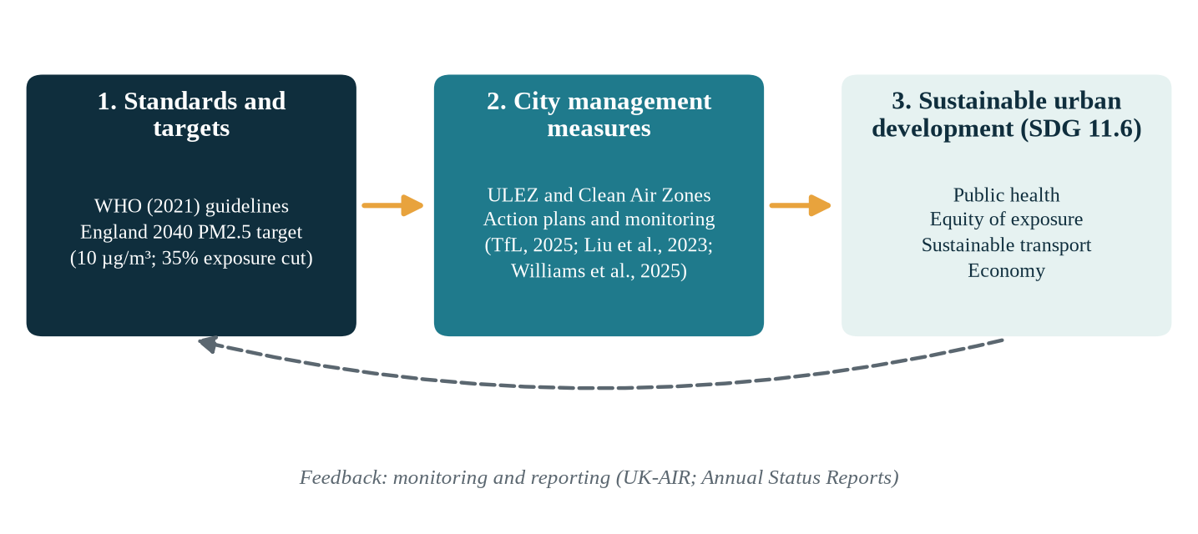
Note. Author's synthesis based on World Health Organization (2021), Transport for London (2025), Liu et al. (2023), Williams et al. (2025) and United Nations (2015).
[INSERT YOUR PREVIOUSLY MARKED LITERATURE REVIEW HERE AS AN IMAGE. It is not counted in the word limit. Delete this box after inserting.]

RESEARCH PROJECT

Materials and Methods
This project uses an interpretivist philosophy, because policy meaning is socially constructed in documents (Saunders et al., 2023). The approach is inductive, so themes will come from the data rather than from tested theory. The design is mono-method qualitative, using archival and documentary research with a cross-sectional time horizon (Saunders et al., 2023). Figure 2 maps each methodological choice onto a layer of the research onion.
Figure 2
Research Onion Applied to This Project
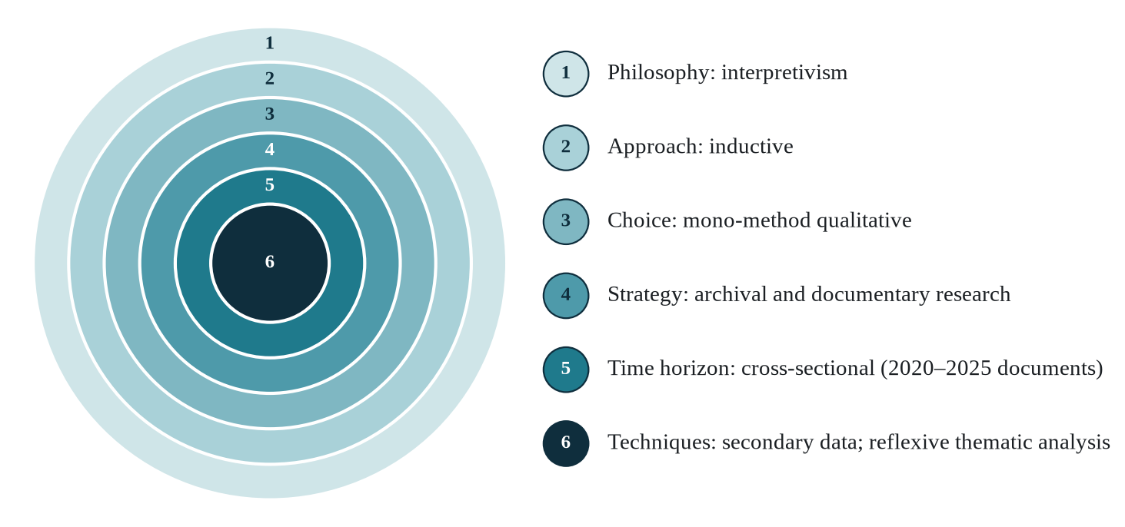
Note. Adapted from Saunders et al. (2023).
The materials are public secondary documents published from 2020 onwards. They include Defra and UK-AIR reports and Department for Transport traffic statistics. Office for National Statistics data will provide population and deprivation context. City Annual Status Reports and scheme evaluations will form the core corpus. Peer-reviewed journal articles will add independent evidence on how well schemes work. Reputable newspapers will be used only to triangulate how the public and politicians frame these measures.
Sampling is purposive, because I need cities that have actually introduced clean air measures. Four to six major cities will be chosen, such as London, Birmingham, Sheffield, Bristol, Manchester and Glasgow. About 30 to 40 documents will be screened against clear criteria in the first two weeks. Documents are included if they are recent, official or peer-reviewed, publicly available and about air quality management. Unsourced, advocacy, non-UK and duplicate documents are excluded to protect credibility.
Analysis follows the six phases of reflexive thematic analysis (Braun & Clarke, 2021). I will read each document closely, code it inductively, generate and review themes, then define and write them up. In reflexive thematic analysis, themes are patterns of shared meaning built around a central idea (Braun & Clarke, 2021). The researcher's interpretive role is treated as a resource, not a bias to remove. NVivo or a structured spreadsheet will manage the codes and extracts for each theme. A reflexive journal and audit trail will make my interpretations transparent.
These methods suit the question because it asks how and why, not how much (Saunders et al., 2023). Existing quantitative studies already measure pollution outcomes, so another measurement study would add little (Liu et al., 2023; Weber & Dacre, 2025). However, documents can lack detail or reflect institutional bias, which limits what they reveal (Bowen, 2009). I will reduce this risk by triangulating official and peer-reviewed sources. Trustworthiness will follow four criteria: credibility, transferability, dependability and confirmability (Lincoln & Guba, 1985). Credibility will come from triangulation, and dependability from a documented screening log and audit trail. Transferability will rest on thick description of each city's context. Remaining limitations include the lack of stakeholder voices and the institutional purpose of documents.
Only public documents are used and no humans participate, so ethical risk is low. I will confirm exemption with my supervisor in Week 1 and cite every source accurately.

Expected Outcomes
The study should produce a code book, a thematic map and a cross-city interpretation. These outcomes are anticipated, so they are expectations rather than findings already established. I expect health to dominate the justification, with equity and economic aims less visible (Hypothesis 1). I expect official reports to describe outcomes more favourably than independent evaluations (Hypothesis 2). I also expect fleet compliance to recur as a key mechanism (Hypothesis 3; Williams et al., 2025). Any evidence that contradicts these expectations will be reported openly in the final report.

Benefits
Academically, the study offers interpretive evidence that complements quantitative evaluations (Liu et al., 2023; Weber & Dacre, 2025). City authorities may gain transferable lessons on framing and implementing clean air measures. Policymakers may see more clearly how equity features, given persistent exposure gaps (Gadenne et al., 2024). Residents may benefit from clearer accountability for clean air decisions.

Significance and Innovation
The project is original because it examines how cities justify air quality management, not only whether pollution falls. It links clean air policy to Sustainable Development Goal 11.6 (United Nations, 2015). Its framework connects standards, city measures and sustainability dimensions, as Figure 1 shows. Methodologically, it applies reflexive thematic analysis to policy documents with a transparent audit trail (Braun & Clarke, 2021). The findings may also help explain why similar schemes perform differently in Birmingham and Sheffield (Liu et al., 2023; Williams et al., 2025).

ROLE OF PERSONNEL
The study needs three roles, and Table 1 summarises their responsibilities and time.
Table 1
Personnel, Responsibilities and Duration
Role | Responsibilities | Duration
Student researcher | Designs the protocol; collects, codes and analyses documents; writes the report | 6 weeks, about 25 hours per week
Supervisor | Reviews the protocol, theme maps and draft; confirms ethics exemption | About 12 hours in total
Librarian (optional) | Advises on database access and search strategy | About 3 hours in Weeks 1–2

BUDGET
Costs are low because secondary data removes participant payments, travel and transcription (Bowen, 2009).
Table 2
Proposed Budget (Indicative, in Australian Dollars)
Item | Detail | Cost (AUD)
Student researcher | 150 hours at $35 per hour (in-kind) | 5,250
Supervisor | 12 hours at $90 per hour (in-kind) | 1,080
Librarian | 3 hours at $60 per hour (in-kind) | 180
Computer and backup | Existing equipment and university storage | 0
NVivo and Zotero | University licence and free reference manager | 0
Paywalled articles | Document delivery for sources not openly available | 150
Total | $150 cash and $6,510 in-kind | 6,660

Hourly rates are assumed for costing purposes and are not official salary scales. Cash costs are limited to paywalled sources, which justifies the small request.

TIMEFRAME
The project runs for six weeks, as Figure 3 shows. Weeks 1 and 2 cover scoping, the ethics check, the literature review and source screening. Coding and theme development occupy Weeks 3 to 5, following Braun and Clarke (2021). Week 6 covers interpretation, writing and dissemination, including a recorded presentation. The scope is realistic because about 30 to 40 public documents suit one researcher's capacity in this period.
Figure 3
Six-Week Gantt Chart
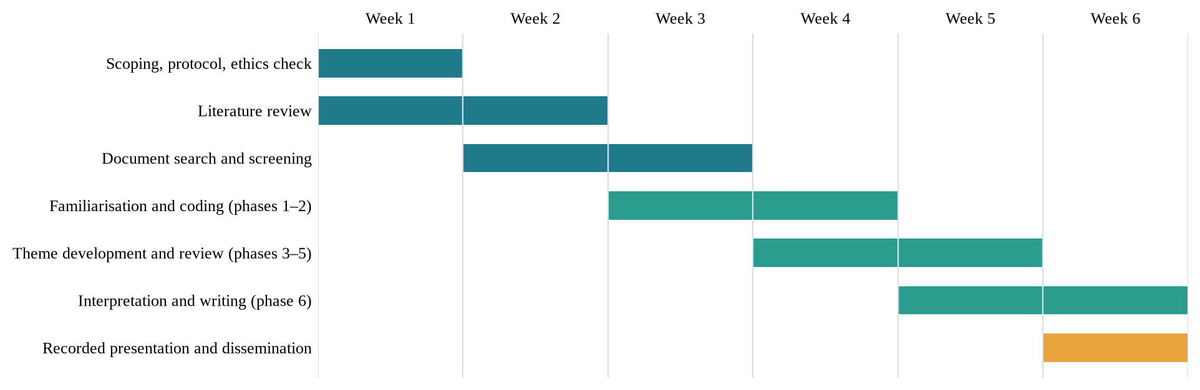
Note. Phases refer to Braun and Clarke (2021). The amber bar marks the final stage.

REFERENCES
Braun, V., & Clarke, V. (2021). Thematic analysis: A practical guide. SAGE Publications.
Bowen, G. A. (2009). Document analysis as a qualitative research method. Qualitative Research Journal, 9(2), 27–40. https://doi.org/10.3316/QRJ0902027
Department for Environment, Food & Rural Affairs. (2024). Air pollution in the UK 2023: Compliance assessment summary. UK-AIR. https://uk-air.defra.gov.uk/library/annualreport/assets/documents/annualreport/air_pollution_uk_2023_Compliance_Assessment_Summary_Issue1.pdf
Environmental Targets (Fine Particulate Matter) (England) Regulations 2023 (SI 2023/96). https://www.legislation.gov.uk/uksi/2023/96/contents
Gadenne, L., Leroutier, M., Toneto, R., & Upton, B. (2024). Exposure to air pollution in England, 2003–23 [Report]. Institute for Fiscal Studies. https://ifs.org.uk/publications/exposure-air-pollution-england-2003-23
Lincoln, Y. S., & Guba, E. G. (1985). Naturalistic inquiry. SAGE Publications.
Liu, B., Bryson, J. R., Sevinc, D., Cole, M., Elliott, R., Bartington, S., Bloss, W., & Shi, Z. (2023). Assessing the impacts of Birmingham's Clean Air Zone on air quality: Estimates from a machine learning and synthetic control approach. Environmental and Resource Economics, 86(1–2), 203–231. https://doi.org/10.1007/s10640-023-00794-2
Office for Health Improvement and Disparities. (n.d.). Air pollution: Applying All Our Health. GOV.UK. https://www.gov.uk/government/publications/air-pollution-applying-all-our-health/air-pollution-applying-all-our-health
Saunders, M. N. K., Lewis, P., & Thornhill, A. (2023). Research methods for business students (9th ed.). Pearson.
Transport for London. (2025). London-wide ULEZ one year report. https://content.tfl.gov.uk/london-wide-ulez-one-year-report.pdf
United Nations. (2015). Transforming our world: The 2030 Agenda for Sustainable Development (A/RES/70/1). https://sdgs.un.org/2030agenda
Weber, J., & Dacre, H. F. (2025). UK air quality showed clear improvement from 2015 to 2024 but breaching of targets remains very common. Environmental Science: Atmospheres. https://doi.org/10.1039/d5ea00055f
Williams, G., Chan, H. K.-H., & Ortiz, P. F. (2025). Exploring the effects of Sheffield's clean air zone on air quality and traffic volume. Environmental Research Communications, 7(8). https://doi.org/10.1088/2515-7620/adf52f
World Health Organization. (2021). WHO global air quality guidelines: Particulate matter (PM2.5 and PM10), ozone, nitrogen dioxide, sulfur dioxide and carbon monoxide. https://www.who.int/publications/i/item/9789240034228
[INSERT THE REFERENCE LIST FROM YOUR LITERATURE REVIEW HERE AS AN IMAGE, if required by the template. Delete this box after inserting.]

