HEAL840 Summative Assignment 2

Strengthening Exercise Versus Usual Care for Adults with Knee Osteoarthritis:
Synthesis, Application and Critical Reflection in the Aotearoa New Zealand Context

Student ID: 25306045
HEAL840
Auckland University of Technology
Due: Monday, 19 October 2026, 4 pm

Word count: 2,204 (main text, Introduction to Conclusions; excludes title page, tables, figures, reference list, AI statement and appendices)

Introduction and Practice Dilemma
Knee osteoarthritis (OA) is a leading cause of pain, disability and reduced quality of life (QoL) (Øiestad et al., 2023, p. 2). International guidelines list structured land-based exercise as a core treatment for knee OA (Bannuru et al., 2019, p. 1578). However, the practice dilemma in Aotearoa New Zealand (NZ) physiotherapy is more specific than this general recommendation. Clinicians must decide whether a structured strengthening programme should be prioritised over usual care for adults with knee OA. These adults commonly present with four linked problems: pain, stiffness, limited physical function and reduced QoL. The decision matters from the patient's point of view because these problems restrict work, family roles and cultural participation.
The dilemma is also a question of equity. Māori women living with OA described pain that affected their mental, spiritual and whānau wellbeing, and their ability to attend the marae (McGruer et al., 2019, p. 128). Few participants had received information about OA from health professionals (McGruer et al., 2019, p. 128). Physiotherapy outside limited public services is largely user-pays in NZ (Buhler et al., 2025, p. 1). Furthermore, low physiotherapy accessibility is statistically associated with areas that have a high proportion of Māori residents (Buhler et al., 2025, p. 1). Therefore, an effective exercise programme may still widen inequity if Māori cannot access it.
Te Tiriti o Waitangi affirmed Māori sovereignty and guaranteed the protection of Māori hauora (health) (Came et al., 2020, p. 209). The Ministry of Health (2020, p. 1) applies five Tiriti principles from the Waitangi Tribunal's Hauora inquiry: tino rangatiratanga, equity, active protection, options and partnership. Tino rangatiratanga provides for Māori self-determination and mana motuhake, meaning Māori authority over their own lives, including the design, delivery and monitoring of services (Ministry of Health, 2020, p. 1). Active protection requires the Crown to act, to the fullest extent practicable, to achieve equitable outcomes for Māori (Ministry of Health, 2020, p. 1). Social justice is understood as a moral obligation to confront injustice, oppression and inequity while promoting participation, opportunity and equity (Nemetchek, 2019, p. 244). From this perspective, the dilemma is not only whether strengthening works, but for whom, and under what conditions.

PICO Variant Question and Literature Search
Following marker feedback on Assignment 1, the practice dilemma now names all four outcomes, so it aligns precisely with the PICO question (Table 1).
Table 1
PICO Variant and Question
PICO element | Description
P (Population) | Adults with knee osteoarthritis
I (Intervention) | Structured strengthening (resistance) exercise
C (Comparison) | Usual (normal) care
O (Outcomes) | Pain, stiffness, physical function and quality of life
PICO question | In adults with knee osteoarthritis, does structured strengthening exercise, compared with usual care, improve pain, stiffness, physical function and quality of life?

The systematic search combined population, intervention and outcome concept blocks using Boolean operators across PubMed, CINAHL and Scopus (Table 2). Following feedback, the population and outcome blocks are now reported in the search string. Limits were English language, peer-reviewed primary randomised controlled trials (RCTs) and the course date range. Study selection is reported using a PRISMA 2020 flow diagram (Page et al., 2021, p. 1) (Figure 1). Three single RCTs met all criteria and were retained.
Table 2
Summary of the Systematic Literature Search
Search element | Detail
Population block | ("Osteoarthritis, Knee"[MeSH] OR "knee osteoarthritis" OR "knee OA" OR "osteoarthritis of the knee") AND (adult* OR "middle aged" OR aged)
Intervention block | ("Resistance Training"[MeSH] OR "Exercise Therapy"[MeSH] OR "strengthening exercise*" OR "strength training" OR "resistance exercise*")
Outcome block | (pain OR stiffness OR "physical function*" OR "quality of life")
Combined string | Population AND Intervention AND Outcome; subject headings adapted to CINAHL Headings and Scopus TITLE-ABS-KEY fields
Databases (records) | PubMed (n = 186); CINAHL (n = 142); Scopus (n = 97); total n = 425
Limits and filters | English language; peer-reviewed; randomised controlled trials; adults; course date range
Exclusion criteria | Systematic reviews and meta-analyses; editorials, letters and conference abstracts; trials without a usual-care or no-exercise control

Figure 1
PRISMA 2020 Flow Diagram of Study Selection
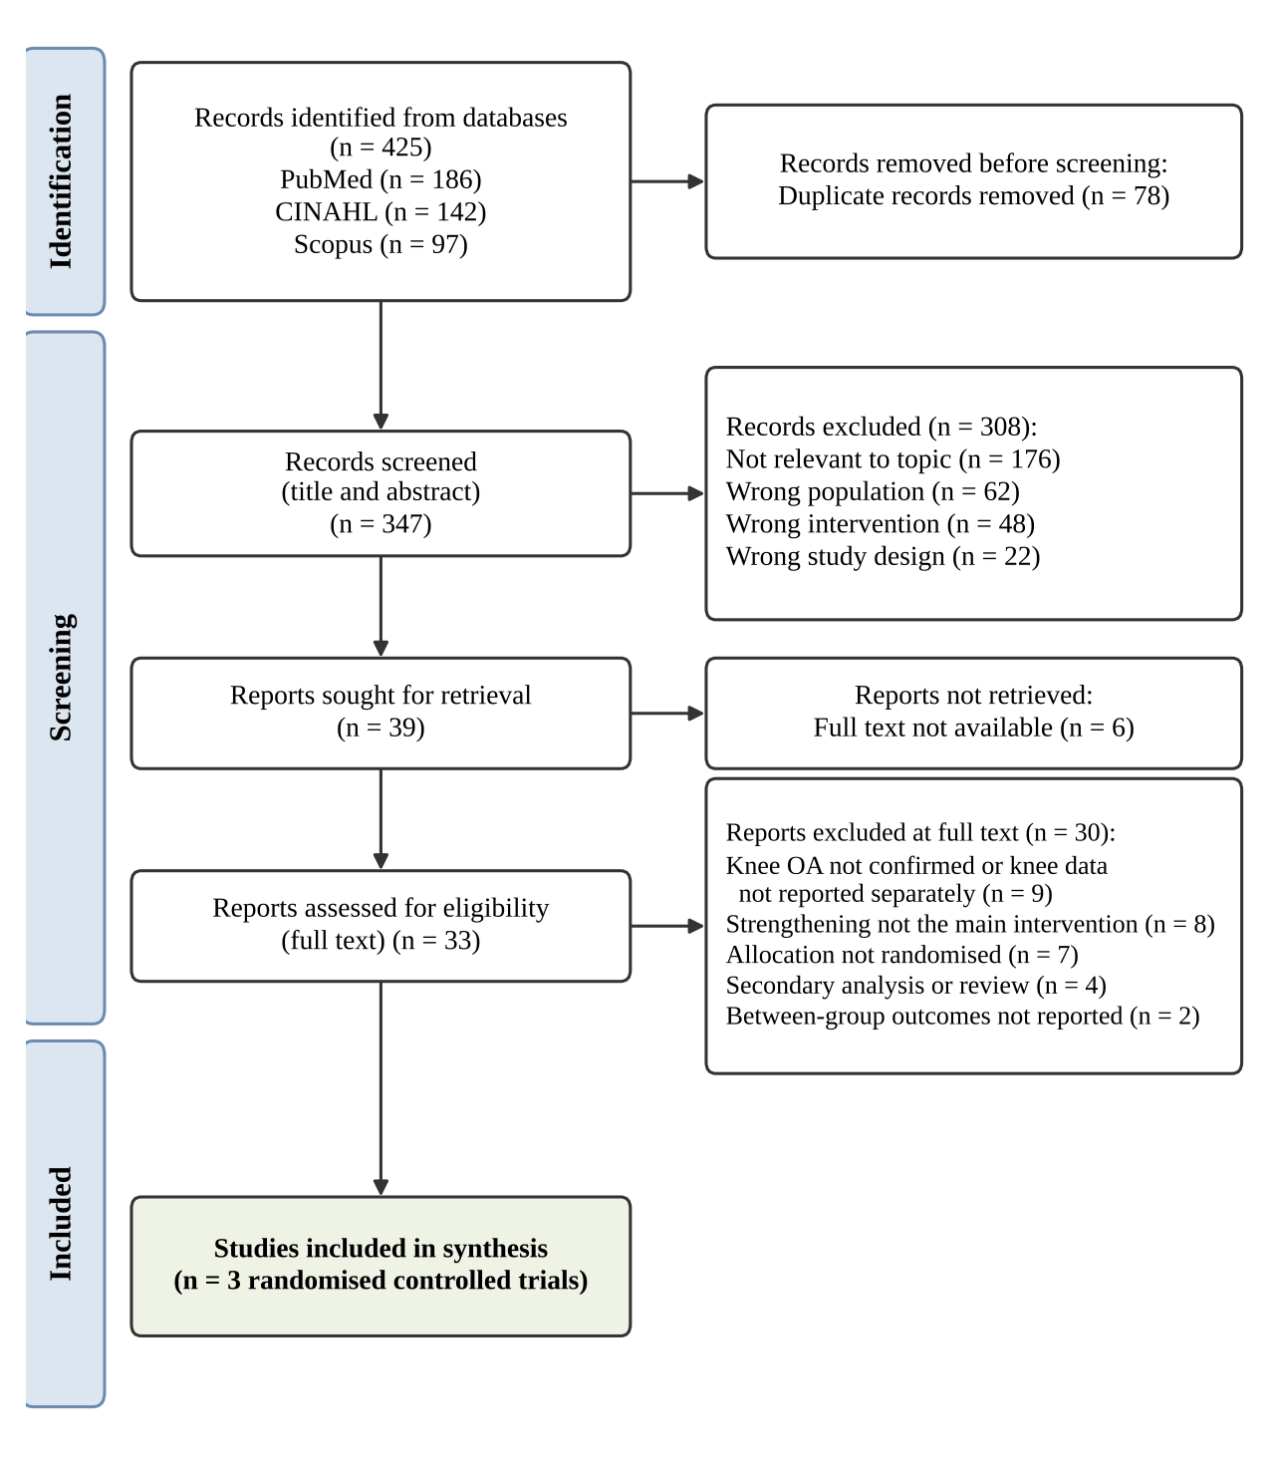
Note. Adapted from the PRISMA 2020 flow diagram template (Page et al., 2021, p. 1).

Critique Tools and Summary of Critiques
All three studies were appraised using the Critical Appraisal Skills Programme (CASP) RCT checklist, which asks whether results are valid, what they are, and whether they will help locally (Critical Appraisal Skills Programme [CASP], 2018, p. 1). The tool fits the design because RCTs are the gold standard for effectiveness, as randomisation balances observed and unobserved participant characteristics (Hariton & Locascio, 2018, p. 1716). CASP has no explicit cultural domain. Therefore, each appraisal added a cultural safety and equity lens, asking who was excluded and whose outcomes were measured (Curtis et al., 2019, p. 1). Following Assignment 1 feedback, each judgement now uses the tool's own responses of yes, no or can't tell. Full appraisals are presented in Appendices B–D.

Study 1: Øiestad et al. (2023)
This three-arm RCT compared 12 weeks of supervised strength exercise, aerobic exercise and usual care in 168 adults with knee OA in Norway (Øiestad et al., 2023, p. 1). Strengths included prospective registration, concealed allocation and blinded outcome assessors (Øiestad et al., 2023, pp. 2–3). The trial stopped early at 168 of 207 planned participants, so it was underpowered (Øiestad et al., 2023, p. 2). Only 60% of the strength group returned training diaries, which leaves adherence uncertain (Øiestad et al., 2023, p. 6). Culturally, people who did not speak Norwegian or had a body mass index (BMI) above 35 kg/m² were excluded (Øiestad et al., 2023, p. 3). The authors also acknowledged that user involvement was not part of the trial design (Øiestad et al., 2023, p. 11).

Study 2: Sadeghi et al. (2023)
This single-centre, four-arm Iranian RCT randomised 96 adults to quadriceps, hamstring, combined strengthening or no intervention for eight weeks (Sadeghi et al., 2023, p. 433). Allocation used concealed opaque envelopes, and the assessor and analyst were blinded (Sadeghi et al., 2023, p. 435). However, the trial was registered retrospectively and analysed per-protocol (Sadeghi et al., 2023, pp. 433, 435). Post-intervention physical function values in Table 2 are identical to baseline BMI values in Table 1, which suggests a reporting error (Sadeghi et al., 2023, p. 439). Culturally, a validated Persian WOMAC was used, and controls were offered the exercises after the trial (Sadeghi et al., 2023, pp. 434–435). Nevertheless, ethnicity and socioeconomic status were not reported, and 79% of participants were women (Sadeghi et al., 2023, p. 436).

Study 3: Ali et al. (2025)
This single-centre Pakistani RCT compared supervised strengthening, three times weekly for 12 weeks, with standard care in 60 adults (Ali et al., 2025, pp. 1–2). Standard care included joint protection advice, lifestyle modification and medication, which matches the PICO comparator closely (Ali et al., 2025, p. 2). However, the sample combined knee and hip OA without reporting knee results separately (Ali et al., 2025, p. 1). The authors described multiple imputation despite reporting no missing data or dropouts (Ali et al., 2025, p. 2). Subgroup analyses were described but not reported, and no registry number was given (Ali et al., 2025, pp. 2–3). Positively, interviewer-administered questionnaires were used to reduce literacy-related bias, an equity-sensitive choice (Ali et al., 2025, p. 2).

Comparison and Synthesis

Synthesis of Study Results
Table 3 compares the three studies. All three trials report benefits favouring strengthening, but the size of benefit falls as follow-up lengthens and rigour increases.
Table 3
Comparison and Synthesis Matrix of the Three Randomised Controlled Trials
Feature | Øiestad et al. (2023) | Sadeghi et al. (2023) | Ali et al. (2025)
Design and setting | Three-arm pragmatic RCT; primary and secondary care, Norway | Four-arm single-centre RCT; rheumatology clinic, Iran | Two-arm single-centre RCT; rehabilitation centre, Pakistan
Participants | n = 168; aged 35–70; knee OA | n = 96; aged 40–70; knee OA; 79% women | n = 60; aged 45–75; knee or hip OA
Intervention | Supervised strength and balance, 2–3 sessions weekly for 12 weeks | Home quadriceps, hamstring or combined strengthening daily, 5 days weekly for 8 weeks | Supervised progressive resistance, 45 minutes three times weekly for 12 weeks
Comparator | Usual care | No intervention | Standard care (advice and medication)
Follow-up | 4 months and 1 year | 8 weeks | 6 and 12 weeks
Pain | NRS −0.9 (95% CI −1.7 to −0.02) at 1 year; KOOS Pain not significant | VAS −36.1 mm (combined vs control) | WOMAC −2.7 (95% CI −3.5 to −1.9)
Stiffness | Not measured separately; KOOS Symptoms not significant | Reduced in all exercise arms vs control | WOMAC −1.1 (95% CI −1.5 to −0.7)
Function | KOOS ADL 7.3 (95% CI −0.1 to 14.6), not significant | No between-group difference (p = .219) | WOMAC −8.8 (95% CI −11.1 to −6.5)
Quality of life | KOOS QoL 6.5 (95% CI −0.9 to 14.0), not significant | Not measured | SF-36 physical functioning +19.8 (95% CI 16.6 to 23.0)
Key appraisal concerns | Underpowered; attrition; adherence uncertain | Retrospective registration; per-protocol; table reporting error | Mixed knee and hip sample; imputation inconsistency; implausible effect sizes; no registration
Cultural and equity factors | Excluded non-Norwegian speakers and BMI > 35; no user involvement | Validated Persian WOMAC; controls offered exercise; no ethnicity data | Interviewer-administered questionnaires; no ethnicity data
Relevance to PICO | High | Moderate | Moderate to low
Note. Data from Øiestad et al. (2023, pp. 1–9), Sadeghi et al. (2023, pp. 433–439) and Ali et al. (2025, pp. 1–4). ADL = activities of daily living; NRS = numeric rating scale; VAS = visual analogue scale.
For pain, the short trials showed large effects. Combined strengthening reduced pain on a visual analogue scale by 36 mm more than control at eight weeks (Sadeghi et al., 2023, p. 436). Similarly, Ali et al. (2025, p. 4) reported a WOMAC pain difference of −2.7 points at 12 weeks. In contrast, Øiestad et al. (2023, p. 9) found a small pain difference of −0.9 on a 0–10 scale at one year. For stiffness, both short trials showed reductions (Ali et al., 2025, p. 4; Sadeghi et al., 2023, p. 437). Øiestad et al. (2023, p. 9) found no significant difference in KOOS Symptoms, the closest stiffness measure. Function results were inconsistent. Sadeghi et al. (2023, p. 437) found no between-group difference, Ali et al. (2025, p. 4) reported large gains, and Øiestad et al. (2023, p. 9) found no significant difference. For QoL, Øiestad et al. (2023, p. 6) found no significant difference at one year, whereas Ali et al. (2025, p. 4) reported very large SF-36 gains. Sadeghi et al. (2023, p. 433) did not measure QoL.
These findings align with a meta-analysis of 77 RCTs. Exercise effects peaked at about two months and were no better than usual care after nine months (Goh et al., 2019, p. 356). Pooled effect sizes were moderate for pain (0.56) and small for QoL (0.21) (Goh et al., 2019, p. 356). Ali et al.'s (2025, p. 4) effect sizes above 2.7 for QoL are therefore implausibly large.

Synthesis of Critiques
The critiques reveal an inverse pattern: the most rigorous trial produced the smallest effects. Øiestad et al. (2023) had registration, concealment, blinded assessors and one-year follow-up, yet was underpowered. Sadeghi et al. (2023) and Ali et al. (2025) showed larger effects but had short follow-up, single sites and reporting inconsistencies. Intention-to-treat analysis is regarded as least biased, and trials should be prospectively registered (Hariton & Locascio, 2018, p. 1716). Sadeghi et al. (2023) met neither standard, and Ali et al. (2025) reported no registration. No trial could blind participants, so self-reported pain and QoL were vulnerable to expectation effects. Comparators also differed: usual care (Øiestad et al., 2023, p. 4), no intervention (Sadeghi et al., 2023, p. 433) and standard care with medication (Ali et al., 2025, p. 2). A no-intervention control is likely to inflate apparent benefit, since controls in Sadeghi et al. (2023, p. 437) reported worsening pain. Culturally, none reported ethnicity, involved Indigenous peoples, or measured outcomes beyond physical and psychological health.

Appropriateness of Research Designs
An RCT is the appropriate design for an effectiveness question about intervention versus usual care (Hariton & Locascio, 2018, p. 1716). However, the three trials answer the PICO question to different degrees. Øiestad et al. (2023) used a pragmatic primary-care design with usual care and long follow-up, making it most applicable. Sadeghi et al. (2023) was largely explanatory, comparing muscle groups against no treatment, which answers a slightly different question. Ali et al. (2025) matched the comparator and all four outcomes, but its mixed knee and hip sample weakens direct relevance. All three relied on volunteers, who may not represent the wider population, a recognised drawback of RCTs (Hariton & Locascio, 2018, p. 1716).

Critical Discussion: Adequacy and Application in Aotearoa New Zealand

Adequacy of the Evidence
Collectively, the evidence is adequate to support strengthening as an option for short-term pain and stiffness relief. It is inadequate to show sustained improvement in function or QoL compared with usual care. Only one trial followed participants for a year, and it was underpowered (Øiestad et al., 2023, p. 2). Its QoL difference of 6.5 points was also below the 10-point clinically important difference used to plan the trial (Øiestad et al., 2023, pp. 5–6). The two trials showing large benefits carry substantial risk of bias. Therefore, the evidence answers the PICO question only partially, and with low-to-moderate confidence.

Application, Te Tiriti o Waitangi and Māori Health
The evidence base was generated without Māori participants or Māori worldviews. This matters because Te Whare Tapa Whā describes wellbeing across physical, mental, spiritual and whānau dimensions (McGruer et al., 2019, p. 128). The trials measured mainly taha tinana (physical health), with Ali et al. (2025) adding some mental health measures. None measured taha wairua or taha whānau, which Māori women identified as central to living with OA (McGruer et al., 2019, p. 128). Consequently, the outcomes valued in the trials may not reflect the outcomes valued by Māori.
Exclusion criteria further limit transferability. Øiestad et al. (2023, p. 3) excluded people with BMI above 35 kg/m² and those not speaking Norwegian. In NZ, equivalent exclusions would remove people who already face the greatest barriers to care. Graham and Masters-Awatere (2020, p. 193) found that many Māori experience the public health system as hostile and alienating. Their review identified organisational structures, staff interactions and practical costs as barriers, with whānau support as a key facilitator (Graham & Masters-Awatere, 2020, p. 193). Clinic-based, user-pays programmes delivered in this way would conflict with the principles of equity and active protection.
Applying the Tiriti principles changes how the evidence should be used (Figure 2). Tino rangatiratanga and partnership require Māori to co-design programme goals, settings and outcome measures (Ministry of Health, 2020, p. 1). The options principle requires properly resourced kaupapa Māori services, such as marae-based or community group strengthening (Ministry of Health, 2020, p. 1). Equity and active protection require removing cost barriers and monitoring outcomes by ethnicity. Cultural safety also requires clinicians to critique their own power and assumptions, rather than expecting Māori to adapt (Curtis et al., 2019, p. 1).
Figure 2
Evidence-to-Practice Framework Applying Te Tiriti o Waitangi to the Synthesised Evidence
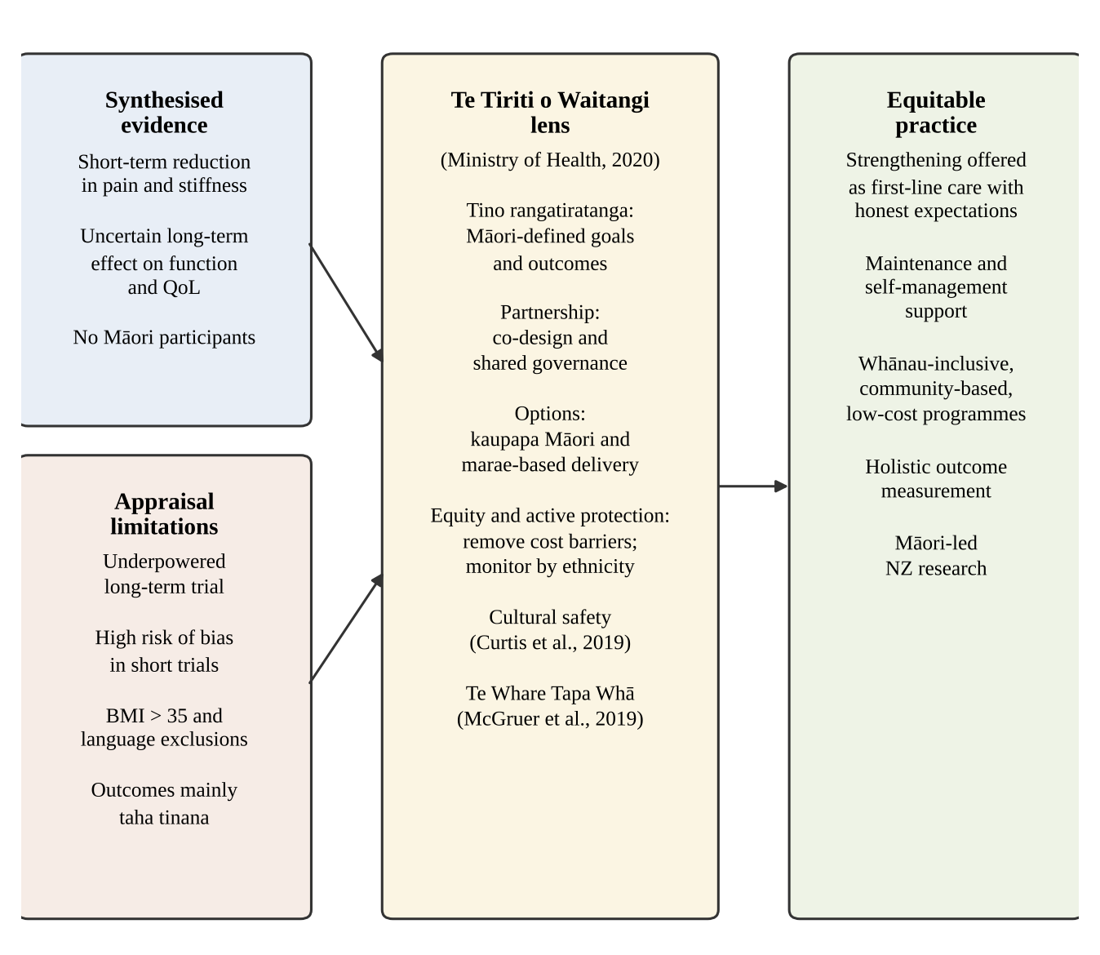
Note. Developed by the author from the synthesis, using principles from the Ministry of Health (2020, p. 1), Curtis et al. (2019, p. 1) and McGruer et al. (2019, p. 128).
From a social justice perspective, offering strengthening only to those who can pay would reproduce inequity rather than confront it (Nemetchek, 2019, p. 244). Thus, the evidence could inform practice, but it should not be implemented as a stand-alone, clinic-based, user-pays programme.

Conclusions and Recommendations
The synthesis shows that strengthening exercise probably reduces pain and stiffness in the short term compared with usual care. Evidence for lasting gains in function and QoL is weak, and benefits fade without maintenance (Goh et al., 2019, p. 356). The critiques show that larger effects came from less rigorous trials. None of the studies included Māori, measured holistic wellbeing, or addressed access barriers.
The following recommendations are made for NZ physiotherapy practice:
- Offer progressive strengthening as part of first-line knee OA care, consistent with guidelines (Bannuru et al., 2019, p. 1578), but explain expected benefits honestly as modest and short-term.
- Build long-term maintenance and self-management support into programmes, because benefits decline after the supervised period (Øiestad et al., 2023, p. 11).
- Co-design programmes with Māori communities and providers, including whānau-inclusive, marae-based and kaupapa Māori options (Ministry of Health, 2020, p. 1).
- Reduce cost barriers through funded or low-cost community delivery, and record outcomes by ethnicity to monitor equity (Buhler et al., 2025, p. 1).
- Assess outcomes holistically using Te Whare Tapa Whā, not only pain and function (McGruer et al., 2019, p. 128).
- Support Māori-led NZ trials with long follow-up, inclusive eligibility, prospective registration and attention-matched controls.

References
Ali, A. A., Hussain, A., Waqas, S., Jokhio, S. A., & Zainab, W. (2025). Effects of strengthening exercises on the quality of life of patients with osteoarthritis. Journal of Health, Wellness, and Community Research, 3(7), Article e376. https://doi.org/10.61919/zx234g19
Bannuru, R. R., Osani, M. C., Vaysbrot, E. E., Arden, N. K., Bennell, K., Bierma-Zeinstra, S. M. A., Kraus, V. B., Lohmander, L. S., Abbott, J. H., Bhandari, M., Blanco, F. J., Espinosa, R., Haugen, I. K., Lin, J., Mandl, L. A., Moilanen, E., Nakamura, N., Snyder-Mackler, L., Trojian, T., . . . McAlindon, T. E. (2019). OARSI guidelines for the non-surgical management of knee, hip, and polyarticular osteoarthritis. Osteoarthritis and Cartilage, 27(11), 1578–1589. https://doi.org/10.1016/j.joca.2019.06.011
Buhler, M., Shah, T., Perry, M., Tennant, M., Kruger, E., & Milosavljevic, S. (2025). Spatial equity of physiotherapy accessibility in Aotearoa New Zealand in relation to Māori and Pacific ethnicity, socioeconomic deprivation, and rurality. Health Policy, 163, Article 105498. https://doi.org/10.1016/j.healthpol.2025.105498
Came, H., O'Sullivan, D., Kidd, J., & McCreanor, T. (2020). The Waitangi Tribunal's WAI 2575 report: Implications for decolonizing health systems. Health and Human Rights, 22(1), 209–220. https://pmc.ncbi.nlm.nih.gov/articles/PMC7348423/
Critical Appraisal Skills Programme. (2018). CASP randomised controlled trial checklist. https://casp-uk.net/casp-tools-checklists/
Curtis, E., Jones, R., Tipene-Leach, D., Walker, C., Loring, B., Paine, S.-J., & Reid, P. (2019). Why cultural safety rather than cultural competency is required to achieve health equity: A literature review and recommended definition. International Journal for Equity in Health, 18, Article 174. https://doi.org/10.1186/s12939-019-1082-3
Goh, S.-L., Persson, M. S. M., Stocks, J., Hou, Y., Lin, J., Hall, M. C., Doherty, M., & Zhang, W. (2019). Efficacy and potential determinants of exercise therapy in knee and hip osteoarthritis: A systematic review and meta-analysis. Annals of Physical and Rehabilitation Medicine, 62(5), 356–365. https://doi.org/10.1016/j.rehab.2019.04.006
Graham, R., & Masters-Awatere, B. (2020). Experiences of Māori of Aotearoa New Zealand's public health system: A systematic review of two decades of published qualitative research. Australian and New Zealand Journal of Public Health, 44(3), 193–200. https://doi.org/10.1111/1753-6405.12971
Hariton, E., & Locascio, J. J. (2018). Randomised controlled trials—The gold standard for effectiveness research. BJOG: An International Journal of Obstetrics and Gynaecology, 125(13), 1716. https://doi.org/10.1111/1471-0528.15199
McGruer, N., Baldwin, J. N., Ruakere, B. T., & Larmer, P. J. (2019). Māori lived experience of osteoarthritis: A qualitative study guided by Kaupapa Māori principles. Journal of Primary Health Care, 11(2), 128–137. https://doi.org/10.1071/HC18079
Ministry of Health. (2020). Te Tiriti o Waitangi framework. https://www.health.govt.nz/system/files/2024-05/whakamaua-tiriti-o-waitangi-framework-a3-aug20.pdf
Nemetchek, B. (2019). A concept analysis of social justice in global health. Nursing Outlook, 67(3), 244–251. https://doi.org/10.1016/j.outlook.2018.12.023
Øiestad, B. E., Årøen, A., Røtterud, J. H., Østerås, N., Jarstad, E., Grotle, M., & Risberg, M. A. (2023). The efficacy of strength or aerobic exercise on quality of life and knee function in patients with knee osteoarthritis. A multi-arm randomized controlled trial with 1-year follow-up. BMC Musculoskeletal Disorders, 24, Article 714. https://doi.org/10.1186/s12891-023-06831-x
Page, M. J., McKenzie, J. E., Bossuyt, P. M., Boutron, I., Hoffmann, T. C., Mulrow, C. D., Shamseer, L., Tetzlaff, J. M., Akl, E. A., Brennan, S. E., Chou, R., Glanville, J., Grimshaw, J. M., Hróbjartsson, A., Lalu, M. M., Li, T., Loder, E. W., Mayo-Wilson, E., McDonald, S., . . . Moher, D. (2021). The PRISMA 2020 statement: An updated guideline for reporting systematic reviews. BMJ, 372, Article n71. https://doi.org/10.1136/bmj.n71
Sadeghi, A., Rostami, M., Khanlari, Z., Zeraatchi, A., Jalili, N., Karimi Moghaddam, A., Karimi Moghaddam, Z., Fallah, R., & Sangtarash, F. (2023). Effectiveness of muscle strengthening exercises on the clinical outcomes of patients with knee osteoarthritis: A randomized four-arm controlled trial. Caspian Journal of Internal Medicine, 14(3), 433–442. https://doi.org/10.22088/cjim.14.3.433

HEAL840 AI Use Statement
Tools used: Claude (Anthropic) and Grammarly.
Purpose(s): Claude was used to help organise the assignment structure, check alignment with the rubric and marker feedback, draft and refine wording, and cross-check citations and page numbers against the original articles. Grammarly was used to check spelling, grammar and punctuation.
Representative prompts: "Check my synthesis against the rubric and my Assignment 1 feedback." "Check that each in-text citation matches the page in the original article."
Verification: I checked every statement, statistic and page number against the three trial PDFs and the original sources in the reference list. All references are real, published sources that I have located and read.
Ethical compliance: AI assistance is acknowledged here. No personal or patient data was entered into any AI tool. The final question, search, appraisal, synthesis and critical reflection are my own work.

Appendix A
Reflection on How Formative Assessment 2 Informed This Assignment
Formative Assessment 2 was where I first examined the New Zealand social context of my topic, and the feedback changed this assignment in four specific ways.
First, the marker asked me to cite literature to support my definition of social justice. My original definition was unsupported. In this assignment, I define social justice using a published concept analysis, which describes it as confronting injustice, oppression and inequity while promoting participation and equity (Nemetchek, 2019, p. 244). This definition gave me a clearer test for the evidence: whether strengthening programmes would reach those with the greatest need.
Second, the marker noted that some of my explanations of te Tiriti principles related only to healthcare, and advised me to read the course resources. I learned that Te Tiriti affirmed Māori sovereignty and guaranteed protection of Māori hauora (Came et al., 2020, p. 209). I now explain tino rangatiratanga as self-determination and mana motuhake, meaning Māori authority over their own lives, not only participation in treatment choices (Ministry of Health, 2020, p. 1). This shaped my recommendation that Māori co-design programme goals and outcomes, rather than simply be offered existing programmes.
Third, the marker identified that my principles came from the Ministry of Health framework but were not cited. I have now cited this source consistently, with page numbers, throughout the assignment.
Fourth, the marker asked me to cite sources for all statements. I have therefore supported each contextual claim with New Zealand evidence, including research on Māori experiences of osteoarthritis (McGruer et al., 2019, p. 128) and physiotherapy access (Buhler et al., 2025, p. 1).
Overall, the formative feedback moved my thinking from "does strengthening work?" to "does it work equitably, and for whom?" This reframing now runs through my critiques, synthesis and recommendations. In future practice, I will check whether evidence includes Māori and whether its outcomes reflect Māori understandings of wellbeing before applying it.

Appendix B
Critical Appraisal of Study 1: Øiestad et al. (2023)
Citation: Øiestad, B. E., Årøen, A., Røtterud, J. H., Østerås, N., Jarstad, E., Grotle, M., & Risberg, M. A. (2023). BMC Musculoskeletal Disorders, 24, Article 714. https://doi.org/10.1186/s12891-023-06831-x
Appraisal tool: CASP Randomised Controlled Trial Checklist (Critical Appraisal Skills Programme [CASP], 2018, p. 1). Responses use the tool's options of yes, no or can't tell; questions 7 and 8 are answered descriptively.
Rationale for selection: Selected because it compares supervised strengthening directly with usual care in adults with knee OA. It also measures quality of life, pain and function, and has the longest follow-up (one year) of any trial found.
CASP question | Answer | Critical appraisal and evidence
Section A: Are the results of the trial valid?
1. Did the trial address a clearly focused issue? | Yes | Population (adults 35–70 with symptomatic, radiographic knee OA), intervention (12-week strength exercise), comparator (usual care) and primary outcome (KOOS QoL at one year) were clearly stated (Øiestad et al., 2023, pp. 1–2).
2. Was the assignment of patients to treatments randomised? | Yes | Computer-generated lists were prepared by an independent biostatistician, in blocks of six, with concealed envelopes (Øiestad et al., 2023, p. 3). Concealment prevents foreknowledge of allocation, which reduces selection bias (Hariton & Locascio, 2018, p. 1716).
3. Were all of the patients who entered the trial properly accounted for at its conclusion? | No | Seven participants withdrew consent and were excluded, and 19 attended baseline only (Øiestad et al., 2023, p. 6). A modified intention-to-treat analysis was therefore used (Øiestad et al., 2023, p. 6). Full intention-to-treat is regarded as least biased (Hariton & Locascio, 2018, p. 1716).
4. Were patients, health workers and study personnel 'blind' to treatment? | No | Participants and physiotherapists could not be blinded. Outcome assessors were blinded (Øiestad et al., 2023, p. 3). Self-reported outcomes such as KOOS remain open to expectation bias.
5. Were the groups similar at the start of the trial? | Yes | Groups were balanced, except for more men and smokers in the usual-care group (Øiestad et al., 2023, p. 6).
6. Aside from the experimental intervention, were the groups treated equally? | Can't tell | The usual-care group was told to live as usual and avoid new structured exercise (Øiestad et al., 2023, p. 4). Exercise groups received physiotherapist attention, and advice given was not recorded (Øiestad et al., 2023, p. 8).
Section B: What are the results?
7. How large was the treatment effect? | Small | KOOS QoL difference at one year was 6.5 (95% CI −0.9 to 14.0) for strength versus usual care (Øiestad et al., 2023, p. 6). Pain on a 0–10 scale improved by 0.9 at one year, and quadriceps strength improved at four months (Øiestad et al., 2023, p. 9).
8. How precise was the estimate of the treatment effect? | Imprecise | Confidence intervals were wide and crossed zero. The trial stopped at 168 of 207 planned participants (Øiestad et al., 2023, p. 2). The 6.5-point estimate is below the 10-point clinically important difference used for planning (Øiestad et al., 2023, p. 5).
Section C: Will the results help locally?
9. Can the results be applied to the local population, or in your context? | Can't tell | The pragmatic primary-care setting is relevant. However, people aged over 70, with BMI above 35, or not speaking Norwegian were excluded (Øiestad et al., 2023, p. 3). Physiotherapy in NZ is largely user-pays, unlike the trial setting (Buhler et al., 2025, p. 1).
10. Were all clinically important outcomes considered? | No | QoL, pain, function and strength were measured, but stiffness was not reported separately. Spiritual and whānau wellbeing, important to Māori with OA, were not measured (McGruer et al., 2019, p. 128).
11. Are the benefits worth the harms and costs? | Can't tell | Only two adverse events occurred (Øiestad et al., 2023, p. 8). Cost-effectiveness is to be reported separately (Øiestad et al., 2023, p. 6).
Cultural considerations and social justice | — | Excluding non-Norwegian speakers and people with BMI above 35 removed groups who often face the greatest barriers to care (Øiestad et al., 2023, p. 3). Ethnicity was not reported, and the authors acknowledged no user involvement (Øiestad et al., 2023, p. 11). Applying these findings in NZ would require Māori partnership and culturally safe delivery (Curtis et al., 2019, p. 1; Ministry of Health, 2020, p. 1).
Appraisal Summary
Positive / methodologically sound | Negative / relatively poor methodology | Unknowns
Clear, pre-registered primary outcome | Stopped early and underpowered | Effect in a fully powered trial
Independent, concealed randomisation | Modified intention-to-treat; attrition | Effect for Māori and people with BMI above 35
Blinded outcome assessors | Only 60% returned training diaries | Cost-effectiveness
Pragmatic primary-care setting | Exclusions limit equity and transferability | How to maintain benefits beyond 12 weeks
One-year follow-up

Appendix C
Critical Appraisal of Study 2: Sadeghi et al. (2023)
Citation: Sadeghi, A., Rostami, M., Khanlari, Z., Zeraatchi, A., Jalili, N., Karimi Moghaddam, A., Karimi Moghaddam, Z., Fallah, R., & Sangtarash, F. (2023). Caspian Journal of Internal Medicine, 14(3), 433–442. https://doi.org/10.22088/cjim.14.3.433
Appraisal tool: CASP Randomised Controlled Trial Checklist (Critical Appraisal Skills Programme [CASP], 2018, p. 1). Responses use the tool's options of yes, no or can't tell; questions 7 and 8 are answered descriptively.
Rationale for selection: Selected because it tests strengthening of the muscles around the knee against a control group, using pain, stiffness and function outcomes that match three of the four PICO outcomes.
CASP question | Answer | Critical appraisal and evidence
Section A: Are the results of the trial valid?
1. Did the trial address a clearly focused issue? | Yes | The aim was to test strengthening of the hamstrings and quadriceps on pain, physical function and morning stiffness in knee OA (Sadeghi et al., 2023, p. 434).
2. Was the assignment of patients to treatments randomised? | Yes | A researcher not involved in the study generated a blocked, stratified sequence; allocation used concealed opaque envelopes (Sadeghi et al., 2023, p. 435).
3. Were all of the patients who entered the trial properly accounted for at its conclusion? | Yes | All 96 randomised participants completed and were analysed (Sadeghi et al., 2023, p. 436). However, the stated approach was per-protocol (Sadeghi et al., 2023, p. 435), and adherence logs were not reported.
4. Were patients, health workers and study personnel 'blind' to treatment? | No | Participants and the instructing physiotherapist were not blinded. The outcome assessor and statistical analyst were blinded (Sadeghi et al., 2023, p. 435).
5. Were the groups similar at the start of the trial? | Yes | No significant baseline differences in age, sex or BMI were found (Sadeghi et al., 2023, p. 436). The control group had numerically higher BMI and WOMAC scores (Sadeghi et al., 2023, p. 439).
6. Aside from the experimental intervention, were the groups treated equally? | No | Exercise groups received written instructions and weekly phone calls; the control group received no intervention (Sadeghi et al., 2023, pp. 433, 435). This attention imbalance may inflate effects.
Section B: What are the results?
7. How large was the treatment effect? | Large | Combined strengthening reduced VAS pain by 36.1 mm versus control (Sadeghi et al., 2023, p. 436). WOMAC pain and stiffness also improved, but physical function did not differ between groups (Sadeghi et al., 2023, p. 437).
8. How precise was the estimate of the treatment effect? | Imprecise | Groups of 24 produced wide intervals, for example −52.19 to −22.89 mm for VAS (Sadeghi et al., 2023, p. 436). Post-intervention physical function values in Table 2 duplicate baseline BMI values in Table 1, a reporting error (Sadeghi et al., 2023, p. 439).
Section C: Will the results help locally?
9. Can the results be applied to the local population, or in your context? | Can't tell | A single Iranian clinic, 79% women, and exclusion of people using anti-inflammatory medication limit transferability (Sadeghi et al., 2023, pp. 434, 436). NZ usual care commonly includes such medication.
10. Were all clinically important outcomes considered? | No | Quality of life, a PICO outcome, was not measured (Sadeghi et al., 2023, p. 433). Outcomes after eight weeks are unknown (Sadeghi et al., 2023, p. 442).
11. Are the benefits worth the harms and costs? | Can't tell | The home programme is low cost, and the number needed to treat for a 30% pain reduction was three for combined exercise (Sadeghi et al., 2023, p. 441). Harms and costs were not reported.
Cultural considerations and social justice | — | A validated Persian WOMAC was used, showing attention to cultural validity of measurement (Sadeghi et al., 2023, p. 435). Controls were offered the exercises after the trial, an ethically just practice (Sadeghi et al., 2023, p. 434). However, ethnicity and socioeconomic status were not reported, and retrospective registration weakens transparency (Sadeghi et al., 2023, p. 433). Hariton and Locascio (2018, p. 1716) state that all RCTs should be registered.
Appraisal Summary
Positive / methodologically sound | Negative / relatively poor methodology | Unknowns
Concealed, stratified randomisation | Retrospective registration | Durability of effects
Blinded assessor and analyst | No-intervention control with unequal attention | Effect on quality of life
No loss to follow-up | Short eight-week follow-up | Transferability to men and to people using medication
Validated, culturally adapted outcome tool | Reporting error in Table 2 | Effect for Māori
Low-cost home programme | Quality of life not measured

Appendix D
Critical Appraisal of Study 3: Ali et al. (2025)
Citation: Ali, A. A., Hussain, A., Waqas, S., Jokhio, S. A., & Zainab, W. (2025). Journal of Health, Wellness, and Community Research, 3(7), Article e376. https://doi.org/10.61919/zx234g19
Appraisal tool: CASP Randomised Controlled Trial Checklist (Critical Appraisal Skills Programme [CASP], 2018, p. 1). Responses use the tool's options of yes, no or can't tell; questions 7 and 8 are answered descriptively.
Rationale for selection: Selected because, following formative feedback, its standard-care comparator matches the PICO comparator, and it measures all four PICO outcomes. Its mixed knee and hip sample is a recognised limitation.
CASP question | Answer | Critical appraisal and evidence
Section A: Are the results of the trial valid?
1. Did the trial address a clearly focused issue? | Yes | The trial tested a 12-week supervised strengthening programme against standard care on pain, stiffness, function and QoL (Ali et al., 2025, p. 1). However, the population included hip as well as knee OA (Ali et al., 2025, p. 1).
2. Was the assignment of patients to treatments randomised? | Yes | An independent statistician prepared a computer-generated randomisation list (Ali et al., 2025, p. 2). Allocation concealment was not described.
3. Were all of the patients who entered the trial properly accounted for at its conclusion? | Yes | No participant dropouts occurred, and all 60 were analysed (Ali et al., 2025, p. 2). However, the authors also reported using multiple imputation for missing data, which is inconsistent (Ali et al., 2025, p. 2).
4. Were patients, health workers and study personnel 'blind' to treatment? | No | Only outcome assessors were blinded (Ali et al., 2025, p. 2). Participants and therapists knew the allocation.
5. Were the groups similar at the start of the trial? | Yes | Age, sex, BMI, OA duration and comorbidities were similar between groups (Ali et al., 2025, p. 4).
6. Aside from the experimental intervention, were the groups treated equally? | No | The intervention group received 36 supervised sessions, and the authors acknowledged the lack of an attention-matched control (Ali et al., 2025, pp. 2, 6).
Section B: What are the results?
7. How large was the treatment effect? | Very large | WOMAC pain −2.7, stiffness −1.1 and function −8.8, with SF-36 effect sizes up to 3.39 (Ali et al., 2025, p. 4).
8. How precise was the estimate of the treatment effect? | Can't tell | Intervals were narrow, but standard deviations were unusually small (Ali et al., 2025, p. 4). Effect sizes far exceed pooled estimates of 0.56 for pain and 0.21 for QoL (Goh et al., 2019, p. 356), suggesting possible bias or reporting error.
Section C: Will the results help locally?
9. Can the results be applied to the local population, or in your context? | Can't tell | A single tertiary centre, consecutive sampling and a mixed knee and hip sample limit transferability (Ali et al., 2025, p. 2). The authors noted a homogeneous sample (Ali et al., 2025, p. 6).
10. Were all clinically important outcomes considered? | Yes | WOMAC and SF-36 covered pain, stiffness, function and physical, mental and social QoL (Ali et al., 2025, p. 2). Spiritual and whānau dimensions were not captured (McGruer et al., 2019, p. 128).
11. Are the benefits worth the harms and costs? | Can't tell | No adverse events were reported (Ali et al., 2025, p. 3). Costs of 36 supervised sessions were not analysed, which matters where physiotherapy is user-pays (Buhler et al., 2025, p. 1).
Cultural considerations and social justice | — | Interviewer-administered questionnaires were used to reduce literacy-related bias, an equity-sensitive design choice (Ali et al., 2025, p. 2). Standard care reflected real-world practice, including medication (Ali et al., 2025, p. 2). However, ethnicity was not reported, subgroup analyses were described but not presented, and no trial registration was given (Ali et al., 2025, pp. 2–3).
Appraisal Summary
Positive / methodologically sound | Negative / relatively poor methodology | Unknowns
Comparator matches PICO (standard care) | Mixed knee and hip population | Knee-specific results
All four PICO outcomes measured | Implausibly large effect sizes | Long-term durability
Independent randomisation | Imputation reported despite no missing data | Cost-effectiveness
Blinded assessors | No registration; subgroup results unreported | Effect for Māori and diverse populations
Literacy-sensitive data collection | Single centre; 12-week follow-up

