PROJECT TITLE
Development of a Treatment Process for Potable Water Production Using Ceramic Membrane Filtration

Abstract
Safe drinking water remains out of reach for 2.2 billion people (WHO/UNICEF, 2023). Ceramic membranes offer chemical stability and long life, but evidence on materials, fouling, hybrid designs and contaminants is fragmented (Fu et al., 2024; Jarrar et al., 2024). This project will compare published performance and sustainability data to build a decision framework for ceramic membrane treatment trains. It uses a desk-based design with systematic screening and structured extraction (Page et al., 2021). The expected outcome is an evidence-based selection guide that supports Sustainable Development Goal 6 at no cost.

AIMS
- To compare ceramic membrane materials and fabrication routes by strength, pore structure, cost and removal performance.
- To evaluate fouling-control methods and hybrid configurations by reported flux, cleaning demand and contaminant removal.
- To assess removal of heavy metals, arsenic, PFAS, microplastics and pathogens, and map where evidence is weak.
- To develop a decision framework that selects a ceramic membrane treatment train using performance, cost and sustainability criteria.

RESEARCH QUESTIONS
Three research questions address these aims, and each links to one or more aims.
RQ1: Which ceramic membrane materials give the best balance of strength, cost and removal performance for potable water? (Aims 1 and 3)
RQ2: Which fouling-control methods and hybrid configurations most improve flux stability and contaminant removal? (Aims 2 and 3)
RQ3: How do the sustainability and cost indicators of ceramic membrane treatment trains compare with polymeric and conventional options? (Aim 4)

BACKGROUND
[INSERT YOUR PREVIOUSLY MARKED LITERATURE REVIEW HERE AS AN IMAGE. It is not counted in the word limit. Delete this box after inserting.]
Access to safe drinking water remains limited in many parts of the world. In 2022, 2.2 billion people lacked safely managed drinking water, and global coverage was only 73 per cent (WHO/UNICEF, 2023). Membrane processes increasingly complement coagulation, sedimentation and sand filtration (Jarrar et al., 2024). Ceramic membranes attract interest because they offer chemical and thermal stability, low fouling and long working life (Hosseinzadeh et al., 2025). Full-scale plants operate in several countries and appear economically competitive over the long term (Akash et al., 2024). Hosseinzadeh et al. (2025) found that ceramic membranes used fewer chemicals and produced less waste and CO₂ than conventional treatment.
Material choice strongly shapes the strength, cost and performance of ceramic membranes. Alumina is the most common commercial option because of its strength and low cost (Jarrar et al., 2024). Zirconia, however, resists acidic conditions better than alumina does (Jarrar et al., 2024). Clay and waste-based supports reach flexural strengths of 25 to 40 MPa (Bahrouni et al., 2025) and up to 20 MPa (El Azizi et al., 2025). However, lower cost may reduce mechanical integrity and pore uniformity (Fu et al., 2024). A polymer coating on a ceramic support removed over 97% of heavy metals from agricultural drainage water (Azzam et al., 2025).
Fouling remains the main operating problem because it raises energy use and lowers flux (Cai et al., 2023). Ozonation can make cake layers more reversible and reduce cleaning frequency (Xie et al., 2024). Conductive ceramic membranes may limit fouling and degrade pollutants, but large-scale stability is unproven (Lin et al., 2024). Oxidation combined with ceramic filtration alters foulant–membrane interactions at the molecular level (Lin et al., 2025). Ceramic–nanofiltration hybrids removed more dissolved organic carbon and divalent ions than nanofiltration alone (Xie et al., 2025). Ceramic membranes also serve desalination pretreatment, oily-water treatment, membrane distillation and wastewater bioenergy systems (Ahmad et al., 2025; Al Bahri et al., 2025; Alessandro & Macedonio, 2025; Zhang et al., 2025).
Removal performance varies considerably with the type of target contaminant treated. Nanofiltration membranes reject multivalent metals well, but results for monovalent ions are more variable (Covaliu-Mierlă et al., 2023). Arsenic removal varies strongly with feedwater pH and the presence of coexisting ions (Ab Hamid et al., 2024; Dashtban Kenari et al., 2025). Conventional ceramic membranes took up little PFAS, yet an iron-based membrane removed about 99% of PFOA in one pass (Chen et al., 2025). Alumina membranes removed 72 to 82 per cent of cosmetic microplastic alternatives (Kim et al., 2025). Virus rejection varied with transmembrane pressure, fouling condition and the pretreatment plan used (Ahmadi et al., 2025). Waste-based and natural ceramic membranes also removed organic dyes from industrial wastewater (Malebadi et al., 2025). A systematic review for WHO guidance found ceramic log-reduction data scarcer than for granular media filtration (Burke et al., 2025).
Existing studies usually test one material, foulant or contaminant, often at bench scale. Evidence is therefore fragmented across materials, fouling control, contaminant classes and sustainability. My literature review found no integrated comparison linking these factors to treatment-train selection for potable water. This gap matters because utilities need defensible choices, and Sustainable Development Goal 6 targets safe, affordable drinking water (United Nations, 2015). Figure 1 shows the conceptual framework that guides the project design.
Figure 1
Conceptual Framework for Selecting a Ceramic Membrane Treatment Train
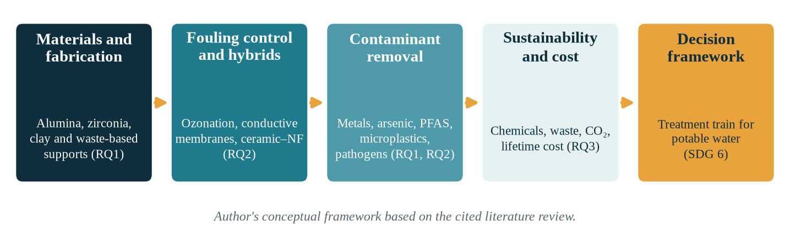
Note. Author's synthesis based on Cai et al. (2023), Hosseinzadeh et al. (2025) and Jarrar et al. (2024). RQ = research question.
The task is to synthesise published data into a consistent comparison. The suggested strategy is structured, transparent screening and extraction (Page et al., 2021).

RESEARCH PROJECT

Materials and Methods
This project uses a desk-based comparative evaluation of published secondary data, so no laboratory work is needed. The design suits the aims because many experiments already exist, and the gap lies in comparing them consistently. Figure 2 summarises the workflow from literature search to decision framework.
Figure 2
Workflow of the Desk-Based Comparative Evaluation
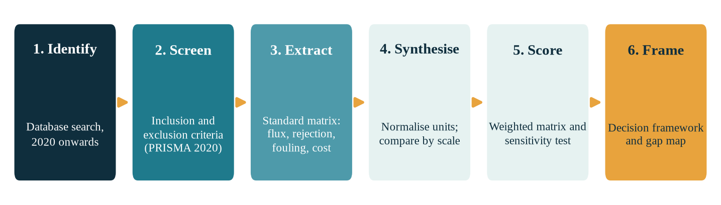
Note. Screening and reporting follow Page et al. (2021).
Data sources are peer-reviewed articles from 2020 onwards, found through databases such as Scopus and Web of Science. The WHO/UNICEF (2023) report will also supply the global drinking water access data. Records are included if they study ceramic membranes for water treatment. They must also report quantitative data on flux, rejection, fouling, strength, energy, cost or life-cycle impact. Opinion pieces, non-English papers and duplicate records are excluded from the review. Screening and reporting will follow the PRISMA 2020 statement (Page et al., 2021).
Data will be extracted into a standard matrix recording material, pore size, feed water and operating pressure. The matrix will also record test scale, flux, rejection, fouling control and cost indicators. Values will be converted to common units for fair comparison across studies. Bench-scale results will be kept separate from pilot and full-scale results. Comparison tables and narrative synthesis will answer research questions 1 and 2.
For research question 3, a scoring matrix will rate each configuration on removal, fouling control, strength, cost and sustainability. The matrix draws on the five factors in Figure 1, so each research question maps to a clear analysis step. Criterion weights will be varied in a sensitivity test, to show whether rankings stay stable. To check accuracy, I will re-extract 10% of records after one week and compare the results.
Test conditions differ between studies, and positive results are published more often. Conclusions will therefore be graded by evidence strength and scale. Only published sources are used and no people or animals are involved. Ethics approval is therefore not expected, and I will confirm this with my supervisor.

Expected Outcomes
Four deliverables are expected: an extraction database, comparison tables, an evidence-gap map and a decision framework. These outcomes are anticipated, so they are expectations rather than established findings. I expect hybrid configurations to outperform standalone ceramic membranes for organic carbon and divalent ions (Xie et al., 2025). I expect waste-based membranes to be cheaper but more variable (Fu et al., 2024). I expect the largest evidence gaps for PFAS, microplastics and viruses at full scale (Burke et al., 2025; Chen et al., 2025). The framework will pair each source-water type and priority contaminant with a recommended treatment train. Any evidence that contradicts these expectations will be reported openly.

Benefits
Utilities and engineers would gain a clear guide for selecting ceramic membrane treatment trains. Researchers would gain a prioritised map of evidence gaps for emerging contaminants. Communities lacking safe water may benefit indirectly, because better technology choices support affordable supply (WHO/UNICEF, 2023). Regulators may use the evidence summary when judging future guidance, as WHO reviews already do (Burke et al., 2025).

Significance and Innovation
The project is innovative because it integrates materials, fouling control, contaminant removal and sustainability in one framework. Existing reviews tend to treat these factors separately rather than together (Cai et al., 2023; Hosseinzadeh et al., 2025). Its sustainability criteria draw on evidence that ceramic membranes may use fewer chemicals and last longer (Hosseinzadeh et al., 2025). The expected outcome therefore directly supports Sustainable Development Goal 6 (United Nations, 2015).

ROLE OF PERSONNEL
The study needs three roles, and Table 1 summarises their responsibilities and time.
Table 1
Personnel, Responsibilities and Duration
Role | Responsibilities | Duration
Student researcher | Designs the protocol; searches, screens and extracts data; builds the framework; writes the report | 6 weeks, about 25 hours per week
Supervisor | Reviews the protocol, scoring matrix and draft; confirms ethics status | About 12 hours in total
Librarian (optional) | Advises on database access and search strategy | About 3 hours in Weeks 1–2

BUDGET
No funds are requested, because the study uses published data and existing university resources.
Table 2
Proposed Budget (All Costs in Dollars)
Item | Detail | Cost ($)
Student researcher | About 150 hours of coursework time | 0
Supervisor | About 12 hours within normal supervision | 0
Librarian | About 3 hours of university service | 0
Database access | Existing university subscriptions | 0
Software | Free reference manager and existing spreadsheet | 0
Computer and storage | Existing equipment | 0
Laboratory consumables | None required for a desk-based design | 0
Total | Overall project cost | 0

Time is the main input, and it is shown in hours rather than dollars. Every item uses an existing resource, so the overall budget is zero.

TIMEFRAME
The project runs for six weeks, as Figure 3 shows. Weeks 1 and 2 cover the protocol and screening, and Weeks 2 and 3 cover extraction. Comparison, scoring and the sensitivity test follow in Weeks 3 to 5. Week 6 covers report writing, referencing, and final submission of the proposal. The scope is realistic because it covers only published studies from 2020 onwards. One researcher can screen and extract these studies within the six-week period.
Figure 3
Six-Week Gantt Chart
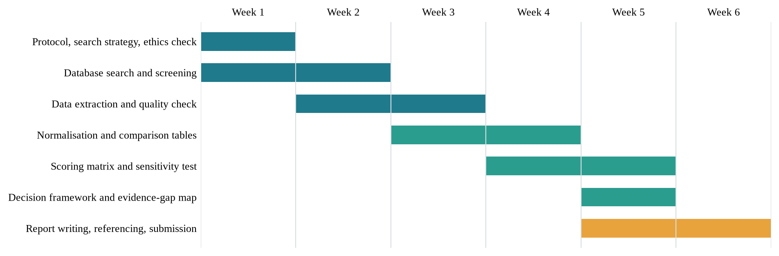
Note. The amber bar marks the final reporting stage.

REFERENCES
Ab Hamid, N. H., Rushdan, A. I., Nordin, A. H., Norrrahim, M. N. F., Muhamad, S. N. H., Mohd Tahir, M. I. H., Rosli, N. S. B., Mohd Pakrudin, N. H., Roslee, A. S., Muhammad Asyraf, M. R., & Knight, V. F. (2024). A review: The state-of-the-art of arsenic removal in wastewater. Water Reuse, 14(3), 279–311. https://doi.org/10.2166/wrd.2024.142
Ahmad, S. T., Ahmad, R., Shaukat, H., Rout, P. R., Fazal, T., & Dumfort, A. (2025). Bioenergy production from wastewater using cost-effective ceramic membranes: A review. Environmental Chemistry Letters. https://doi.org/10.1007/s10311-025-01822-x
Ahmadi, J., Ho, J., Gigla, P. H., Hübner, U., Tiehm, A., & Drewes, J. E. (2025). Rejection of viruses and mobile genetic elements by ceramic ultrafiltration membranes: Impacts of operational conditions and implications for water reuse system performance validation. Water Reuse, 15(3), 557–574. https://doi.org/10.2166/wrd.2025.054
Akash, F. A., Shovon, S. M., Rahman, W., Rahman, M. A., Chakraborty, P., Prasetya, T. A. E., & Monir, M. U. (2024). Advancements in ceramic membrane technology for water and wastewater treatment: A comprehensive exploration of current utilizations and prospective horizons. Desalination and Water Treatment, 319, Article 100569. https://doi.org/10.1016/j.dwt.2024.100569
Al Bahri, J., Zhai, C., Al Abri, M., Liu, Y., & Xia, S. (2025). Comprehensive review on advanced ceramic membranes for oily water treatment. Environmental Science: Water Research & Technology, 11(12), 2844–2859. https://doi.org/10.1039/D5EW00842E
Alessandro, F., & Macedonio, F. (2025). A critical review of membrane distillation using ceramic membranes: Advances, opportunities and challenges. Materials, 18(14), Article 3296. https://doi.org/10.3390/ma18143296
Azzam, N. M., Ali, S. S., Mohamed, G. G., Omar, M. M., & Amin, S. K. (2025). Fabrication of composite ceramic polymeric membranes for agricultural wastewater treatment. Scientific Reports, 15, Article 2330. https://doi.org/10.1038/s41598-025-85542-w
Bahrouni, J., Attia, A., Elberrichi, F. Z., Dammak, L., Baklouti, L., Ben Aissa, M.-A., Ben Amar, R., & Deratani, A. (2025). Green and sustainable clay ceramic membrane preparation and application to textile wastewater treatment for color removal. Membranes, 15(10), Article 292. https://doi.org/10.3390/membranes15100292
Burke, M., Wells, E., Larison, C., Rao, G., Bentley, M. J., Linden, Y. S., Smeets, P., DeFrance, J., Brown, J., & Linden, K. G. (2025). Systematic review of microorganism removal performance by physiochemical water treatment technologies. Environmental Science & Technology, 59(41), 21763–21775. https://doi.org/10.1021/acs.est.4c03459
Cai, C., Sun, W., He, S., Lu, P., Zhang, J., & Liang, H. (2023). Ceramic membrane fouling mechanisms and control for water treatment. Frontiers of Environmental Science & Engineering, 17(10), Article 126. https://doi.org/10.1007/s11783-023-1726-9
Chen, S., Qiu, L., Yu, X., Shen, X., Wang, X., Wang, J., Zhang, Y., Chu, L., Zhang, M., Zhou, Z., Wang, Y., Ma, H., Gu, C., & Chen, Z. (2025). Renewable Fe-based ceramic membrane for efficient per- and polyfluoroalkyl substances (PFAS) removal with light-driven regenerative ability. Separation and Purification Technology, 379, Article 134948. https://doi.org/10.1016/j.seppur.2025.134948
Covaliu-Mierlă, C. I., Păunescu, O., & Iovu, H. (2023). Recent advances in membranes used for nanofiltration to remove heavy metals from wastewater: A review. Membranes, 13(7), Article 643. https://doi.org/10.3390/membranes13070643
Dashtban Kenari, S. L., Mortazavi, S., Mosadeghsedghi, S., Atallah, C., & Volchek, K. (2025). Advancing ceramic membrane technology for sustainable treatment of mining discharge: Challenges and future directions. Membranes, 15(4), Article 112. https://doi.org/10.3390/membranes15040112
El Azizi, A., El Harouachi, H., Ahoudi, D., Maliki, S., Mansori, M., & Loutou, M. (2025). Phosphate tailings and clay-based ceramic membranes: Tailoring microstructure and filtration properties via alkali activation. Membranes, 15(2), Article 52. https://doi.org/10.3390/membranes15020052
Fu, Z., Zhou, Z., Liu, Z., Yang, H., & Chen, Z. (2024). Feasibility and challenges of low-cost ceramic membranes in water treatment applications. Desalination and Water Treatment, 320, Article 100739. https://doi.org/10.1016/j.dwt.2024.100739
Hosseinzadeh, F., Hashemi, H., & Sarpoolaky, H. (2025). Sustainable ceramic membrane for water and wastewater treatment: A comprehensive review of environmental, social, and economic aspects. Desalination, 615, Article 119231. https://doi.org/10.1016/j.desal.2025.119231
Jarrar, R., Abbas, M. K. G., & Al-Ejji, M. (2024). Environmental remediation and the efficacy of ceramic membranes in wastewater treatment—A review. Emergent Materials, 7, 1295–1327. https://doi.org/10.1007/s42247-024-00687-0
Kim, S. Y., Kim, S., & Park, C. (2025). Evaluation of ceramic membrane filtration for alternatives to microplastics in cosmetic formulations using FlowCam analysis. Membranes, 15(1), Article 35. https://doi.org/10.3390/membranes15010035
Lin, B., Deng, X., Chen, J., Low, Z.-X., Zhong, Z., & Xing, W. (2025). Integration of oxidation processes and ceramic membrane filtration for advanced water treatment: A review of foulant–membrane interactions. Advanced Membranes, 5, Article 100138. https://doi.org/10.1016/j.advmem.2025.100138
Lin, Z., Liu, L., Zhang, C., Su, P., Zhang, X., Li, X., & Jiao, Y. (2024). Emerging conductive ceramic membranes for water purification and membrane fouling mitigation. Chemical Engineering Journal, 493, Article 152568. https://doi.org/10.1016/j.cej.2024.152568
Malebadi, K. A., Sawunyama, L., Seheri, N. H., & Onwudiwe, D. C. (2025). Application of ceramic membranes derived from waste and natural materials for the removal of organic dyes from wastewater: A review. Ceramics, 8(3), Article 80. https://doi.org/10.3390/ceramics8030080
Page, M. J., McKenzie, J. E., Bossuyt, P. M., Boutron, I., Hoffmann, T. C., Mulrow, C. D., Shamseer, L., Tetzlaff, J. M., Akl, E. A., Brennan, S. E., Chou, R., Glanville, J., Grimshaw, J. M., Hróbjartsson, A., Lalu, M. M., Li, T., Loder, E. W., Mayo-Wilson, E., McDonald, S., … Moher, D. (2021). The PRISMA 2020 statement: An updated guideline for reporting systematic reviews. BMJ, 372, Article n71. https://doi.org/10.1136/bmj.n71
United Nations. (2015). Transforming our world: The 2030 Agenda for Sustainable Development (A/RES/70/1). https://sdgs.un.org/2030agenda
WHO/UNICEF. (2023). Progress on household drinking water, sanitation and hygiene 2000–2022: Special focus on gender. World Health Organization and United Nations Children's Fund.
Xie, X., Wang, L., Wei, J., He, H., Guo, Z., Wang, C., Wen, X., & Song, Y. (2024). Progress in ceramic membrane coupling ozonation process for water and wastewater treatment: A critical review. Chemical Engineering Journal, 493, Article 152475. https://doi.org/10.1016/j.cej.2024.152475
Xie, Y., Liu, Z., Yu, J., Shan, Z., Liu, H., & Zhang, Y. (2025). Water purification efficiency and membrane fouling behavior of ceramic membrane–nanofiltration in treating water treatment plant production wastewater. Membranes, 15(12), Article 387. https://doi.org/10.3390/membranes15120387
Zhang, Y., Chen, T., Chen, X., Fu, K., Qiu, M., & Fan, Y. (2025). The application of pressure-driven ceramic-based membrane for the treatment of saline wastewater and desalination – A review. Desalination, 597, Article 118327. https://doi.org/10.1016/j.desal.2024.118327
[INSERT THE REFERENCE LIST FROM YOUR LITERATURE REVIEW HERE AS AN IMAGE, as the template requires. Delete this box after inserting.]

