Pharmacist Prescribing for Blood Pressure Control in Adults with Hypertension
Synthesis, application and critical reflection in Aotearoa New Zealand
HEAL840 Critical Enquiry for Evidence-based Practice
Written Assignment 2: Synthesis, application and critical reflection
Student ID: 26347613
Due date: Monday 19 October 2026, 4 pm
Word count: 2,208 words
(Body text, including tables, figures and captions; excluding title page, reference list, AI declaration and appendices)

Introduction and Practice Dilemma
Hypertension is a leading modifiable cause of cardiovascular disease (CVD). A 5 mmHg fall in systolic blood pressure (SBP) lowers major CVD events by about 10% (Blood Pressure Lowering Treatment Trialists' Collaboration [BPLTTC], 2021, p. 1625). In Aotearoa New Zealand (NZ), pharmacist prescribers must prescribe collaboratively with a medical prescriber (Raghunandan et al., 2021, Background section). Yet they wrote only 0.25% of dispensed prescriptions between 2016 and 2020 (Raghunandan et al., 2021, Results section). The practice dilemma is whether NZ should expand pharmacist prescribing for hypertension, and whether this would reduce or widen inequities for Māori.
This dilemma is also a te Tiriti o Waitangi issue. Māori and Pacific peoples carry the highest CVD burden in NZ (Wheeler et al., 2025, p. 1). These groups also receive less CVD risk assessment and show lower medicine adherence, linked to access, relationship and cultural safety barriers (Wheeler et al., 2025, p. 1). Older Māori with heart failure were 1.53 times more likely than non-Māori to be non-adherent (Hikaka et al., 2023, p. 847). Curtis et al. (2019, p. 1) link such inequities to institutionalised racism and to systems that fail to deliver equitable care. The Te Tiriti o Waitangi framework commits services to tino rangatiratanga, equity, active protection, options and partnership (Ministry of Health [MoH], 2020, p. 1). Hikaka et al. (2021, p. 124) showed these principles can shape pharmacist services so Māori control their own medicine decisions.
Social justice is wider than health. Drawing on Fraser, it involves fair redistribution of resources, recognition of cultural identity and equal participation in decisions (Estellés & O'Neill, 2024, Abstract). Pharmacist prescribing could bring prescribers closer to communities, but may widen gaps if it mainly reaches advantaged groups. Only 12% of pharmacist prescribers' patients were Māori, against 16.5% of the population (Raghunandan et al., 2021, Results and Discussion sections).

PICO Variant Question
Blood glucose was removed after Assignment 1 feedback (Table 1).
Table 1
PICO Variant and Focused Question
Element | Description
Population | Adults (≥18 years) with uncontrolled hypertension in ambulatory care
Intervention | Pharmacist-led care that includes prescribing or protocol-based adjustment of antihypertensive medicines, with assessment, education and follow-up
Comparison | Usual care (physician-led care or usual pharmacy care)
Outcome | Change in systolic blood pressure (mmHg)
Question | In adults with uncontrolled hypertension, does pharmacist-led care that includes prescribing or medication adjustment reduce SBP compared with usual care?

Literature Search Summary
PubMed (MEDLINE) was searched on 16 October 2026 using MeSH and title/abstract terms (Table 2). Limits were English language and publication from 2018 to 2025. Inclusion required adults with hypertension, pharmacist-led medication management, a BP outcome, an ambulatory setting and a single primary study. Ninety-nine studies met these criteria (Figure 1). Three were selected purposively to contrast designs within the evidence hierarchy. Searching one database is a limitation, so some studies may have been missed.
Table 2
PubMed Search Strategy
Concept | Search terms (combined with AND)
Population | "Hypertension"[MeSH] OR hypertension[tiab] OR hypertensive[tiab]
Intervention | "Pharmacists"[MeSH] OR pharmacist[tiab] OR pharmacists[tiab] OR "pharmacist-led"[tiab] OR "pharmacist-directed"[tiab]
Outcome | "blood pressure"[tiab] OR systolic[tiab]
Limits | English; 2018–2025; NOT review, systematic review, meta-analysis, protocol, editorial, comment or letter
Results | 367 records; 281 after publication-type limits
Figure 1
Adapted PRISMA Flow Diagram of Study Selection
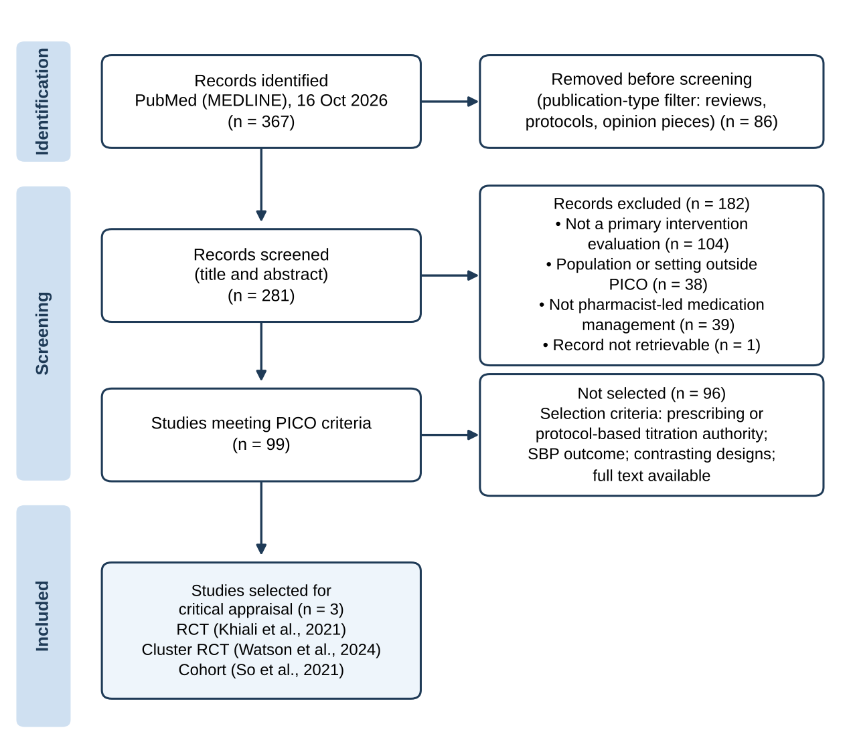

Critique Tools and Summary of Critiques
The CASP randomised controlled trial (RCT) checklist was used for the two trials (Critical Appraisal Skills Programme [CASP], 2020, Q1–Q11). Watson et al. (2024) was also checked against the CONSORT stepped-wedge extension (Hemming et al., 2018, Item 17a). So et al. (2021) is a single-group retrospective cohort. Following marker feedback, the JBI cohort checklist replaced the RCT tool for this study (JBI, 2020, Q1–Q11). Wheeler et al. (2025, p. 1) found 71% of NZ CVD studies scored low on an adapted CONSIDER tool. Therefore, the CONSIDER statement was added as a cultural lens. Its eight domains include governance, participation, and analysis and findings (Huria et al., 2019, p. 1). Full appraisals are in Appendices B–D.

Khiali et al. (2021): Individual RCT (Appendix B)
Khiali et al. (2021) randomised 126 adults with uncontrolled BP at one Iranian heart clinic (p. 284). Patients self-titrated medicines by protocol under pharmacist supervision, versus cardiologist-led usual care (pp. 283–284). Independent, computer-generated allocation and similar baseline groups reduced selection bias (pp. 284–285). However, nobody was blinded, and only 122 participants were analysed without intention-to-treat (p. 285). At six months, SBP fell by 34.9 versus 33.6 mmHg (p = .63) (p. 288). No confidence interval was reported (p. 288). Large falls in both groups suggest regression to the mean. Socially, the trial excluded blind and illiterate people (p. 284). It also enrolled only patients owning a digital BP monitor (p. 289). These rules exclude people already facing inequity.

Watson et al. (2024): Stepped-Wedge Cluster RCT (Appendix C)
Watson et al. (2024) studied 890 patients in 59 Alberta pharmacies (p. 190). After certification, pharmacists assessed risk, prescribed or adjusted medicines and reviewed patients monthly (p. 193). SBP fell 4.76 mmHg more than usual care at three months (95% CI 2.02–7.50) (p. 196). However, the planned stepped-wedge analysis was abandoned, and groups were compared regardless of time (p. 194). Without time adjustment, this design resembles an uncontrolled before-and-after study (Hemming et al., 2018, Item 17a). Also, 45 pharmacists withdrew, so their patients stayed as controls (Watson et al., 2024, p. 194). Pharmacists recruited patients, some home readings replaced office readings, and control follow-up was unspecified (pp. 193, 197). A co-author was the journal's paid editor-in-chief (p. 198). Culturally, 78.4% of participants were white and 4.5% First Nations (p. 195). No Indigenous governance or subgroup analysis was reported.

So et al. (2021): Retrospective Cohort (Appendix D)
So et al. (2021) reviewed 215 records from two Alberta pharmacies using a "Pharmacist First" workflow (p. 377). These pharmacists held additional prescribing and laboratory authority (p. 376). SBP fell from 139.83 to 131.26 mmHg in 201 patients with hypertension (p. 377). Using the JBI checklist, confounders were not identified and no control group existed (JBI, 2020, Q4–Q5). BP was not measured in a standard way, and patients were selected by having a care plan (So et al., 2021, p. 379). Reporting was also inconsistent. The database abstract gives a 4.2-month median follow-up, but this was time to first visit; overall follow-up was 19 months (p. 377). Ethnicity was not recorded, so nobody can tell who benefited.

Synthesis of the Three Studies and Critiques

Comparing and Contrasting the Studies
All three studies tested pharmacist-led medication management for adults with uncontrolled hypertension. They differed in pharmacist role, comparator and follow-up (Table 3). Only Watson et al. (2024) tested pharmacist prescribing directly against usual care. Khiali et al. (2021) tested pharmacist-supervised patient self-titration against specialist care.
Table 3
Comparison of the Three Study Sources
Feature | Khiali et al. (2021) | Watson et al. (2024) | So et al. (2021)
Design | Individual RCT | Stepped-wedge cluster RCT | Retrospective single-group cohort
Setting; n | Iranian heart clinic; 126 | 59 Canadian pharmacies; 890 | 2 Canadian pharmacies; 215
Pharmacist role | Supervised patient self-titration | Certified prescribing, monthly review | Prescribing within routine workflow
Comparator | Cardiologist care | Usual pharmacy care | None
SBP result | No difference (p = .63) | −4.76 mmHg (95% CI 2.02–7.50) | −8.57 mmHg before–after
Main bias risk | No blinding; no ITT | Time not adjusted; crossover | Confounding; unstandardised BP
Equity reporting | No ethnicity; excluded illiterate | 4.5% First Nations; no subgroup | No ethnicity

Synthesis of Results
The results point in one direction, but with weak certainty (Figure 2). The only significant between-group effect was 4.76 mmHg (Watson et al., 2024, p. 196). This is close to the 5 mmHg change linked to about 10% fewer major CVD events (BPLTTC, 2021, p. 1625). Yet the lower confidence limit of 2.02 mmHg would be clinically modest. Khiali et al. (2021) found no added benefit, possibly because over 85% of both groups reached control (p. 286). So et al. (2021) reported the largest fall, but an uncontrolled change cannot be attributed to the intervention (p. 379). No study measured CVD events, and trial follow-up was six months or less.
Figure 2
Systolic Blood Pressure Findings Across the Three Studies
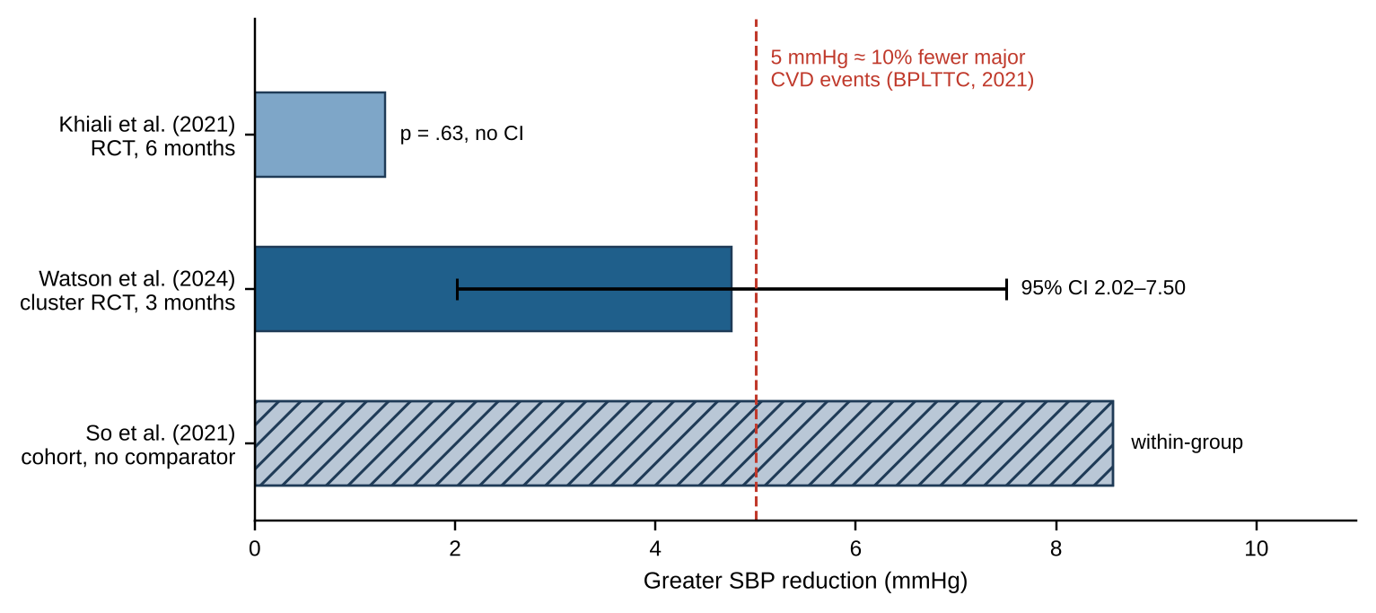
Note. Trial bars are between-group differences; So et al. (2021) shows within-group change only.

Synthesis of Critiques
Three shared weaknesses stand out across the critiques. First, no study blinded patients or pharmacists, so performance bias was possible (CASP, 2020, Q4). Second, BP measurement varied, especially where home readings replaced office readings (Watson et al., 2024, p. 197; So et al., 2021, p. 379). Third, none reported results by ethnicity or showed Indigenous governance, which are core CONSIDER domains (Huria et al., 2019, p. 1). Two studies also came from one Alberta research group, sharing authors Al Hamarneh and Tsuyuki. This reduces independence.

Appropriateness of Designs for the PICO Question
Randomised trials offer the highest causal inference for an intervention question (Watson et al., 2024, p. 192). The cluster design suited a pharmacy-level service, but its weakened analysis moved it towards before-and-after evidence (Hemming et al., 2018, Item 17a). Khiali et al.'s (2021) individual RCT had stronger internal validity but tested a different intervention. So et al.'s (2021) cohort shows real-world feasibility but cannot answer a causal question (JBI, 2020, Q4–Q5). Thus, the best-designed study answers a different question, and the most relevant one is weakened.

Critical Discussion: Adequacy and Application in Aotearoa New Zealand

Adequacy of the Evidence
Together, the studies give low-to-moderate certainty that pharmacist prescribing modestly lowers SBP over three months. This partly answers the PICO question but not the dilemma, which concerns NZ, Māori and long-term outcomes. Alberta pharmacists prescribe independently, and results may differ where scope differs (Watson et al., 2024, p. 197). In contrast, NZ pharmacist prescribers work collaboratively with medical prescribers (Raghunandan et al., 2021, Background section). Khiali et al.'s (2021) findings also come from a health system with different care quality (p. 288).

Te Tiriti o Waitangi and Māori Health
Applying the MoH (2020, p. 1) framework shows that this evidence does not meet te Tiriti obligations (Table 4). Hikaka et al. (2021, p. 124) used the same principles to design a pharmacist medicines review with and for Māori. This offers a practical NZ model.
Table 4
Te Tiriti o Waitangi Principles Applied to the Synthesised Evidence
Principle | Gap in the evidence | Implication for NZ practice
Tino rangatiratanga | No Māori or Indigenous input in any study | Māori and hauora Māori providers co-lead service design
Equity | No results reported by ethnicity | Monitor SBP control by ethnicity from the start
Active protection | Exclusion of illiterate people and those without monitors | Fund validated monitors and literacy-friendly education
Options | Only pharmacy or clinic models tested | Offer kaupapa Māori and mobile options alongside pharmacy care
Partnership | Whānau roles were not studied | Build care plans with patients, whānau and the wider team
Note. Principles from MoH (2020, p. 1); application informed by Hikaka et al. (2021, p. 124).
Cultural safety also requires accountability, measured by progress towards equity as defined by communities (Curtis et al., 2019, p. 1). A service that lowers average SBP but leaves Māori behind would therefore not be culturally safe.

Social Justice
Through Fraser's lens, redistribution means placing prescribers where unmet need is greatest (Estellés & O'Neill, 2024, Abstract). Currently, Māori are under-represented among pharmacist prescribers' patients (Raghunandan et al., 2021, Results section). Recognition requires relationships and cultural safety, which Māori and Pacific patients identified as key to CVD care (Wheeler et al., 2025, p. 1). Participation requires Māori voice in service design and research governance (Huria et al., 2019, p. 1). Expanding pharmacist prescribing without these conditions risks benefiting mainly the already advantaged.

Conclusions and Recommendations
The three studies suggest pharmacist prescribing may lower SBP by a small but useful amount. However, design flaws, short follow-up and missing equity data limit confidence. The evidence does not justify a wide NZ rollout, but supports carefully evaluated, te Tiriti-based services:
- Integrate pharmacist prescribers into collaborative primary care teams, using protocols and monthly follow-up (Watson et al., 2024, p. 193).
- Co-design services with Māori and hauora Māori providers, structured around te Tiriti principles (Hikaka et al., 2021, p. 124).
- Record ethnicity and report SBP control for Māori, so equity can be measured (Curtis et al., 2019, p. 1).
- Remove access barriers such as monitor ownership and literacy requirements (Khiali et al., 2021, pp. 284, 289).
- Fund an NZ pragmatic cluster RCT with Māori governance, 12-month follow-up and CONSIDER-based reporting (Huria et al., 2019, p. 1).

References
Blood Pressure Lowering Treatment Trialists' Collaboration. (2021). Pharmacological blood pressure lowering for primary and secondary prevention of cardiovascular disease across different levels of blood pressure: An individual participant-level data meta-analysis. The Lancet, 397(10285), 1625–1636. https://doi.org/10.1016/S0140-6736(21)00590-0
Critical Appraisal Skills Programme. (2020). CASP randomised controlled trial standard checklist. https://casp-uk.net/casp-tools-checklists/
Curtis, E., Jones, R., Tipene-Leach, D., Walker, C., Loring, B., Paine, S.-J., & Reid, P. (2019). Why cultural safety rather than cultural competency is required to achieve health equity: A literature review and recommended definition. International Journal for Equity in Health, 18, Article 174. https://doi.org/10.1186/s12939-019-1082-3
Estellés, M., & O'Neill, J. (2024). Social justice imaginaries and education policy in Aotearoa New Zealand (2017–2024). New Zealand Journal of Educational Studies. Advance online publication. https://doi.org/10.1007/s40841-024-00348-0
Hemming, K., Taljaard, M., McKenzie, J. E., Hooper, R., Copas, A., Thompson, J. A., Dixon-Woods, M., Aldcroft, A., Doussau, A., Grayling, M., Kristunas, C., Goldstein, C. E., Campbell, M. K., Girling, A., Eldridge, S., Campbell, M. J., Lilford, R. J., Weijer, C., Forbes, A. B., & Grimshaw, J. M. (2018). Reporting of stepped wedge cluster randomised trials: Extension of the CONSORT 2010 statement with explanation and elaboration. BMJ, 363, Article k1614. https://doi.org/10.1136/bmj.k1614
Hikaka, J., Abey-Nesbit, R., McIntosh, B., Schluter, P. J., Nishtala, P. S., Scrase, R., & Jamieson, H. A. (2023). Utility of big data to explore medication adherence in Māori and non-Māori community-dwelling older adults with heart failure in Aotearoa New Zealand: A cross-sectional study. Drugs & Aging, 40(9), 847–855. https://doi.org/10.1007/s40266-023-01044-2
Hikaka, J., Jones, R., Hughes, C., Connolly, M. J., & Martini, N. (2021). Utilising te Tiriti o Waitangi to approach health intervention development and research: Pharmacist-facilitated medicines review interventions for Māori older adults. Journal of Primary Health Care, 13(2), 124–131. https://doi.org/10.1071/HC20114
Huria, T., Palmer, S. C., Pitama, S., Beckert, L., Lacey, C., Ewen, S., & Smith, L. T. (2019). Consolidated criteria for strengthening reporting of health research involving Indigenous peoples: The CONSIDER statement. BMC Medical Research Methodology, 19, Article 173. https://doi.org/10.1186/s12874-019-0815-8
JBI. (2020). Checklist for cohort studies. https://jbi.global/sites/default/files/2020-10/Checklist_for_Cohort_Studies.pdf
Khiali, S., Khezerlo-aghdam, N., Namdar, H., & Entezari-Maleki, T. (2021). Pharmacist-directed self-management of blood pressure versus conventional management in patients with hypertension: A randomized control trial. High Blood Pressure & Cardiovascular Prevention, 28(3), 283–290. https://doi.org/10.1007/s40292-021-00445-x
Ministry of Health. (2020). Te Tiriti o Waitangi framework. https://www.health.govt.nz/system/files/2024-05/whakamaua-tiriti-o-waitangi-framework-a3-aug20.pdf
Raghunandan, R., Marra, C. A., Tordoff, J., & Smith, A. (2021). Examining non-medical prescribing trends in New Zealand: 2016–2020. BMC Health Services Research, 21, Article 418. https://doi.org/10.1186/s12913-021-06435-y
So, R., Al Hamarneh, Y. N., Oleksyn, C., Purschke, M., & Tsuyuki, R. T. (2021). Impact of a "Pharmacist First" innovative workflow plan in patients with hypertension and/or diabetes. Canadian Pharmacists Journal, 154(6), 376–380. https://doi.org/10.1177/17151635211016498
Watson, K. E., Chan, J. C. H., Pan, B., Al Hamarneh, Y. N., & Tsuyuki, R. T. (2024). Enhancing hypertension detection and control through a hypertension certification program for pharmacists: A cluster randomized trial (the RxPATH study). Canadian Pharmacists Journal, 157(4), 190–199. https://doi.org/10.1177/17151635241254089
Wheeler, A., Rahiri, J.-L., Ellison-Lupena, R., Hanchard, S., Brewer, K. M., Paynter, J., Winter-Smith, J., Selak, V., Ameratunga, S., Grey, C., & Harwood, M. (2025). Assessing the gaps in cardiovascular disease risk assessment and management in primary care for Māori and Pacific peoples in Aotearoa New Zealand: A systematic review. The Lancet Regional Health – Western Pacific, 56, Article 101511. https://doi.org/10.1016/j.lanwpc.2025.101511

HEAL840 AI Declaration
Tools used: Claude (Anthropic), October 2026.
Purpose(s): Checking alignment with the rubric and marker feedback; refining the PubMed search string; structuring the synthesis; suggesting plainer, more concise wording; checking reference details against PubMed records.
Representative prompts: 'Check my PICO and search string against my Assignment 1 feedback'; 'Suggest how to make this paragraph more concise'; 'Check this reference list against APA 7.'
Verification: All content was checked against the three original articles (including page numbers), the PubMed records, the Ministry of Health (2020) framework and the course rubric. All references were confirmed against their original sources.
Ethical compliance: I confirm that any AI assistance was appropriately acknowledged, that all sources are genuine and verifiable, and that the final work is my own search, analysis, synthesis and critique.

Appendix A: Reflection on Formative Assessment 2
Formative assessment 2 feedback showed that my te Tiriti content was descriptive and unsupported. I made four changes. First, I defined social justice beyond health, using Fraser's redistribution, recognition and participation model (Estellés & O'Neill, 2024, Abstract). Second, I cited the Ministry of Health framework as the source of the principles (MoH, 2020, p. 1). Third, following my lecturer's advice, I used Joanna Hikaka's work to link the principles to pharmacist services (Hikaka et al., 2021, p. 124; Hikaka et al., 2023, p. 847). Fourth, I supported each claim with literature. Assignment 1 feedback also led me to remove blood glucose, correct the search and use the JBI cohort tool. These changes moved my writing from description towards critical, equity-focused analysis.

Appendix B: CASP RCT Appraisal of Khiali et al. (2021)
CASP question | Answer | Justification
1. Clear question | Yes | HBPM versus usual care; BP outcome (p. 283)
2. Randomised | Yes | Independent random-number list (p. 284)
3. All accounted for | Partly | 122 of 126 analysed; no ITT (p. 285)
4. Blinding (a–c) | No | Open label; assessor blinding not reported
5. Similar at baseline | Yes | Demographics and BP similar (p. 285)
6. Treated equally | Yes | Same visits at months 1, 3 and 6 (p. 284)
7. Effects reported | Partly | Means and p-values; no effect sizes (p. 288)
8. Precision | No | No 95% CI for group difference (p. 288)
9. Benefits vs harms and costs | Can't tell | No event difference; no costing (pp. 286, 289)
10. Applicable locally | Partly | Iranian clinic; illiterate people excluded (p. 284)
11. Greater value | Can't tell | No added BP benefit (p. 288)
Cultural (CONSIDER) | Weak | No ethnicity or community governance; ethics approved (p. 284)

Appendix C: CASP RCT Appraisal of Watson et al. (2024)
CASP question | Answer | Justification
1. Clear question | Yes | Certification versus usual care; SBP at 3 months (p. 190)
2. Randomised | Yes | Pharmacies randomised, stratified urban/rural (p. 193)
3. All accounted for | Partly | 45 pharmacists withdrew; patients stayed control (p. 194)
4. Blinding (a–c) | No/No/Yes | Patients and pharmacists unblinded; statistician blinded (p. 193)
5. Similar at baseline | Partly | More East Asian controls (p. 195)
6. Treated equally | No | Control follow-up unspecified (p. 193)
7. Effects reported | Partly | Time not adjusted (p. 194; Hemming et al., 2018, Item 17a)
8. Precision | Yes | 95% CI 2.02–7.50 (p. 196)
9. Benefits vs harms and costs | Can't tell | No harms or costs; satisfaction 75.9/90 (p. 197)
10. Applicable locally | Partly | Independent prescribing differs from NZ (p. 197)
11. Greater value | Can't tell | Three-month follow-up only (p. 197)
Cultural (CONSIDER) | Weak | 4.5% First Nations; no subgroup; ethics approved (pp. 194–195)

Appendix D: JBI Cohort Appraisal of So et al. (2021)
JBI question | Answer | Justification
1. Groups similar | N/A | Single group (p. 377)
2. Exposure measured similarly | N/A | No comparison group
3. Exposure valid and reliable | Unclear | Intervention components undocumented (p. 379)
4. Confounders identified | No | None reported
5. Confounding strategies | No | No adjustment
6. Free of outcome at start | N/A | Baseline BP recorded (p. 377)
7. Outcome valid and reliable | No | Unstandardised BP measurement (p. 379)
8. Follow-up sufficient | Yes | Median 19 months (p. 377)
9. Follow-up complete | Unclear | Two excluded; missing data unclear (p. 377)
10. Incomplete follow-up addressed | No | Not described
11. Appropriate analysis | Partly | Paired t test, unadjusted (p. 377)
Cultural (CONSIDER) | Weak | Ethnicity not recorded; ethics waiver granted (p. 377)

