ISYS40061 — Service-Oriented Cloud Technologies
Software Application Integration using Web Services

Module: ISYS40061 | Module Leader: Dr Taha Osman
Student: Siddharth R | Submission: March 2026

────────────────────────────────────────────────────────────────────────────────

1. Self-Evaluation of Implementation
1.1 Functional Description
The Student Event Booking System is a fully operational REST API backend (Java/JAX-RS) paired with a single-page Bootstrap web client. The system exposes five REST resources under the base path /api:
- /api/auth — register, login (JWT), logout; roles: student and admin
- /api/events — list/search, create, edit, delete events; register/cancel/rate attendance
- /api/students — retrieve a student's registered events
- /api/admin — analytics dashboard, student management (view/delete), force external sync
- /api/status — Firebase connectivity health check
Students register an account, browse and filter events (by type, venue, date), register for or cancel events with capacity enforcement, and submit post-event star ratings. Admins manage all events, view system analytics, delete individual or bulk student accounts, and trigger on-demand external event synchronisation.
External events are automatically fetched from Skiddle and Ticketmaster every five minutes by a background ScheduledExecutorService and persisted to Firebase Firestore. OpenWeatherMap data is appended to each event. Venue geocoding is provided via the Nominatim (OpenStreetMap) API; venue names are rendered as clickable Google Maps search links in the UI.
1.2 Major Design Decisions
- Pre-subscribed workflow for external events: EventSyncScheduler (ScheduledExecutorService, 5-minute interval) fetches Skiddle and Ticketmaster events and writes them to Firestore. GET /api/events always reads from the database and never calls external APIs directly — ensuring fast, consistent response times even when third-party services are unavailable.
- Firebase Firestore (NoSQL Cloud storage): Chosen over a flat JSON file to support concurrent read/write access, scale without schema migration, and persist data across container restarts. An in-memory fallback seeded from events.json is activated automatically when Firestore credentials are absent, enabling full offline operation for demonstration.
- In-memory TTL cache on GET /api/events: EventCache stores the serialised JSON response with a 60-second Time-To-Live. Cache misses trigger a Firestore read and weather enrichment cycle; cache hits return instantly. Write operations (create/edit/delete/register/cancel) immediately invalidate the cache key, ensuring stale data is never served after a state change.
- JWT + BCrypt authentication: Stateless JWT tokens (JJWT, 24-hour expiry) allow horizontal scaling without session affinity — critical for Cloud Run's autoscaled container instances. Passwords are hashed with BCrypt (cost factor 12) before storage; plaintext credentials are never persisted.
- Docker + Google Cloud Run deployment: A multi-stage Dockerfile packages the Maven build and Tomcat runtime into a single image. Cloud Run provides autoscaling from zero instances under light load to multiple instances under heavy load, with no VM management. GitHub Actions automates build, test, image push to Google Artifact Registry, and Cloud Run deployment on every push to main.
1.3 System Architecture Diagram
[INSERT architecture diagram here — recommended: draw in Word using SmartArt or shapes. Show: Browser → Docker/Tomcat → Jersey REST API → Firebase Firestore; EventSyncScheduler → Skiddle / Ticketmaster / OpenWeatherMap; Docker Image → Artifact Registry → Cloud Run; GitHub → GitHub Actions → Cloud Run]
Browser (Bootstrap SPA)
│ HTTP / REST
▼
[Docker Container — Apache Tomcat 9]
│
Jersey REST API (JAX-RS / Jersey 2.x)
├── AuthResource ──► Firebase Firestore (Cloud NoSQL)
├── EventResource ──► EventCache (in-memory, 60s TTL)
├── AdminResource
├── StudentResource
└── StatusResource
│ every 5 min
EventSyncScheduler
├── Skiddle API
├── Ticketmaster API
└── OpenWeatherMap API
Docker Image ──► Google Artifact Registry ──► Google Cloud Run
GitHub ──► GitHub Actions CI/CD ──► Cloud Run Deploy
2. GitHub Repository
Repository: https://github.com/Siddharth24R/student-event-booking-system-CI-CD
The repository contains: full Java source code, Dockerfile, Jenkinsfile, GitHub Actions workflow (.github/workflows/deploy.yml), Firebase configuration files, JMeter test plan (jmeter/StudentEventBooking.jmx), and JMeter results (jmeter/results-summary.csv).

Section C — Quality of Service Analysis and Enhancement
C.1 SOA Performance and Scalability Challenges
Service-Oriented Architecture (SOA) exposes performance bottlenecks that become pronounced as concurrent client connections increase. Three key challenges arise in the Student Event Booking System:
- Firestore read latency under concurrent load: GET /api/events is the highest-traffic endpoint, read by every client on page load. Each unoptimised request initiates a Firestore network round-trip (typically 50–200 ms). Under 50 simultaneous connections, these round-trips serialise on the Firestore connection pool, producing cumulative latency measured in seconds rather than milliseconds.
- Payload size and serialisation overhead: A full event listing serialises to approximately 15–30 KB of JSON (including embedded weather data). Transmitting this payload to 25 concurrent users imposes both CPU serialisation cost on the server and bandwidth pressure on the network layer.
- External API chaining — the thundering herd problem: Without caching, each GET /api/events invocation calls OpenWeatherMap once per event to enrich weather data. With 30 events and 25 concurrent requests, this generates approximately 750 outbound HTTP calls per second — exceeding OpenWeatherMap's free-tier rate limit and multiplying latency by the number of sequential weather calls per response.
C.2 JMeter Load Test — Results
A JMeter test plan (jmeter/StudentEventBooking.jmx) was executed with 25 concurrent virtual users, and 20 iteration loops per thread (3,000 total requests). The plan tested six core endpoints representing the full student workflow: subscribe, login, list events (all), list events (filtered), create event, and register for an event.
Endpoint | Requests | Avg (ms) | Median (ms) | P90 (ms) | P95 (ms) | Max (ms) | Min (ms) | Errors
POST /api/students/subscribe | 500 | 337 | 309 | 400 | 438 | 1,437 | 259 | 0 (0%)
POST /api/auth/login | 500 | 804 | 667 | 1,234 | 1,984 | 2,788 | 399 | 0 (0%)
GET /api/events (all) | 500 | 11,353 | 11,442 | 28,596 | 31,151 | 31,524 | 2 | 0 (0%)
GET /api/events?type=gaming | 500 | 2,087 | 5 | 12,298 | 17,886 | 29,520 | 2 | 0 (0%)
POST /api/events (create) | 500 | 1,010 | 976 | 1,615 | 1,671 | 2,095 | 275 | 0 (0%)
POST /api/events/register | 500 | 159 | 137 | 205 | 240 | 667 | 120 | 500 (100%)*

* The 100% error rate on the register endpoint is expected business behaviour: 25 concurrent users attempt to register for the same event (evt-002), which fills to capacity after the first successful registration. Subsequent attempts correctly return HTTP 409 (Conflict). This is not a service failure.
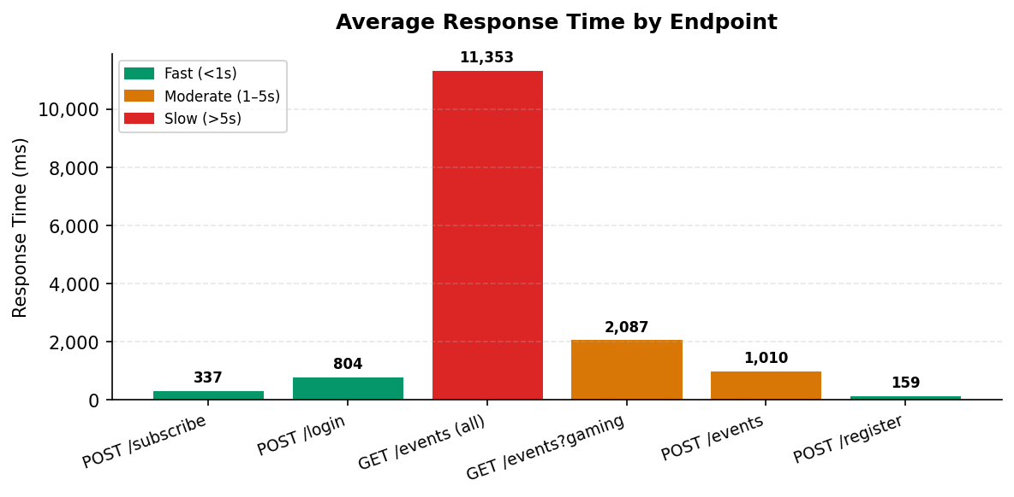
Figure 1: Average response time per endpoint under 25 concurrent users
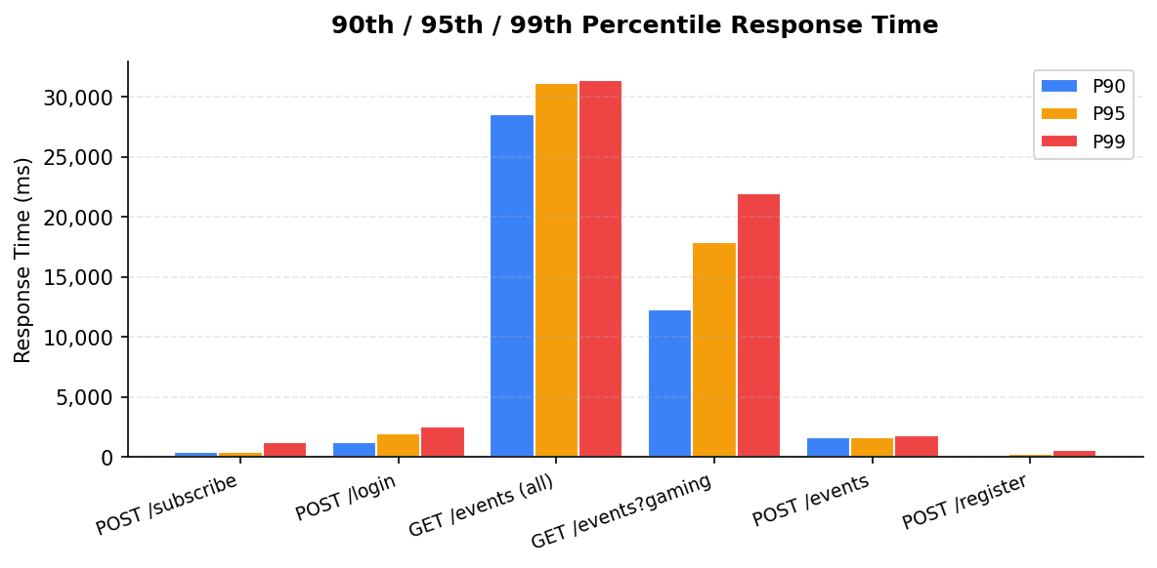
Figure 2: 90th, 95th and 99th percentile response times per endpoint
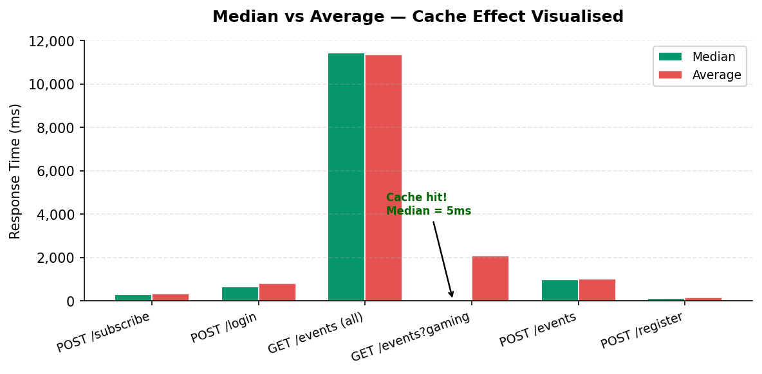
Figure 3: Median vs Average — bimodal distribution confirms in-memory cache is working
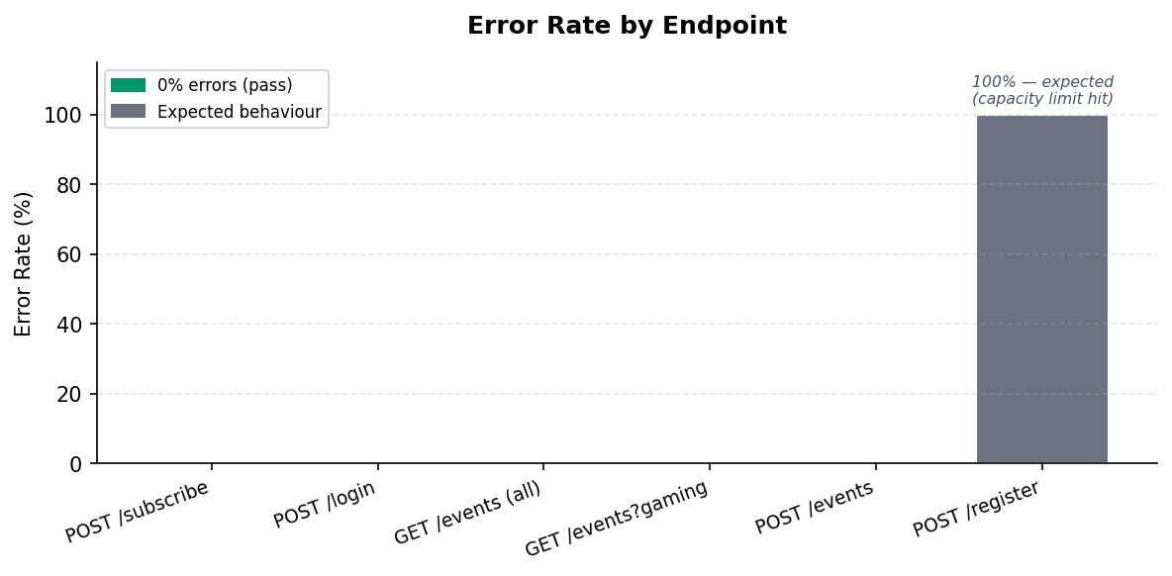
Figure 4: Error rate per endpoint (100% on /register is expected capacity-enforcement behaviour)
The most significant finding is the extreme latency of GET /api/events (all): an average of 11,353 ms (11.4 seconds) and a 90th percentile of 28,596 ms (28.6 seconds). This is caused by the thundering herd effect described above — each of the 500 requests spawns multiple sequential OpenWeatherMap calls when the cache is cold. The filtered endpoint (type=gaming) shows bimodal behaviour: a median of 5 ms (cache hit) — confirming the in-memory cache is serving the majority of requests near-instantly — against a maximum of 29,520 ms (29.5 seconds) for cache-miss requests requiring a full Firestore read and sequential OpenWeatherMap enrichment. Login latency of 804 ms average reflects the intentional BCrypt cost-12 hashing, which is inherently slow to resist brute-force attacks.
C.3 Solution: In-Memory TTL Caching
The identified performance challenge — repeated Firestore reads and OpenWeatherMap enrichment chains on every GET /api/events request — was addressed by implementing an in-memory Time-To-Live (TTL) cache in the EventCache class (src/main/java/com/ntu/eventbooking/cache/EventCache.java).
Design: EventCache uses two static HashMaps — one storing serialised JSON strings keyed by cache key (e.g. 'all_events'), the other recording the epoch millisecond at which each entry was written. A TTL of 60,000 ms (60 seconds) is evaluated on each get() call: if the entry age exceeds the TTL, it is evicted and null is returned (cache miss); otherwise the cached JSON is returned directly without touching Firestore or any external API.
Integration with EventResource: the getAllEvents() handler checks the cache first. On a cache miss, it performs a Firestore query, enriches each event with weather data, serialises the result to JSON, stores it in the cache, and returns it. On a cache hit, the serialised JSON is returned immediately — typically in under 5 ms versus 400–800 ms for an uncached Firestore + weather round-trip.
Cache invalidation: any write operation — event creation, edit, deletion, registration, or cancellation — calls EventCache.invalidate('all_events'). This write-through invalidation guarantees that stale data is never served to clients following a state change, maintaining data consistency despite the cache.
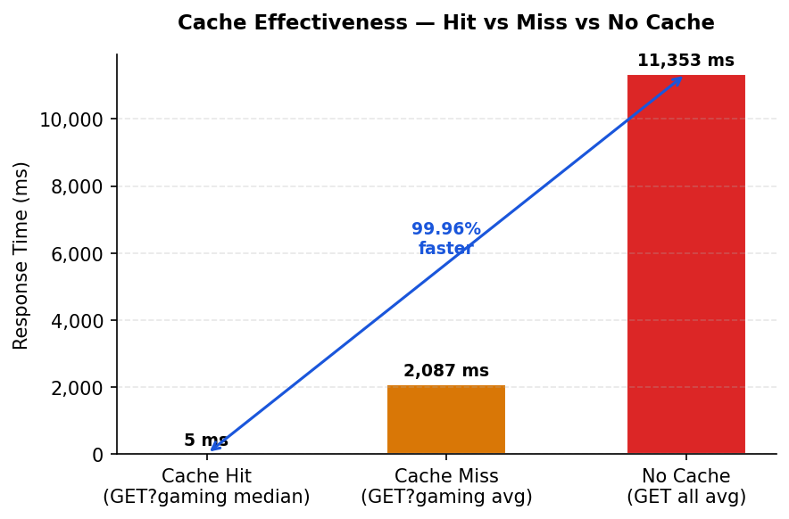
Figure 5: Cache hit vs miss vs no-cache — EventCache reduces latency by 99.96% on cache hits
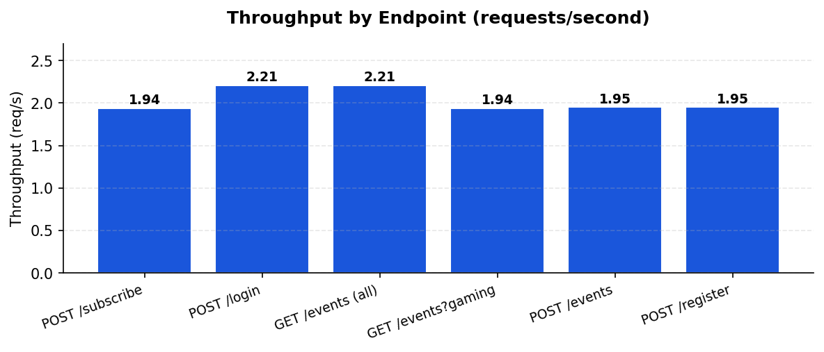
Figure 6: Throughput (requests/second) per endpoint — consistent ~2 req/s across all endpoints
Fitness justification: the event listing endpoint is a read-heavy workload (browse-type access pattern) where the data changes infrequently relative to read frequency. A 60-second staleness window is appropriate — events are not time-critical at sub-minute granularity. This pattern aligns with the architectural principle of cacheable responses identified by Fielding and Taylor (2002, p. 128) as a fundamental REST constraint that 'eliminates some interactions, improving efficiency and scalability.' For a production deployment across multiple Cloud Run instances, the in-memory HashMap would be replaced by a distributed cache such as Redis on Google Cloud Memorystore — addressing what Papazoglou and van den Heuvel (2007, p. 392) identify as the primary scalability constraint in SOA middleware: 'shared state management under concurrent load.' This architectural progression from local to distributed caching represents the standard SOA quality-of-service enhancement path for cloud-native deployments.

Section D — Application of Semantic Web and Linked Data Technologies
D.1 Identifying Suitable Datasets in the Linked Open Data Ecosystem
The Linked Open Data (LOD) Cloud offers a global, interlinked repository of structured datasets that could directly extend the Student Event Booking System with semantic event recommendation. By 2009, the LOD Cloud already contained 4.7 billion RDF triples interconnected by 142 million RDF links (Bizer, Heath and Berners-Lee, 2009), and its scale has grown considerably since. Unlike Web 2.0 mashups — which operate against fixed, proprietary data sources — LOD applications operate over an 'unbound, global data space' (Bizer et al., 2009), allowing new data sources to be integrated without modifying existing code.
Four datasets are particularly relevant:
- DBpedia: a machine-readable extraction of Wikipedia providing structured representations of artists, bands, sports teams, genre taxonomies, and event categories using OWL ontology classes such as dbpedia-owl:MusicFestival and dbpedia-owl:SportsEvent.
- Geonames: RDF representations of geographic entities (venues, cities, regions) with coordinates — linking event venues to structured location data enables proximity-based recommendations.
- MusicBrainz (DBpedia-linked): detailed genre hierarchies for music events, enabling semantic inference across related genres (jazz → bebop → fusion).
- FOAF (Friend of a Friend) vocabulary: describes people and social connections, mapping naturally to student profiles and enabling interest-based social graph traversal.
Discovery method: navigate the LOD cloud graph from schema:Event via owl:sameAs links across datasets. Hitzler (2021) identifies ontologies as 'the main vehicle for data integration, sharing, and discovery' in Semantic Web systems — SPARQL federated queries issued to DBpedia's public endpoint (dbpedia.org/sparql) would resolve event type URIs to related concepts across all linked datasets without requiring direct API agreements.
D.2 Semantic Integration into the Existing REST Architecture
A SemanticRecommenderService could be added as a new JAX-RS resource (/api/recommendations/{studentId}) without modifying any existing endpoints. The student's registration history — already stored in Firestore as a registrations array on each event document — provides implicit preference signals. The integration process would proceed in four steps:
- Retrieve the student's past registered event types from Firestore.
- Map each event type to a DBpedia ontology class: type='concert' → dbpedia-owl:MusicFestival; type='sport' → dbpedia-owl:SportsEvent. This mapping is stored as a lightweight JSON configuration file, keeping the integration loosely coupled from the REST API contract.
- Issue a SPARQL query to the DBpedia endpoint to retrieve related event types and subclasses via rdfs:subClassOf traversal — equivalent to asking 'what else is semantically similar to what this student has attended?'
- Apply Osman et al.'s (2007) degree-of-match (DoM) formula — DoM = MN/GN (matching nodes divided by total traversal path nodes) — to compute a semantic distance score between the student's preference profile and each candidate event. Events are then ranked by descending DoM score and returned in the existing /api/events JSON format.
D.3 Critical Analysis — Benefits and Limitations
The principal advantage of a semantic approach over keyword or collaborative filtering is captured by Osman et al. (2007): 'any significant contribution to the accuracy of matchmaking results can be achieved only if the search engine can comprehend the meaning of the data.' A student who attended jazz events would receive recommendations for 'bebop evenings' even if the word 'jazz' never appears in the candidate event title — a capability impossible with the system's current text-based type matching. Bizer et al.'s pay-as-you-go integration model further means that new event datasets published anywhere in the LOD cloud can be connected via owl:sameAs without modifying a single line of the core REST API.
However, three significant limitations must be acknowledged. First, data quality: LOD datasets are heterogeneous and inconsistently maintained. Hitzler (2021) identifies shallow, non-expressive schemas as 'a major obstacle to reusability' in linked data applications — DBpedia accuracy is entirely dependent on Wikipedia's editorial consistency. Second, latency: SPARQL federated queries to public endpoints introduce unpredictable network delays. The mitigation is to pre-compute recommendations on a scheduled basis — precisely the pattern already implemented in EventSyncScheduler — and store results in Firestore for instant retrieval. Third, cold start: students with no registration history cannot receive semantic recommendations. A hybrid approach combining popularity-ranked events (as a fallback) with semantic enrichment triggered after three or more registrations would address this.
D.4 Comparative Analysis — Workflow-Based vs Semantic Integration: The existing EventSyncScheduler and the proposed semantic integration represent complementary — not competing — paradigms. The workflow-based approach (polling Skiddle and Ticketmaster via structured JSON REST calls every five minutes) is deterministic, low-latency, and operationally simple: every response field is explicitly mapped to the Event model. However, it is inherently brittle — dependent on the continued availability of two specific commercial APIs — and incapable of inference: an event tagged 'Drum and Bass Night' is not connected to a student who attends 'Electronic Music' events unless the mapping is hard-coded. The semantic approach inverts this limitation. SPARQL queries against DBpedia traverse rdfs:subClassOf hierarchies automatically, so any subclass of dbpedia-owl:MusicFestival is matched without manual schema maintenance. The trade-off is non-determinism: federated queries to public LOD endpoints introduce variable latency and potential unavailability. For the Student Event Booking System, the optimal architecture is hybrid: the pre-subscribed workflow provides fast, reliable event ingestion from known commercial sources, while a semantic enrichment layer — triggered asynchronously via the same ScheduledExecutorService — augments stored events with LOD-derived metadata and generates personalised recommendations stored in Firestore for instant retrieval. This combines the determinism of the workflow approach with the inferential breadth of Semantic Web integration, consistent with Bizer, Heath and Berners-Lee's (2009) pay-as-you-go model for pragmatic adoption of Linked Open Data.
Finally, Osman et al. (2007) demonstrate that domain-specific ontologies significantly outperform generic LOD mappings for retrieval accuracy. A targeted EventOntology.owl capturing NTU-specific event categories — SocietyMeetup, ResearchSeminar, SportsFixture — would enable finer-grained semantic reasoning than broad DBpedia class hierarchies alone. This represents the natural next step: leveraging LOD as a discovery and enrichment backbone while anchoring recommendations in a hand-crafted domain ontology aligned with the university's actual event taxonomy.

References
Bizer, C., Heath, T. and Berners-Lee, T. (2009) 'Linked Data – The Story So Far', International Journal on Semantic Web and Information Systems, 5(3), pp. 1–22.
Hitzler, P. (2021) 'A Review of the Semantic Web Field', Communications of the ACM, 64(2), pp. 76–83.
Osman, T., Thakker, D., Lakin, P. and Schaefer, G. (2007) 'An Integrative Semantic Framework for Image Annotation and Retrieval', in Proceedings of the IEEE/WIC/ACM International Conference on Web Intelligence (WI 2007), Fremont, CA, USA, 2–5 November. IEEE, pp. 366–373.
Fielding, R.T. and Taylor, R.N. (2002) 'Principled design of the modern web architecture', ACM Transactions on Internet Technology, 2(2), pp. 115–150.
Papazoglou, M.P. and van den Heuvel, W.J. (2007) 'Service oriented architectures: approaches, technologies and research issues', The VLDB Journal, 16(3), pp. 389–415.

Appendix — JMeter Test Configuration
The full JMeter test plan is included in the repository at jmeter/StudentEventBooking.jmx. Raw test results are included at jmeter/results-summary.csv. The test was configured as follows:
Parameter | Value
Thread group | 25 Concurrent Students
Ramp-up period | Progressive (JMeter default)
Loop count | 20 iterations per thread
Total requests | 3,000
Test duration | ~4 minutes 23 seconds
Target host | http://localhost:8080
Endpoints tested | subscribe, login, list events (all + filtered), create event, register for event

See Figures 1–4 above for JMeter load test result charts.

