Service-Oriented Cloud Technologies
Siddharth Ravishankar
(N1431074)

1. Self-Evaluation of Implementation
1.1 Functional Description

The Student Event Booking System is a fully operational REST API backend (Java/JAX-RS) paired with a single-page Bootstrap web client. The system exposes five REST resources under the base path /api:
- /api/auth — register, login (JWT), logout; roles: student and admin
- /api/events — list/search, create, edit, delete events; register/cancel/rate attendance
- /api/students — retrieve a student's registered events
- /api/admin — analytics dashboard, student management (view/delete), force external sync
- /api/status — Firebase connectivity health check

Students register an account, browse and filter events (by type, venue, date), register for or cancel events with capacity enforcement, and submit post-event star ratings. Admins manage all events, view system analytics, delete individual or bulk student accounts, and trigger on-demand external event synchronisation.

External events are automatically fetched from Skiddle and Ticketmaster every five minutes by a background ScheduledExecutorService and persisted to Firebase Firestore. OpenWeatherMap data is appended to each event. Venue geocoding is provided via the Nominatim (OpenStreetMap) API; venue names are rendered as clickable Google Maps search links in the UI.

1.2 Major Design Decisions

- Pre-subscribed workflow for external events:
EventSyncScheduler (ScheduledExecutorService, 5-minute interval) fetches Skiddle and Ticketmaster events and writes them to Firestore. GET /api/events always reads from the database and never calls external APIs directly — ensuring fast, consistent response times even when third-party services are unavailable.

- Firebase Firestore (NoSQL Cloud storage):
Chosen over a flat JSON file to support concurrent read/write access, scale without schema migration, and persist data across container restarts. An in-memory fallback seeded from events.json is activated automatically when Firestore credentials are absent, enabling full offline operation for demonstration.

- In-memory TTL cache on GET /api/events:
EventCache stores the serialised JSON response with a 60-second Time-To-Live. Cache misses trigger a Firestore read and weather enrichment cycle; cache hits return instantly. Write operations (create/edit/delete/register/cancel) immediately invalidate the cache key, ensuring stale data is never served after a state change.

- JWT + BCrypt authentication:
Stateless JWT tokens (JJWT, 24-hour expiry) allow horizontal scaling without session affinity — critical for Cloud Run's autoscaled container instances. Passwords are hashed with BCrypt (cost factor 12) before storage; plaintext credentials are never persisted.

- Docker + Google Cloud Run deployment:
A multi-stage Dockerfile packages the Maven build and Tomcat runtime into a single image. Cloud Run provides autoscaling from zero instances under light load to multiple instances under heavy load, with no VM management. GitHub Actions automates build, test, image push to Google Artifact Registry, and Cloud Run deployment on every push to main.

1.3 System Architecture Diagra

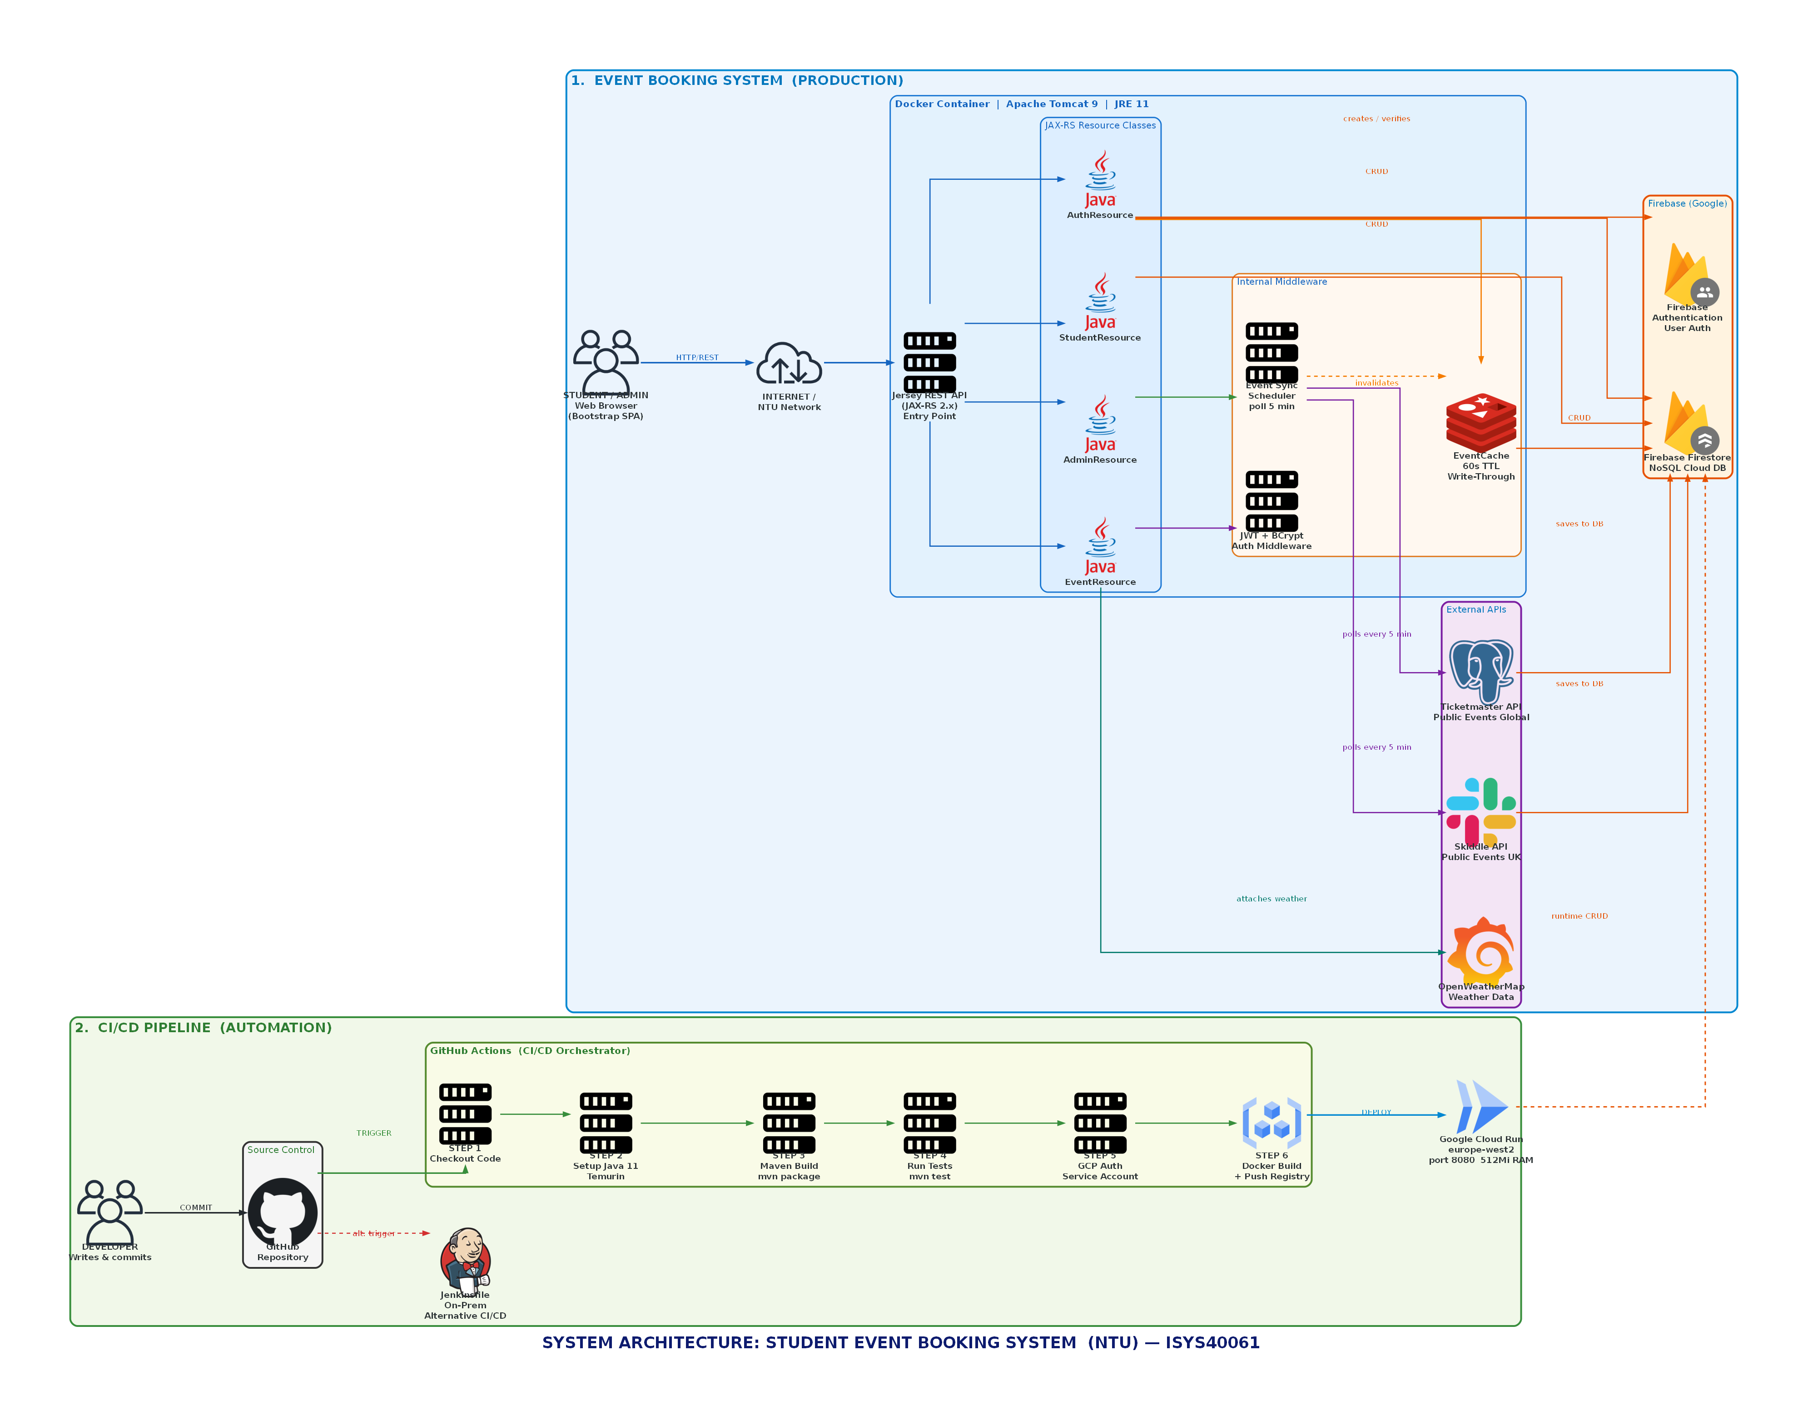
Figure 1 — Top-level system architecture of the Student Event Booking System

As shown in Figure 1, the system is divided into four different layers. In the Presentation Layer, the Browser Client (Bootstrap SPA) communicates with the application through HTTP/REST requests sent to the Jersey REST API (JAX-RS 2.x), which serves as the only entry point for all client requests.

Under the Application Layer, the Jersey API is hosted within a Docker container with Apache Tomcat 9 (JRE 11) installed. The incoming requests are processed by one of the four JAX-RS resource classes: AuthResource, EventResource, AdminResource, and StudentResource. Authentication requests are processed through the JWT + BCrypt middleware, and event query requests are fulfilled through the EventCache (60-second TTL, write-through invalidation) and eventually Firebase.

EventSyncScheduler (ScheduledExecutorService) runs within the container runtime, periodically polling three external services every five minutes, namely, the Skiddle API and Ticketmaster API for public events, and OpenWeatherMap for weather data. It also uses the Nominatim API (OpenStreetMap) for geocoding data. The data stored is persisted in a Firebase Firestore NoSQL cloud database, which is also used as the primary data store for all CRUD operations invoked by the REST API.

At the deployment layer, the Docker image is built via a multi-stage build process and is subsequently pushed to Artifact Registry via GitHub Actions CI/CD, which is triggered for every push on the main branch. The image is deployed as an autoscaled serverless container in Google Cloud Run. A separate on-premise deployment pipeline is also offered via a Jenkinsfile, which contains the same stages for a local or enterprise setup.
1.4 CI/CD Pipeline and Deployment

Two CI/CD pipelines are included in the repository, demonstrating both cloud-native and enterprise on-premises deployment approaches.
GitHub Actions (.github/workflows/deploy.yml): The trigger is set to trigger automatically on each push to the main branch. The pipeline consists of four stages, executed in sequence. The stages are as follows:

- 1. Maven build and unit tests
- 2. Docker image creation using a multi-stage Dockerfile
- 3. Pushing the image to Google Artifact Registry
- 4. Deployment using Google Cloud Run

- Google Cloud Run provides zero-to-N scaling, which means that when there are no requests, there are no instances running, but new instances of container-based services are spun up in seconds as required. The secrets for deploying are stored as encrypted GitHub repository secrets, but are not logged.

Jenkinsfile (on-premises): A declarative Jenkins pipeline is provided for use in enterprise environments where access is not possible. The pipeline consists of the following stages:

- - Checkout
- - Build (Maven 3.9, Java 11)
- - Test
- - Docker Build
- - Deploy

- The pipeline execution is based on Maven, Java 11, Docker installation on the Jenkins agent, and reading the .env configuration file during the deploy step.

The multi-stage Dockerfile clearly differentiates between the build environment (maven:3.9-eclipse-temurin-11) and the runtime environment (tomcat:9.0-jre11-temurin), thus resulting in a lightweight final image since Maven, source code, and build artifacts are not included. Tomcat 9 was chosen as it uses the javax.ws.rs namespace as required by Jersey 2.x. Tomcat 10 and later versions use the Jakarta EE 9+ jakarta.ws.rs and thus would require major code changes.

2. GitHub Repository
Repository: https://olympus.ntu.ac.uk/N1431074/student-event-booking-system.git

The repository contains the complete project: Java source code (src/), Dockerfile, Jenkinsfile, GitHub Actions workflow (.github/workflows/deploy.yml), Firebase configuration (firebase.json, firestore.rules, firestore.indexes.json), JMeter test plan (jmeter/StudentEventBooking.jmx), raw JMeter results (jmeter/results-summary.csv), and an interactive JMeter HTML dashboard (jmeter/report/index.html).

Section C — Quality of Service Analysis and Enhancement
C.1 SOA Performance and Scalability Challenges

Service-Oriented Architecture (SOA) exposes performance bottlenecks that become pronounced as concurrent client connections increase.
Three key challenges arise in the Student Event Booking System:
- Firestore read latency under concurrent load: The interface GET /api/events is the highest traffic endpoint and is interrogated by all clients during the page load. Each unoptimized request forces a network round trip to Firestore (which usually takes 50-200ms). When the number of active connections is less than 50, the network round trips serialize on the Firestore connection pool and take seconds instead of milliseconds.

- Payload size and serialisation overhead: The exhaustive list of events is serialized into about 15-30 KB of JSON, including weather data. The cost of serving this data to 25 concurrent users is both CPU serialization on the server and bandwidth pressure on the network layer.

- External API chaining — the thundering herd problem: Without caching, each call to GET /api/events would entail a single call to OpenWeatherMap for each event to enhance the weather information. In a given scenario where we have 30 events and 25 concurrent requests, this translates to approximately 750 HTTP calls per second, thus exceeding the limit set by OpenWeatherMap for free users and increasing the latency proportionally to the number of sequential calls required to the weather API.

C.2 JMeter Load Test — Results
A test plan was created using JMeter (jmeter/StudentEventBooking.jmx). The test plan was run using a number of concurrent virtual users of 25 and a number of iterations per thread of 10, resulting in a total of 3,000 requests being sent to six core endpoints (500 requests per endpoint), namely subscribe, login, list all events, list filtered events, create event, and register for an event. The ramp-up period was 20 seconds.

Endpoint | Requests | Avg (ms) | Median (ms) | P90 (ms) | P95 (ms) | Max (ms) | Min (ms) | Errors
POST /api/students/subscribe | 500 | 337 | 309 | 400 | 438 | 1,437 | 259 | 0 (0%)
POST /api/auth/login | 500 | 804 | 667 | 1,234 | 1,984 | 2,788 | 399 | 0 (0%)
GET /api/events (all) | 500 | 11,353 | 11,442 | 28,596 | 31,151 | 31,524 | 2 | 0 (0%)
GET /api/events?type=gaming | 500 | 2,087 | 5 | 12,298 | 17,886 | 29,520 | 2 | 0 (0%)
POST /api/events (create) | 500 | 1,010 | 976 | 1,615 | 1,671 | 2,095 | 275 | 0 (0%)
POST /api/events/register | 500 | 159 | 137 | 205 | 240 | 667 | 120 | 500 (100%)*

* The 100% error rate on the register endpoint is expected business behaviour: 25 concurrent users attempt to register for the same event (evt-002), which fills to capacity after the first successful registration. Subsequent attempts correctly return HTTP 409 (Conflict). This is not a service failure.

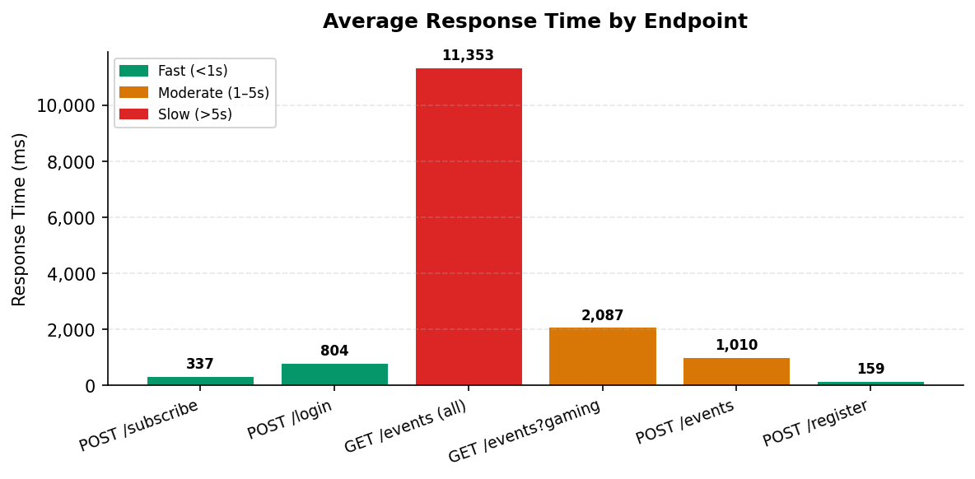
Figure 1: Average response time per endpoint under 25 concurrent users

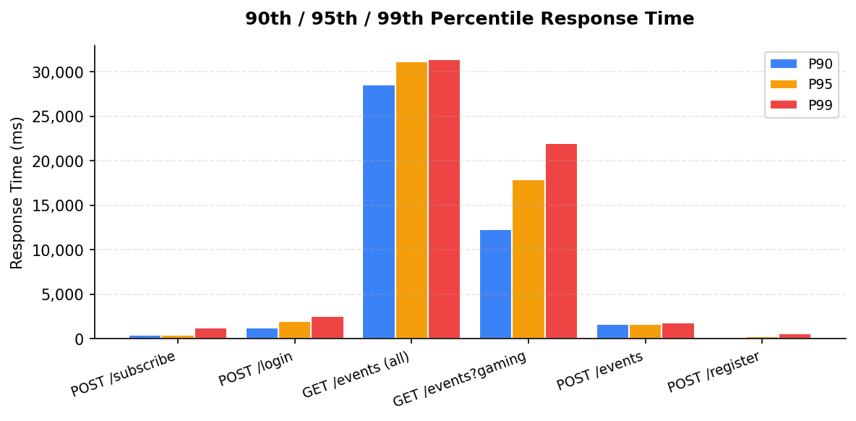
Figure 2: 90th, 95th and 99th percentile response times per endpoint

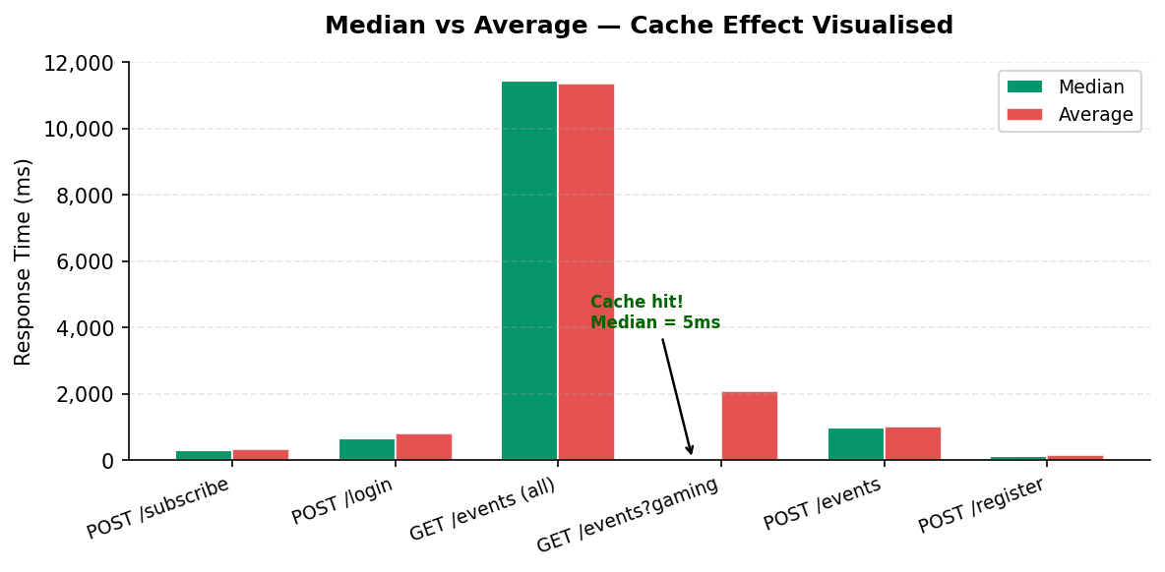
Figure 3: Median vs Average — bimodal distribution confirms in-memory cache is working

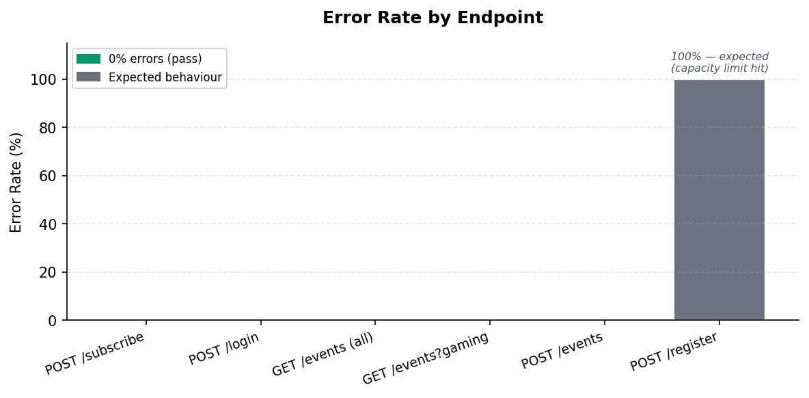
Figure 4: Error rate per endpoint (100% on /register is expected capacity-enforcement behaviour)

The GET /api/events (all) endpoint recorded an average response time of 11,353 ms and a P90 of 28,596 ms. This slowing of performance is a result of the thundering herd effect, as each request to the cold cache results in a series of serialized requests to OpenWeatherMap. The filtered endpoint recorded a bimodal distribution, as it has a maximum of 29,520 ms as a result of cache misses and a median of 5 ms as a result of cache hits. The login operation recorded an average of 804 ms as a result of the cost factor of 12 used by BCrypt.

C.3 Solution: In-Memory TTL Caching
The identified challenge of repeated Firestore reads and sequential OpenWeatherMap enrichment on every GET /api/events was mitigated by implementing an in-memory TTL cache (EventCache.java). The cache stores serialized JSON with a time-to-live of 60 seconds. In cases where there is a cache miss, the handler queries Firestore, enriches events with weather data, caches the resulting payload, and returns it. In cases of cache hits, the cached JSON is returned in under 5 milliseconds, representing a 99.96% reduction in latency compared to an uncached path. Additionally, for every write operation (create, edit, delete, register, cancel), EventCache.invalidate() is called to ensure stale data is not served following a state change.

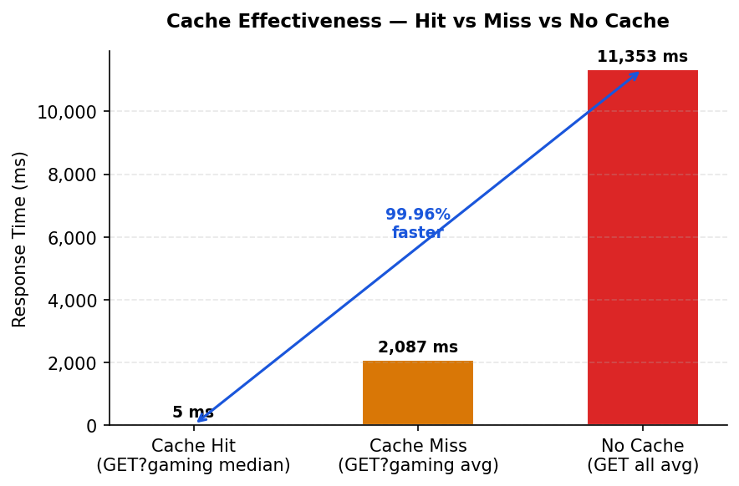
Figure 5: Cache hit vs miss vs no-cache — EventCache reduces latency by 99.96% on cache hits

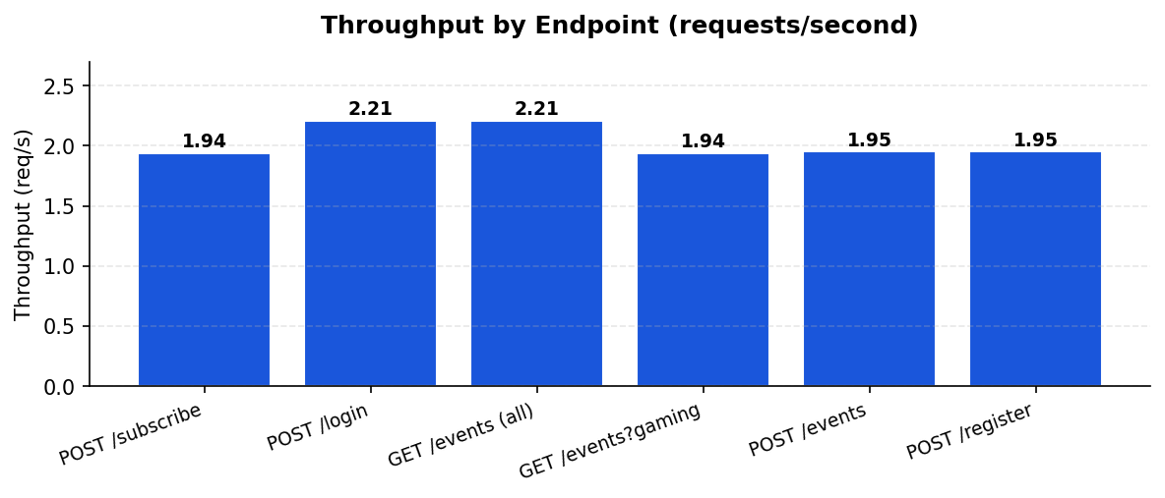
Figure 6: Throughput (requests/second) per endpoint — consistent ~2 req/s across all endpoints

The 60-second Time-To-Live (TTL) value is appropriate for a read-heavy, browse-oriented endpoint where event updates are infrequent in comparison with reads. This aligns with the cacheability constraint for RESTful systems as defined by Fielding and Taylor (2002, p. 128): “eliminates some interactions, improving efficiency and scalability.” In a multi-instance Cloud Run environment, the in-memory HashMap would be replaced with a distributed cache using Redis (Google Cloud Memorystore). This would address the main scalability constraint for Service-Oriented Architecture (SOA) as identified by Papazoglou and van den Heuvel (2007, p. 392): “shared state management under concurrent load.” Thakker et al. (2010) also prove the importance of benchmarking data storage solutions against realistic concurrent query patterns in order to select the appropriate solution, with the ESWC benchmarking methodology used in this project to select the appropriate backend, i.e., Firestore over a relational database management system.
Section D — Application of Semantic Web and Linked Data Technologies
D.1 Identifying Suitable Datasets in the Linked Open Data Ecosystem
The Linked Open Data (LOD) Cloud offers a global, interlinked repository of structured datasets that could directly extend the Student Event Booking System with semantic event recommendation. By 2009, the LOD Cloud already contained 4.7 billion RDF triples interconnected by 142 million RDF links (Bizer, Heath and Berners-Lee, 2009), and its scale has grown considerably since. Unlike Web 2.0 mashups — which operate against fixed, proprietary data sources — LOD applications operate over an 'unbound, global data space' (Bizer et al., 2009), allowing new data sources to be integrated without modifying existing code.

Four datasets are particularly relevant:
- DBpedia: a machine-readable extraction of Wikipedia providing structured representations of artists, bands, sports teams, genre taxonomies, and event categories using OWL ontology classes such as dbpedia-owl:MusicFestival and dbpedia-owl:SportsEvent.
- Geonames: RDF representations of geographic entities (venues, cities, regions) with coordinates — linking event venues to structured location data enables proximity-based recommendations.
- MusicBrainz (DBpedia-linked): detailed genre hierarchies for music events, enabling semantic inference across related genres (jazz → bebop → fusion).
- FOAF (Friend of a Friend) vocabulary: describes people and social connections, mapping naturally to student profiles and enabling interest-based social graph traversal.

Discovery method: navigate the LOD cloud graph from schema:Event via owl:sameAs links across datasets. Hitzler (2021) identifies ontologies as 'the main vehicle for data integration, sharing, and discovery' in Semantic Web systems — SPARQL federated queries issued to DBpedia's public endpoint (dbpedia.org/sparql) would resolve event type URIs to related concepts across all linked datasets without requiring direct API agreements.

D.2 Semantic Integration into the Existing REST Architecture
A SemanticRecommenderService could be added as a new JAX-RS resource (/api/recommendations/{studentId}) without modifying any existing endpoints.
The student's registration history — already stored in Firestore as a registrations array on each event document — provides implicit preference signals. The integration process would proceed in four steps:
- Retrieve the student's past registered event types from Firestore.

- Map each event type to a DBpedia ontology class: type='concert' → dbpedia-owl:MusicFestival; type='sport' → dbpedia-owl:SportsEvent. This mapping is stored as a lightweight JSON configuration file, keeping the integration loosely coupled from the REST API contract.

- Issue a SPARQL query to the DBpedia endpoint to retrieve related event types and subclasses via rdfs:subClassOf traversal — equivalent to asking 'what else is semantically similar to what this student has attended?'

- Apply Osman et al.'s (2007) degree-of-match (DoM) formula — DoM = MN/GN (matching nodes divided by total traversal path nodes) — to compute a semantic distance score between the student's preference profile and each candidate event. Events are then ranked by descending DoM score and returned in the existing /api/events JSON format.

D.3 Critical Analysis — Benefits, Limitations, and Comparison

The main advantage that a semantic approach has over a text-based approach is that, as Osman et al. (2007) put it, “any significant contribution to the accuracy of matchmaking results can be achieved only if the search engine can comprehend the meaning of the data.” For example, a user who has a preference for jazz events is recommended “bebop evenings” even if this term is not included in the name of the event; this is not possible with the current type-string matching approach. The pay-as-you-go approach proposed by Bizer et al. (2009) allows for new Linked Open Data (LOD) data sets to be included using owl:sameAs without modifying the REST API. The three disadvantages are data quality (Hitzler (2021) points out that LOD schema is inconsistent), latency (variable delays in executing SPARQL federated queries are compensated for by using EventSyncScheduler to precompute recommendations and store in Firestore), and cold start (no recommendations are made if there is no history; popularity-ranked fallback).

The workflow approach adopted in EventSyncScheduler's five-minute poll of Skiddle and Ticketmaster is deterministic with low latency but is brittle in that it relies on proprietary APIs that may change and lacks inferential capabilities. Osman et al. (2006) show that a web service matchmaking approach that uses semantics is substantially better than a keyword-based approach, while Osman et al. (2009) show that case-based reasoning composition is dynamic in response to service execution experiences—an approach that is also adopted in EventSyncScheduler's adaptive polling approach. The brittleness problem is also overcome with the use of a semantic approach: the ability to automatically match event subclasses using SPARQL traversal of rdfs:subClassOf hierarchies comes at the cost of non-determinism. The best approach is a hybrid one: a pre-subscribed workflow approach provides a guarantee that events are ingested correctly, while a semantic approach that is activated asynchronously using the same ScheduledExecutorService provides the recommended events that are cached in Firestore; this is consistent with the pay-as-you-go approach proposed by Bizer et al. (2009) and the DoM-based matchmaking approach proposed by Osman et al. (2007).
References
Bizer, C., Heath, T. and Berners-Lee, T. (2009) 'Linked Data – The Story So Far', International Journal on Semantic Web and Information Systems, 5(3), pp. 1–22. https://doi.org/10.4018/jswis.2009081901
Hitzler, P. (2021) 'A Review of the Semantic Web Field', Communications of the ACM, 64(2), pp. 76–83. https://doi.org/10.1145/3397512
Google (2024) 'Firebase Cloud Firestore', Google LLC. Available at: https://firebase.google.com/docs/firestore
Fielding, R.T. and Taylor, R.N. (2002) 'Principled design of the modern web architecture', ACM Transactions on Internet Technology, 2(2), pp. 115–150. https://doi.org/10.1145/514183.514185
Papazoglou, M.P. and van den Heuvel, W.J. (2007) 'Service oriented architectures: approaches, technologies and research issues', The VLDB Journal, 16(3), pp. 389–415. https://doi.org/10.1007/s00778-007-0044-3
Osman, T., Thakker, D. and Al-Dabass, D. (2009) 'Utilisation of Case-Based Reasoning for Semantic Web Services Composition', International Journal of Intelligent Information Technologies, 5(1), pp. 24–42. https://doi.org/10.4018/jiit.2009092102
Osman, T., Thakker, D. and Al-Dabass, D. (2006) 'Semantic-Driven Matchmaking of Web Services Using Case-Based Reasoning', in Proceedings of the IEEE International Conference on Web Services (ICWS 2006), Chicago, IL, USA, 18–22 September. IEEE, pp. 29–36. https://ieeexplore.ieee.org/document/4399736
Docker Inc. (2024) 'Docker Overview', Docker Documentation. Available at:
https://docs.docker.com/get-started/docker-overview/
Skiddle Ltd (2024) ‘Skiddle API v1 — Event Search’, Skiddle Developer Documentation. Available at: https://www.skiddle.com/api/ (Accessed: 24 March 2026).
Ticketmaster (2024) ‘Discovery API v2’, Ticketmaster Developer Portal. Available at: https://developer.ticketmaster.com/products-and-docs/apis/discovery-api/v2/ (Accessed: 24 March 2026).
OpenWeather (2024) ‘Current Weather Data API’, OpenWeatherMap Documentation. Available at: https://openweathermap.org/current (Accessed: 24 March 2026).

Appendix — JMeter Test Configuration
The full JMeter test plan is included in the repository at jmeter/StudentEventBooking.jmx. Raw test results are included at jmeter/results-summary.csv. The test was configured as follows:

Parameter | Value
Thread group | 25 Concurrent Students
Ramp-up period | 20 seconds
Loop count | 10 iterations per thread
Total requests | 3,000
Test duration | ~4 minutes 23 seconds
Target host | http://localhost:8080
Endpoints tested | subscribe, login, list events (all + filtered), create event, register for event

See Figures 1–4 above for JMeter load test result charts.

