

A
Project Report

On

E-Shop Website
Submitted To

(Department of Computer Science)

In Practical fulfillment for the Graduation

By

Mr. Chavan Siddharth Pratapsinh Mr. Jadhav Parvin Pandurang

Under the guidance of

Prof. Miss. Pawar A.R

Through

Sangola Mahavidyalaya, Sangola.

Sangola-413307.

2021-2022

Certificate

Certificate of project field work completion
Certificate that project fieldwork report titled

“E-Shop Website”

has been completed satisfactory impartial fulfillment of B.sc (Computer Science)-III course of Sholapur University, Sholapur for the academic year 2021-2022

By following students of

Sangola Mahavidyalaya, Sangola

Mr. Chavan Siddharth Pratapsinh Mr. Jadhav Parvin Pandurang

Project Guidence H.O.D
Dept. of Computer Science

External Examiner

Place:- Sangola

Date:-

INDEX

Sr.No | Name | Page No.
1 | Acknowledgement | 3
2 | About Technology | 4
3 | Introducation | 5
4 | Requirements | 6
5 | Salient Features | 7
6 | Limitation and Drawback | 8
7 | Future Enhancement | 9
8 | User Manual | 10
9 | Flow diagram | 11
10 | Source Code | 13
11 | Output Screen | 36
12 | Bibliography | 40

ACKNOWLEDGEMENT

ACKNOWLEDGEMENT
.
Before starting to project report we have to thanks to

Dept. Of Computer Science.
For giving us to change to present ourselves with great potential and for

providing us glorious platform towards our future career.

It gives me great pleasure to remain deeply inspected to our Project guide Miss. Pawar A.R Under whose guidance

We completed the project.The faith and confidence shown by him in our boosted our moral and motivated us to perform better in preparing this project.

We are thankful to all staff members for their valuable suggestion in completing this work.

We are also thankful to my all friends who help me directly or indirectly to carry this project successfully.Thanks must finally to our family especially to our parents, who are always with us.

About Technology

Technology Used in this WebSite (Eshop) :-

- Django

  - Python
    - PyCharm

- Django :- Django is a high-level Python web framework that encourages rapid development and clean, pragmatic design. Built by experienced developers, it takes care of much of the hassle of web development, so you can focus on writing your app without needing to reinvent the wheel. It’s free and open source.

- Python :- Python is a high-level, interpreted, general-purpose programming language. Its design philosophy emphasizes code readability with the use of significant indentation. Python is dynamically-typed and garbage-collected.

  - PyCharm :- PyCharm is a dedicated Python Integrated Development Environment (IDE) providing a wide range of

essential tools for Python developers, tightly integrated to create a convenient environment for productive Python, web, and data science development.

Introducation

1. An eCommerce website is an information technology method in which traders, businesses/distributors/marketers can sell

products/services and the customer can purchase on that website electronically by using the internet on the mobile and computer.

2. It means an e-commerce website is an online shop. e means electronic. Commerce means business. Website means the group of

HTML web pages and that is created to market/sell
information/product/services.

3. From a bigger perspective, every website on the internet is the eCommerce Website. It can be the platform, it can be a marketplace, it can be a portal, it can be apps, it can be an

entertainment website, shopping website, online courses website and online degree college.

4. This is full-fledged shopping website in this website Login Page , Logout page , Add to card , Add to Favourite , also some
other functions like total bill and superior UI/UX

Requirements

- Hardware Requirements :- Most current computers and laptops have high enough specifications to be used to oCharm website. also its open in mobile.

  - Software Requirements:- Any Browser and Stable

Internet Connection . install Python latest version , Pycharm Software or also any text editor ex. Visual Studio Code , install Django latest version.

- Module packages :- pip install django , Django-admin.py startproject project-name , Django-admin.py startproject project-name.

Salient Features

- User-Friendly Design. Perhaps the most important feature customers want in an ecommerce site is a good user experience

- Mobile-Friendly Features.

- Multiple Payment Options.

- 24/7 Customer Service.

- User Reviews.

- User Features and Discounts.

- Extensive Product Information.

- Add to card , Add to favorite Features for better user exprience.

Limitation and Drawback

- No One Can Buy During a Site Crash.

- Customers Can't Try Before They Buy.

- Ecommerce Is Highly Competitive.

- Customers Can Be Impatient.

- Shipping Times Can Be Lengthy.

- Physical Retail Is Still More Popular Despite Decline.

Future Enhancement

- Adding review function for users.

- Adding rating function for user.

- Website Should be implementing for nerwork.
- We can provide for much harder algorithms.

- Use data analysis to improve our strategy.

User Manual

- How to Start :- In this, we will discuss how to start the Website. To start the Website following steps should be takes place.

- First start machine.

- You will see verious icons on desktop.

- Select Project Any Browser.

- Search our website name and tap to search.

- After opening the website , you will see Categories of product in the left side of screen in Navbar we will see card , Orders and right side navbar corner we will see login button.
- If you are login then you will see logout button.

- If you are select the shop the product you will press to add card button.

- Then go to card button then you will see your selected products.

- Then press to check out button.

- Then one pop will be show there we will fill your address and phone number.

- Then Your order finaly completed.

- We will see your order in order button in navbar

- To exit you will be logout and close the tab and browser.

Flow diagram

- Workflow of Django

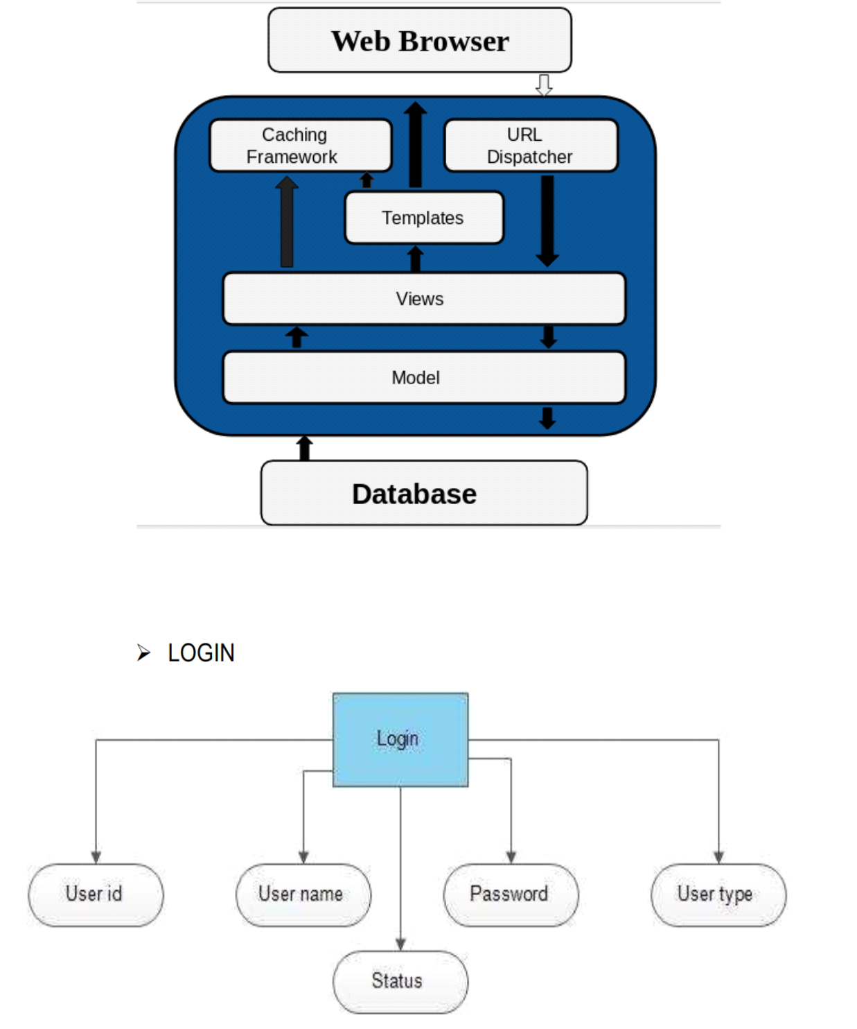
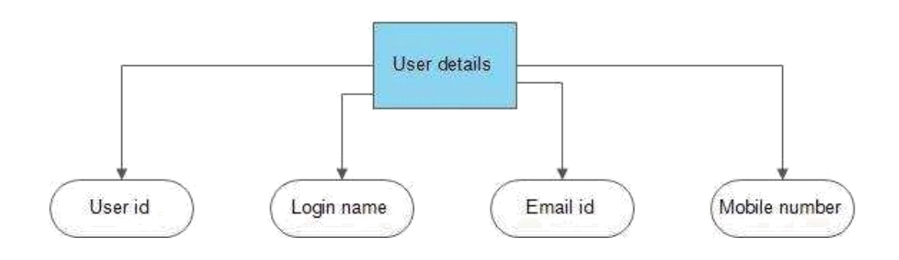
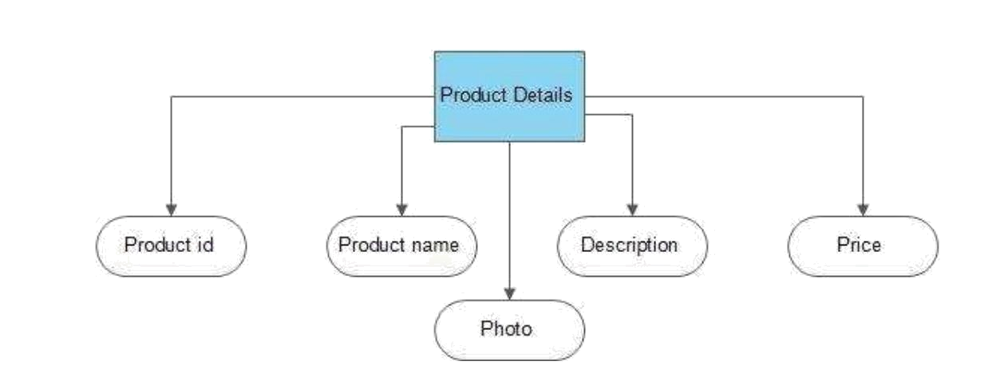

Source Code

- base.html

<!doctype html>

<html lang="en">

<head>

<!-- Required meta tags -->

<meta charset="utf-8">

<meta name="viewport" content="width=device-width, initial-scale=1, shrink-to-fit=no">

<!-- Bootstrap CSS -->

<link rel="stylesheet"

href="https://maxcdn.bootstrapcdn.com/bootstrap/4.0.0/cs
s/bootstrap.min.css"

integrity="sha384-

Gn5384xqQ1aoWXA+058RXPxPg6fy4IWvTNh0E263X

mFcJlSAwiGgFAW/dAiS6JXm"

crossorigin="anonymous">

<title>Hello, world!</title>

<style>

nav{

background-color: white;
}

.one-edge-shadow {

box-shadow: 0 8px 2px -5px rgb(246, 245, 245);
}

.display-8{
font-weight: 200;

font-size: 30px;

}

</style>

</head>

<body>

<!-- navbar -->

<nav class="one-edge-shadow sticky-top navbar navbar-expand-lg navbar-light bg-white">

<a class="navbar-brand" href="/">E-Shop</a> <button class="navbar-toggler" type="button" data-

toggle="collapse" data-target="#navbarSupportedContent"

aria-controls="navbarSupportedContent" aria-expanded="false" aria-label="Toggle navigation">

<span class="navbar-toggler-icon"></span> </button>

<div class="collapse navbar-collapse"

id="navbarSupportedContent">

<ul class="navbar-nav mr-auto">
<li class="nav-item active">

<a class="nav-link" href="/store">Store <span class="sr-only">(current)</span></a>

</li>

</ul>

<ul class=" navbar-nav my-2 my-lg-0"> <li class="nav-item ">

<a class="nav-link" href="/cart">Cart <span class="badge badge-

info">{{request.session.cart.keys|length}}</span> <span class="sr-only">(current)</span></a>
</li>

{% if request.session.customer %}

<li class="nav-item ">

<a class="nav-link" href="/orders">Orders<span class="sr-only">(current)</span></a>
</li>

<li class="nav-item ">

<a class="nav-link" href="/logout">Logout<span class="sr-only">(current)</span></a>
</li>
{% else %}

<li class="nav-item ">

<a class="nav-link" href="/signup">Signup<span class="sr-only">(current)</span></a>
</li>

<li class="nav-item ">

<a class="nav-link" href="/login">Login<span class="sr-only">(current)</span></a>
</li>

{% endif %}

</ul>

</div>

</nav>

</body>

</html>

- index.html

{% extends 'base.html' %}

{% block content %}

{% load cart %}

{% load custom_filter %}
<!-- body -->

<div class="container-fluid mt-3"> <div class="row">

<!-- filter -->

<div class="col-lg-3 mx-auto">
<div class="list-group">

<a href="/" class="list-group-item list-group-item-action">All Products</a>

{% for category in categories %}

<a href="/?category={{category.id}}" class="list-group-item list-group-item-

action">{{category.name}}</a> {% endfor %}
</div>

</div>

<!-- all products -->

<div id='products' class="col-lg-9 mx-auto"> <div class="row mx-auto">

{% for product in products %} <div class="card mx-auto mb-3"

id={{product.id}} style="width: 18rem;">

<img class="card-img-top" src="{{product.image.url}}" alt="Card image cap">
<div class="card-body">
<p class="card-

title">{{product.name}}</p>
<p class="card-
text"><b>{{product.price|currency}}</b></p>
<!-- {{product |

is_in_cart:request.session.cart }} --> </div>

<div class="card-footer p-0 no-
gutters">

{% if
product|is_in_cart:request.session.cart %}
<div class="row no-gutters">
<form

action="/#{{product.id}}" class="col-2 " method="post">
{% csrf_token %}
<input hidden

type="text" name='product' value='{{product.id}}'> <input hidden

type="text" name='remove' value='True'>
<input type="submit"

value=" - " class="btn btn-block btn-light border-right"> </form>

<div class="text-center

col">{{product|cart_quantity:request.session.cart}} in Cart</div>

<form
action="/#{{product.id}}" class="col-2 " method="post">
{% csrf_token %}
<input hidden

type="text" name='product' value='{{product.id}}'>

<input type="submit"

value=" + " class="btn btn-block btn-light border-left"> </form>
</div>
{% else %}
<form action="/#{{product.id}}"

method="POST" class="btn-block">
{% csrf_token %}
<input hidden type="text"
name='product' value='{{product.id}}'>

<input type="submit"
class="float-right btn btn-light form-control"
value="Add To Cart">
</form>

{% endif %}

</div>

</div>
{% endfor %}
</div>
</div>

</div>
</div>

{% endblock %}

- login.html

{% extends 'base.html' %}
{% block content %}

<div class="container">

<div class="p-4 m-4">

<div class="col-lg-4 mt-4 border mb-4 mx-auto rounded pt-4">
<div class="text-center col">

<img

src="https://upload.wikimedia.org/wikipedia/commons/thumb/c/ c8/Shopping_cart_with_food_clip_art_2.svg/307px-Shopping_cart_with_food_clip_art_2.svg.png" alt=""

class="" style="height: 150px;"> <!-- <hr> -->

<div class="display-8">Create An Account</div>
<hr>
</div>

<h3 hidden class="alert alert-light border mt-4 mb-4 rounded">Login Here</h3>

<form action="/login" method="POST">

{% csrf_token %}

{% if error%}

<div class="alert alert-danger" role="alert"> {{error}}

</div>
{% endif %}
<!-- email -->
<div class="form-group">
<label for="">Email</label>

<input required type="email" name="email" id=""
value="{{values.email}}"

class=" form-control-sm form-control"
placeholder="example@gmail.com">
</div>

<!-- password -->
<div class="form-group">
<label for="">Password</label>

<input type="password"
name="password"
id=""
class="form-control form-control-sm"

placeholder="********">
</div>

<hr>

<div class="form-group">

<input class="btn btn-sm btn-info col-lg-4" type="submit" value="Login">

</div>

</form>
</div>

</div>
</div>

{% endblock %}

- signup.html

{% extends 'base.html' %}

{% block content %}

<div class="container mt-4">

<div class="p-4 m-4">

<div class="col-lg-5 rounded mx-auto border pt-4"> <div class="text-center col">

<img

src="https://upload.wikimedia.org/wikipedia/commons/thumb/c/ c8/Shopping_cart_with_food_clip_art_2.svg/307px-Shopping_cart_with_food_clip_art_2.svg.png" alt=""

class="" style="height: 150px;"> <!-- <hr> -->
<div class="display-8">Create An Account</div>
<hr>

</div>

<h3 hidden class="alert alert-light border rounded">Create An Account</h3>

<form action="/signup" method="POST">

{% csrf_token %}

{% if error%}

<div class="alert alert-danger" role="alert"> {{error}}
</div>

{% endif %}
<!-- firstname -->
<div class="form-group">

<label for="">First Name</label> <input type="text" name="firstname"

id="" value="{{values.first_name}}" class="form-control form-control-sm"
placeholder="">

</div>

<!-- last name -->
<div class="form-group">

<label for="">Last Name</label> <input type="text" name="lastname"

id="" value="{{values.last_name}}" class="form-control form-control-sm"

>
</div>

<!-- phone -->

<div class="form-group"> <label for="">Phone</label> <input type="text" name="phone"
id="" class="form-control form-control-sm"
value="{{values.phone}}"
placeholder="565698959"
>

</div>
<!-- email -->
<div class="form-group">
<label for="">Email</label>

<input required type="email" name="email" id=""
value="{{values.email}}"
class=" form-control-sm form-control"
placeholder="example@gmail.com">

</div>

<!-- password -->

<div class="form-group">
<label for="">Password</label>
<input type="password"
name="password"

id=""
class="form-control form-control-sm"
placeholder="********">
</div>

<hr>
<div class="form-group">

<input class="btn btn-sm btn-info" type="submit" value="Create An Account ">

</div>
</form>
</div>
</div>

</div>

{% endblock %}

- card.html

{% extends 'base.html' %}

{% block content %}

{% load cart %}
{% load custom_filter %}
<div class="container">
<div class="border rounded p-4 m-4">

<p class="display-4 pl-4 ml-4">Your Cart</p> <hr>
<table class="table">
<thead>

<tr>
<th>Sno.</th>
<th>Image</th>
<th>Product</th>

<th>Price</th>
<th>Quantity</th>
<th>Total</th>
</tr>
</thead>
<tbody>

{% for product in products %}
<tr>
<td>{{forloop.counter}}</td>

<td><img style="height: 80px;" class="rounded-circle" src="{{product.image.url}}" alt=""></td>

<td>{{product.name}}</td> <td>{{product.price|currency}}</td>

<td>{{product|cart_quantity:request.session.cart}}</td>

<td>{{product|price_total:request.session.cart|currency}}</td> </tr>

{% endfor %}

</tbody>

<tfoot>
<tr>
<th colspan="4"></th>

<th class="" colspan="">Total</th>

<th>{{products|total_cart_price:request.session.cart|currency}} </th>

</tr>
</tfoot>
</table>
<hr>
<div class="m-3 p-3">

<a href="#" data-toggle="modal" data-target="#exampleModal" class="btn btn-outline-info border rounded col-lg-3 float-right">Check out</a>
</div>
</div>

</div>

<!-- modal -->

<!-- Modal -->

<div class="modal fade" id="exampleModal" tabindex="-1" role="dialog" aria-labelledby="exampleModalLabel" aria-hidden="true">

<div class="modal-dialog" role="document"> <div class="modal-content">
<div class="modal-header">

<h5 class="modal-title" id="exampleModalLabel"> Check Out Form

</h5>
<hr>

<button type="button" class="close" data-dismiss="modal" aria-label="Close">

<span aria-hidden="true">&times;</span> </button>
</div>

<div class="modal-body">
<div class="m-2 p-3">

<form action="/check-out" method="POST"> {% csrf_token %}
<div class="form-group">
<label for="">Address</label>

<input type="text" name="address" id="" class="form-control" placeholder="" aria-describedby="helpId">

</div>

<div class="form-group">
<label for="">Phone</label>

<input type="text" name="phone" id="" class="form-control" placeholder="" aria-describedby="helpId">
</div>

<input type="submit" class="btn float-right btn-outline-info col-lg-6" value="Check out">

</form>
</div>
</div>

</div>
</div>
</div>

{% endblock %}

- orders.html

{% extends 'base.html' %}

{% block content %}

{% load cart %}

{% load custom_filter %}

<div class="container">

<div class="border rounded p-4 m-4">

<p class="display-4 pl-4 ml-4">Your Orders</p> <hr>

<table class="table">

<thead>

<tr>

<th>Sno.</th>

<th>Image</th>
<th>Product</th>

<th>Date</th>

<th>Price</th>

<th>Quantity</th>

<th>Total</th>

<th>Status</th>
</tr>

</thead>

<tbody>

{% for order in orders %}
<tr>

<td>{{forloop.counter}}</td>

<td><img style="height: 80px;" class="rounded-circle" src="{{order.product.image.url}}" alt=""></td>

<td>{{order.product.name}}</td> <td>{{order.date}}</td> <td>{{order.price|currency}}</td> <td>{{order.quantity}}</td>

<td>{{order.quantity|multiply:order.price|currency}}</td >

{% if order.status %} <td><small class="badge badge-
success">Completed</small></td>

{%else%}
<td><small class="badge badge-

warning">Pending</small></td> {% endif %}
</tr>

{% endfor %}

</tbody>

</table>

</div>

</div>

{% endblock %}

- init.py

from .product import Product from .category import Category from .customer import Customer from .orders import Order

- Category.py

from django.db import models

class Category(models.Model):
name = models.CharField(max_length=20)

@staticmethod

def get_all_categories():
return Category.objects.all()

def __str__(self):
return self.name

- Customer.py

from django.db import models

from django.core.validators import MinLengthValidator

class Customer(models.Model):
first_name = models.CharField(max_length=50)
last_name = models.CharField(max_length=50)
phone = models.CharField(max_length=15)

email = models.EmailField()
password = models.CharField(max_length=500)

def register(self):
self.save()

@staticmethod
def get_customer_by_email(email):
try:

return Customer.objects.get(email=email)
except:
return False

def isExists(self):
if Customer.objects.filter(email = self.email):
return True

return False

- Order.py

from django.db import models from .product import Product from .customer import Customer import datetime

class Order(models.Model):
product = models.ForeignKey(Product,

on_delete=models.CASCADE)
customer = models.ForeignKey(Customer,
on_delete=models.CASCADE)
quantity = models.IntegerField(default=1)

price = models.IntegerField()

address = models.CharField(max_length=50, default='', blank=True)

phone = models.CharField(max_length=50, default='', blank=True)

date = models.DateField(default=datetime.datetime.today)
status = models.BooleanField(default=False)

def placeOrder(self):
self.save()

@staticmethod
def get_orders_by_customer(customer_id):

return
Order.objects.filter(customer=customer_id).order_by('-date')

- Product.py

from django.db import models
from .category import Category

class Product(models.Model):

name = models.CharField(max_length=50) price = models.IntegerField(default=0) category = models.ForeignKey(Category,

on_delete=models.CASCADE, default=1)

description = models.CharField(max_length=200, default='' , null=True , blank=True)
image = models.ImageField(upload_to='uploads/products/')

@staticmethod
def get_products_by_id(ids):
return Product.objects.filter(id__in =ids)

@staticmethod
def get_all_products():
return Product.objects.all()

@staticmethod
def get_all_products_by_categoryid(category_id):
if category_id:
return Product.objects.filter(category = category_id)

else:
return Product.get_all_products();
- manage.py

#!/usr/bin/env python
"""Django's command-line utility for administrative tasks."""

import os
import sys

def main():
os.environ.setdefault('DJANGO_SETTINGS_MODULE',
'Eshop.settings')
try:

from django.core.management import execute_from_command_line
except ImportError as exc:
raise ImportError(

"Couldn't import Django. Are you sure it's installed and " "available on your PYTHONPATH environment
variable? Did you "
"forget to activate a virtual environment?"

) from exc
execute_from_command_line(sys.argv)

if __name__ == '__main__':
main()

Output Screen
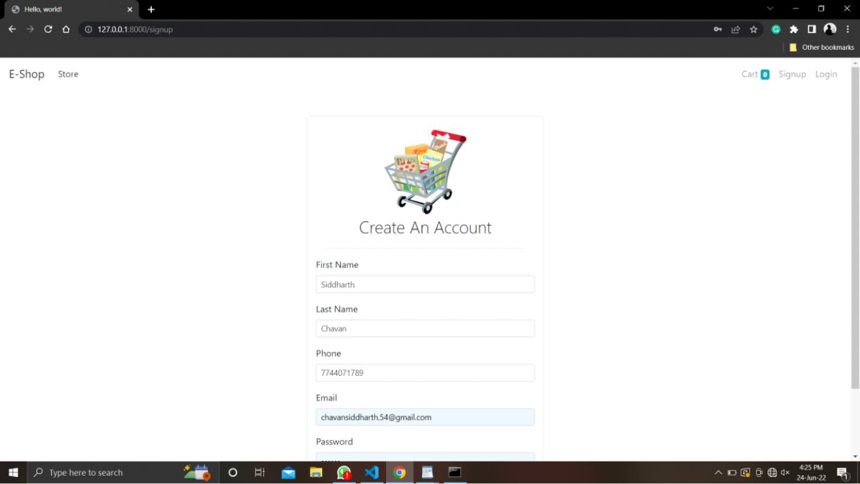
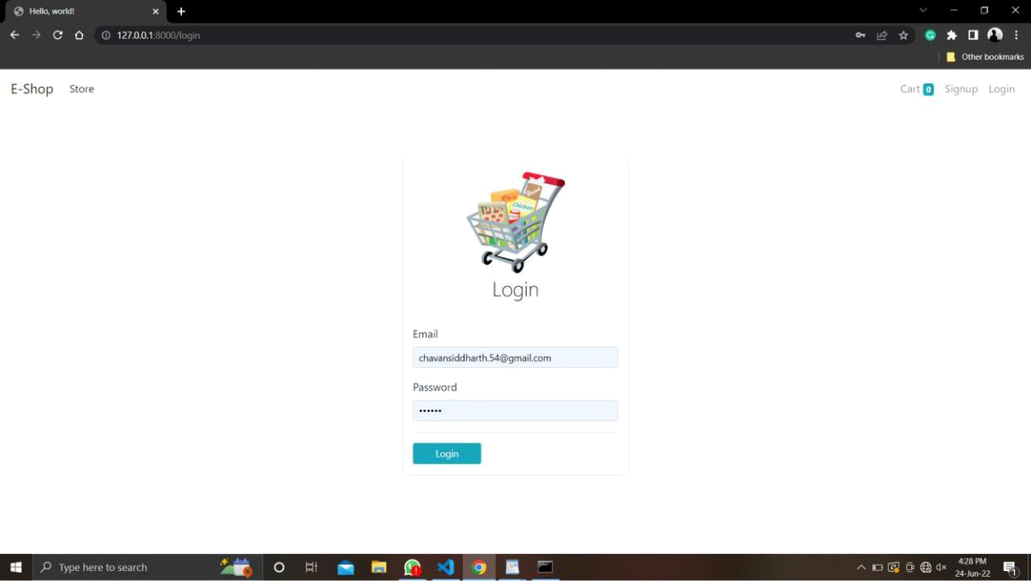
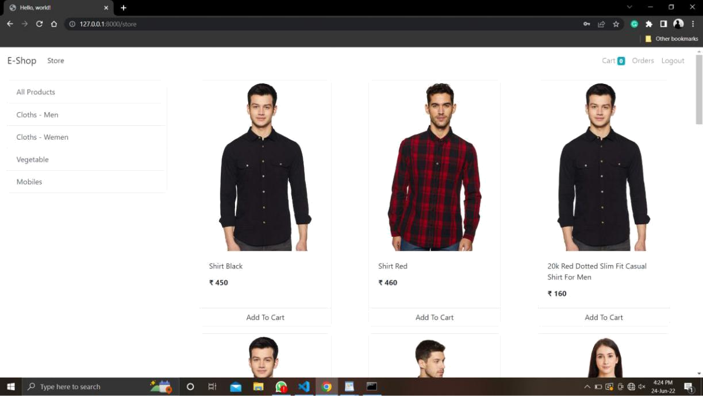
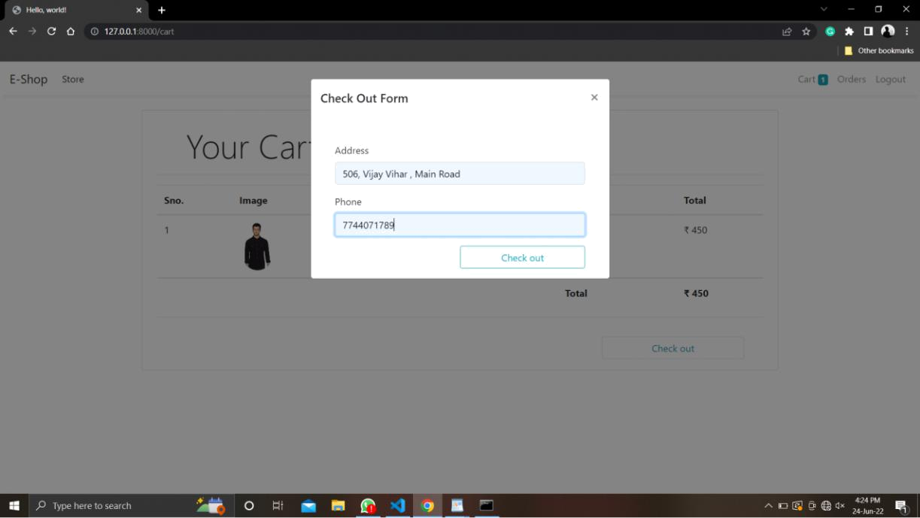
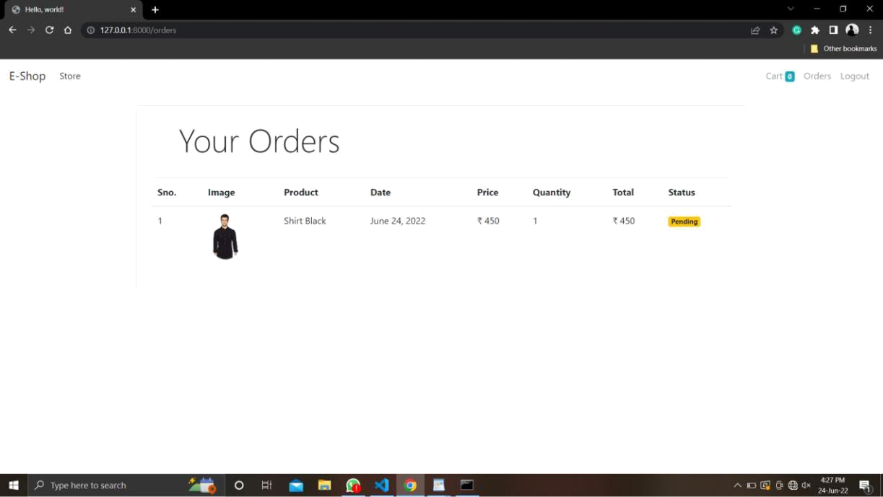
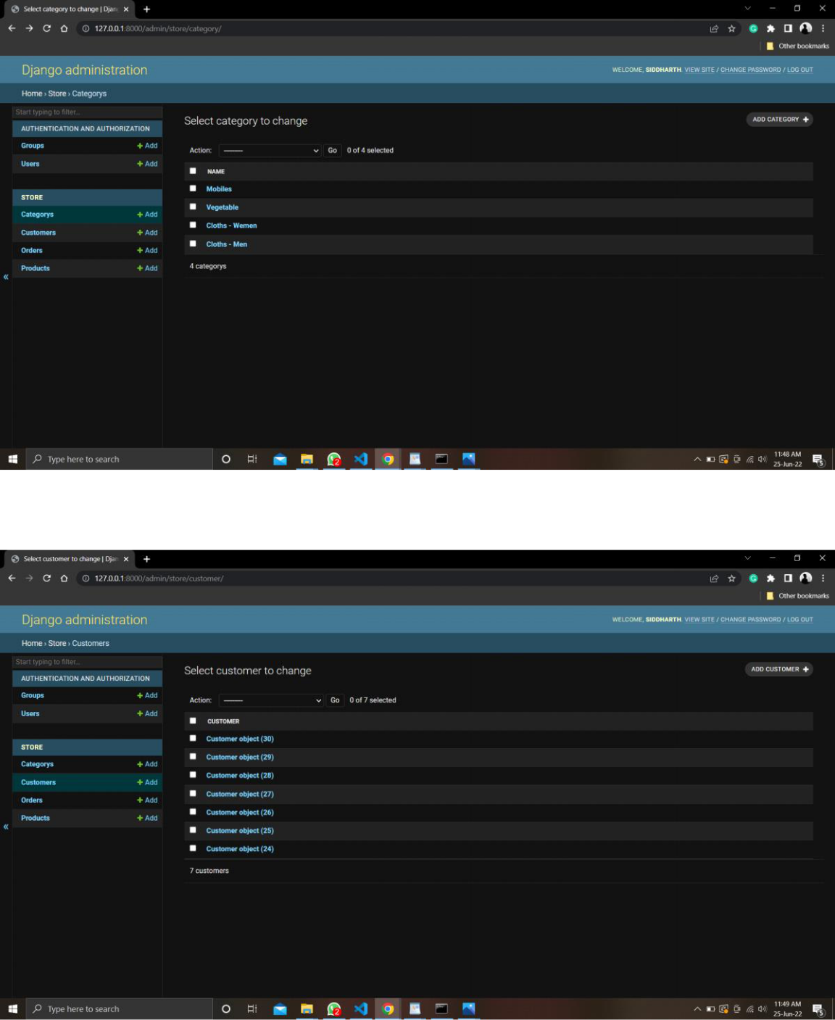
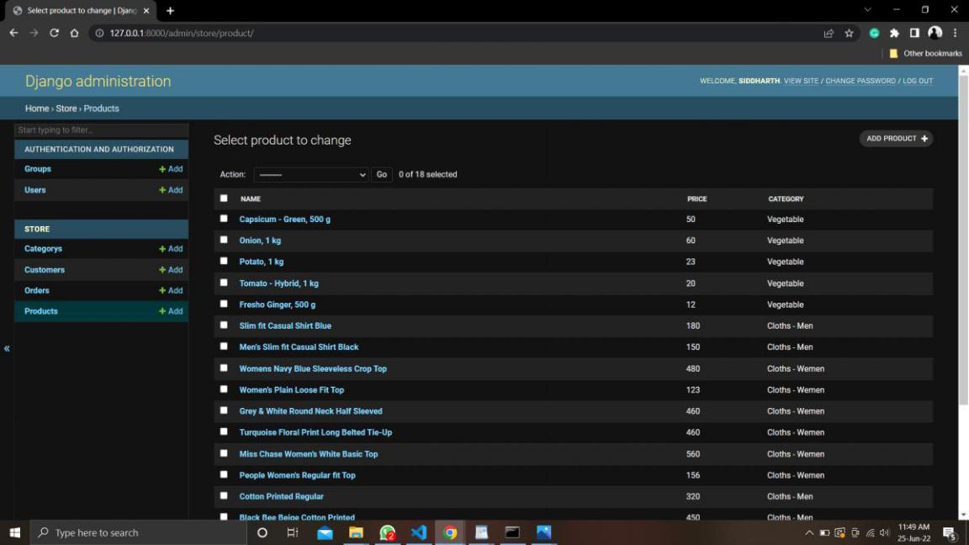

Bibliography

For the completion of the Python (Django) E-shop website.

Documentation we have referred to the following Articles and videos

- Django documentation

- Basic of Python and HTML/CSS in YouTube Videos

