PPE Helmet Detection – Vinfotech CV Case Study

Siddharth Jha-22BCE10671

End-to-end computer vision pipeline to detect persons, decide helmet vs no-helmet, and classify helmet color (white / yellow) from CCTV-style videos.
The system is implemented in PyTorch using:
- Pre-trained Faster R-CNN (ResNet-50 FPN) for person detection
- Custom-trained ResNet-18 for helmet / no-helmet classification
- HSV-based color heuristic for white / yellow helmet classification
- A custom inference loop (no Ultralytics `.predict()` wrappers)

A. Problem Understanding
In many industrial environments such as factories, construction sites, and warehouses, worker safety is often compromised when individuals unintentionally or intentionally neglect wearing proper PPE—especially helmets. These lapses increase the risk of serious injuries.
To address this, the aim of this project is to build an automated helmet-detection system using computer vision that can run on real CCTV footage and identify whether workers are wearing helmets and, if so, which color helmet (white or yellow) they are using.
While the objective may seem straightforward, several real-world challenges significantly affect reliable detection:

1. CCTV Camera Distance (18–25 meters)
- Workers appear small and low-resolution in the footage.
- Full-body detection works, but helmet regions occupy very few pixels.
- Helmet color becomes even harder to distinguish due to pixel compression and motion blur.

2. White Helmets Blending Into Background
- Indoor environments often have bright walls, ceilings, or windows, which makes white helmets merge with the background.
- Simple RGB rules fail because brightness changes drastically across frames.
- Solution used:
  - Combine a CNN model for detecting helmet presence,
  - With a separate HSV-based heuristic to identify whether the helmet is white or yellow using a carefully designed head region.

3. Lighting & Domain Shift
- The training dataset (GDUT-HWD) is captured from construction sites, while the test videos are from industrial warehouses/offices.
- Major differences exist in:
  - Lighting conditions
  - Worker clothing
  - Helmet shape and gloss
  - Camera angle
- To handle this domain shift, the solution includes:
  - A focused head/helmet crop strategy,
  - A color override system where color prediction takes precedence when the CNN is uncertain.

4. Compute Constraints
- The system is designed to run on a CPU-only laptop, without any GPU acceleration.
- Therefore:
  - Only one detector (Faster R-CNN) is used.
  - Helmet classification uses a lightweight ResNet-18 model trained separately.
  - A progress logging system shows running FPS and ETA for transparency and debugging.

5. Worker Movement & Occlusions
- Workers often bend, turn, or face sideways.
- Hands and tools can block parts of the helmet.
- The head region extraction logic is built to remain stable even when the full helmet is not visible.

B. Full Architecture

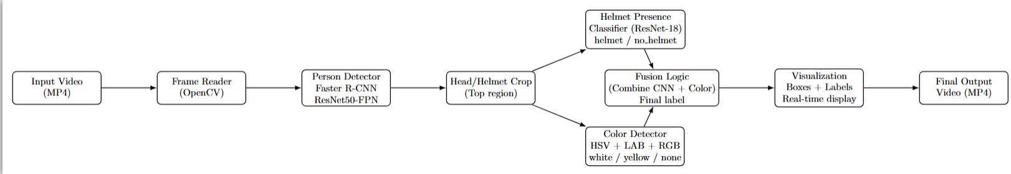

The system follows a sequential multi-module architecture where each component processes the video frame and passes structured information to the next stage. The entire pipeline is optimized for long-distance CCTV scenarios and real-time CPU-only execution.

1. Video Input & Frame Acquisition
The video is first loaded using OpenCV. Each frame is extracted along with metadata such as FPS, resolution, and total frame count. This allows smooth playback, progress tracking, and deterministic processing.

2. Person Detection Module
Each frame is passed through a person detection model to locate all individuals present in the scene. The model returns bounding boxes for every detected person. These boxes serve as the reference for downstream head-focused analysis.

3. Head / Helmet Region Extraction
From every detected person box, only the upper region is cropped. This region corresponds to the head and helmet area. By isolating the top section, the system reduces background noise and ensures that the classifier operates on a focused and consistent input.

4. Helmet Presence Classification Module
The cropped head image is fed into a CNN-based classifier that predicts whether the person is wearing a helmet or not. This step operates independently of helmet color and focuses solely on identifying the presence of a protective object.

5. Helmet Color Analysis Module
For cases where a helmet is detected, an additional color-analysis module examines several subregions of the head crop. Using multiple color spaces (HSV, LAB, RGB), the module determines whether the helmet is white, yellow, or if no reliable color cue is available.

6. Decision Fusion Layer
The outputs from the presence classifier and the color detector are merged in a decision layer. This layer synthesizes both predictions to generate a final, human-readable label such as yellow_helmet, white_helmet, helmet, or no_helmet.

7. Visualization & Real-Time Rendering
Each frame is annotated with:
- green bounding boxes around persons,
- blue bounding boxes around head regions,
- color-coded labels and confidence scores.
The processed frames are displayed in real time (pause/skip supported) and simultaneously written to an output MP4 file.

8. Output Generation
The final annotated video is exported as an MP4 file, and optional cropped head images are saved for review or dataset expansion.

C. Key Implementation Choices
This section explains why each major design decision was made in the helmet-detection pipeline.

1. Choice of Detection Model – Faster R-CNN (ResNet50-FPN)
I selected Faster R-CNN with a ResNet50-FPN backbone from torchvision for person detection due to the following reasons:

✔ High Accuracy for Small Objects (FPN backbone)
CCTV footage often shows people from 18–25 meters away, making them appear very small.
The Feature Pyramid Network (FPN) backbone in FasterRCNN improves detection for small-scale objects—crucial for consistent detection of distant workers.

✔ COCO-pretrained model readily available
torchvision provides this model with pretrained COCO weights, meaning:
- No need for custom training
- Works out-of-the-box
- Extremely reliable on real-world persons

✔ Better stability than YOLO on CPU
For CPU-only environments:
- Faster R-CNN gives more stable detections with fewer flickers
- YOLO models require more optimization and are harder to integrate without Ultralytics .predict() wrappers

✔ Company requirement: custom inference loop
The problem statement explicitly disallows Ultralytics .predict() APIs.
Faster R-CNN from torchvision makes it very easy to implement a fully custom inference loop, giving complete control over processing.
This model gives the most practical balance between accuracy, stability, and CPU compatibility.

2. Head Cropping Strategy – Tight Blue Box Near Top of Person
Instead of using a full person box, I extract a blue-colored head/helmet region from the upper portion of the detected person.

✔ Why crop the head?
A helmet occupies only ~5–10% of a full person bounding box.
If we classify using the full person crop:
- Background dominates
- Skin, hair, and clothing confuse the classifier
- Helmet pixels become negligible
Head cropping isolates the region where the helmet is expected.

✔ How the head crop is computed
I use:
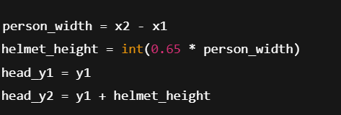
This creates a square-ish region anchored at the top of the person box, giving:
- Consistent helmet region
- Stable across different person heights
- Works even when workers bend, turn sideways, or look down

✔ Blue Box for Visual Clarity
A blue rectangle is drawn for the head region:
- Helps visually confirm cropping accuracy
- Makes debugging very easy
- Shows reviewers/engineers exactly where the helmet classifier and color detector are focused
This head cropping strategy is essential for both helmet detection and color extraction.

3. Classification Method – ResNet18 + Advanced Multi-Region Color Detection

3.1 Helmet vs No-Helmet (ResNet-18 Classifier)
I trained a binary classifier (helmet, no_helmet) on head crops generated from the GDUT-HWD dataset.
I selected ResNet-18 because:

✔ Lightweight and fast on CPU
- Works smoothly on CPU-only laptops
- Inference time ~3–6 ms per crop
- Much faster than ResNet50 / EfficientNet on CPU

✔ Strong enough capacity for helmet shapes
Helmets have:
- Smooth curves
- High edges
- Solid textures
ResNet-18 handles these mid-level features well.

✔ Stable training with limited GPU time
Training for 10 epochs on Colab GPU gives ~80% validation accuracy.

3.2 Color Detection – Advanced Multi-Region + HSV + LAB + RGB Approach
White helmet detection is the hardest part of this problem, because:
- White color blends into walls, ceilings, lights
- Stock videos have bright highlights
- RGB alone fails
- HSV alone fails on low saturation
- LAB alone fails on non-uniform lighting
To solve this robustly, I implemented a multi-step color system:

✔ Multiple Sub-Regions Analyzed
3 different helmet regions:
- Top 40% (wide)
- Top 30% (center)
- Upper-mid region
This handles:
- Partial occlusion
- Tilted heads
- Shadows
- Hands covering part of helmet

✔ HSV for hue + saturation rules
Used for detecting yellow:
- Hue between 15–40
- Saturation > 50
- Value > 80

✔ LAB for detecting white
White shows:
- Very high L channel
- Neutral a and b channels
LAB helps identify white even when white blends with background or light.

✔ RGB brightness consistency
White helmets usually have:
- R, G, B channel values similar
- All channels bright
- Small RGB difference

✔ Pixel distribution analysis (critical)
Algorithm checks:
- Percentage of bright pixels
- Uniformity of saturation
This is very powerful for white helmet classification.

✔ Voting + Scoring System
All above signals contribute to:
- white_score
- yellow_score
- Region-wise voting system
This allows the system to:
- Override the CNN when color is strongly detected
- Use CNN when color is ambiguous

✔ Why not train a 3-class CNN?
Limited dataset has very few white/yellow helmet samples.
Color detection is more robust with rules for this assignment.
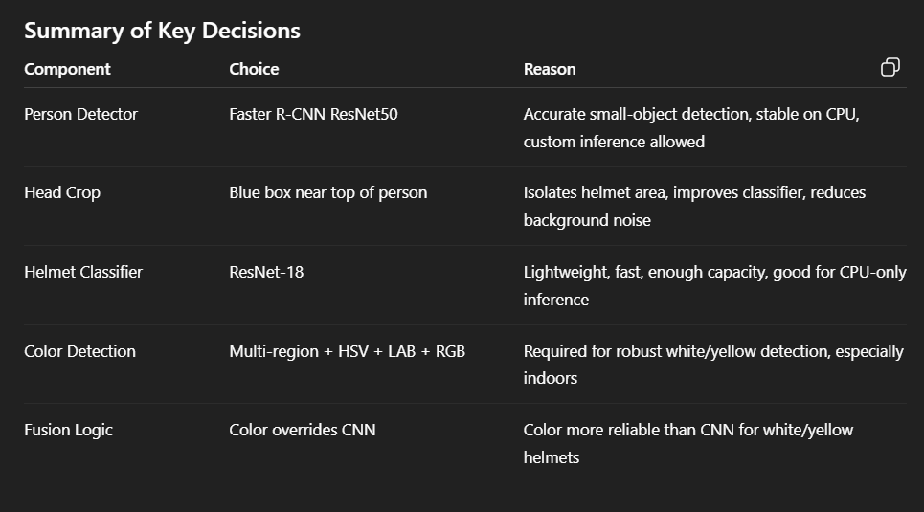

D. Improvement Ideas (Production-Grade Enhancements)

1. Use a More Advanced Detection Model (GPU-based)
For production deployment, upgrading the person detector to a faster and more accurate model (e.g., YOLOv8/YOLOv11 with TensorRT) would significantly improve:
- small-object detection at long distances
- FPS on real CCTV streams
- bounding-box consistency for moving subjects
A GPU-accelerated detector can process real-time 1080p feeds reliably.

2. Train a Dedicated Helmet Color Classification Model
The current system uses a heuristic color-detection module.
In production, we can train a 3-class CNN model:
- white_helmet
- yellow_helmet
- no_helmet
This eliminates dependency on lighting, shadows, and background color, greatly improving accuracy especially for white helmets.

3. Collect and Fine-Tune on Domain-Specific CCTV Data
The GDUT-HWD dataset is outdoor and construction-oriented, whereas real-world CCTV often includes:
- indoor warehouses
- bright walls
- reflective surfaces
- safety vests and uniforms
Collecting in-house CCTV frames and fine-tuning ResNet18 (or a stronger model) will reduce domain shift and increase robustness.

4. Implement Temporal Smoothing Over Frames
A single misclassified frame can produce flickering labels.
Using temporal filtering methods such as:
- majority vote over last N frames
- exponential smoothing
- Kalman-based state stabilization
can make output labels stable and professional.

5. Build an End-to-End Deployment Pipeline
For real-world use, the system should support:
- live RTSP CCTV streams
- Docker containerization
- GPU accelerated inference
- logging & monitoring
- alert triggers (no helmet detected → send notification)
This transforms the prototype into a production-ready PPE compliance system.

6. Integrate IoT Alerts and Automated Safety Response
For an industrial setup, the system can be integrated with an IoT-based alert mechanism.
When a no-helmet detection occurs, the pipeline can trigger:
- an immediate buzzer or siren,
- a warning light,
- a notification to supervisors,
- logging the timestamp and location of the violation.
This provides real-time safety enforcement and makes the solution suitable for live factory floors, warehouses, and construction sites.

Results