**Holistic Development Program**

**for**

**Education Quality Improvement**

**With**

**AROMA PUMP, PALANPUR**

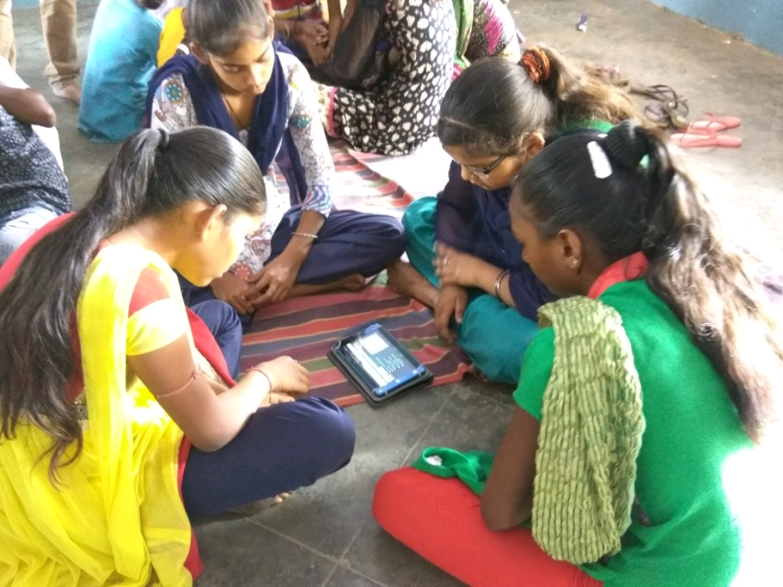

14/09/2017

Version: 1.0

ANAND SONI

Director

ARYA CONSULTANCY

B1103 – Infinity tower, corporate road,

prahaladnagar, Ahmedabad – 380015

Mobile: 9898585452 & 8980005950

email: ARYACONSULTANCYGUJARAT@GMAIL.COM

Website: www.schoolslens.com

# Introduction

Our main goal is to use cutting edge technologies combined with student psychology to develop innovative solutions that **make education interesting yet affordable** and available on demand. Our target audience is under-privileged students. Our focus is to help teachers enrich their classroom teaching using our innovative yet affordable solutions. We truly believe that education is the birth-right of every child and hence all our efforts are made to expand the reach of quality education to every corner of India with the help of technology and innovation.

All our products and services are based upon solid research across India. We have been researching in the field of primary education in Gujarat for past 6 years. Our research has taken us to 250+ government schools across 23 districts of Gujarat. We have met, discussed and interviewed 1000s of teachers, principals, students and their parents. Based on our research, we have found many critical issues of today’s primary education scenario in government schools. Our educational solutions and services make great use of technology. We believe technology should be used at optimum level inside the school premises. It should enhance and enrich the learning process of every child. Today’s students are growing up with technologies like computer, mobile phone, internet, etc… and it is school’s responsibility to teach them the correct usage of these technologies as part of the learning process.

We are the first company in India to introduce **Holistic Development Program (HDP)** targeted towards based on Blended Interactive Learning methodology. HDP’s main focus is students in standard 1 to 10 where we help them build necessary life-skills during the time they spend at school. Based on our research, we have a firm belief that students are most influenced by their parents during their elementary education and hence HDP includes an extensive parent development program that is tailored as per company’s needs. Based on our research outcomes, we are very certain that the best way to educate our children is to provide them with the best academic solutions. Therefore, we provide excellent tools, training and services.

For more information about our work and our partner’s company, please visit our website: [www.schoolslens.com](http://www.schoolslens.com)

**Our Team – The People:**

We have six offices in Ahmedabad including our R&D Lab. Our current employee strength is 70+ and we are in the process of hiring 20+ employees in 2017 for new product development and expansion of our operations in other parts of Gujarat and India. In addition to our employees, we are associated with many trainers, public speakers and educationalists that are part of our “education IDOL educationalists panel”. We all work together with one goal to elevate the standard of education in students of Gujarat through our Holistic Development Program (HDP)

**Our Accomplishments so far:**

We achieved and beaten every goal and mile-stone in the first two years of operations. Here are some of the highlights of our achievements:

* Working with Sarva Shiksha Abhiyan, Gandhinagar for the development of e-Class and e-Content initiatives targeted towards the upliftment of education quality in 14000+ government primary schools spread acrosss 33 districts of Gujarat
* Our e-learning product ‘sLate’ is accepted by Govt of Gujarat for their upcoming ‘tablet based education’ project and it was launched by Honorable Chief Minister of Gujarat Mr Vijay Rupani in a state-level event on 04/Feb/2017 at Gandhinagar.
* Successfully executed education based CSR projects from various organizations and improved quality of education for 5000+ students and teachers using 1200+ tablets spread across 37 tablet labs within 13 schools acrosss the state of Gujarat
* Touched, moved and inspired **25000+ students, teachers and parents** through our initiative called ‘education IDOL’ within last three years
* Researched **250+ government schools from Rural and Urban area of Gujarat** to understand the real issues of these schools and presented the report at “Ed Leadership World Education Conference” in 2015
* Introduction of new education methodology called **Blended Interactive Learning** for the primary education in Gujarat which focuses on Holistic Development of students within school environment.
* Torrent Group, Shri Jagdamba Polymerse, Concord Biotech, AIA Engineering Ltd., GCSR,YUVA Unstopable etc., we work as a implementing agency for the Holistic Development Program.

# **Holistic development Program design for aroma group**

We have an insightful discussion with Shri V.K.Shah and Shri C.D.Shah regarding to develop a program for employees as well as their children. Based on this discussion three major points were derived that will be covered in the program. First is children remain happy and they take interest in their study/subject, second is to support AROMA’s employees for their bright future and happy life and third provide motivation & support to enhance children’s capacity and capability. We are very happy to work with AROMA because of this noble cause and support to employees for their bright future. An HDP outcome has been visual and measurable. We will be covered content domain and cognitive domain.

# **Process of academic development for the students**

1. Pre Assessment/Testing: Classification of children in appropriate subject groups as per their competency.
2. Formation of students groups
3. Decide math, science and language activities and progress plan as per group requirement
4. Implement activities by Subject experts
5. Post Assessment
6. Reports and analysis of the progress

|  |  |  |
| --- | --- | --- |
| One batch : 35 to 40 students | Time : 11:00 am to 5:00 pm | Session: Diwali & Summer Vacation or Sat. &  Sunday |

# **Holistic development program for employee’s children (5 steps)**

**1. Learning Assessments & Post Assessment Analysis:**

A learning assessment will be done to measure the quality of student learning of every student of classes 3-10. The subjects will be Gujarati, Maths, EVS (Science and Social Studies) and English. The test will be designed to check for real understanding. The test should be low-stakes for students and teachers so that it does not create pressures and fears among students and parents. Purpose of the assessment is to identify student’s gaps, common wrong answer and misconceptions from the assessment. After completion the activities, again will do post assessment for each students. This enables us to compare actual student’s growth and development qualitatively as well quantitatively, also finds learning patterns, findings, recommendations and analysis from it.

After assessment completion we derive weaker skills, common errors in the concept, misconceptions, mental blocks etc. and finalized below method for enhance students’ skills, language competency and human behaviour.

**2. Inquiry based learning Session (IBL):**

Traditional education is mostly about knowledge acquisition. There are very few systems, regardless of specialization, that seek to enhance intelligence. Most syllabi leave little space or time for doubting and questioning received knowledge, asking questions, investigating them, arriving at justified conclusions, or thinking critically.

*Inquiry-Oriented Education* seeks to develop the abilities, predispositions, attitudes, habits of mind, and mindset characteristic of rational inquiry. It includes the components of mathematical, scientific, conceptual, and historical inquiries, as foundations for research, as well as for professional, public, and personal lives. In this form of education, knowledge acquisition happens as a by-product of inquiry.

Thus inquiry based learning describes an environment in which learning is driven by a process of enquiry owned by the students. It is essential that our students are educated for knowledge creation, lifelong learning and leadership. They will take on leading roles in their future working environments: directing change, asking important questions, solving problems and developing new knowledge.

Benefits of Enquiry based learning:

1. Fundamentally, students are more engaged with the subject. Learning is perceived as being more relevant to their own needs, thus they are enthusiastic and ready to learn.
2. Self directed learning not only develops key skills for postgraduate study but also leads to original thought that contributes to larger research projects, papers and publications.
3. Working within and communicating to a group are vital for a student’s employability.
4. Allows students to develop a more flexible approach to their studies, giving them the freedom and the responsibility to organize their own pattern of work within the time constraints of the task.

**3. Blended Interactive learning Session (BIL):**

Blended learning is a student cantered approach to create a learning experience whereby the learner interacts with other students, with the instructor, and with content through technology and face to face environments. Technology is changing the way we do things. All like that there are fun ways of learning coding for instance. We immediately see the outcome that is something fun and tangible.

Benefits of Blended Interactive learning (BIL):

1. Learner is more engaged using a variety of content types.
2. BIL is complements both environments and helps all types of learners in various ways.
3. Assess learner trends and act accordingly
4. Own paced and self learning

**4. Activity Based learning Session (ABL)**

Activity based learning is a methodology where children of different ages are grouped together in one class and learn at their own pace through facilitated exercises. So many learning materials use and students learn with small groups. Main purpose is children take interest and solve the problems by own space.

Benefits of Activity Based learning:

1. Activity based learning gaining the knowledge by doing activities.
2. It allows placing for self learning.
3. Evaluation is inbuilt in the system which makes it quite child friendly.
4. Creative and communicative skills are bound to groom in this way of learning
5. Project-Based Learning (PBL) is an innovative, systematic teaching method that promotes student engagement through deep investigations of complex questions. It’s learning by doing. At its best, the PBL focuses on imparting specific knowledge and skills while inspiring students to question actively, [think critically](https://www.noodle.com/articles/the-value-of-critical-thinking), and draw connections between their studies and the real world.

Benefits of Project Based learning:

1. Connecting academic situations to the real world is [one of the largest benefits of project based learning](http://www.methodschools.org/blog/7-ways-project-based-learning-prepares-students-for-the-future). Students learn with the same approach they will eventually use in their hobbies, passions, and careers. This ingrains essential problem-solving techniques within them early on, drastically increasing their chances of success in whatever career they choose once their education has completed.
2. project based learning requires the use of multiple problem-solving methods, which helps students not only cultivate a balanced approach but also learn to switch approaches when their initial attempt fails to work.
3. Another benefit of project based learning is its effect on students' interpersonal skills. Because projects are often large and complex, students are grouped together to work, which fosters communication skills and encourages even students with diverse and possibly conflicting personalities to find a common ground, or at the very least a way to work together without constant tension. Part of this teamwork building helps introduce students to the specialization and delegation that are extremely prominent in the real world. Some students will naturally be more adept at some problem-solving methods than others, so students will figure out how to allocate resources (themselves) optimally by having part of the group work on one subset of tasks while another part works on another subset.
4. Overall, project based learning encourages students to develop a balanced, diverse approach to solving real-world problems, both on their own and in a team. Project based learning prepares students for success in the real world like no other teaching style can.

**5. Scholarship for Employee’s children:**

Why:

Challenges that are present for first generation students or those of lower strata stem are one of the following:

1. Lack of parental experiences in higher education
2. Lack of ability to persist
3. Lack of Human and Cultural Capital
4. Lack of ability to finish academic programs

What:

Scholarship program seeks to ensure equality of opportunity to help the children of only AROMA employees to become what they would like to be so that they have a choice and are not dictated by economic and social necessity.

By supporting higher education, Torrent’s interest would be to see that any deserving child should not get restricted to follow his/her dreams due to financial constraints and at the same time to create a cadre of intellectuals.

How:

1. The scholarship is to be initiated to take care of lower strata people
2. It could drive with income and position levels
3. One view is, Torrent could contribute 50% of the education cost of the children and remaining 50% could be met by the parents – This might include Tuition fees and Boarding fees, if the case may be.
4. Parents contribution is essential in terms of their willingness for their children’s education and also from the perspective of ownership of the process
5. It should be rolled out from elementary to higher secondary students also (KG o XII)
6. The scholarship could be open for all the students up to STD IV without any conditions

# **Holistic development program for employee**

Employees are back bone of the company. Each employee is important for the company. A motivated workforce means a highly productive staff, all of which will help you achieve your business goals and this should be a main objective in organizational and business plan.

As per our discussion, we will be involved employees as parents’ community. Every parents are interested in their child growth, wants to motivate them but unfortunately they do not understand that which of their actions leads them to succeed as their role of a parents.

A workshop module will be designed focusing on following areas:

* Importance of life (JIVAN VIDHYA)
* Importance of Parenting
* Know and Understand ability of your children (Child psychology and trust)
* Role of parents in enhancing child’s abilities

# **Cost structure**

After collecting the details of the employees we will decide cost structure and payments scheduled for the Holistic Development Program. Total duration of the program is for one year (12 months) starting from September 2017 to August 2018 and tentative cost of the program around 6 to 8 lakhs. We covered students from Gr.1 to 10 and employees of the company. All materials provided by ARYA CONSULTANY and arrangement provide by AROMA.

**---------------------------------------------------------------------------------------------------------------------------------------------------------**

**Thank you for your time. We look forward to hearing from you in near future.**

**Please feel free to contact us for any questions you may have.**

**Contact Details:**

ANAND SONI

Director,

Mobile: (+91) 98 98 58 54 52

e-mail: aryaconsultancygujarat@gmail.com