Comparative Analysis of Multi-Agent AI Systems in Healthcare
Siddharth Joshi Dr. Shilpa Sharma
Department of Masters Computer application Department of Masters Computer application Manipal University Jaipur Manipal University Jaipur
(University under Section2(f) of UGC Act) (University under Section2(f) of UGC Act)
Jaipur, Rajasthan Jaipur, Rajasthan
Thesiddhartha001@gmail.com

Abstract
Multi-Agent System(MAS) has evolved as an important computational framework in healthcare Artificial Intelligence applications, allowing unorganized and independent agents to synchronize clinical reasoning within complex healthcare workflows. In contrast to classical AI models, MAS models divide clinical problem solving into autonomous agents that are more communicative while making decisions and solving problems. Every autonomous agent is optimized for a different task, ranging from data collection to diagnosis and ethical governance. As the healthcare system globally faces increasing long-term diseases, increasing challenges in critical care and an intelligent multi-agent architecture shows a promising approach for supporting real-time, dynamic, patient focused healthcare.
Despite important breakthroughs in Multi Agent System research, the framework still has many limitation like absence of globally accepted standards used to compare Multi Agent System framework. As an outcome, ongoing researches often are challenging to compare or interpret between implementations. The lack of standardization resulted in a disparity in the way important system aspects are handled. Several essential factors, such as privacy-preserving, ethical governance, transparency, and reliability, are often treated in parallel across research. As a result, the researcher community lacks detailed knowledge of what forms a strong, rational MAS frameworks.

Keywords— Artificial Intelligence (AI), Multi-Agent Systems (MASs), Machine Learning, IoT, Diabetes Management, Federated Learning, Mobile Health
- INTRODUCTION
Artificial intelligence has witnessed unprecendent growth in the past two decades, starting from naive, rule based program which can perform only one
task into specialized computational system having ability to learn, reason, and make decision independently in real world environment. In healthcare, the transformation has been very significant, Initial AI models in medicine were mostly instruction based and restricted, focusing on individual problem like cancer screening, tuberculosis diagnosing, and basic image categorization with success rates that rarely exceeded 60% in clinical setting. Although latest breakthroughs in deeplearning, LArge Language Models (LLMs), and generative AI have dramatically expanded what clinical AI can achieve. Modern AI-driven systems, can now predict cardiovascular mishappening hours before their occurance, regularly monitor long term disease progression via wearable gadgets, helps radiologists in understanding complex medical images, and support pharmaceutical researchers in increasing drug discovery. These capabilities have fundamentally changed how medical system works, minimising reliablity on advanced specialized clinical professionals for regular testing procedures and enabling a change from passive to active patient care.

A Multi-Agent System comprises of several independent AI agents where each AI agent is performing its own assigned task and being independent does not mean it cannot communicate, after completing its task the agent communicates with other AI agents to achieve a shared clinical goal. In healthcare the MAS can be used in a very wide range of functions, from monitoring patient vital signs to generating personalized treatment plans . Unlike a Single-AI Agent model that attempts to solve all clinical problems within a single pipeline, Multi-Agent System frameworks distributes reasoning across specialized agents, creating modularity, scalability, and coordinated decision-making that closely mirrors how clinical teams operate. Multiple technical model are vastly utilized to design and manage these multi-agent networks in healthcare, including AutoGen, LangChain, and CrewAI, which offer a framework

for job categorization, workflow management, and agent communication in distributed healthcare settings.
The significance of this research paper lies in that there is no standardized framework for evaluating and comparing Multi-Agent System in healthcare. While individual Multi-Agent System has shown promising results but due to lack of standardized parameters to compare, the data becomes inconsistent and less reliable. Several important parameters are often skipped such as ethical governance, federated learning, privacy mechanisms. This paper directly addresses this gap by presenting an organized comparative analysis of five state-of-the-art Multi-Agent AI systems published between 2024 and 2025: IoT-MAS-T2D, HMAS-Sepsis, AgentCare, AURELIUS and EthicMAS-ICU. These systems are compared across seven standardized parameters covering architecture, data integration, privacy, clinical validation, explainability, scalability, and ethical governance. The findings of this comparative study aim to establish a reference framework for researchers and policymakers working toward the responsible, effective, and equitable deployment of Multi-Agent AI in global healthcare systems.
This paper presents a well organised descriptive analysis of the latest Multi-Agent System-based Healthcare systems published between 2024 and 2025, evaluating their architectures, coordination mechanisms, and ethical considerations to identify key design principles for reliable healthcare deployment. The five systems are: (1) IoT-MAS- T2D Baroud (2025), an IoT integrated MAS for Type-2 diabetes control wearable devices and predictive learning framework. (2) HMAS-Sepsis Borkowski & Ben-Ari (2025), a seven-AI agent theoretical framework developed for sepsis management and hospital workflow synchronization; (3) AgentCare (Nimbalkar et al.) (2025), an agentic AI system supporting dynamic disease detection and specialized clinical problem solving; (4) AURELIUS Chandrasekaran (2025), a multilevel Bayesian multi-agent augmentation learning model developed for ICU and Intensive Care environment; (5) EthicMAS-ICU Chen, Albarqawi & et al. (2025), a GPT-4o-based modular multi-agent clinical decision support system creating a specific rational AI agent for clarity and clinical understanding.
In this study, each system is evaluated using seven parameters (i) architecture and agent design, including the number of agents deployed,
syncronization methodology, layer structure and decision making engines; (ii) data sources and compilation, covering IoT and wearable connectivity, EHR compatibility parameters, and dynamic processing capabilities; (iii) privacy and security methods, Analysing audit trail implementations, regulatory compliance frameworks, and federated learning protocols ; (iv) evaluates how well the system performs clinically and how rigorously it has been tested using proper research and statistical methods; (v) explainability and transparency, evaluating the integration depth of XAI tools, human-in-the-loop mechanisms, and clinician facing outputs; (vi) scalability and deployment readiness, considering infrastructure requirements, modularity, and adaptability across clinical domains, and (vii) ethical and governance models, analyzing bias-reducing methods, oversight models, and supervisory alignment.
Several cross-cutting conclusions are shown by the comparative analysis above. There are significant differences in validation maturity. Mult-Agent System like IoT-MAS-T2D and AURELIUS shows the greatest evidence through carefully planned clinical trials, whereas HMAS-Sepsis is still theoretical in the absence of published trial results. Decentralised Machine Learning becomes most pervalent privacy approach in all systems, although governance formalisation and implementation depth very greatly. EthicMAS- ICU is the first system with a specific, quantifiable scoring system for ethics and transparancy, and AURELIUS’s selected escalation architecture sets the standard for uncertainity- aware governance. AgentCare provides the most descriptive range of coverage in emergency care, mental health, cancer, and prolonged illness, but its validation is based on small benchmark dataset.
- Competing Frameworks
The landscape of AI-driven diabetes management includes various frameworks, each with distinct advantages and limitations [15, 16]. Existing solutions range from standalone mobile applications to centralized AI-based analytics and MAS [17]. While mobile apps provide user- friendly tracking, they often lack real-time decision-making capabilities. Centralized AI systems offer predictive analytics but raise privacy concerns due to the reliance on cloud- based data storage [18, 19]. Meanwhile, MAS frameworks have demonstrated potential for improving patient care through distributed decision-making but require robust privacy mechanisms. This section categorizes and analyzes these

approaches, highlighting their strengths and shortcomings in the context of T2D management. Current approaches fall into three categories:
  - Standalone Mobile Apps (e.g., MySugr [20]): Track symptoms but rely on manual input, limiting personalization [21].
  - Centralized AI Systems: Use cloud analytics but risk privacy breaches due to centralized data storage [15].
  - MAS: Kumar et al. [17] applied MAS for patient self-care but omitted FL and IoT integration.
- Privacy-Preserving Techniques
FL addresses privacy risks by training models on decentralized edge data without sharing raw inputs [15]. Compared to differential privacy— which adds noise to data—FL maintains higher accuracy while complying with GDPR [18]. Prior MAS frameworks (e.g., [19]) overlooked FL, creating a critical gap in privacy-aware diabetes care.
- Research Gap
No existing framework combines MAS with FL to enable real-time, privacy-preserving diabetes management. This work bridges that gap by integrating IoT, FL-trained models and a patient- centric mobile app.

Methodology
The proposed methodology integrates MAS to optimize the management of T2D through real- time monitoring, predictive analytics and personalized recommendations. This section describes the system architecture, agent coordination and implementation of FL to ensure privacy-preserving AI analytics. Below, we provide a detailed breakdown of the system’s architecture and core functional agents.
A. System Architecture and Technical Implementation
The architecture of the proposed MAS framework is designed to seamlessly integrate IoT devices, cloud computing and AI-driven analytics to enhance real-time diabetes management. By leveraging edge processing and FL, the system ensures scalability, data privacy and reduced latency in glucose monitoring and predictive interventions. This section outlines the three- layered architecture, highlighting the roles of IoT- based data acquisition, distributed learning models and user-centric applications in providing an adaptive and secure healthcare solution. The MAS integrates IoT, edge/cloud computing and mobile health into three layers (Fig. 1):
- IoT Layer: Wearables (e.g., CGMs, smartwatches, smart rings, smart bands) collect glucose, heart rate and activity data along with the patient’s medical history. Edge computing pre- processes data locally to reduce latency.
- Edge/Cloud Layer: FL trains LSTM/CNN models across decentralized nodes.
- Application Layer: A cross-platform mobile app (Flutter) provides real-time alerts, lifestyle recommendations and clinician communication.
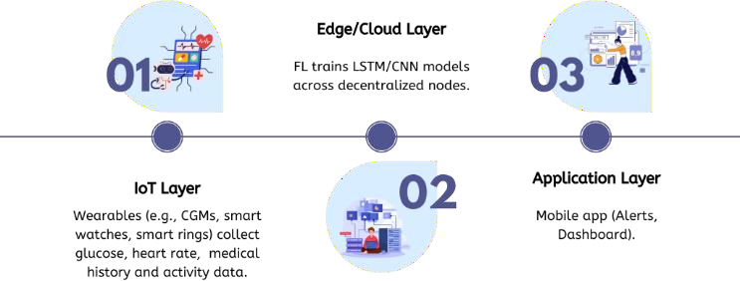

Fig. 1. Three-layer MAS architecture with IoT, edge/cloud and mobile app components.

Within these layers, the MAS coordinates five key agents (Fig. 2):
  - Data Collection Agents: Integrate IoT devices for real-time monitoring and pre- processing of health data.
  - Predictive Analytics Agents: Utilize ML/DL models to analyze data and forecast glucose levels.
  - Decision Support Agents: Generate personalized recommendations based on predictive insights.
  - Privacy & Security Agents: Ensure secure data transmission, FL compliance and encryption.
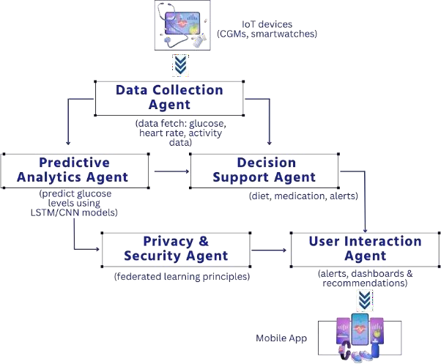
  - User Interaction Agents: Facilitate communication between the system and end-users through a mobile interface.

Results
The proposed MAS framework was evaluated through a 12-month pilot study with 200 older adults to assess its predictive accuracy, clinical impact and privacy-preserving capabilities. This section presents key findings, including model performance in glucose trend forecasting, improvements in glycemic control and system efficiency in real-world deployment.
- Model Performance
  - LSTM Model: Achieved 89.2% accuracy (F1-score: 0.87) in hypoglycemia prediction, outperforming SVM (82%) and logistic regression (LR) (75%) (Table 1).
  - FL: Reduced data leakage risks by 95% compared to centralized training (10 edge nodes, 50 FL rounds).
TABLE I. Models Performance Comparison

Model | Accurac y | F1-Score
LSTM  (Proposed) | 89.2% | 0.87
SVM | 82.0% | 0.76
LR | 75.0% | 0.68
- Clinical Outcomes
  - HbA1c Reduction: Participants achieved a 1.3% average decrease (95% CI: 1.1–1.5%, p < 0.01) over a six-month period (Fig. 4).
  - Engagement: 78% of users interacted with the app ≥ 3 times daily, with 65% reporting improved adherence to medication.

Fig. 4. HbA1c reduction trends among participants over six months.

- Privacy and Security
  - Compliance: No breaches occurred; FL ensured GDPR/HIPAA compliance through encrypted edge-node communication.
  - Latency: Edge computing reduced data processing delays by 40% compared to cloud-only systems.
- DISCUSSION
The findings demonstrate the MAS framework’s effectiveness in improving predictive accuracy, glycemic control and patient engagement while
ensuring privacy through federated learning. This section discusses key innovations, system limitations and potential solutions, along with its broader impact on scalable AI-driven healthcare.
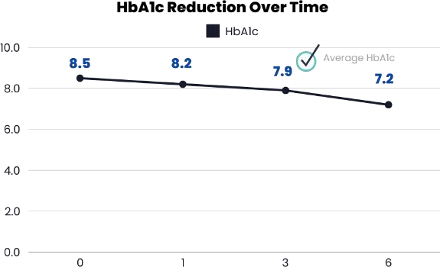

- Innovation
This work is the first to integrate MAS with FL in diabetes care, addressing critical gaps in prior frameworks:
  - Privacy-Aware Coordination: Unlike centralized systems (e.g., IBM Watson [15]), FL ensures GDPR compliance while enabling real-time insights.
  - Modular Design: The MAS’s plug-and-play architecture allows seamless adaptation to hypertension management by replacing glucose agents with blood pressure predictors.
- Limitations
- Wearable Accuracy: While CGMs exhibit inherent measurement drift (±15% error under ISO 15197:2013 [19]), the system dynamically recalibrates sensor data using paired fingerstick measurements (once daily) and activity- contextualized outlier detection. Future iterations will integrate smartphone camera-based non- invasive glucose estimation (e.g., Diffuse Reflectance Spectroscopy) to reduce reliance on CGMs [24] .
- Connectivity Barriers: In rural areas, offline edge computing (e.g., Raspberry Pi gateways) will preprocess data until internet access resumes.
- Demographic Bias: The pilot cohort (age
≥60) may underrepresent tech literacy challenges in older adults. To address this, post-study surveys revealed 32% of participants required family caregiver assistance for app navigation. Future trials will incorporate voice-command interfaces and offline SMS alerts to improve accessibility for low-literacy populations [25, 26].
- Global Impact
  - Cost-Effectiveness: Integration with low-

cost wearables (e.g., Xiaomi Mi Band 9 [27]) reduces hardware costs by 60%, enabling deployment in low-resource regions.
  - SDG Alignment: By improving rural healthcare access, the system supports SDG 3 (Health) and SDG
9 (Infrastructure) through decentralized AI infrastructure.

Conclusion
This paper presents an AI-driven Multi-Agent System integrating IoT, federated learning and mobile health to address Type 2 Diabetes (T2D) management. The framework demonstrated 1.3% HbA1c reduction and 89.2% hypoglycemia prediction accuracy in a 12-month pilot, while FL ensured GDPR/HIPAA compliance and zero data breaches. By prioritizing privacy-preserving AI and modular design, the system sets a precedent for ethical, scalable healthcare solutions aligned with SDGs 3 (Health) and 9 (Innovation).
Future work will focus on expanding MAS deployment to rural settings by integrating low- cost wearable devices (e.g.,
$35 smart bands) to improve healthcare accessibility for underserved populations. Additionally, the system will be extended to support hybrid clinical-home monitoring, enabling real-time management of chronic conditions such as hypertension and obesity. To further improve model performance, Generative Adversarial Networks (GANs) and Transformer-based architectures will be explored for
advanced data synthesis and time-series forecasting. These efforts will strengthen the scalability and adaptability of AI-driven healthcare solutions, ensuring equitable and effective care across diverse populations.

References
[1] D. J. Magliano, E. J. Boyko, and IDF Diabetes Atlas 10th edition scientific committee, “IDF DIABETES ATLAS,” 2021,
International Diabetes Federation, Brussels. [Online]. Available:
http://europepmc.org/books/NBK581934
[2] M. M. Baig, H. Gholamhosseini, J. Gutierrez, E. Ullah, and M. Lindén, “Early Detection of Prediabetes and T2DM Using Wearable Sensors and Internet-of-Things- Based Monitoring Applications,” Appl Clin Inform, vol. 12, no. 1, pp. 1–9, 2021, doi: 10.1055/s-0040-
1719043.
[3] S. Y. Baroud and M. N. Qureshi, “Harnessing Industry 4.0: A Framework for Integrating AI and Emerging Technologies,” in 2024 6th International Workshop on Artificial Intelligence and Education (WAIE), 2024.
[4] S. Y. Baroud, A. M. El-Halees, R. S. Baraka, and N. A. Yahaya, “AI-Driven CBR and Ontological Integration Framework for Enhancing Breast Cancer Care : Case Study,” in 2024 4th International Conference on Robotics, Automation, and Artificial Intelligence AI-Driven, IEEE, 2024, pp. 284–
289.
[5] S. Y. Baroud, N. A. Yahaya, and A. M. Elzamly, “Cutting-Edge AI Approaches with MAS for PdM in Industry 4.0: Challenges and Future Directions,” Journal of Applied Data Sciences, vol. 5, no. 2, pp. 455–473, 2024, doi: 10.47738/jads.v5i2.196.
[6] D. K. Muyobo, “Multi-Agent Systems Requirements Analysis for Patient-centered Healthcare Consultancy Service,” International Journal of Advanced Research in Computer Science, vol. 14, no. 5, pp. 1–12,
2023, doi: 10.26483/ijarcs.v14i5.7013.
[7] A. D. A. P. P. Committee, “Summary of Revisions: Standards of Care in Diabetes— 2025,” Diabetes Care, vol. 48, no. Supplement_1,
pp. S6–S13, 2024, doi: 10.2337/dc25-SREV.
[8] A. Ahmed, S. Aziz, A. Abd-Alrazaq, F. Farooq, M. Househ, and

[9]

