Interface in Java
An interface in Java is a blueprint of a class. It has static constants and abstract methods.
The interface in Java is a mechanism to achieve abstraction. There can be only abstract methods in the Java interface, not method body. It is used to achieve abstraction and multiple inheritance in Java.
In other words, you can say that interfaces can have abstract methods and variables. It cannot have a method body.
- Java Interface also represents the IS-A relationship.
- It cannot be instantiated just like the abstract class.
- Since Java 8, we can have default and static methods in an interface.
- Since Java 9, we can have private methods in an interface.
Why use Java interface?
There are mainly three reasons to use interface. They are given below.
- It is used to achieve abstraction.
- By interface, we can support the functionality of multiple inheritance.
- It can be used to achieve loose coupling.
How to declare an interface?
An interface is declared by using the interface keyword. It provides total abstraction; means all the methods in an interface are declared with the empty body, and all the fields are public, static and final by default. A class that implements an interface must implement all the methods declared in the interface.
Syntax:
interface <interface_name>{

// declare constant fields
// declare methods that abstract
// by default.
}
Example:
interface Animal {
void eat();
void sleep();
}
In this example, the Animal interface declares two method signatures: eat() and sleep(). Any class implementing the Animal interface must provide concrete implementations for these methods.
Internal addition by the compiler
The Java compiler adds public and abstract keywords before the interface method. Moreover, it adds public, static and final keywords before data members.
In other words, Interface fields are public, static and final by default, and the methods are public and abstract.
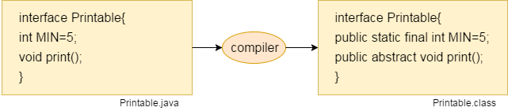
Relationship Between Classes and Interfaces
As shown in the figure given below, a class extends another class, an interface extends another interface, but a class implements an interface.
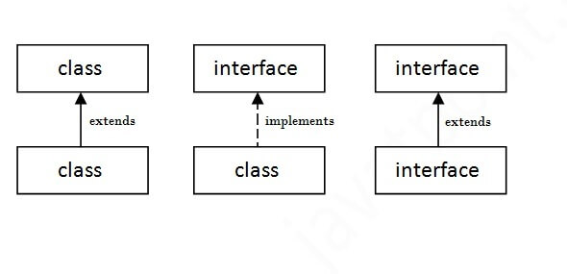
Java Interface Example
In this example, the Printable interface has only one method, and its implementation is provided in the A6 class.
File Name: InterfaceExample.java
interface printable{
void print();
}
class InterfaceExample implements printable{
public void print(){System.out.println("Hello");}
public static void main(String args[]){
InterfaceExample obj = new InterfaceExample();
obj.print();
}
}
Output:
Hello
Java Interface Example: Drawable
In this example, the Drawable interface has only one method. Its implementation is provided by Rectangle and Circle classes. In a real scenario, an interface is defined by someone else, but its implementation is provided by different implementation providers. Moreover, it is used by someone else. The implementation part is hidden by the user who uses the interface.
File: TestInterface1.java
//Interface declaration: by first user
interface Drawable{
void draw();
}
//Implementation: by second user
class Rectangle implements Drawable{
public void draw(){System.out.println("drawing rectangle");}
}
class Circle implements Drawable{
public void draw(){System.out.println("drawing circle");}
}
//Using interface: by third user
class TestInterface1{
public static void main(String args[]){
Drawable d=new Circle();//In real scenario, object is provided by method e.g. getDrawable()
d.draw();
}}

Output:
drawing circle
Java Interface Example: Bank
Let's see another example of java interface which provides the implementation of Bank interface.
File: TestInterface2.java
interface Bank{
float rateOfInterest();
}
class SBI implements Bank{
public float rateOfInterest(){return 9.15f;}
}
class PNB implements Bank{
public float rateOfInterest(){return 9.7f;}
}
class TestInterface2{
public static void main(String[] args){
Bank b=new SBI();
System.out.println("ROI: "+b.rateOfInterest());
}}
Output:
ROI: 9.15
Multiple Inheritance in Java by Interface
If a class implements multiple interfaces, or an interface extends multiple interfaces, it is known as multiple inheritance.
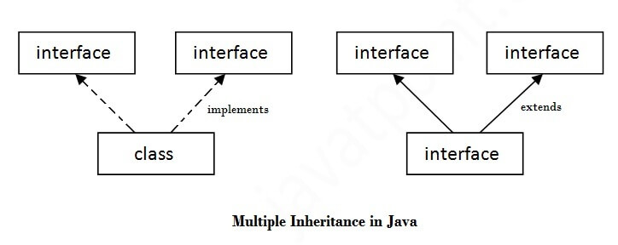
File Name: InterfaceDemo.java
interface Printable{
void print();
}
interface Showable{
void show();
}
class A7 implements Printable,Showable{
public void print(){System.out.println("Hello");}
public void show(){System.out.println("Welcome");}

public static void main(String args[]){
A7 obj = new A7();
obj.print();
obj.show();
}
}
Output:
Hello
Welcome
Q) Multiple inheritance is not supported through class in java, but it is possible by an interface, why?
Multiple inheritance is not supported in the case of class because of ambiguity. However, it is supported in case of an interface because there is no ambiguity. It is because its implementation is provided by the implementation class. For example:
interface Printable{
void print();
}
interface Showable{
void print();
}

class TestInterface3 implements Printable, Showable{
public void print(){System.out.println("Hello");}
public static void main(String args[]){
TestInterface3 obj = new TestInterface3();
obj.print();
}
}
Output:
Hello
As we can see in the above example, Printable and Showable interface have same methods but its implementation is provided by class TestTnterface1, so there is no ambiguity in the program.
Interface Inheritance
A class implements an interface, but one interface extends another interface.
File Name: TestInterface4.java
interface Printable{
void print();
}
interface Showable extends Printable{
void show();
}
class TestInterface4 implements Showable{
public void print(){System.out.println("Hello");}
public void show(){System.out.println("Welcome");}

public static void main(String args[]){
TestInterface4 obj = new TestInterface4();
obj.print();
obj.show();
}
}
Output:
Hello
Welcome

Difference between abstract class and interface
Abstract class and interface both are used to achieve abstraction where we can declare the abstract methods. Abstract class and interface both can't be instantiated.
But there are many differences between abstract class and interface that are given below.
Abstract class | Interface
1) Abstract class can have abstract and non-abstract methods. | Interface can have only abstract methods. Since Java 8, it can have default and static methods also.
2) Abstract class doesn't support multiple inheritance. | Interface supports multiple inheritance.
3) Abstract class can have final, non-final, static and non-static variables. | Interface has only static and final variables.
4) Abstract class can provide the implementation of interface. | Interface can't provide the implementation of abstract class.
5) The abstract keyword is used to declare abstract class. | The interface keyword is used to declare interface.
6) An abstract class can extend another Java class and implement multiple Java interfaces. | An interface can extend another Java interface only.
7) An abstract class can be extended using keyword "extends". | An interface can be implemented using keyword "implements".
8) A Java abstract class can have class members like private, protected, etc. | Members of a Java interface are public by default.
9)Example:  public abstract class Shape{  public abstract void draw();  } | Example:  public interface Drawable{  void draw();  }

