Multithreading in Java
Multithreading in Java is a process of executing multiple threads simultaneously.
A thread is a lightweight sub-process, the smallest unit of processing. Multiprocessing and multithreading, both are used to achieve multitasking.
Threads use a shared memory area. They don't allocate separate memory area so saves memory, and context-switching between the threads takes less time than process.
Java Multithreading is mostly used in games, animation, etc.
Advantages of Java Multithreading
1) It doesn't block the user because threads are independent and you can perform multiple operations at the same time.
2) You can perform many operations together, so it saves time.
3) Threads are independent, so it doesn't affect other threads if an exception occurs in a single thread.
4) Multithreading can significantly enhance the performance of applications by making better use of multiple CPU cores. Each thread can run on a separate core, allowing for parallel processing and faster execution of tasks.
5) In applications with a graphical user interface (GUI), multithreading can help keep the interface responsive. Long-running tasks can be handled in the background by separate threads, preventing the main thread from freezing and improving user experience.
6) Threads within the same process share the same memory and resources, which makes it easier to share data between them without the need for complex inter-process communication mechanisms.
7) Using multiple threads can simplify the design of complex applications, allowing for more modular and manageable code. For example, separate threads can be dedicated to different tasks, such as network communication, file I/O, and computation.
8) Multithreading allows an application to continue processing while waiting for I/O operations to complete. This leads to better utilization of CPU resources as threads can perform useful work during I/O waits.

Multitasking
Multitasking is a process of executing multiple tasks simultaneously. We use multitasking to utilize the CPU. Multitasking can be achieved in two ways:
- Process-based Multitasking (Multiprocessing)
- Thread-based Multitasking (Multithreading)
1) Process-based Multitasking (Multiprocessing)
- Each process has an address in memory. In other words, each process allocates a separate memory area.
- A process is heavyweight.
- Cost of communication between the process is high.
- Switching from one process to another requires some time for saving and loading registers, memory maps, updating lists, etc.
2) Thread-based Multitasking (Multithreading)
- Threads share the same address space.
- A thread is lightweight.
- Cost of communication between the thread is low.
Note: At least one process is required for each thread.
What is Thread in Java?
A thread is a lightweight subprocess, the smallest unit of processing. It is a separate path of execution.
Threads are independent. If there occurs exception in one thread, it doesn't affect other threads. It uses a shared memory area.
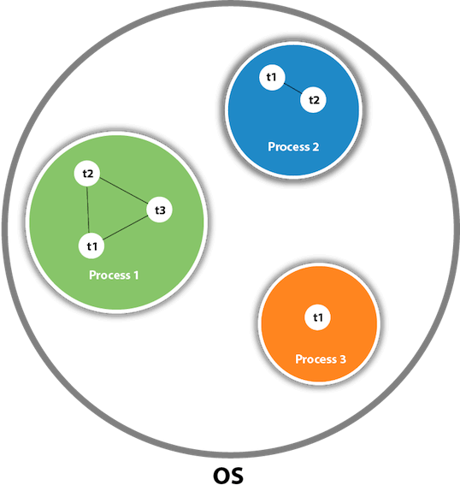
As shown in the above figure, a thread is executed inside the process. There is context-switching between the threads. There can be multiple processes inside the OS, and one process can have multiple threads.
Note: At a time one thread is executed only.
Java Thread class
Java provides Thread class to achieve thread programming. Thread class provides constructors and methods to create and perform operations on a thread. Thread class extends Object class and implements Runnable interface.

Life cycle of a Thread (Thread States)
In Java, a thread always exists in any one of the following states. These states are:
- New
- Active
- Blocked / Waiting
- Timed Waiting
- Terminated
Explanation of Different Thread States
New: Whenever a new thread is created, it is always in the new state. For a thread in the new state, the code has not been run yet and thus has not begun its execution.
Active: When a thread invokes the start() method, it moves from the new state to the active state. The active state contains two states within it: one is runnable, and the other is running.
- Runnable: A thread, that is ready to run is then moved to the runnable state. In the runnable state, the thread may be running or may be ready to run at any given instant of time. It is the duty of the thread scheduler to provide the thread time to run, i.e., moving the thread the running state.
A program implementing multithreading acquires a fixed slice of time to each individual thread. Each and every thread runs for a short span of time and when that allocated time slice is over, the thread voluntarily gives up the CPU to the other thread, so that the other threads can also run for their slice of time. Whenever such a scenario occurs, all those threads that are willing to run, waiting for their turn to run, lie in the runnable state. In the runnable state, there is a queue where the threads lie.
- Running: When the thread gets the CPU, it moves from the runnable to the running state. Generally, the most common change in the state of a thread is from runnable to running and again back to runnable.
Blocked or Waiting: Whenever a thread is inactive for a span of time (not permanently) then, either the thread is in the blocked state or is in the waiting state.
For example, a thread (let's say its name is A) may want to print some data from the printer. However, at the same time, the other thread (let's say its name is B) is using the printer to print some data. Therefore, thread A has to wait for thread B to use the printer. Thus, thread A is in the blocked state. A thread in the blocked state is unable to perform any execution and thus never consume any cycle of the Central Processing Unit (CPU). Hence, we can say that thread A remains idle until the thread scheduler reactivates thread A, which is in the waiting or blocked state.
When the main thread invokes the join() method then, it is said that the main thread is in the waiting state. The main thread then waits for the child threads to complete their tasks. When the child threads complete their job, a notification is sent to the main thread, which again moves the thread from waiting to the active state.
If there are a lot of threads in the waiting or blocked state, then it is the duty of the thread scheduler to determine which thread to choose and which one to reject, and the chosen thread is then given the opportunity to run.
Timed Waiting: Sometimes, waiting for leads to starvation. For example, a thread (its name is A) has entered the critical section of a code and is not willing to leave that critical section. In such a scenario, another thread (its name is B) has to wait forever, which leads to starvation. To avoid such scenario, a timed waiting state is given to thread B. Thus, thread lies in the waiting state for a specific span of time, and not forever. A real example of timed waiting is when we invoke the sleep() method on a specific thread. The sleep() method puts the thread in the timed wait state. After the time runs out, the thread wakes up and start its execution from when it has left earlier.
Terminated: A thread reaches the termination state because of the following reasons:
- When a thread has finished its job, then it exists or terminates normally.
- Abnormal termination: It occurs when some unusual events such as an unhandled exception or segmentation fault.
A terminated thread means the thread is no more in the system. In other words, the thread is dead, and there is no way one can respawn (active after kill) the dead thread.
The following diagram shows the different states involved in the life cycle of a thread.
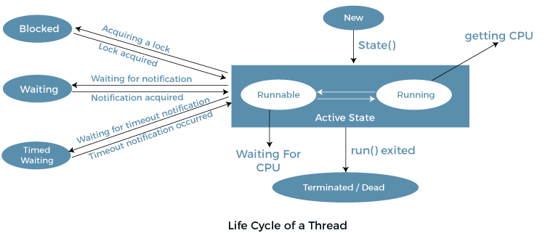
Implementation of Thread States
In Java, one can get the current state of a thread using the Thread.getState() method. The java.lang.Thread.State class of Java provides the constants ENUM to represent the state of a thread. These constants are:
- public static final Thread.State NEW
It represents the first state of a thread that is the NEW state.
- public static final Thread.State RUNNABLE
It represents the runnable state.It means a thread is waiting in the queue to run.
- public static final Thread.State BLOCKED
It represents the blocked state. In this state, the thread is waiting to acquire a lock.
- public static final Thread.State WAITING
It represents the waiting state. A thread will go to this state when it invokes the Object.wait() method, or Thread.join() method with no timeout. A thread in the waiting state is waiting for another thread to complete its task.
- public static final Thread.State TIMED_WAITING
It represents the timed waiting state. The main difference between waiting and timed waiting is the time constraint. Waiting has no time constraint, whereas timed waiting has the time constraint. A thread invoking the following method reaches the timed waiting state.
- sleep

public static final Thread.State TERMINATED

It represents the final state of a thread that is terminated or dead. A terminated thread means it has completed its execution.
How to create a thread in Java
Multithreading is a fundamental concept in Java programming, allowing developers to execute multiple tasks concurrently within a single program. Threads are lightweight processes that run within the context of a larger process, enabling efficient utilization of system resources and enhancing application responsiveness. In this section, we will explore how to create threads in Java, covering various approaches, best practices.
There are the following two ways to create a thread:
- By Extending Thread Class
- By Implementing Runnable Interface
Thread Class
The simplest way to create a thread in Java is by extending the Thread class and overriding its run() method. Thread class provide constructors and methods to create and perform operations on a thread. Thread class extends Object class and implements Runnable interface.
Constructors of Thread Class
- Thread()
- Thread(String name)
- Thread(Runnable r)
- Thread(Runnable r, String name)
Thread Class Methods
- public void run(): is used to perform action for a thread.
- public void start(): starts the execution of the thread.JVM calls the run() method on the thread.
- public void sleep(long miliseconds): Causes the currently executing thread to sleep (temporarily cease execution) for the specified number of milliseconds.
- public void join(): waits for a thread to die.
- public void join(long miliseconds): waits for a thread to die for the specified miliseconds.
By Implementing Runnable Interface
Another approach to creating threads in Java is by implementing the Runnable interface. The Runnable interface should be implemented by any class whose instances are intended to be executed by a thread. Runnable interface have only one method named run(). This approach is preferred when we want to separate the task from the thread itself, promoting better encapsulation and flexibility.
public void run(): is used to perform action for a thread.
Starting a Thread
The start() method of the Thread class is used to start a newly created thread. It performs the following tasks:
- A new thread starts (with new callstack).
- The thread moves from New state to the Runnable state.
- When the thread gets a chance to execute, its target run() method will run.

Thread Creation
1) Creating Thread by Extending Thread Class

File Name: Multi.java

class Multi extends Thread{
public void run(){
System.out.println("thread is running...");
}
public static void main(String args[]){
Multi t1=new Multi();
t1.start();
}
}
Output:
thread is running...
In this example, we define a custom thread by extending the Thread class and overriding the run() method with our desired functionality. We then instantiate the thread and call its start() method to begin execution.

2) Java Thread Example by implementing Runnable interface

FileName: Multi3.java

class Multi3 implements Runnable{
public void run(){
System.out.println("thread is running...");
}

public static void main(String args[]){
Multi3 m1=new Multi3();
Thread t1 =new Thread(m1); // Using the constructor Thread(Runnable r)
t1.start();
}
}
Output:
thread is running...
In this example, we define a class MyRunnable that implements the Runnable interface and provides the task logic inside its run() method. We then create a new Thread object, passing an instance of MyRunnable to its constructor, and start the thread using the start() method.
If we are not extending the Thread class, the class object would not be treated as a thread object. So, we need to explicitly create the Thread class object. We are passing the object of our class that implements Runnable so that the class's run() method may execute.

Thread.sleep() in Java with Examples
The Java Thread class provides the two variants of the sleep() method. First one accepts only an argument, whereas the other variant accepts two arguments. The method sleep() is being used to halt the working of a thread for a given amount of time. The time up to which the thread remains in the sleeping state is known as the sleeping time of the thread. After the sleeping time is over, the thread starts its execution from where it has left.
What is Thread.sleep()?
The Thread.sleep() method is a static method of the Thread class that causes the currently executing thread to sleep (pause its execution) for a specified number of milliseconds.

Basic Usage of Thread.sleep() Method
Here's a simple example of using Thread.sleep():
File Name: SleepExample.java
public class SleepExample {
public static void main(String[] args) {
System.out.println("Start");
try {
Thread.sleep(2000); // Pause for 2000 milliseconds (2 seconds)
} catch (InterruptedException e) {
System.out.println("Thread interrupted");
}
System.out.println("End");
}
}
Output:
Start
End
In this example, the main thread prints "Start", pauses for 2 seconds, and then prints "End".
Example of the sleep() method in Java : on the custom thread
The following example shows how one can use the sleep() method on the custom thread.
FileName: TestSleepMethod1.java

class TestSleepMethod1 extends Thread{
public void run(){
for(int i=1;i<5;i++){
// the thread will sleep for the 500 milli seconds
try{
Thread.sleep(2000);
}catch(InterruptedException e)
{
System.out.println(e);
}
System.out.println(i);
}
}
public static void main(String args[]){
TestSleepMethod1 t1=new TestSleepMethod1();
TestSleepMethod1 t2=new TestSleepMethod1();
t1.start();
t2.start();
}
}

Can we start a thread twice
No. After starting a thread, it can never be started again. If you does so, an IllegalThreadStateException is thrown. In such case, thread will run once but for second time, it will throw exception.
Let's understand it by the example given below:
public class TestThreadTwice1 extends Thread{
public void run(){
System.out.println("running...");
}
public static void main(String args[]){
TestThreadTwice1 t1=new TestThreadTwice1();
t1.start();
t1.start();
}
}
Output:
running
Exception in thread "main" java.lang.IllegalThreadStateException

What if we call Java run() method directly instead start() method?
- Each thread starts in a separate call stack.
- Invoking the run() method from the main thread, the run() method goes onto the current call stack rather than at the beginning of a new call stack.
FileName: TestCallRun1.java

class TestCallRun1 extends Thread{
public void run(){
System.out.println("running...");
}
public static void main(String args[]){
TestCallRun1 t1=new TestCallRun1();
t1.run();//fine, but does not start a separate call stack
}
}
Output:
running...

Java join() method
The join() method in Java is provided by the java.lang.Thread class that permits one thread to wait until the other thread to finish its execution. Suppose th be the object the class Thread whose thread is doing its execution currently, then the th.join(); statement ensures that th is finished before the program does the execution of the next statement. When there are more than one thread invoking the join() method, then it leads to overloading on the join() method that permits the developer or programmer to mention the waiting period. However, similar to the sleep() method in Java, the join() method is also dependent on the operating system for the timing, so we should not assume that the join() method waits equal to the time we mention in the parameters. The following are the three overloaded join() methods.

class MyThread extends Thread {
private String threadName;
MyThread(String name) {
threadName = name;
}
// Override the run method to define the task for the thread
public void run() {
for (int i = 1; i <= 5; i++) {
System.out.println(threadName + " - Count: " + i);
try {
// Sleep for a while to simulate some work
Thread.sleep(1000);
} catch (InterruptedException e) {
System.out.println(threadName + " interrupted.");
}
}
System.out.println(threadName + " finished.");
}
}
public class MultiThreadingExample {
public static void main(String[] args) {
// Create instances of MyThread
MyThread thread1 = new MyThread("Thread 1");
MyThread thread2 = new MyThread("Thread 2");
MyThread thread3 = new MyThread("Thread 3");
// Start the threads
thread1.start();
thread2.start();
thread3.start();
// Wait for all threads to finish
try {
thread1.join();
thread2.join();
thread3.join();
} catch (InterruptedException e) {
System.out.println("Main thread interrupted.");
}
System.out.println("All threads have finished.");
}
}
Explanation
By extending the Thread class and overriding its run method to print a message five times with a one-second delay in between, this Java programme illustrates multithreading.
Three instances of MyThread are generated and launched using the start function in the main class, MultiThreadingExample, enabling them to operate concurrently. In order to guarantee that the main thread waits for every thread to finish before issuing a final message stating that every thread has finished, the join() method is employed.

