Java static keyword
The static keyword in Java is used for memory management mainly. We can apply static keyword with variables, methods, blocks and nested classes. The static keyword belongs to the class than an instance of the class.
The static can be:
- Variable (also known as a class variable)
- Method (also known as a class method)
- Block
- Nested class
Beyond memory management, the static keyword in Java has several other uses. When it comes to variables, it means that the variable is shared by all instances of the class and belongs to the class as a whole, not just any one instance. Static methods are available throughout the programme since they can be called without first generating an instance of the class. When the class loads, static blocks are used to initialise static variables or carry out one-time operations. Furthermore, nested static classes can be instantiated individually but are still linked to the outer class. Moreover, class names can be used to access static variables and methods directly, eliminating the need to build an object instance. This is especially helpful for constants or utility methods.
1) Java static variable

If we declare any variable as static, it is known as a static variable.
- The static variable can be used to refer to the common property of all objects (which is not unique for each object), for example, the company name of employees, college name of students, etc.
- The static variable gets memory only once in the class area at the time of class loading.
- Static variables in Java are also initialized to default values if not explicitly initialized by the programmer. They can be accessed directly using the class name without needing to create an instance of the class.
- Static variables are shared among all instances of the class, meaning if the value of a static variable is changed in one instance, it will reflect the change in all other instances as well.
Advantages of Static Variable
1. It makes your program memory efficient (i.e., it saves memory).
Example of Static Variable
Filename: TestStaticVariable1.java
//Java Program to demonstrate the use of static variable
class Student{
int rollno;//instance variable
String name;
static String college ="ITS";//static variable
//constructor
Student(int r, String n){
rollno = r;
name = n;
}
//method to display the values
void display ()
{
System.out.println(rollno+" "+name+" "+college);}
}
//Test class to show the values of objects
class TestStaticVariable1{
public static void main(String args[]){
Student s1 = new Student(111,"Karan");
Student s2 = new Student(222,"Aryan");
//we can change the college of all objects by the single line of code
//Student.college="BBDIT";
s1.display();
s2.display();
}
}
Output:
111 Karan ITS
222 Aryan ITS
Explanation
The usage of static variables is demonstrated in this Java programme. In addition to a static variable called college, the Student class defines two instance variables: rollno and name. It has a constructor to set the instance variables' initial values and a display() function to output the rollno, name, and college values. Two Student objects, s1 and s2, with different roll numbers and names, are created via the TestStaticVariable1 class. After that, each object's display() method is called, printing its details. The college name can be modified for all objects at once by uncommenting the line Student.college="BBDIT";, demonstrating how static variables are shared by all instances of a class.
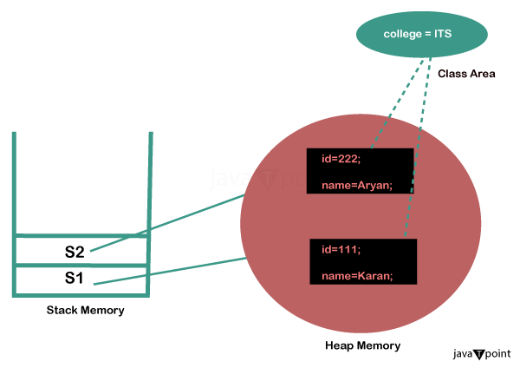

2) Java Static Method
If we apply a static keyword with any method, it is known as a static method.
- A static method belongs to the class rather than the object of a class.
- A static method can be invoked without the need for creating an instance of a class.
- A static method can access static data members and can change their value of it.
Filename: TestStaticMethod.java
//Java Program to demonstrate the use of a static method.
class Student{
int rollno;
String name;
static String college = "ITS";
//static method to change the value of static variable
static void change(){
college = "BBDIT";
}
//constructor to initialize the variable
Student(int r, String n){
rollno = r;
name = n;
}
//method to display values
void display(){System.out.println(rollno+" "+name+" "+college);}
}
//Test class to create and display the values of object
public class TestStaticMethod{
public static void main(String args[]){
Student.change();//calling change method
//creating objects
Student s1 = new Student(111,"Karan");
Student s2 = new Student(222,"Aryan");
Student s3 = new Student(333,"Sonoo");
//calling display method
s1.display();
s2.display();
s3.display();
}
}
Output:
111 Karan BBDIT
222 Aryan BBDIT
333 Sonoo BBDIT
Explanation
This Java programme demonstrates how to use a static method inside of a class. In addition to a static variable called college, the Student class defines two instance variables: rollno and name. To alter the value of the static variable college, it has a static function called change(). In addition, the class has a constructor for initialising instance variables and a display() method for printing the rollno, name, and college values. The main method of the TestStaticMethod class shows how to use the change() method to modify the college value. After then, the display() method is used to create three Student objects (s1, s2, and s3) with distinct roll numbers and names, and their details are shown. This illustrates how the static method change() influences the static variable college for all instances of the class.
Let's see another example of a static method that performs a normal calculation.

Restrictions for the Static Method
There are the following two main restrictions for the static method.
- The static method cannot use non-static data members or call a non-static method directly.
- this and super keyword cannot be used in static context.
Filename: A.java
class A{
int a=40;//non static

public static void main(String args[]){
System.out.println(a);
}
}
Output:
Compile Time Error
Explanation
The Java code provided contains a class called A. A defined instance variable with the value 40 that is designated as non-static is present in class A. Nonetheless, an attempt is made to use System.out.println(a); to directly access the instance variable an in the class A main method. Because static methods in Java cannot directly access non-static variables, this will lead to a compilation problem. An instance of class A must first be generated in order to access the non-static variable an inside the static main method. The variable a can then be accessed using that instance. It would therefore be OK to use A obj = new A(); System.out.println(obj.a); to access an in the main method.
Q) Why is the Java main() method static?
Ans) In Java, main() method is static because the object is not required to call a static method. If it were a non-static method, the JVM would create an object first and then call the main() method, which would lead to the problem of extra memory allocation.

3) Java Static Block
- It is used to initialize the static data member.
- It is executed before the main() method at the time of class loading.
Example of Static block
Filename: A2.java
class A2{
static
{
System.out.println("static block is invoked");
}
public static void main(String args[]){
System.out.println("Hello main");
}
}
Output:
static block is invoked
Hello main
Explanation
In the given Java code, there's a class named A2. Inside this class, there's a static block, which is a block of code enclosed within curly braces and marked with the static keyword. Static blocks are executed only once when the class is loaded into memory, before the execution of the main method or the creation of any object of the class. In this case, the static block contains the statement System.out.println("static block is invoked");, that prints the message "static block is invoked" to the console when the class A2 is loaded into memory.
Additionally, there's a main method in the class A2 that prints "Hello main" to the console when executed. However, since the main method is the entry point of the program, it needs to be invoked explicitly, typically by the Java Virtual Machine (JVM) when executing the program. Therefore, when you run the program, the static block is executed first, printing the message from the static block, followed by the execution of the main method, printing "Hello main" to the console.
Q) Can we execute a program without main() method?
Ans) No, one of the ways was the static block, but it was possible till JDK 1.6. Since JDK 1.7, it is not possible to execute a Java class without the main() method.

