Java Variables
A variable is a container which holds the value while the Java program is executed. A variable is assigned with a data type.
Variable is a name of memory location. There are three types of variables in java: local, instance and static.

Variable
A variable is the name of a reserved area allocated in memory. In other words, it is a name of the memory location. It is a combination of "vary + able" which means its value can be changed.
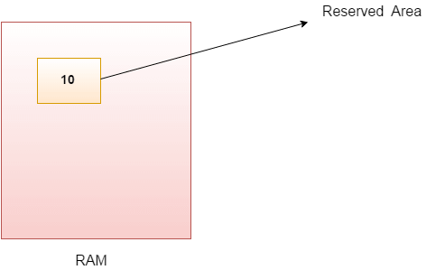
- int data=50;//Here data is variable
Types of Variables
There are three types of variables in Java:
- local variable
- instance variable
- static variable
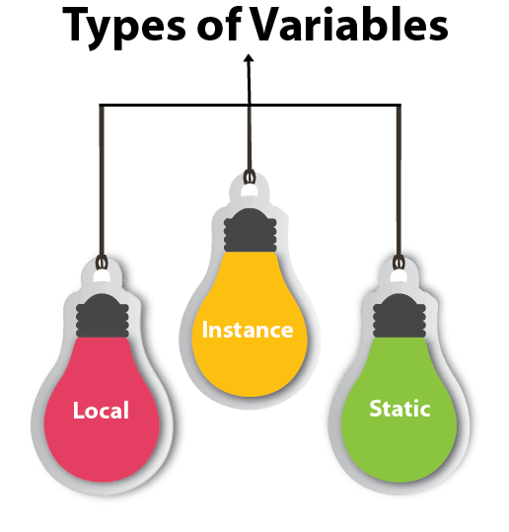
1) Local Variable
A variable declared inside the body of the method is called local variable. You can use this variable only within that method and the other methods in the class aren't even aware that the variable exists.
A local variable cannot be defined with "static" keyword.
Example of Local Variable

public class LocalVariableExample {
public static void main(String[] args)
{
//defining a Local Variable
int num = 10;
System.out.println(" Variable: " + num);
}
}
Output:
Variable: 10

2) Instance Variable
A variable declared inside the class but outside the body of the method, is called an instance variable. It is not declared as static.
It is called an instance variable because its value is instance-specific and is not shared among instances.
Example of Instance Variable

import java.io.*;
public class InstanceVariableDemo {
//Defining Instance Variables
public String name;
public int age=19;
//Creadting a default Constructor initializing Instance Variable
public InstanceVariableDemo()
{
this.name = "Deepak";
}
public static void main(String[] args)
{
// Object Creation
InstanceVariableDemo obj = new InstanceVariableDemo();
System.out.println("Student Name is: " + obj.name);
System.out.println("Age: "+ obj.age);
}
}
The this keyword in Java is a reference variable that refers to the current object. It is used within an instance method or a constructor to access members of the current object such as instance variables, methods, and constructors.
3) Static variable
A variable that is declared as static is called a static variable. It cannot be local. You can create a single copy of the static variable and share it among all the instances of the class. Memory allocation for static variables happens only once when the class is loaded in the memory.
Example Static variable
public class Main {
int a=10;
static int b=10;
Main()
{
b++;
System.out.println("Hello, World!"+ b);
}
public static void main(String[] args)
{
Main m =new Main();
Main m1 =new Main();
Main m2 =new Main();
System.out.println("Hello, World!"+ b);
}
}

