- Implement Euclidean algorithm, extended Euclidean algorithm, and using extended Euclidean algorithm find multiplicative inverse of a number.
- Implement following traditional ciphers-
- Caser cipher
- Affine cipher
- Vigenère cipher
- Block Cipher (if possible)
- Implement RSA public key cryptosystem based on the following procedure:
- Implement Rabin public key cryptosystem based on the following procedure:
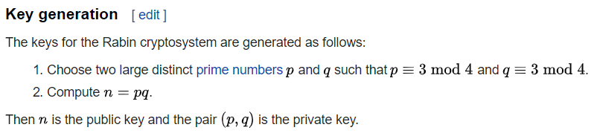

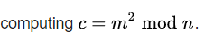
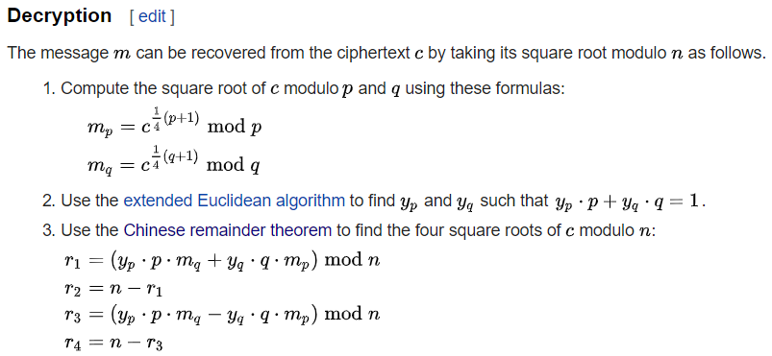
- Implement Elgamal public key cryptosystem based on the following procedure:

- Implement RSA digital signature scheme based on the following algorithm:
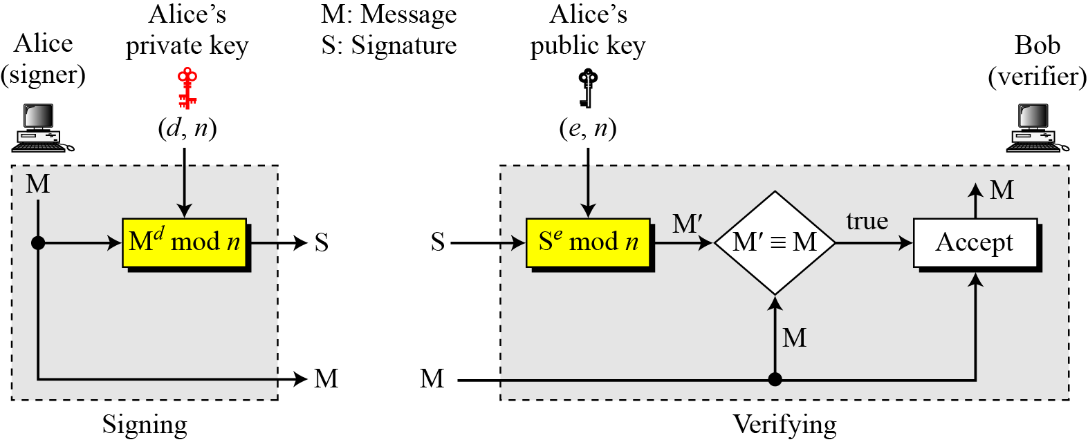
Note: key generation steps are same as in the RSA cryptosystem.

- Implement Elgamal digital signature scheme based on the following algorithm:

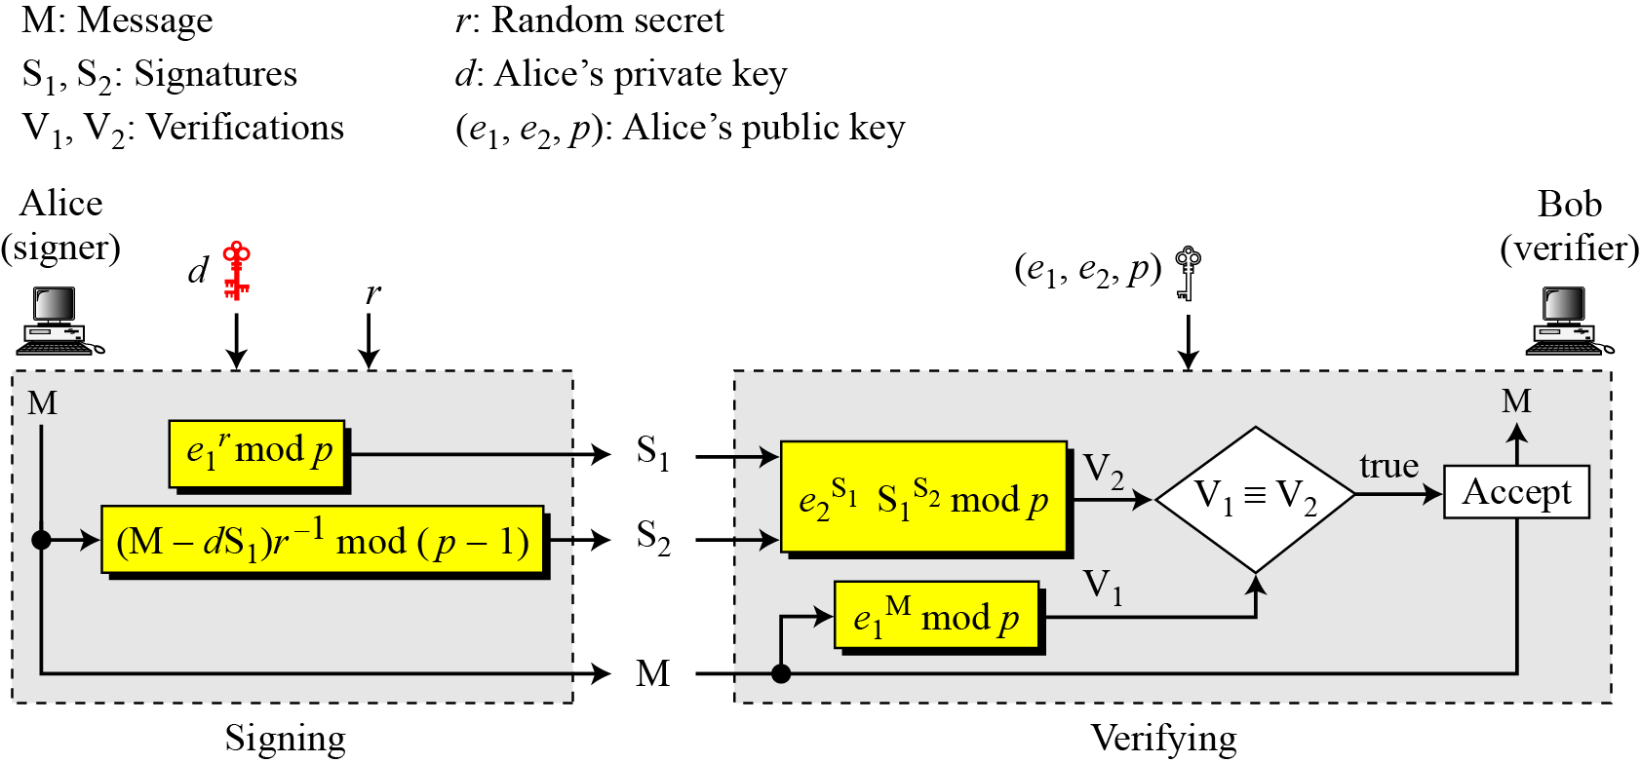
Note: key generation steps are same as in the Elgamal cryptosystem.

- Implement DSS digital signature scheme based on the following algorithm:
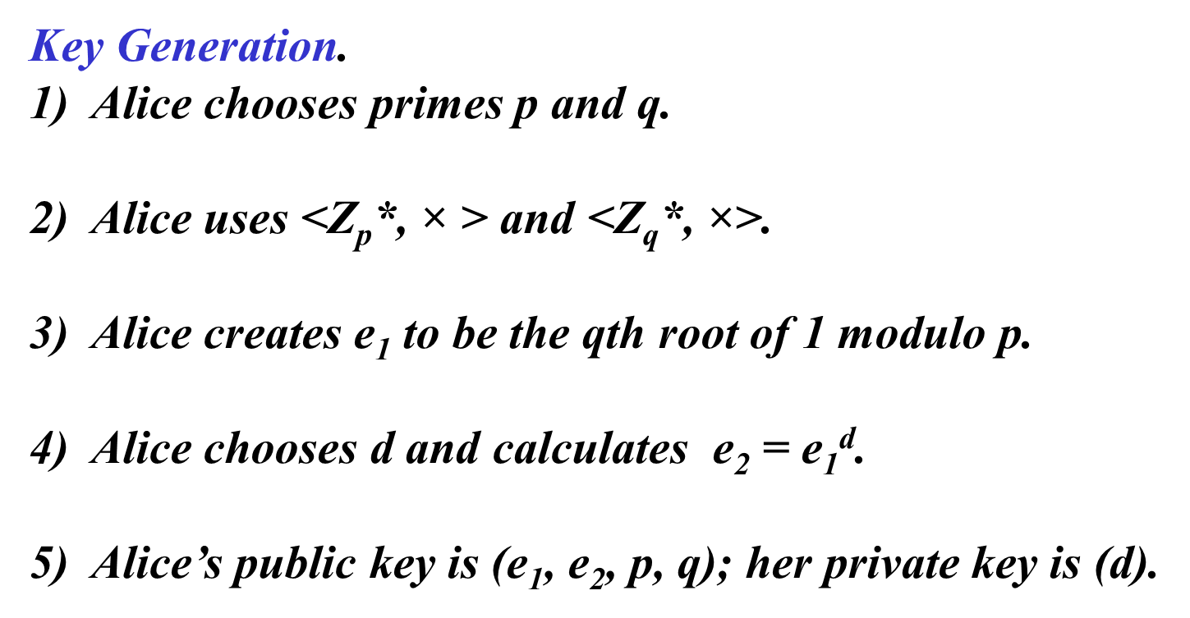
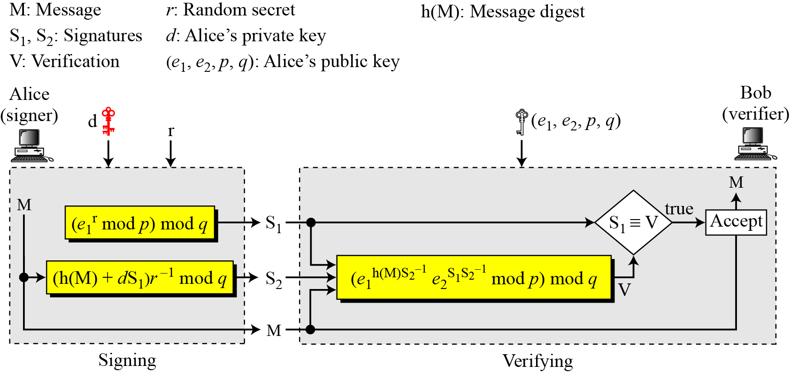
- Implement MD5 and SHA-512 Hash function
Follow this link: https://docs.python.org/3/library/hashlib.html

