Create metric server
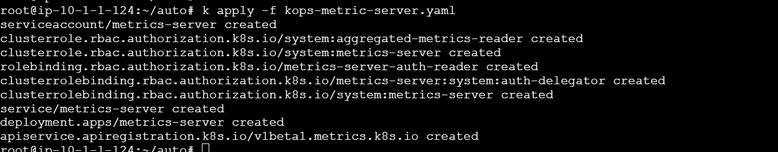
Deployed in kube-system namespace
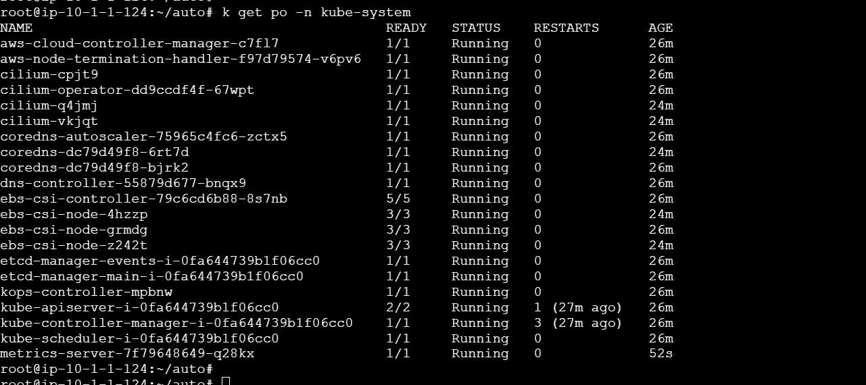

Created Deployment
