export NAME=soapfree.online
export KOPS_STATE_STORE=s3://soapfree.online
export AWS_REGION=us-east-2
export CLUSTER_NAME=soapfree.online
export EDITOR='/usr/bin/nano'

kops create cluster --name=soapfree.online \
--state=s3://soapfree.online --zones=us-east-2a,us-east-2b \
--node-count=2 --control-plane-count=1 --node-size=t3.medium --control-plane-size=t3.medium \
--control-plane-zones=us-east-2a --control-plane-volume-size 10 --node-volume-size 10 \
--ssh-public-key ~/.ssh/id_ed25519.pub \
--dns-zone=soapfree.online --dry-run --output yaml

root@ip-10-1-1-126:~# vi cluster.yaml
root@ip-10-1-1-126:~#
root@ip-10-1-1-126:~#
root@ip-10-1-1-126:~#
root@ip-10-1-1-126:~# kops create -f cluster.yaml

Created cluster/soapfree.online
Created instancegroup/control-plane-us-east-2a
Created instancegroup/nodes-us-east-2a
Created instancegroup/nodes-us-east-2b
Added ssh credential

To deploy these resources, run: kops update cluster --name soapfree.online --yes

root@ip-10-1-1-126:~# kops update cluster --name soapfree.online --yes –admin

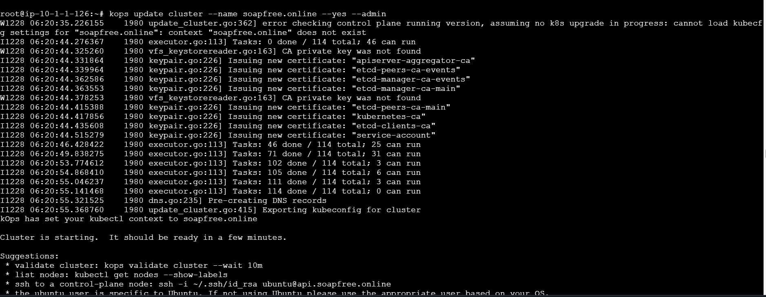
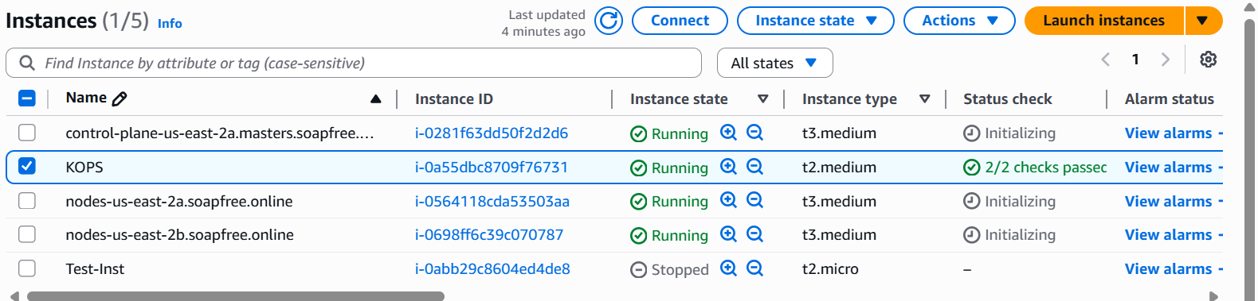
Cluster Deployed

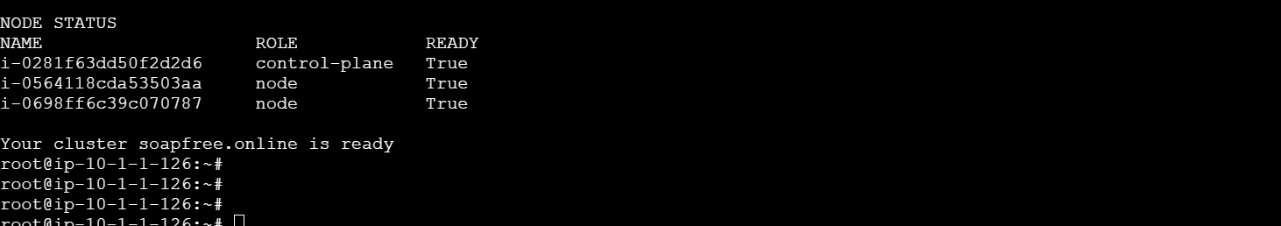

root@ip-10-1-1-126:~# k get no
NAME STATUS ROLES AGE VERSION
i-0281f63dd50f2d2d6 Ready control-plane 5m10s v1.33.7
i-0564118cda53503aa Ready node 3m5s v1.33.7
i-0698ff6c39c070787 Ready node 2m49s v1.33.7
root@ip-10-1-1-126:~#
root@ip-10-1-1-126:~#
root@ip-10-1-1-126:~#
